MEDIC INITIAL TRAINING CURRICULUM PART-2
Review and updated at January 2019

Contents
UNIVERSAL PRECAUTIONS 21
SUMMARY OF MANAGEMENT 21
HANDWASHING 21
PROTECTIVE CLOTHING 22
ISOLATION 22
SHARPS 23
CLEANING ROUTINE 23
LAB STAFF 23
COMMON SYMPTOMS 24
FEVER 24
Causes of fever 24
Symptoms associated with fever 25
Signs of serious illness 25
How to measure the temperature 25
Treatment 25
Complication 25
Common causes of fever in special population 26
PAIN 27
Examination of pain 27
Treatment 29
Acute abdominal pain 29
CARDIOVASCULAR DISEASE 33
HYPERTENSION 33
DEFINITION 33
CAUSES 33
SIGNS AND SYMPTOMS 33
COMPLICATIONS 33
DIAGNOSIS 34
ASSESSMENT OF HBP 34
TREATMENT 35
ISCHAEMIC HEART DISEASE (IHD) 39
DEFINITION 39
RISK FACTORS 39
MYOCARDIAL INFARCTION (MI) – HEART ATTACK 40
DEFINITION 40
SIGNS AND SYMPTOMS 40
DIAGNOSIS 40
TREATMENT 40
ANGINA (ISCHAEMIC HEART DISEASE) 41
DEFINITION 41
SYMPTOMS 41
DIAGNOSIS 41
TREATMENT 41
HEART FAILURE 42
DEFINITION 42
SIGNS AND SYMPTOMS 42
CAUSES 43
INVESTIGATIONS 43
TREATMENT 43
CHRONIC HEART FAILURE 45
Clinical examination 45
Treatment: 45
CARDIAC MEDICATIONS 45
PREVENTION 46
RHEUMATIC FEVER 46
DEFINITION 46
SIGNS and SYMPTOMS 46
DIAGNOSIS 46
DISEASE COURSE 47
COMPLICATIONS 47
TREATMENT 47
PREVENTION 48
VALVULAR HEART DISEASE 49
DEFINITION 49
CAUSES 49
SYMPTOMS 49
DIAGNOSIS 49
TREATMENT 50
INFECTIVE ENDOCARDITIS 50
DEFINITION 50
CAUSES 50
RISK FACTORS 50
SIGNS AND SYMPTOMS 50
DIAGNOSIS 50
TREATMENT 50
CONGENITAL HEART DISEASE 51
Atrial septal defect (ASD) 51
Ventricular septal defect (VSD) 51
Coarctation of the aorta 52
Tetralogy of Fallot 52
RESPIRATORY DISEASES 53
CHEST EXAMINATION 53
ACUTE RESPIRATORY INFECTIONS (ARI) 53
UPPER RESPIRATORY TRACT INFECTIONS 53
OTITIS 53
COMMON COLD 58
SINUSITIS 59
PHARYNGITIS 60
TONSILLITIS 61
LARYNGOTRACHEITIS AND LARYNGOTRACHEOBRONCHITIS (CROUP) 63
PERTUSSIS 64
ACUTE EPIGLOTTITIS 65
DIPHTHERIA 66
INFLUENZA 68
LOWER RESPIRATORY TRACT INFECTIONS (LRTIs) 70
ACUTE BRONCHITIS 70
CHRONIC BRONCHITIS 70
BRONCHIOLITIS 71
PNEUMONIA IN CHILDREN UNDER 5 YEARS OF AGE 73
PNEUMONIA IN CHILDREN OVER 5 YEARS AND ADULTS 76
PARAGONIMUS 78
CHRONIC RESPIRATORY DISEASES 80
CHRONIC OBSTRUCTIVE PULMONARY DISEASE (COPD) 80
BRONCHIECTASIS 83
INTERSTITIAL LUNG DISEASE 84
ASTHMA 85
TUBERCULOSIS 91
GASTROINTESTINAL DISEASES 97
Acute abdominal pain 97
GASTROINTESTINAL BLEEDING 98
GASTRO-OESOPHAGEAL REFLUX DISEASE 100
GASTRITIS 100
PEPTIC ULCER DISEASE 101
DIARRHOEA 104
ACUTE DIARRHOEA 104
DIARRHOEA WITHOUT BLOOD 109
DYSENTERY – DIARRHOEA WITH BLOOD 109
CHOLERA 111
LIVER DISEASES 113
LIVER FUNCTION TESTS (LFTs) 113
HEPATITIS 114
LIVER CIRRHOSIS 115
BILIARY COLIC 119
ACUTE CHOLECYSTITIS 119
ACUTE PANCREATITIS 120
LIVER ABSCESS 122
INTESTINAL WORMS 123
SOIL-TRANSMITTED HELMINTHS 123
TAENIA (TAPE WORM) 124
GENITO-URINARY SYSTEM 125
URINARY TRACT INFECTIONS (UTI) 125
ACUTE PROSTATITIS 128
URINARY STONES 128
ACUTE KIDNEY INJURY (AKI) 130
ACUTE GLOMERULONEPHRITIS 131
NEPHROTIC SYNDROME 133
GENITAL INFECTIONS 136
URETHRAL DISCHARGE 136
ABNORMAL VAGINAL DISCHARGE 137
Bacterial vaginosis and trichomoniasis 140
Vulvovaginal candidiasis 140
GENITAL ULCERS 141
GENITAL ULCERS AND WARTS IN WOMEN 143
HAEMATOLOGY DISEASES 145
ANAEMIA 145
THALASSAEMIA 147
BETA β THALASSAEMIA 148
ALPHA THALASSAEMIA 150
COMPLICATION 150
G6PD Deficiency (Glucose-6- Phosphate Dehydrogenase Deficiency) 151
SIGNS AND SYMPTOMS 151
DIAGNOSIS 151
TREATMENT 151
DRUGS AND CHEMICALS THAT CAUSE SEVERE HAEMOLYSIS IN G6PD DEFICIENT PEOPLE: 151
DRUGS WITH POSSIBLE RISK IN G6PD SUBJECTS 151
PREVENTION FROM HAEMOLYSIS 151
BLOOD TRANSFUSION 152
INDICATIONS 152
VOLUME TO BE TRANSFUSED 153
MONITORING 153
RATE OF TRANSFUSION 153
RISKS DURING BLOOD TRANSFUSION 154
MOST COMMON CAUSES OF TRANSFUSION REACTION 154
INFECTIOUS DISEASES 155
DEFINITION 155
BACTERIAL DISEASES 157
BACTERIAL MENINGITIS 157
TREATMENT 159
PREVENTION 159
VACCINATION 159
LEPTOSPIROSIS 160
RISK FACTORS 160
SIGNS AND SYMPTOMS 160
COMPLICATION 160
DIAGNOSIS 161
TREATMENT 161
PREVENTION 161
VACCINATION 161
SCRUB TYPHUS 162
DIAGNOSIS 162
TREATMENT 162
PREVENTION 163
VACCINATION 163
TETANUS 163
SIGNS AND SYMPTOMS 163
TREATMENT 164
PREVENTION 165
TYPHOID FEVER 166
SIGNS AND SYMPTOMS 166
DIAGNOSIS 166
TREATMENT 166
PREVENTION 167
VACCINATION 167
MELIOIDOSIS 167
PATIENTS AT RISK 167
SIGNS AND SYMPTOMS 167
DIAGNOSIS 168
TREATMENT 168
PREVENTION 168
VACCINATION 168
RESISTANT BACTERIAL INFECTIONS 169
ESBL (EXTENDED SPECTRUM BETA LACTAMASE) PRODUCING BACTERIA 169
MRSA (METHICILLIN RESISTANT STAPH AUREUS) 169
PARASITIC DISEASES 170
LYMPHATIC FILARIASIS 170
SIGNS AND SYMPTOMS 170
PREVENTION 171
VACCINE 171
VIRAL DISEASES 172
DENGUE 172
SIGNS AND SYMPTOMS 172
INVESTIGATION 174
ENCEPHILITIS 183
SIGNS AND SYMPTOMS 183
DIAGNOSIS 183
TREATMENT 184
PREVENTION 184
VACCINE 184
MEASLES 185
SIGNS AND SYMPTOMS 185
COMPLICATIONS 185
CASE MANAGEMENT 186
TREATMENT 186
PREVENTION 186
POLIOMYELITIS 187
SIGNS AND SYMPTOMS 187
DIAGNOSIS 187
TREATMENT 187
PREVENTION & VACCINATION 187
RABIES 188
SIGNS AND SYMPTOMS 188
DIAGNOSIS 188
TREATMENT 188
VACCINATION 189
HIV/AIDS 191
Natural history of HIV infection 191
WHO clinical staging of HIV infection 192
TB Screening and diagnosis 193
1. TB risk assessment and diagnosis in PLHIV 194
2. The initial assessment for TB should include: 194
3. Investigations 194
4. Case management and treatment 194
Cotrimoxazole prophylaxis 194
Baseline investigation for pre-ART 195
Adherence counseling 195
Opportunistic Infections (OIs), Prevention, Screening and Management 196
Common infections and co-morbidities 196
Sexually Transmitted Infections (STIs) 196
Hepatitis B and Hepatitis C 196
Disorders due to substance use 197
Depression 197
Non-Communicable Diseases (NCDs) 197
Nutrition 197
Anti-Retroviral Therapy (ART) 198
Anti-Retroviral (ARV) drugs, Dosage, Toxicity and Management 198
Initiation of ART 200
Initiation of ART in co-infections 200
First Line ART 201
Drug interactions 201
Routine investigations in ART patients 202
Immune Reconstitution Inflammatory Syndrome (IRIS) 202
Failures 204
Second-line and Third-line ART regimens 204
Atlas of HIV related conditions and opportunistic infections 205
ELECTROLYTE ABNORMALITIES 209
POTASSIUM 209
HYPERKALAEMIA 209
HYPOKALAEMIA 210
CALCIUM 211
HYPERCALCAEMIA 211
HYPOCALCAEMIA 211
SODIUM 212
HYPERNATRAEMIA 212
HYPONATRAEMA 212
ENDOCRINE DISEASES 214
DIABETES MELLITUS 214
SIGNS AND SYMPTOMS 214
DIAGNOSIS 214
COMPLICATIONS 215
Diabetic Ketoacidosis (DKA) 215
Hyperosmolar Hyperglycaemia State (HHS) 216
DIABETES in PREGNANCY 221
HYPOGLYCAEMIA 221
ENDOCRINE DISEASE 222
THYROID DISEASE 222
HYPOTHYROIDISM 222
HYPERTHYROIDISM 223
SIGNS AND SYMPTOMS: 223
DIAGNOSIS 224
TREATMENT 224
FOLLOW UP 224
PREVENTION 224
GOITRE 225
SIGNS AND SYMPTOMS 225
Clinical (WHO classification) 225
INVESTIGATION 225
COMPLICATION 225
TREATMENT 225
PREVENTION 225
MUSCULOSKELETAL DISORDERS 226
INFECTIOUS ARTHRITIS 226
SEPTIC ARTHRITIS 226
SIGNS AND SYMPTOMS 226
DIAGNOSIS 226
TREATMENT 227
PREVENTION 227
NON-INFECTIOUS ARTHRITIS 227
OSTEOARTHRITIS 228
SIGNS AND SYMPTOMS 228
DIAGNOSIS 228
TREATMENT 228
RHEUMATOID ARTHRITIS 229
SIGNS AND SYMPTOMS 229
DIAGNOSIS 229
TREATMENT 229
GOUT 230
RISK FACTORS 230
SIGNS AND SYMPTOMS 230
COMPLICATIONS 231
DIAGNOSIS 231
TREATMENT 231
PREVENTION 231
DISORDERS OF THE BONES 232
OSTEOMYELITIS 232
SIGNS AND SYMPTOMS 232
DIAGNOSIS 232
TREATMENT 232
PREVENTION 233
NEUROLOGICAL DISORDERS 234
HEADACHE 234
CAUSES 234
DIAGNOSIS 234
DANGER SIGNS 234
EMERGENCY CAUSES 235
MENINGITIS/ENCEPHALITIS 235
SUBARACHNOID HAEMORRHAGE 235
STROKE 235
ACUTE (CLOSED ANGLE) GLAUCOMA 235
TENSION HEADACHE 236
MIGRAINE 236
DEPRESSION 237
TRAUMA RELATED 237
DANGER SIGNS OF BLEEDING IN THE BRAIN 237
TUMOURS 238
TEMPORAL ARTERITIS 238
OTHER 239
EPILEPSY 239
STROKE 242
NUTRITION 246
Six essential nutrients 246
Carbohydrates 246
Proteins 246
Fats 247
Important vitamins and minerals 247
Others vitamins: 249
Water 250
MALNUTRITION 251
Causes of malnutrition 251
How to prevent malnutrition? 251
Types of acute malnutrition 252
Dry malnutrition: MARASMUS malnutrition. 252
Wet malnutrition: KWASHIORKOR malnutrition 253
Complications of acute severe malnutrition 254
How do we check malnutrition? 254
MUAC 254
Weight for Height for children from 6 months to 10 years old (Z score) 254
Weight for Height for Adolescents and adults 254
MODERATE ACUTE MALNUTRITION MANAGEMENT 255
Nutrition assessment 255
Management 255
Assessing for possible causes and Health Education 255
Investigations 256
Systematic supportive treatment 256
Immunisations 256
Follow up 256
SEVERE ACUTE MALNUTRITION MANAGEMENT 257
Important background information to remember before treating SAM 257
Stages of treatment: 257
Hypoglycaemia 258
Hypothermia 259
Dehydration 259
Electrolyte imbalance 260
Infection 260
Micronutrient deficiencies 260
Initiate feeding - start milk feeds 261
Catch up growth 262
VITAMIN DEFICIENCIES 263
VITAMIN A DEFICIENCY 263
VITAMIN B1 DEFICIENCY 265
SKIN DISEASES 268
BACTERIAL SKIN INFECTIONS 268
IMPETIGO 268
ABSCESS 269
CELLULITIS AND ERYSIPELAS 269
FUNGAL SKIN INFECTIONS 270
CANDIDA 270
RINGWORM 270
VIRAL SKIN INFECTIONS 271
HERPES SIMPLEX 271
VARICELLA ZOSTER/CHICKENPOX 272
HERPES ZOSTER (SHINGLES) 273
PARASITIC SKIN INFECTIONS 274
SCABIES 274
CUTANEOUS LARVA MIGRANS (HOOKWORM INFECTION) 275
LARVA CURRENS (STRONGYLOIDES INFECTION) 276
NON-INFECTIVE SKIN RASH 277
URTICARIA (ALLERGIC RASH) 277
SIGNS AND SYMPTOMS 277
TREATMENT 277
ECZEMA 277
PSORIASIS 278
LEPROSY 279
SIGNS AND SYMPTOMS 279
DIAGNOSIS 280
TREATMENT 280
LEPROSY REACTIONS 281
WOUNDS 282
TREATMENT 282
TETANUS PREVENTION 284
BURNS 285
HISTORY 285
EXAMINATION 285
HEALTH EDUCATION 287
Nutrition 287
Type of food to eat 287
How often to eat 287
Hydration 287
Breastfeeding 287
Weaning 287
Hygiene 288
Personal hygiene 288
Hand washing 288
Environment hygiene 289
Recognizing danger signs of a sick child and signs of malnutrition 289
Signs of malnutrition 289
Danger signs of a sick child 290
Immunization 290
Family planning 290
Safe food preparation 291
Safe feeding 291
DENTAL DISEASES 292
DISEASES OF GUMS AND TEETH 292
DENTAL CARIES 292
GUM DISEASES 292
GINGIVITIS 292
PERIDONTITIS 293
STOMATITIS 293
TRAUMA 294
EYE DISEASES 295
POOR VISION (Refraction error) 295
INFECTIONS 296
CONJUNCTIVITIS 296
TRACHOMA 297
EYE INJURIES 298
CORNEAL ULCERS 299
CATARACT 299
PTERYGIUM 300
GLAUCOMA 301
DIAGNOSIS 301
STRABISMUS 302
CAUSES 302
DIAGNOSIS 302
TREATMENT 302
XEROPHTHALMIA 303
SIGNS AND SYMPTOMS 303
DIAGNOSIS 303
TREATMENT 303
MENTAL HEALTH 305
ESSENTIAL CARE & PRACTICE 305
A. GENERAL PRINCIPLES 305
B. ESSENTIALS OF MENTAL HEALTH CLINICAL PRACTICE 307
DEPRESSION 312
MNS ASSESSMENT 312
PSYCHOSOCIAL INTERVENTION 313
PHARMACOLOGICAL INTERVENTION 314
PSYCHOSES 316
MNS ASSESSMENT 316
PSYCHOSOCIAL INTERVENTIONS 318
PHARMACOLOGICAL INTERVENTIONS 320
FOLLOW UP 323
CHILD & ADOLESCENT MENTAL & BEHAVIOURAL DISORDERS 324
COMMON PRESENTATIONS OF CHILD & ADOLESCENT MENTAL & BEHAVIOURAL DISORDERS 324
PSYCHOSOCIAL INTERVENTIONS 326
PHARMACOLOGICAL INTERVENTION 326
DISORDERS DUE TO SUBSTANCE USE 327
SELF-HARM / SUICIDE 330
PSYCHOSOCIAL INTERVENTION 331
ANXIETY DISORDERS 332
TREATMENT 332
POST TRAUMATIC STRESS DISORDER 332
EMERGENCIES 335
BASIC CARDIO - RESPIRATORY RESUSCITATION 335
What is a shock? 335
Definition 335
Signs of shock 335
Steps of resuscitation 336
Requirements 336
Artificial ventilation (Adult) 337
What do you do in priority to unresponsive patient with a normal breathing? 339
Resuscitation in child 340
Artificial ventilation (Children) 340
In addition to resuscitation: 342
What do you do in case of airway obstruction? 342
Chest thrusts for baby and child 343
Chests thrusts and abdominal thrusts for adult 343
SHOCK 344
COMA 348
CONVULSIONS 351
EMERGENCY TREATMENT 351
DIABETIC EMERGENCIES 353
GASTRO-INTESTINAL BLEEDING 354
NEUROLOGICAL EMERGENCY: STROKE 356
Appendix 357
Appendix 1. FORMAL DIAGNOSIS OF COPD by SPIROMETRY 357
Appendix 2. F-75 and F-100 recipes 358
Appendix 3. ReSoMal 359
Appendix 4: MUAC, z-score table and others nutrition charts 360
Appendix 5: Weight for height and malnutrition 360
Appendix 6: WHO growth chart (Boys) 361
Appendix 7: WHO growth chart (Girls) 362
Appendix 8: Weight for Age table (Boys) 363
Appendix 9: Weight for Age table (Girls) 365
Lists of abbreviations 367
Reference: 370

Figure 1 Pain Measurement Scale (Allinahealth.org, n.d.) 28
Figure 2 Universal Pain Scale (NHS, n.d.) 28
Figure 3 Anatomy 9 body regions 30
Figure 4 Anatomy 9 regions and common diseases (Murtagh, 2015) 30
Figure 5 Plain X ray signs for acute abdomen (Murtagh, 2015) 30
Figure 6 Surgical causes of the acute abdomen (Murtagh, 2015) 31
Figure 7 BP measurement and treatment options 36
Figure 8 Treatment of chronic hypertension (Adult) 37
Figure 9 Atrial Septal Defect (ASD) 51
Figure 10 Ventricular Septam Defect (VSD) 51
Figure 11 Coarctation of the aorta 52
Figure 12 Anatomy of ear 54
Figure 13 Normal ear, COM with Effusion and CSOM 57
Figure 14 Tonsillitis and Peritonsillar Abscess 61
Figure 15 Bronchitis and emphysema 80
Figure 16 Airway with bronchiectasis 83
Figure 17 Bronchial Asthma Airway 85
Figure 18 Anti TB Drugs 94
Figure 19 Acute abdominal pain and 9 regions 97
Figure 20 Anatomy 9 regions and common diseases (Murtagh, 2015) 97
Figure 21 Emergency Treatment for Active GI Bleeding 99
Figure 22 Management algorithm for epigastric pain 103
Figure 23 Kernig's sign and Brudzinski's sign 158
Figure 24 Reading CSF result 159
Figure 25 Dengue case management (WHO) 173
Figure 26 Natural history of HIV/AIDS 191
Figure 27 HIV progression in 3 phases 191
Figure 28 Lymphadenopathy [lymph nodes that you can feel because they are bigger than normal] 205
Figure 29 Angular chelitis 205
Figure 30 Recurrent [for a long time or keeps happening] oral ulcer 205
Figure 31 Herpes zoster 206
Figure 32 Papular pruritic eruption = itchy rash 206
Figure 33 Seborrheic dermatitis = dry skin round the nose 206
Figure 34 Fungal nails 206
Figure 35 Oral candida [thrush] 207
Figure 36 Oral hairy leukoplakia = white on the side of the tongue 207
Figure 37 Acute severe necrotising gingivitis [gums] or periodontitis [around the teeth] 207
Figure 38 Chronic herpes simplex (Oral or Genital) 208
Figure 39 Kaposi sarcoma [type skin cancer – on the skin or in the mouth 208
Figure 40 Severe fungal infection like penicilliosis – suspect if rash + lymph nodes + unwell: 208
Figure 41 Diagnosis for Diabetes 214
Figure 42 Carbohydrate rich foods 246
Figure 43 Protein rich foods 247
Figure 44 Fats rich foods 247
Figure 45 Kwashiorkor and Marasmus 252
Figure 46 Marasmus 253
Figure 47 Kwashiorkor 253
Figure 48 Impetigo 268
Figure 49 The mite invading into the skin. 274
Figure 50 Burn percentage of skin 286
Figure 51 Anatomy of an eye 295
Figure 52 Master Chart of MNS Conditions 310
Figure 53 Master Chart of MNS Conditions 311
Figure 50 Resuscitation in adult (ref: UK's RC) 336
Figure 51 Body position of cardiac massage 337
Figure 52 Hand position of cardiac massage 337
Figure 53 Mouth to mouth ventilation 337
Figure 54 Ambu Bag ventilation 338
Figure 55 Resuscitation in children (ref: UK's RC) 340
Figure 56 Mouth to mouth ventilation (Child over 1 year) 340
Figure 57 Mouth to mouth and nose ventiation (Infants) 341
Figure 58 Ventilation with Ambu bag (Infants, Children and adults) 341
Figure 59 Two fingers technique (Infants) 342
Figure 60 One hand technique CPR (Children) 342
Figure 61 Chest thrusts for baby and child 343
Figure 62 Chest thrusts for adult 343

Table 1 Revised Jones Criteria 47
Table 2 Classification of the severity of pneumonia (Under 5 children) 74
Table 3 Antibiotic treatment in severe pneumonia and pneumonia 75
Table 4 Assessment and Treatment of COPD 81
Table 5 Emergency management on Asthma Attack patient arrival 86
Table 6 Assessment of Severity in ASTHMA ATTACK (Frontières., 2018) 87
Table 7 Treatment of ASTHMA ATTACK (Frontières., 2018) 88
Table 8 Long term treatment of Asthma according to severity 89
Table 9 Anti TB Cat-I 95
Table 10 Anti TB Cat-II 95
Table 11 Side effects of anti-TB drugs 96
Table 12 Acute diarrhoea 104
Table 13 Dehydration assessment 105
Table 14 WHO Guidelines approximate amount of ORS to give in first 4 hours 107
Table 15 Recommendations how much IV Ringers Lactate fluid to give 108
Table 16 LFTs (Liver Function Tests) 113
Table 17 Steoid treatment in Nephrotic Syndrome 134
Table 18 Hb level defining anaemia and transfusion threshold 152
Table 19 Blood group compatability 153
Table 20 Common causes of transfusion reaction 154
Table 21 Definition of infectious disease 155
Table 22 Age and related main bacteria 157
Table 23 WHO clinical staging of HIV infection 192
Table 24 Cotrimoxazole prophylaxis criteria 194
Table 25 Baseline investigation before ART initiation 195
Table 26 ARV, dosage, toxicity and management 198
Table 27 Summary for ART initiation 200
Table 28 First Line ART regiem for child, pregnant and Adults 201
Table 29 Drug Interaction and management 201
Table 30 Routine investigation in ART patients 202
Table 31 Algorithm for ART Failures 204
Table 32 Second Line ARTs 204
Table 33 Third Line ARTs 205
Table 34 General Management of Patients with Acute Stroke 244
Table 9 Iron rich foods 247
Table 10 Folic acid rich foods 248
Table 11 Calcium rich foods 248
Table 12 Vitamin A rich foods 249
Table 13 Other vitamin rich foods 249
Table 14 Causes of malnutrition (ref: TBC) 251
Table 35 Formal diagnosis of COPD by spirometry 357

UNIVERSAL PRECAUTIONS
Universal precautions are simple measures taken to prevent transmission of infection from body fluid and/or blood from:
- Patient to health care worker;
- Patient to patient;
- Health care worker to patient.
All patients’ body fluid should be considered infectious, since it is not known who is infected and who is not. The health worker is most at risk of needle prick injuries and splashes of body fluids into the eyes, mouth etc. These areas can be protected to some degree (see below), but awareness and avoidance of the potential risks are the best way of preventing infection.

SUMMARY OF MANAGEMENT
- Wash hands with water and soap before and after patient contact and after removing gloves.
- Wear gloves if there is a risk of contact with blood and body fluids.
- If there is a risk of splashing of blood or body fluids you can protect yourself further by wearing eye glasses or goggles, mask and/or gown.
- Reduce unnecessary procedures. For example, avoid unnecessary blood transfusions, injections, or suturing.
- Place a patient whose blood or body fluids are likely to contaminate surfaces or other patients in an isolation room or area.

HANDWASHING
Make sure there is running water in your clinic or at least ensure there is access to water.
Wash your hands with plenty of water and (antimicrobial) soap.
Washing hands with soap and water is preferable to alcohol wash.
Alcohol concentration of > 60% needed.
Alcohol should not be used for visible dirt e.g. blood, mucous, saliva: use water and soap.
Hand washing with a good technique covering all surfaces of the hands at the right time is more important than the agent used or the length of time of hand washing (see drawing for technique)
- Wash hands immediately after contact with blood, body fluids, mucous membranes or broken skin, even if gloves are worn.
- Wash hands before and after eating or preparing food.
- Wash hands after using the toilet.
- Wash hands after blowing your nose, coughing or sneezing into your hands.
- Wash hands before giving injections.
- Wash hands after each patient contact.
- Wash hands after handling dirty items.

PROTECTIVE CLOTHING
Gloves
- Wear clean, ordinary thin gloves anytime there is contact with blood, body fluids, mucous membrane, and broken skin.
- Change gloves between tasks or procedures on the same patient.
- Before going to another patient, remove gloves promptly and wash hands immediately.
Gowns
- Plastic gowns should be worn when there is a risk of splashes of blood or other fluids e.g. vaginal deliveries, opening abscesses. Clean them after use.
- Clean work clothes after use.
Eye-cover and mask
- Eyeglasses or goggles and a mask should be used when there is a risk of splashes of body fluids, for example, vaginal deliveries, opening abscesses.

ISOLATION
For airborne transmission:
- Place the patient in a separate room away from other patients. The patient’s room should be well ventilated. The doors should be closed to the hall and the windows open to the outside. This will reduce the chance of airborne infection. If possible, patients’ rooms should have large windows to let in sunlight.
- Wear a mask when working with the patient.
- Limit movement of the patient from the room to other areas.

For droplet transmission:
- Place the patient in an isolation room.
- Wear a mask when working with the patient.
- Limit movement of the patient from the room to other areas.

For contact transmission:
- Place the patient in an isolation room and limit access.
- Wear gloves during contact with patient and with infectious body fluids or contaminated items. Wash hands after each patient contact.
- Wear two layers of protective clothing.
- Limit movement of the patient from the isolation room to other areas.
- Avoid sharing equipment between patients. Use separate equipment for each patient, if supplies allow. If sharing equipment is unavoidable, clean and disinfect it before using it with the next patient.

SHARPS
- Never re-use needles. Avoid recapping needles.
- Discard contaminated disposable sharps immediately into a sharps container (puncture resistant and liquid proof containers).
- The precise location of sharps containers is important. They should be kept as close as possible to where the sharp item is to be used.
- Make sure contaminated equipment is not reused until it has been cleaned, disinfected, and sterilised properly.
- When washing sharp instruments wear heavy gloves and handle with care.

CLEANING ROUTINE
- Routinely clean and disinfect frequently touched surfaces including beds, bed rails, patient examination tables and bedside tables. Always use gloves when cleaning. Clean the area with disinfectant e.g. bleach, alcohol or iodine.
- Clean and disinfect soiled linens and launder them safely. Avoid direct contact with items soiled with blood and body fluids.

LAB STAFF
- Assume all specimens are contaminated.
- Wear gloves.
- Wear eye protection if there is a risk of splashes.
- When cleaning lab equipment wear gloves.
- Do not eat in the lab.
- Wear a mask if dealing with airborne pathogens, such as TB.

COMMON SYMPTOMS

FEVER
Fever means increase in body temperature. Axillary and tympanic (ear) temperature more than 37.5ºC is considered as fever.

Different kinds of body temperature and dangers
- Normal temperature = 37ºC +/- 0.5°C
- Hypothermia < 36.4ºC
- High fever
  - Moderate pyrexia (fever) > 37.6°C
  - High pyrexia (fever) > 38.5°C
  - When body temperature is more than 41 ºC: the body will lose abilities of temperature control, decease sweating. Cells and tissue are damaged and lose their function.
  - When body temperature is more than 42 ºC, the patient will get seizure and die in few hours.
Different kinds of fever and diseases
Constant fever: patient body temperature always increases. This kind of fever is usually found in typhoid, TB or pneumonia patient.

Remittent fever: patient body temperature will increase and then decrease by itself, but still high than normal body temperature. This kind of fever is usually found in fever of unknown origin, Scrub typhus, etc.

Intermittent fever (swinging fever): patient body temperature will increase very high and in 24 hours will decrease below the normal body temperature. The body temperature will continuously alternate between very high and low temperature. This kind of fever usually found in sepsis or bone infection patient.

Relapsing fever = Patient will get fever and then the fever will disappear by itself. The fever appears again in 2-3 days. This kind of fever is usually found in malaria or meningitis.

Irregular fever = Fever cannot follow one kind of fever above. This kind of fever is usually found when the patient takes antibiotic or antipyretic drug.

Causes of fever
- Infection : bacteria, virus, fungus, protozoa or parasitic infection
- Malignancy: lymphoma, leukemia.
- Reaction: immediate after surgery.
- After receiving routine immunization : DPT, BCG, measles
- Extreme sunburn

Symptoms associated with fever
- Chills: feeling cold even though body temperature is high.
- Rigor: a severe chill with chattering of the teeth and severe shivering.
- Rashes: A rash is a noticeable change in the texture or color of your skin. Your skin may become scaly, bumpy, itchy, or otherwise irritated.
- Cough: Coughing is your body’s way of getting rid of an irritant. When something irritates your throat or airway, your nervous system sends an alert to your brain. Your brain responds by telling the muscles in your chest and abdomen to contract and expel a burst of air. A cough is an important defensive reflex that helps protect your body from irritants like mucus, smoke, and allergens such as dust, mold, and pollen. Coughing is a symptom of many illnesses and conditions. Sometimes, the characteristics of your cough can give you a clue to its cause.
- Headache: A headache is a very common condition that causes pain and discomfort in the head, scalp, or neck.
- Dysuria: Painful urination
- Arthralgia: Joint stiffness
- Arthritis: Inflammation of a joint
- Myalgia: Muscle aches

Signs of serious illness
- Sepsis and shock
- Systemic illness: Meningism, seizures, confusion, photophobia, persistent vomiting, rigid abdomen, rash, difficult breathing, chest pain, etc.
- Special general condition: Pregnancy, malnutrition, immune suppression, splenectomy, chronic disease, very young aged or very old aged

How to measure the temperature
- Axilla (+1°F or +0.5°C): Proper measurement of axillary temperature takes 5 minutes.
- Orally
- Per rectally

Treatment
** Look for the signs of serious illness and provide appropriate treatment (E.g. Antibiotic, Anti-malaria) **
If fever over 38°C:
- Remove any unnecessary clothing
- Remove blankets
- Start tepid sponging
- Give Paracetamol P.O (Adult: 1g QID (Max 4 g/day), Child: 15 mg/kg (Max 2g/day)
- If fever is still high, consider to use ibuprofen P.O. (Black box warnings: All NSAIDs have cardiovascular risks and gastrointestinal risks)
- Hydrate patient (Drinking a lot, IV fluid infusion if cannot drink.)

Complication
A rapid rise or fall in temperature may cause a febrile seizure in a small percentage of children younger than age 5.

Common causes of fever in special population
Pregnant women | During delivery | Aging people
Malaria  Urinary and pelvic infection  Respiratory infection | Uterine infection  Placenta retention  Phlebitis  Urinary Tract Infection  Malaria | Urinary Tract Infection (UTI)  Pneumonia  Peritonitis  Cholecystitis  Appendicitis

** If fever is longer than 2 weeks, think for Tuberculosis (TB) and scrub typhus.**

PAIN
Pain is a usually symptom of injury or disease.

Examination of pain
(SOCRATES)

Site: Where is the pain? Or the maximal site of the pain.

Onset: When did the pain start, and was it sudden or gradual? Include also whether it is progressive or regressive.
- Acute onset
- Insidious onset

Character: What is the pain like?
- Aching
- Stabbing
- Throbbing
- Burning
- Constricting/gripping
- Distending
- Colic

Radiation: Does the pain radiate anywhere?
- Extension of pain to another site whilst the initial pain persists

Association: Any other signs or symptoms associated with the pain?

Time course: Does the pain follow any pattern?
- Continuous severe pain
- Slowly increased pain, then relief slowly

Exacerbating and Relieving Factor: Does anything change the pain?

Exacerbating factors
- Abdominal pain after meal
- Musculoskeletal pain are affected by joint movement, muscle exercise and posture

Relieving factors
- Position/movement
- Hot water bottle
- NSAIDs
- Food
- Antacids

Severity: How bad is the pain?
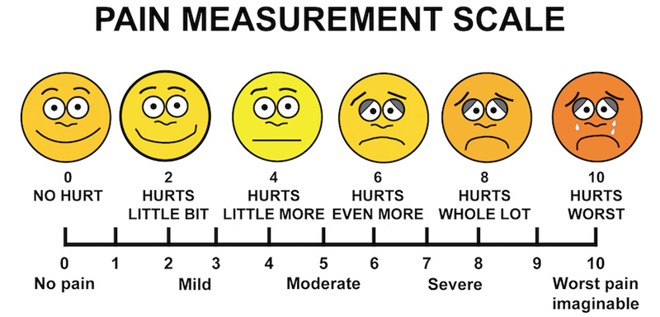
Figure 1 Pain Measurement Scale (Allinahealth.org, n.d.)
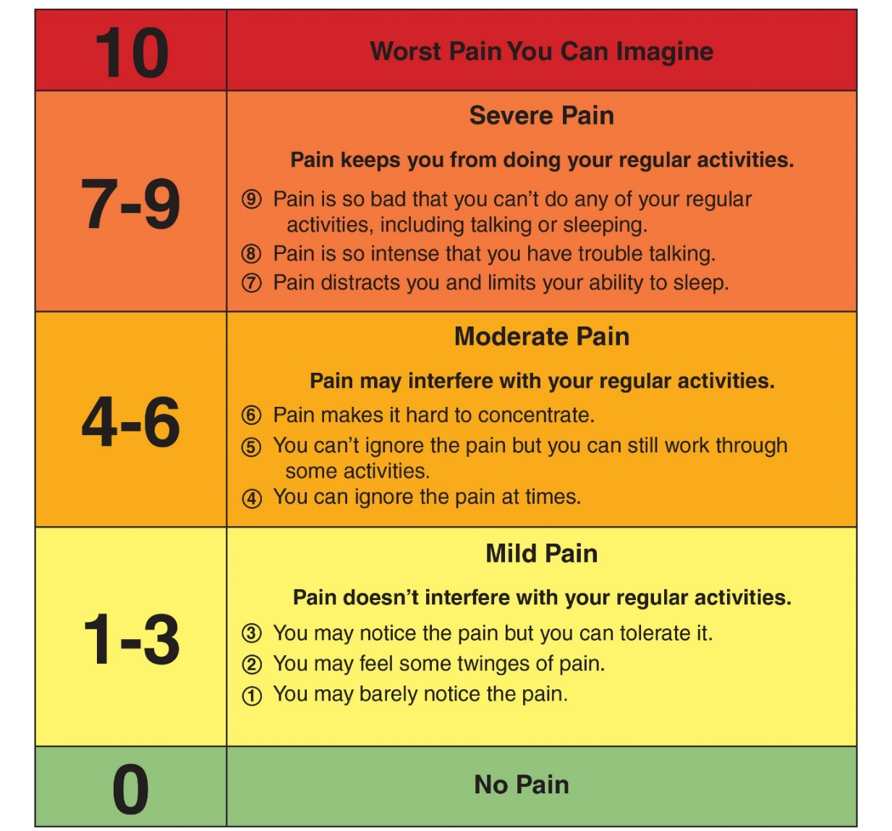
Figure 2 Universal Pain Scale (NHS, n.d.)

Treatment
Step I | Step II | Step III  Opioids are controlled drugs. | Step IV  Opioids are controlled drugs.
Paracetamol  (Consider Amitriptyline for nerve pain) | NSAIDs: Ibuprofen or Diclofenac  AND  Paracetamol | Weak opioid: Tramadol  AND  Paracetamol  AND/OR  Ibuprofen | Strong opioid: Morphine

Warnings:
- Asparin is contraindicated in children below 12 years.
- NSAIDs can exacerbate an asthma attack.
- Never use pain killer higher dose than maximum recommended dose.

Treatment examples:
  - Moderate headache, muscle, joint or bone pain: paracetamol. If moderate muscle or joint pain does not improve with paracetamol, start anti-inflammatory drugs like ibuprofen or diclofenac if not contraindicated.
  - Amitriptyline low dose (high doses are used for treatment of depression) could be used for tingling pain in feet, leg or arms (commonly from diabetes mellitus or trauma) and for prophylaxis of migraine headache. Amitriptyline can make patients drowsy, very good to take at night.
  - The controlled drugs are not available at the clinic, please consider for referral.

Never leave the patient with severe pain without a diagnosis of the underlying cause of pain. Only relieving the pain is not enough. Try to find and treat the cause of pain.

Acute abdominal pain
Definition: Sudden onset of severe abdominal pain that may or may not need referral for surgical intervention.
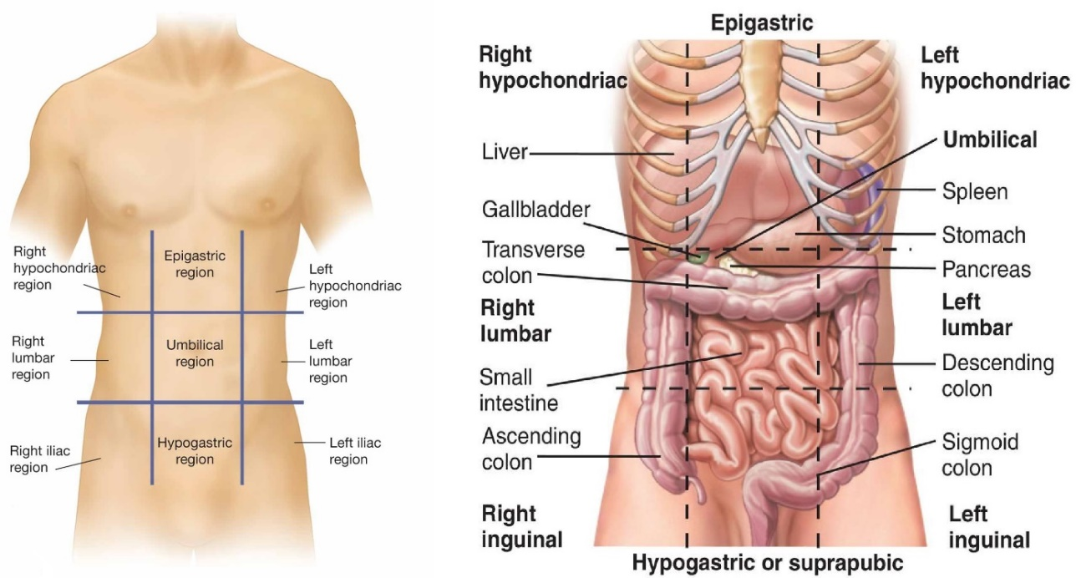
Figure 3 Anatomy 9 body regions
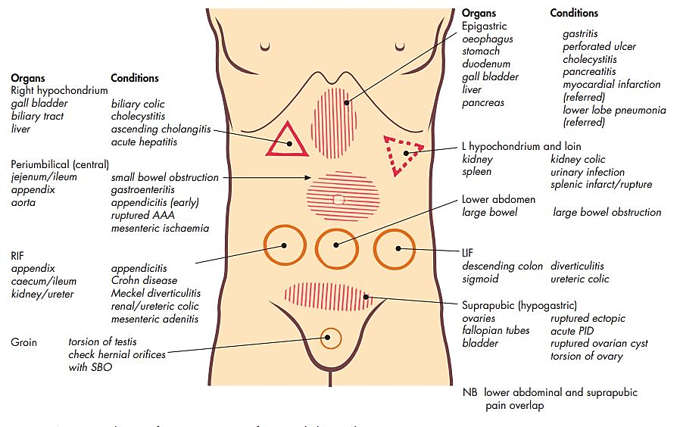
Figure 4 Anatomy 9 regions and common diseases (Murtagh, 2015)
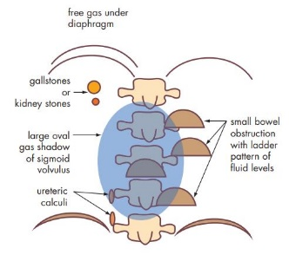
Figure 5 Plain X ray signs for acute abdomen (Murtagh, 2015)
Process | Organ involved | Disorder
Inflammation | Bowl | Inflammatory bowel disease
Inflammation | Appendix | Appendicitis
Inflammation | Gall bladder | Cholecystitis
Inflammation | Liver | Hepatitis
Inflammation | Pancreas | Pancreatitis
Inflammation | Fallopian tube | Salpingitis
Inflammation | Colonic diverticulae | Diverticulitis
Perforation | Duodenum | Perforated duodenal ulcer
Perforation | Stomack | Perforated gastric ulcer
Perforation | Colon (diverticula or cancer) | Faecal peritonitis
Perforation | Gall bladder | Biliary peritonitis
Perforation | Appendix | Appendicitis
Obstruction | Gall bladder | Biliary colic
Obstruction | Small intestine | Acute small bowel obstruction
Obstruction | Large bowel | Acute large bowel obstruction
Obstruction | Ureter | Ureteric colic
Obstruction | Urethra | Acute urinary retention
Obstruction | Mesenteric artery occlusion | Intestinal infarction
Haemorrhage | Fallopian tube | Ruptured ectopic pregnancy
Haemorrhage | Spleen or liver | Ruptured spleen or liver (haemoperitoneum)
Haemorrhage | Ovary | Ruptured ovarian cyst
Haemorrhage | Abdominal aorta | Ruptured abdominal aortic aneurysm (AAA)
Torsion (ischaemia) | Sigmoid colon | Sigmoid volvulus
Torsion (ischaemia) | Ovary | Torsion ovarian cyst
Torsion (ischaemia) | Testes | Torsion of testes
Figure 6 Surgical causes of the acute abdomen (Murtagh, 2015)

Treatment
Try to find and treat the cause. Detail history taking and physical examination is important. Sometimes, laparotomy/surgical is the only way to discover the cause. Two categories to treat abdominal pain

1) Hard abdomen with abdominal pain
This usually has a surgical cause like peritonitis, appendicitis, cholecystitis, intestinal perforation/obstruction, ectopic pregnancy, rupture renal stone, incarcerated hernia and cholangitis might also need operation.
Treatment
- Refer the patient to a hospital
- Nothing by mouth
- IV line keep on
- IV ampicillin + IV genta+ IV metro (1St choice)
- IV chloramphenicol +IV genta (2nd choice)

2) Soft abdomen with abdominal pain
This usually has a non-surgical cause like pyelonephritis, worms, painful menstruation, PID, endometritis, peptic ulcer (without perforation), gynecological or obstetrical problem, hepatitis.

CARDIOVASCULAR DISEASE

HYPERTENSION

DEFINITION
- HYPERTENSION, OR HIGH BLOOD PRESSURE (HBP) is a Systolic BP (SBP) equal or greater than 140mmHg and/or Diastolic BP (DBP) equal or greater to 90mmHg (≥ 140/90mmHg).
  - Hypertension is a risk factor for stroke, heart attack, and kidney failure.
  - The cardiovascular risks of HBP are greater if there are other risk factors such as age (>60 years), gender (males > females), poor diet, smoking, high blood cholesterol, diabetes mellitus and if the patient already has heart disease or kidney disease. (BBG, 2016)
- MALIGNANT HYPERTENSION is very high blood pressure (SBP >180 OR DBP >120) that acutely affects one or more organs (See detailed in EMERGENCY).
- PRE-ECLAMPSIA is a very severe condition in pregnant women with HBP near the end of pregnancy. It can also occur post-partum. This condition is very different from essential hypertension and treatment is also different. (See detailed in obstetric guidelines)

CAUSES
95% of HBP is unknown, called “Essential hypertension”.
5% of HBP has known causes, called “Secondary hypertension”, includes:
- High alcohol intake and smoking
- Obesity
- Pregnancy (Pre-eclampsia)
- Kidney diseases
- Diseases of adrenal gland or other glands
- Drugs (Prednisolone, oral contraceptive pills, amphetamines (YaBa), NSAIDs, salbutamol)
- Pain and anxiety
- Congenital heart disease

SIGNS AND SYMPTOMS
Most patients do not have any symptoms. Some patients suffer from headache, dizziness or fatigue.

COMPLICATIONS

Complications of ACUTELY high BP (EMERGENCY):

Malignant Hypertension
This is a condition of very high blood pressure (SBP >180 OR DBP >120) where there is damage to organs (brain, retina, kidneys or heart) because of the lack of blood flow. This causes:
General | nausea, vomiting
Brain | neurological changes e.g. temporary loss of speech or vision, numbness, confusion, restlessness, convulsion, coma or stroke
Retina | acute visual problems
Kidneys | acute kidney failure
Heart | acute heart failure, aortic dissection (tear in aorta – causes severe chest pain, may cause different BP measurements in right and left arms)

Complications of CHRONICALLY high BP:
If patients have high blood pressure for a long time then they may get complications/symptoms below:
Peripheral blood vessels | HBP may damage blood vessels causing pain in the legs when walking (claudication).
Central Nervous System | Stroke is a common complication of HBP. Transient ischemic attacks and subarachnoid haemorrhage are more common in patients with HBP.
Eyes | Damage to the retina which becomes more severe if the HBP is more severe. This leads to bad eyesight but blindness is rare.
Heart | There is a higher incidence of heart disease associated with HBP mainly because of ischaemic heart disease. HBP puts a lot of pressure on the heart and may lead to left ventricular hypertrophy (thickening of the heart muscle so it doesn’t work as well). Severe hypertension can cause left heart failure. Atrial fibrillation (irregular heart rhythm) is common.
Kidneys | Kidney disease can cause HBP but chronic HBP can also cause chronic kidney failure.

DIAGNOSIS
- Severe hypertension (systolic BP > 180 OR diastolic BP > 120) AND/OR complications

- Hypertension: Monitor High blood pressure once/week x 3 weeks
Note: It is recommended that healthy adults should have their BP checked every 3 years

ASSESSMENT OF HBP
- BP measurements every week for 3 weeks
- Identify risk factors/underlying cause (History taking and examination)
- Urine dipstick for blood/protein/glucose
- Fasting Blood Sugar (FBS)

TREATMENT

Explanation to patient
  - Explain to patients that hypertension is a disease that may not have any symptoms, but it puts them at higher risk for problems like stroke and heart attack.
  - This risk can be reduced by lifestyle changes and in some cases medication.
  - The medication will not cure the problem but will decrease the risk. They will have to take medication and follow up for the rest of their life.

Lifestyle advice for all patients
  - Reduce the amount of salt in diet.
  - Healthy diet e.g. avoid fatty foods / eat more vegetables and fruit.
  - Lose weight if overweight or obese.
  - Alcohol: Advise the patient to stop or if unable to stop at least to reduce.
  - Smoking: Advise the patient to stop or if unable to stop at least to reduce.
  - Exercise at least 30 minutes most days of the week.

When to start medication for HBP
  - (If suspect HBP because of anxiety or because patient is unwell wait until the patient is calmer or better and repeat)
  - Only start medication if the patient has HBP 3 times in 3 weeks. This means that the high BP is likely not to be a single episode, and if the patient follows up every week it is a sign that they will be more likely to follow up and take their medications safely.
  - The patient needs to take the medication regularly. If they do not take it regularly this can be more dangerous for the patient (especially with beta blockers).
  - Once BP is stable on one or two medications then continue the same dose.
  - Do ECG before starting new drug

When following up:
  - If the patient is not attending regular follow up then STOP the medication.
  - Before increasing the dose or changing the medication make sure you check that the patient has been taking the drug every day as instructed.
  - Before starting Enalapril do a pregnancy test for females.
  - If BP too low with medication then reduce dose by same amount you increased it by e.g. if on enalapril 5mg OD reduce to enalapril 2.5mg OD.
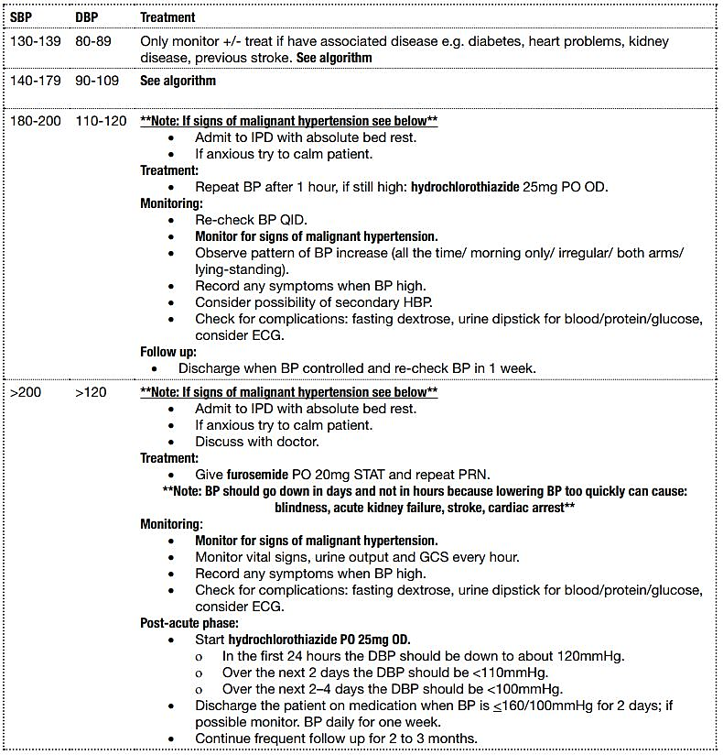
Figure 7 BP measurement and treatment options

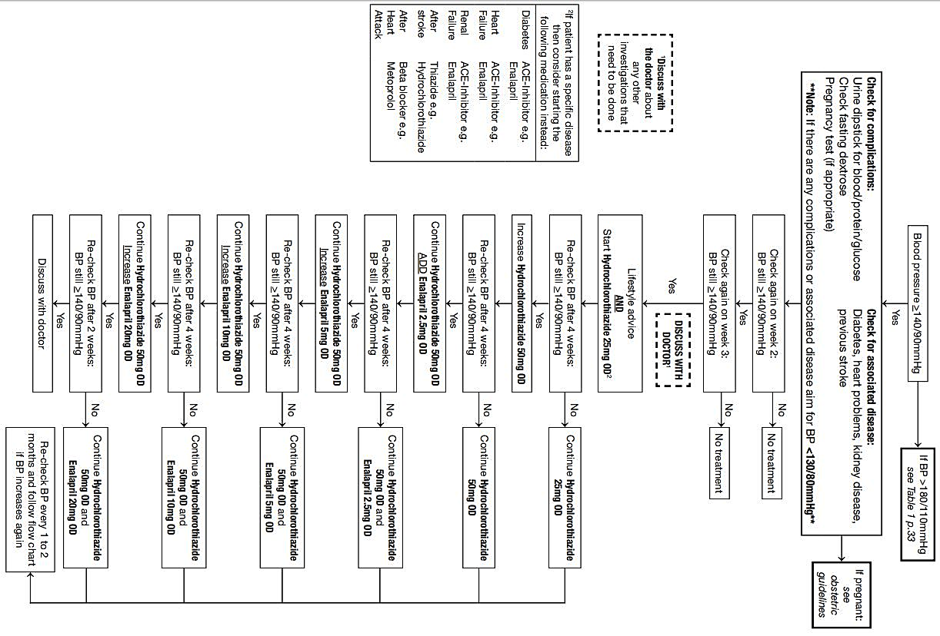
Figure 8 Treatment of chronic hypertension (Adult)

MALIGNANT HYPERTENSION

SBP >180 OR DBP >120 AND signs of organ damage
This is EMERGENCY. Referral is recommended.

Treatment
Furosemide 20 mg PO
(Aim to reduce 25% BP reduction in first few hours)
If unable to refer, consider IV treatment. (Discuss with Doctor.)

Note: If patient has stroke, do not attempt to reduce blood pressure.

ISCHAEMIC HEART DISEASE (IHD)

DEFINITION
The heart is a muscle which has an important role in pumping blood around the body to make sure that the organs in the body have a good supply of oxygen and remove any waste products. The muscle of the heart is supplied with blood by the coronary arteries. When there is a problem with the blood supply to the heart the lack of oxygen means that the muscle cannot function normally. The main symptom of this is chest pain.
There are two conditions where this happens: Myocardial infarction (MI) and ischaemic heart disease (IHD).
- Infarction (myocardial infarction) = heart attack. This is an EMERGENCY. Part of the heart muscle has died due to a lack of blood supply e.g. from a clot.
- Ischaemia (ischaemic heart disease) = angina. Poor oxygen supply to the heart muscle due to a narrowing of the arteries in the heart.
Myocardial infarction | Ischemic Heart Disease (Coronary Artery)
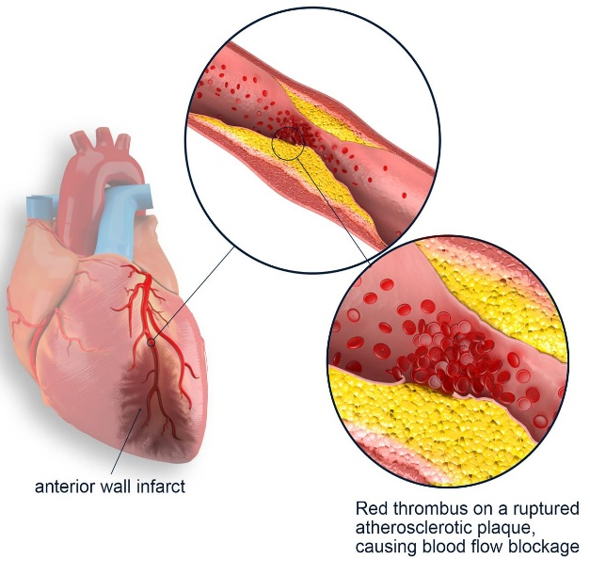 | 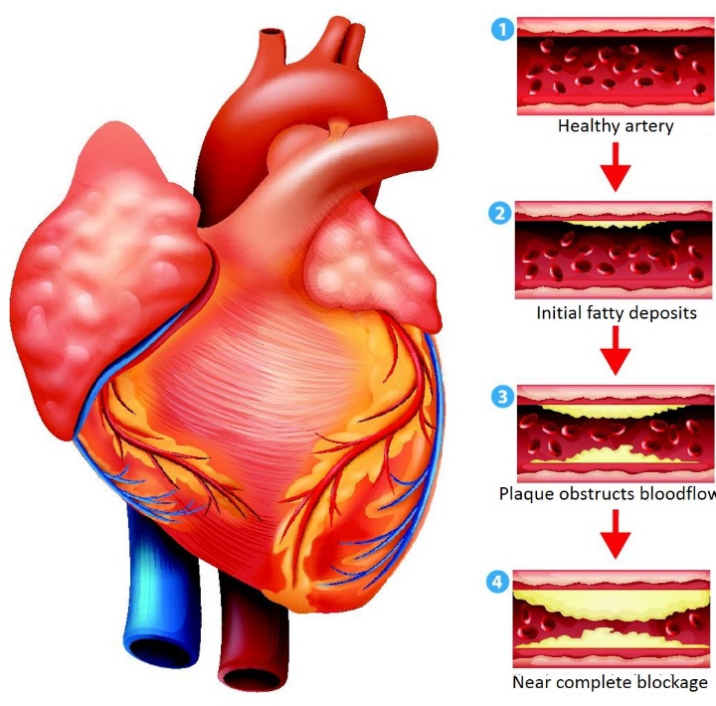

RISK FACTORS
Risk factors are the same for a heart attack and angina.
• Smoking  • Obesity  • Family History  • Diabetes  • High BP | • Lack of exercise  • High stress  • High cholesterol  • Age  • Male

MYOCARDIAL INFARCTION (MI) – HEART ATTACK

DEFINITION
Heart attack (also known as myocardial infarction (MI)) is when there is a complete blockage (e.g. from a clot) to the blood supply to the heart causing part of the heart muscle to die. After a heart attack the dead tissue is replaced by scar tissue so the heart cannot pump as well.

SIGNS AND SYMPTOMS
• Severe sudden onset central or left sided chest pain that may radiate to the left arm or neck that lasts for more than approximately 15 minutes.
• Associated with nausea, sweating, shortness of breath.

DIAGNOSIS
- Clinical signs and symptoms  - There is a specific blood test released by the heart that shows that there is damage to the muscle.  - ECG shows ST elevation. | 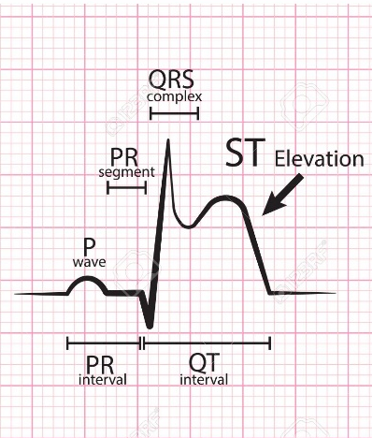

TREATMENT
• This is an emergency.
• Give Aspirin 300mg PO STAT.
• Refer immediately to hospital – this patient needs stronger drugs to break down the clot and may need surgery to open up the arteries.

ANGINA (ISCHAEMIC HEART DISEASE)

DEFINITION
Angina (also known as ischaemic heart disease) is when there is a narrowing of the arteries in the heart, often due to atheroma (fatty patches). This means that there is not enough supply of oxygen to the heart muscle which causes chest pain. Patients with angina are at higher risk of having a heart attack (see above). Angina can be stable or unstable (high risk of turning into a heart attack).

SYMPTOMS
The patient will complain of chest pain. It is important to classify the angina:
1. Stable Angina: chest pain (left or central chest) that comes on with exercise and stops when you sit down/stop exercising.
2. Unstable Angina: chest pain (left or central chest) that happens at rest – This is at very high risk of developing into a heart attack.

DIAGNOSIS
- Clinical history  - ECG may show ST depression.  - Check Hct – anaemia can cause chest pain. | 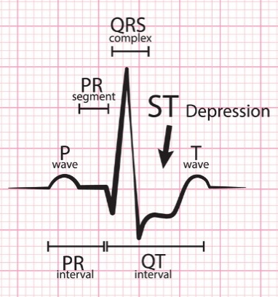

TREATMENT

Lifestyle:
Advise patients to:
• Reduce the amount of salt in diet.
• Avoid fatty foods / Eat more vegetables and fruit.
• Lose weight if overweight or obese.
• Alcohol: Advise the patient to stop or if unable to stop at least to reduce.
• Smoking: Advise the patient to stop or if unable to stop at least to reduce.
• Exercise at least 30 minutes most days of the week.

Medications:
Discuss with the doctor about what treatment is appropriate for each case.
If unstable angina discuss with doctor about referral to hospital as there is a very high risk of developing into a heart attack.
Treatments to be considered are:
• Aspirin (with omeprazole for protection of stomach): reduces stickiness of platelets so they don’t get stuck to the inside of the blood vessels and to each other and block blood flow to the heart.
• Beta-blocker e.g. Propranolol: increase the force and rate of the heart pumping.
• ACE-Inhibitor e.g. Enalapril: prevent a build-up of fluid.
• Nitrates e.g. Isosorbide Mononitrate: relaxes blood vessels to allow good blood flow to heart muscle

HEART FAILURE

DEFINITION
Heart failure occurs when the heart fails to pump enough blood and provide enough oxygen or energy to the organs. In cases where there is doubt about the diagnosis, response to a therapeutic trial will make the diagnosis clear. Heart failure can be chronic and come on slowly or can be acute and present as an emergency. The two sides of the heart can be affected together or separately (left sided or right sided heart failure). Both have different symptoms.

SIGNS AND SYMPTOMS
Chronic Heart Failure
Left sided heart failure | Right sided heart failure
- Breathing difficulties when exercising, which get progressively worse, until difficulties are experienced even when at rest.  - Difficult breathing when lying on the back. The patient uses more pillows to sleep (orthopnoea).  - Dry cough mainly at night +/- pink frothy sputum.  - Crackles (crepitation at lung bases). | - Abdominal pain, anorexia, nausea, bloating.  - Jugular vein distension.  - Hepatomegaly (enlarged liver) sometimes painful.  - Lower leg oedema, or lower back oedema if lying flat.
Acute heart failure:
(may not have all symptoms)
- Sudden worsening of breathing
- Increased JVP
- Lots of crepitation bilaterally
- More oedema
- Low SpO2, fast RR
- Cannot breath when lying flat
- May have history of heart failure (or symptoms of heart failure)

Also do not forget to ask about:
• Alcohol/drug use
• Diet (check for B1 deficiency)
• History of chest pain/palpitations

CAUSES
Common causes of heart failure:
- . Hypertension  - Anaemia  - Beriberi (Vitamin B1 deficiency)  - Hyperthyroidism  - Alcohol, drug addiction | - Myocardial infarction (heart attack)  - Arrhythmia (irregular heart beat)  - Congenital heart disease  - Valvular disease (heart valves too tight or loose)

INVESTIGATIONS
- History taking and clinical examination.
- For all patients check: Hct, BP, TFTs, fasting dextrose.
- An improvement of symptoms with treatment also helps to confirm the diagnosis.
- CXR: to exclude respiratory causes

TREATMENT
 | Assess for | Management
DR | Danger response | Gloves, safe pace, call for health
A | Airway obstruction  Speaking, stridor,  swelling, secretions | Oxygen
B | RR, SpO2, cyanosis  Chest indrawing/  tracheal tug  Listen to chest | Nebulisers if wheeze  Position patient: If dyspnoea sit up right
C | HR, BP, Cap refill  Urine output, Temp  Listen to HS | IV cannula (biggest size possible 16G or 18G)  Take bloods e.g. Hct, Creatinine, BUN, CBC, MS, dextrose etc.  **If signs of heart failure DO NOT GIVE FLUID BOLUS**  Insert catheter and monitor fluid balance (fluid IN/OUT) every hour
D | Check dextrose  Seizures  Pain | Give diuretics e.g. furosemide IV Adults: 40mg Child: 1mg/kg (max 40mg)  Repeat the same dose after 30 minutes if no improvement/has not passed urine  Consider vitamin B1 100mg IM injection  Give digoxin PO only if tachy-arrhythmia on ECG (irregular pulse >120 per minute)
E | AVPU/GCS  Expose and examine | History, further investigations, treatment plan

Vitamin B1
In all acute cases where Beriberi cannot be excluded, a treatment dose of vitamin B1 100mg IM should be considered.
In our clinics vitamin B1 deficiency is relatively common. Diet advice or vitamin B1 tablets should be given to prevent Beriberi, especially in alcoholics and heart failure patients.

Post Emergency Treatment:
- Bed rest.
- Fluid restriction (max of 1.5 litre/day).
- Encourage patient to quit smoking.
- Weigh every day in IPD.
- Continue furosemide 20-40mg PO daily.
- Increase by 20 mg every 2 days to maintain the patient weight stable (maximum 120mg/day unless the patient has chronic renal failure).
- If oedema still continuing consider adding another diuretic e.g. hydrochlorothiazide.
- If available, start treatment with enalapril.

CHRONIC HEART FAILURE
Most of the time, acute heart failure is a complication of a chronic condition. So these patient needs regular-monthly consultation at least than life-long medication/care is essential.

Clinical examination
- Complete Cardiovascular System Examination
- Signs of Left Heart Failure and Right Heart Failure
- Signs of organ ischemia: headache, loss of memory, spleen pain.
- Grading the dyspnea
  - Grade1 : no symptom
  - Grade2 : Dyspnea for major effort
  - Grade3 : Dyspnea for usual effort
  - Grade4 : Symptom at rest

Treatment:
- Lifestyle advice: stop smoking, lose weight, low salt, healthy diet, decrease/stop alcohol and drugs.
- Restrict fluid intake e.g. 1.5L/day.
- Check baseline renal function
- Medication
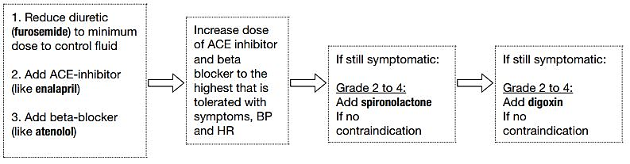

CARDIAC MEDICATIONS
- Furosemide: start 40mg PO OD, maintenance 20-40mg, if resistant oedema 80-120mg daily.
- Enalapril: start with 2.5mg OD for 2 weeks, increase the dose every 2 weeks to aim for 10-20mg BID if tolerates (max 20mg BID) (Note: enalapril OD for High BP and BID for heart failure) monitor BP closely when giving with furosemide.
- Atenolol: Start at 25mg OD, increase to 50mg OD if HR and BP allow. Monitor HR closely. Do not give if patient has asthma.
- Spironolactone: if on ACE-I start at 12.5mg, normal maintenance dose 50mg, (if not on ACE-I start 50mg. maintenance dose 100-200mg).
- Digoxin: For heart failure start 62.5-125mcg OD (elderly start at 62.5mcg); for atrial fibrillation: 750mcg100mcg over 24hrs (given in divided dosages) then maintenance 125-250mcg.
When to change the treatment?
- If the weight is increasing and oedema is appearing: Increase the treatment or add new drug.
- If the grade of the dyspnoea is rising: Increase the treatment or add new drug.
- If the BP is getting low (SBP <90mmHg): decrease diuretic treatment and/or enalapril.
- If you find digoxin intoxication signs: stop digoxin for a few days and when signs have disappeared start again with lower dose.
- If there is hyperkalaemia: stop the enalapril and spironolactone.
- If the patient is improving or stable: do not reduce the dose of medication.

PREVENTION
Encourage patients to change their lifestyle. Give aspirin if there was a heart attack. Give all patients diet advice and vitamin B1 supplementation.

RHEUMATIC FEVER

DEFINITION
Rheumatic fever is an inflammatory disease which sometimes follows a group A Streptococcus pharyngeal infection. It follows pharyngitis / tonsillitis by 2 to 6 weeks (average 20 days).
It is most common in children between 5 and 15 years old. Only 2% of people who have a Streptococcus pharyngitis (non-treated or not well treated) will develop rheumatic fever .

SIGNS and SYMPTOMS
Rheumatic fever affects four sites
- Joints
  - Polyarthritis: Inflammation more than one joint
  - Migratory arthritis: Pain and inflammation move from one joint to another
  - Arthralgia: Joint pain
- Heart
  - Murmur
  - Congestive cardiac failure
  - Cardiomegaly
  - Pericardial rub
- central nervous system
  - Chorea: Rapid involuntary uncoordinated movement
- Skin
  - Nodules: Small, mobile and painless over bony surfaces and tendon
  - Erythema marginatum: Non-itchy, non-painful rash with a raised edge and clear centre
Associated symptoms: Fever, abdominal pain, nasal bleed

DIAGNOSIS
‘Revised Jones Criteria’. There are 3 parts:
Table 1 Revised Jones Criteria
Evidence of recent Streptococcal infection | Major criteria: | Minor criteria
- Increase in anti-streptolysin O (ASO) titre  - Positive throat culture for group A beta-haemolytic streptococcus | - Carditis  - Polyarthritis  - Chorea  - Subcutaneous nodules  - Erythema marginatum | - Arthralgia  - Fever  - Increased CRP  - Previous rheumatic heart disease or  - Rheumatic fever  - Prolonged P-R interval on ECG (if available)
To make a diagnosis of rheumatic fever there must be:
1) Evidence of a recent streptococcal infection AND 2 major criteria,
OR
2) Evidence of a recent streptococcal infection AND 1 major criteria and 2 minor criteria.

DISEASE COURSE
The average course of an attack is about 3 months. Less than 5% of the attacks are longer than 6 months.

COMPLICATIONS
- Reactivation of rheumatic fever (5-50%).
- Chronic rheumatic heart disease (deformity of one or more heart valves). This is the only long-term problem of rheumatic fever. If severe enough, this can lead to chronic heart failure. Chronic rheumatic heart disease usually has no symptoms for years or decades after the initial episode of rheumatic fever.
- Death from congestive heart failure.

TREATMENT
- Bed rest for 2 weeks
- Benzathine penicillin
Child: 50,000 IU/kg IM STAT (max 1.2 million IU)
Adult: 1.2 million IU IM STAT
If benzathine penicillin is not available give penicillin V for 10 days. If your patient is allergic to penicillin, give erythromycin for 10 days.
- Aspirin 50-100mg/kg/day until all symptoms have gone. Decrease dose if side-effects occur: ototoxicity, hyperventilation, abdominal problems.
- Prednisolone
Treat with prednisolone if there are signs of cardiac problems or if aspirin is not enough to control the joint inflammation:
Child: 1-2mg/kg OD for 2-3 weeks, then slowly decrease.
Adult: 60-120mg OD for 2-3 weeks, then slowly decrease.
It may be helpful to use CRP or ESR to guide when you should start to decrease.
When decreasing continue aspirin for 2-3 weeks after stopping prednisolone to avoid a relapse.
Consider giving omeprazole 20mg OD with the prednisolone to protect the stomach lining.
- For Chorea: Rest
Diazepam or phenobarbital.
- Heart failure

PREVENTION
• Primary prevention (primary prophylaxis): To prevent development of acute rheumatic fever:
All patients with suspected streptococcal tonsillitis should be treated with PO Penicillin V for a full 10 day course or a single IM benzathine penicillin dose.
• Secondary prevention (secondary prophylaxis): To prevent recurrent attacks (reactivation):
All patients who had one attack of rheumatic fever should receive IM benzathine penicillin (same dose as treatment) every 4 weeks, up to the patient aged 21 years old OR at least 5 years after an acute attack OR lifelong if there is heart involvement.

VALVULAR HEART DISEASE

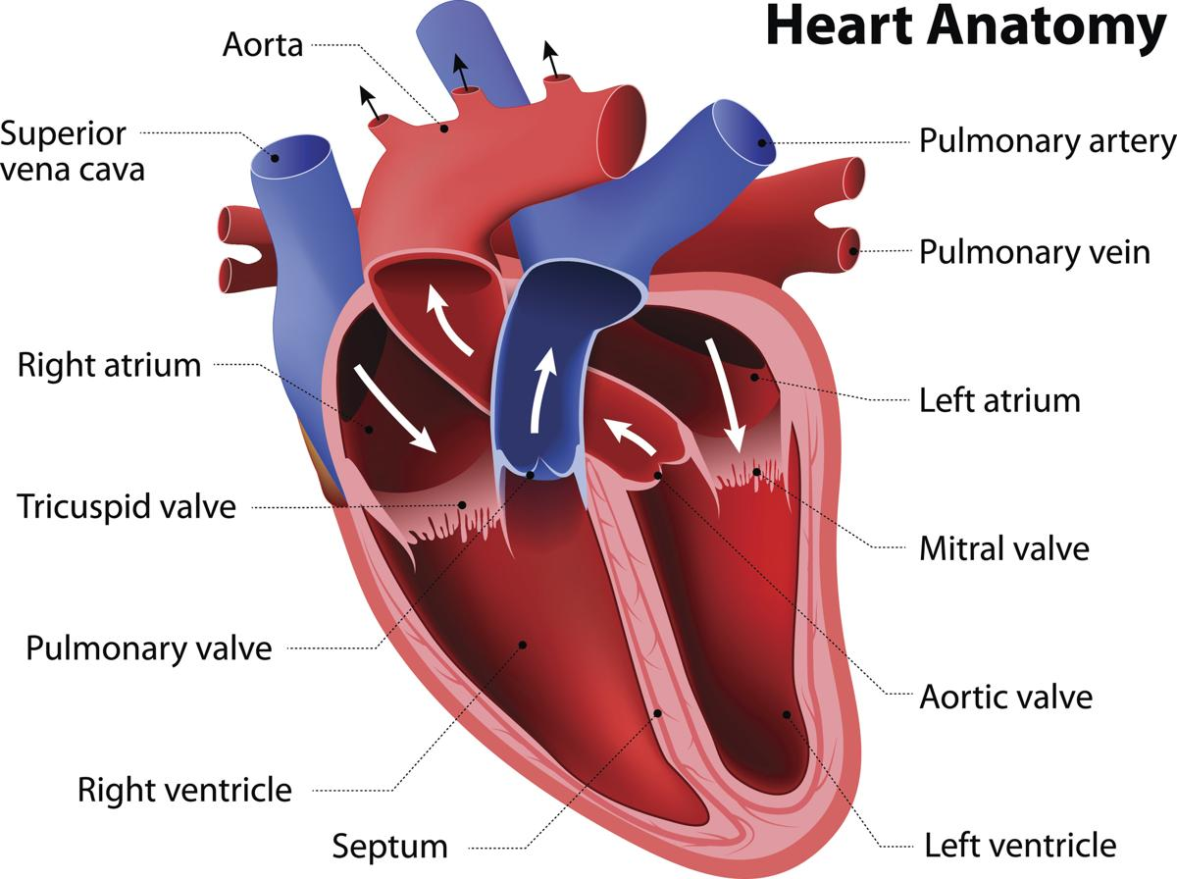

DEFINITION

The valves in the heart can have problems if they are too stiff (stenosis) or if they leak (regurgitation) meaning that the heart has to pump harder which can lead to heart failure.

CAUSES

- Congenital abnormalities

- Infections e.g. Rheumatic fever, endocarditis, syphilis

- Heart Disease e.g. Angina (ischaemic heart disease), high BP, cardiomyopathy

SYMPTOMS
- Difficult/fast breathing | - Symptoms of heart failure: oedema, orthopnoea,
- Tiredness | - frothy pink sputum
- Dizziness | - Children/infant: poor feeding, sweating, poor weight
- Chest pain/angina | - gain, chest indrawing
- Palpitations | - Aortic stenosis: sudden collapse during exercise

DIAGNOSIS

Clinical:
- Listen to the heart

- Normal First heart sound: Caused by mitral and tricuspid valves closing
- Normal Second heart sound: Caused by pulmonary and aortic valves closing

- Systole: the period between the first and second heart sounds

  - Systolic murmur:Murmur heard during systole. Can be caused by aortic/pulmonary stenosis, or mitral/tricuspid regurgitation
- Diastole: the period after the second heart sound before the first heart sound
  - Diastolic murmur:Murmur heard during diastole. Can be caused by mitral/tricuspid stenosis or aortic/pulmonary regurgitation
- Examine for heart failure e.g. oedema, raised JVP, creps both bases, raised RR, low SpO2, cyanosis

- Echocardiogram (heart ultrasound): Is the only definitive way of knowing if there is a problem with the valve.

TREATMENT

  - A valve that is not working needs surgery to replace it.

INFECTIVE ENDOCARDITIS

DEFINITION

Infective endocarditis (IE) is defined as an infection of the endocardial surface of the heart, which may include one or more heart valves, the mural endocardium, or a septal defect.

CAUSES

- Bacterial (most common)

- Fungal e.g. candida (more common in immunosuppressed patients)

- Viral (uncommon)

RISK FACTORS

- Immunosuppressed e.g. HIV, malnutrition, diabetes

- Intravenous drug use

- Artificial heart valves

- Abnormalities of the heart

- Dental disease

SIGNS AND SYMPTOMS

- New murmur on auscultation |  | • | - Weight loss
• | - Fever | • | - Shortness of breath
• | - Chills | • | - Cough
• | - Headache | • | - Night sweats
• | - Muscle pain | • | - Joint pains

DIAGNOSIS

Blood cultures should be taken when the patient has fever from 3 different sites at 3 different times.

Echo shows ‘vegetation’ (lump/cluster of bacteria attached to heart valve).

TREATMENT
  - Antibiotics (for many weeks) e.g. IV ampicillin (4 weeks) and gentamicin (2 weeks).
  - Surgery may be needed.
  - If possible do frequent ECGs to monitor for any damage to the heart.

  - Choice of antibiotic: depends on the likely organism which is affected by the risk factors.

CONGENITAL HEART DISEASE

Atrial septal defect (ASD)
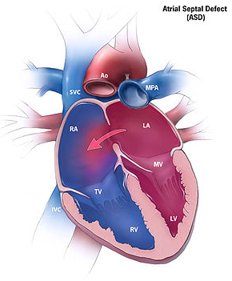  Figure 9 Atrial Septal Defect (ASD) | A hole connect to the atria  Sign and Symptoms  - AF  - Increase JVP  - murmur  - Pulmonary hypertension such as dyspnea, cyanosis, chest pain, ankle swelling  - Reversal to left to right shunt and  - paradoxical embolism as complication  Diagnosis  - ECG  - CXR  - ECHO
Treatment
- Surgical closer is recommended before age 10yrs
- In adult, closer is recommended if symptomatic

Ventricular septal defect (VSD)
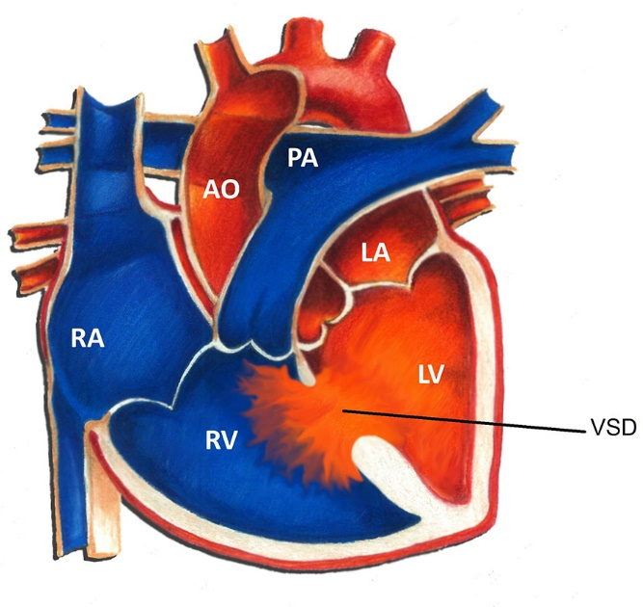  Figure 10 Ventricular Septam Defect (VSD) | A hole connecting the two ventricles  Sign and Symptom  - May present with severe heart failure in infancy or remain asymptomatic  - Heart murmur  - May get Left parasternal heave  - pulmonary hypertension as association  - Aortic regurgitation and  - Infective Endocarditis as complication
Investigation: ECG, CXR, Cardiac catheter
Treatment: Medical, at first many VSD close spontaneously. Surgical closer- failure of medical therapy

Coarctation of the aorta
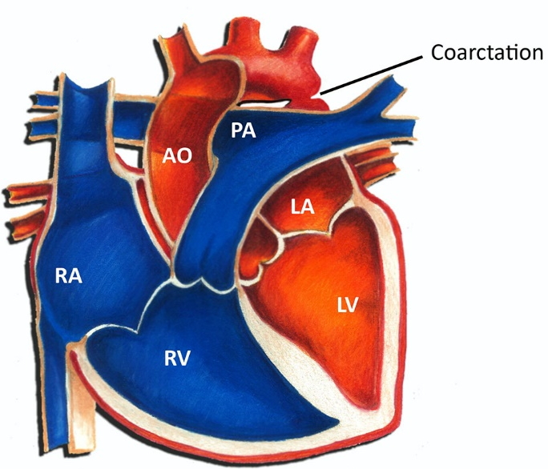  Figure 11 Coarctation of the aorta | Congenital narrowing of the descending aorta  Sign  - Systolic murmur  - Radio femoral delay  - Weak femoral pulse  - BP  - Scapular bruit  - Heart failure,  - infective endocarditis as complication  Treatment  - Surgery

Tetralogy of Fallot
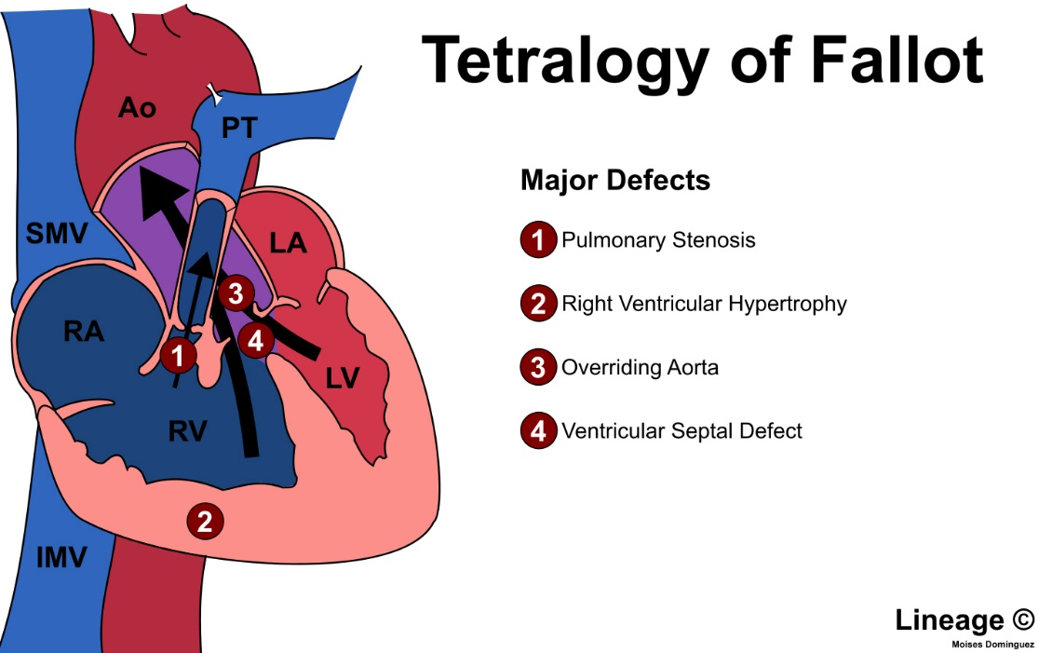
Symptoms  - Murmur  - Cyanosis  - Rapid breathing | Investigation  - ECHO  - Cardiac catheterization  Treatment  - Surgery

RESPIRATORY DISEASES

CHEST EXAMINATION
CHEST EXAMINATION
Abnormal chest sounds (Abnormal lung sounds)
- Always compare both left and right lungs
- Less air entry: Reduced or absent breath sounds
- Vesicular breath sound in lungs (normal)
- Bronchial breath sound in trachea and main bronchi. (normal)
- Bronchial breath sound in lungs (sign of pneumonia)
- Crepitation: crackles sounds
- Wheezing: whistling sounds
- Pleural rub: rough creaking sound

ACUTE RESPIRATORY INFECTIONS (ARI)

ARIs can be divided into

- Upper Respiratory Tract Infections (URTIs): ear, nose, throat, tonsils, sinuses

- Lower Respiratory Tract Infections (LRTIs): lungs

UPPER RESPIRATORY TRACT INFECTIONS

DEFINITION

Upper Respiratory Tract Infections (URTIs): infections of the upper airways which include the ear, nose, throat, tonsils or sinuses. Most of these infections are caused by viruses (so do not need antibiotics) and last for a short time only. The lungs are not affected. If the symptoms are severe and/or last for more than a week, this may be a sign of a more severe bacterial infection or influenza.

OTITIS

Otitis is an infection of the ear. There are two areas of the ear that can be affected:

- Otitis Externa (outer ear)

- Otitis Media (middle ear)

Otitis Externa (OE)
DEFINITION  Skin infection of the ear canal (the outer ear).  CLASSIFICATION (Ariel A Waitzman, 2018)  - Acute diffuse OE - Most common form of OE  - Acute localized OE (furunculosis)  - Chronic OE - Same as acute diffuse OE with longer duration (>6 weeks)  - Eczematous (eczematoid) OE  - Necrotizing (malignant) OE  - Otomycosis - Infection of the ear canal from a fungal species (eg, Candida, Aspergillus)  SYMPTOMS  - Pain or itching of ear  - Ear feels full  - May have discharge that is clear or pus  SIGNS  - Ear canal is red, swollen  - Ear drum: looks normal  - Sometimes fungus in the external ear canal  - Look for foreign body (something that should not be there e.g. a seed) | 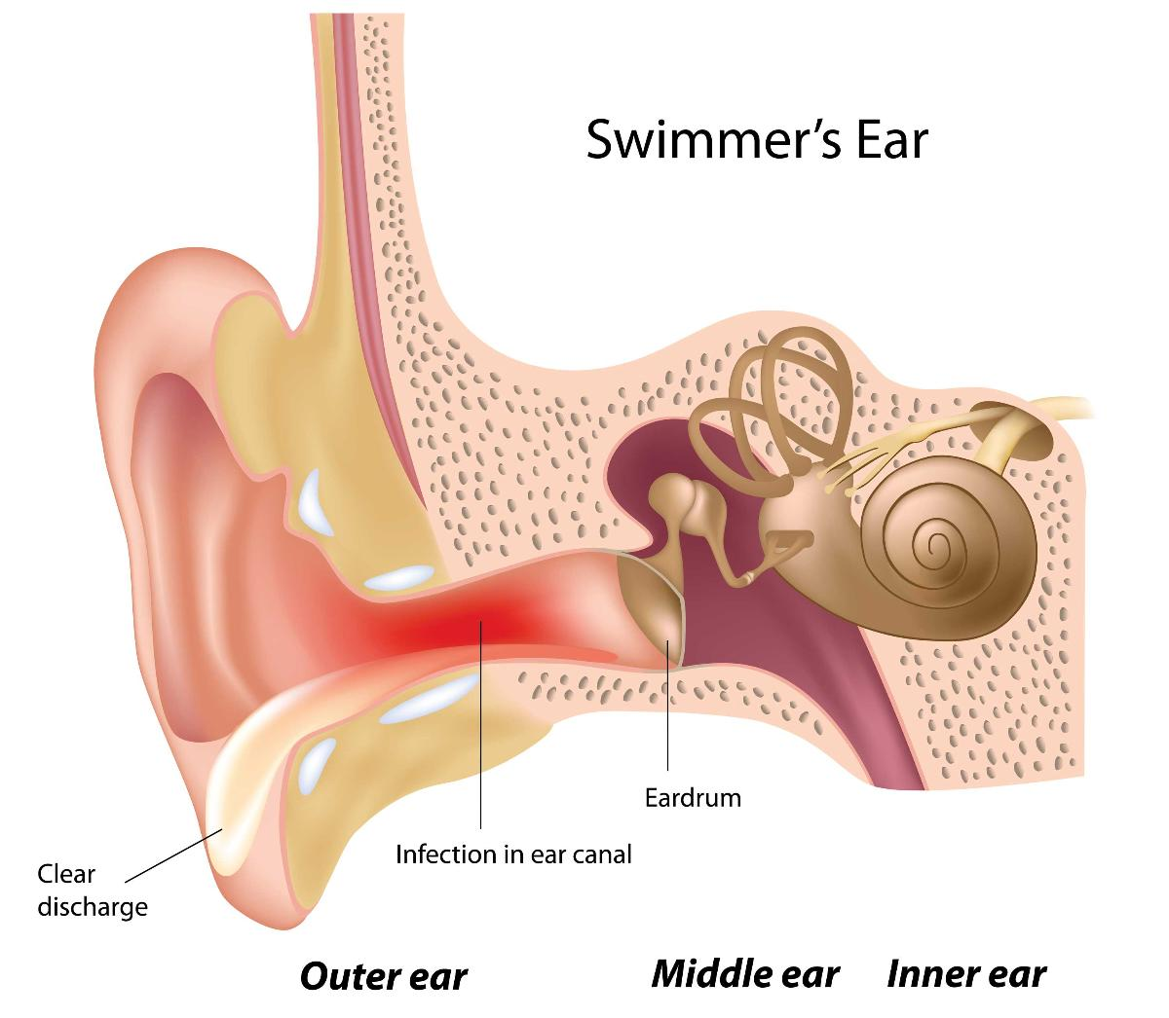  Figure 12 Anatomy of ear
TREATMENT (Frontières., 2018)
- Remove a foreign body, if present.
- Treatment of pain: paracetamol PO
- Local treatment:
• Remove secretions from the auditory canal by gentle dry mopping (use a dry cotton bud or a small piece of dry cotton wool). Consider ear irrigation (0.9% sodium chloride, using a syringe) only if the tympanic membrane can be fully visualized and is intact (no perforation). Otherwise, ear irrigation is contra-indicated.
- Apply ciprofloxacin ear drops in the affected ear(s) for 7 days:
  - Children ≥ 1 year: 3 drops 2 times daily
  - Adults: 4 drops 2 times daily

Acute Otitis Media (AOM)
Acute inflammation of the middle ear, due to viral or bacterial infection, very common in children under 3 years, but uncommon in adults.  ORGANISMS  - Streptococcus pneumoniae, Haemophilus influenzae, Moraxella catarrhalis and  - In older children, Streptococcus pyogenes. | 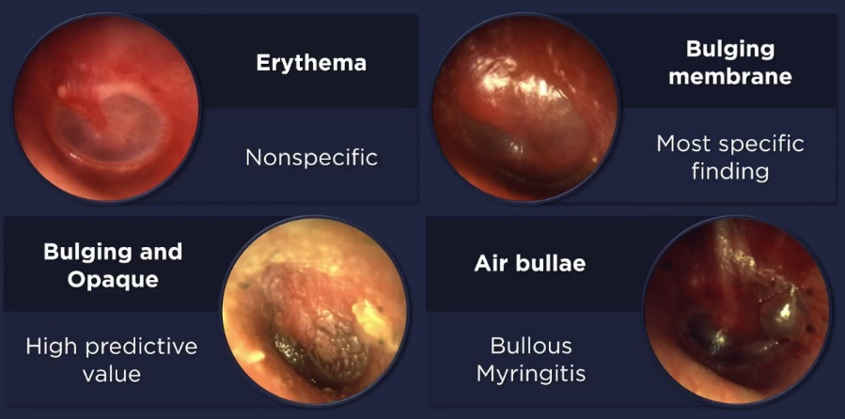
SIGNS AND SYMPTOMS
- Rapid onset of ear pain and
- Ear discharge (otorrhoea) or fever.
- Other signs such as rhinorrhoea, cough, diarrhoea or vomiting are frequently associated, and may confuse the diagnosis, hence the necessity of examining the tympanic membranes.
- Otoscopy: bright red tympanic membrane (or yellowish if rupture is imminent) and presence of pus, either externalized (drainage in ear canal if the tympanic membrane is ruptured) or internalized (opaque or bulging tympanic membrane). The combination of these signs with ear pain or fever confirms the diagnosis of AOM.
Note:
The following otoscopic findings are not sufficient to make the diagnosis of AOM:
• A red tympanic membrane alone, with no evidence of bulging or perforation, is suggestive of viral otitis in a context of upper respiratory tract infection, or may be due to prolonged crying in children or high fever.
• The presence of air bubbles or fluid behind an intact tympanic membrane, in the absence of signs and symptoms of acute infection, is suggestive of otitis media with effusion (OME).
– Complications, particularly in high-risk children (malnutrition, immunodeficiency, ear malformation) include chronic suppurative otitis media, and rarely, mastoiditis, brain abscess or meningitis.

TREATMENT
- Treat the fever and pain with paracetamol

- Note: Do not clean the ear with NSS if the ear drum is perforated or the ear drum cannot easily be seen (as it may be perforated).

Antibiotics:
- Most cases of acute otitis media are caused by viruses so not everyone needs antibiotics.

- If NO RISK FACTORS improvement of symptoms by itself often occurs so if it is possible to re-examine the ear within 48-72 hours then do not give antibiotics on first presentation*.

- Give antibiotics to all with RISK FACTORS: o Children <2 yrs

o Severe infection e.g. vomiting, fever >39°C, severe pain
o Special circumstances e.g. malnutrition, ear malformation, immunodeficiency e.g. HIV
If antibiotics not given initially, re-assess at 48-72 hours, prescribe antibiotics if no improvement or worsening of symptoms.

Choice of antibiotherapy:
• Amoxicillin is the first-line treatment: Amoxicillin PO for 5 days
Children: 30 mg/kg x 3 times daily (max. 3 g daily)
Adults: 1 g x 3 times daily

• Amoxicillin/clavulanic acid is used as second-line treatment, in the case of treatment failure. Treatment failure is defined as persistence of fever and/or ear pain after 48 hours of antibiotic treatment.
- amoxicillin/clavulanic acid (co-amoxiclav) PO for 5 days.
- Use formulations in a ratio of 8:1 or 7:1.
The dose is expressed in amoxicillin:
- Children < 40 kg: 25 mg/kg 2 times daily
- Children ≥ 40 kg and adult: 1 tablet of 875/125 mg 2 times daily
Persistence of a ear drainage alone, without fever and pain, in a child who has otherwise improved (reduction in systemic symptoms and local inflammation) does not warrant a change in antibiotic therapy. Clean ear canal by gentle dry mopping until no more drainage is obtained.

• Macrolides should be reserved for very rare penicillin-allergic patients, as treatment failure (resistance to
macrolides) is frequent.
Azithromycin PO
Children over 6 months: 10 mg/kg once daily for 3 days

Chronic Suppurative Otitis Media (CSOM) (Frontières., 2018)
Chronic bacterial infection of the middle ear with persistent purulent discharge through a perforated tympanic membrane. The principal causative organisms are Pseudomonas aeruginosa, Proteus sp, staphylococcus, and other Gram negative and anaerobic bacteria.
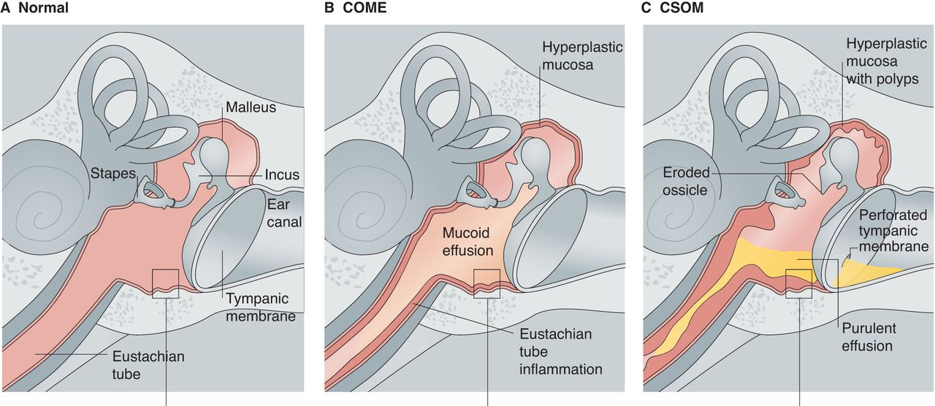
Figure 13 Normal ear, COM with Effusion and CSOM
SIGNS AND SYMPTOMS
- Purulent discharge for more than 2 weeks, often associated with hearing loss or even deafness; absence of pain and fever
- Otoscopy: perforation of the tympanic membrane and purulent exudate

COMPLICATION
- Consider a superinfection (AOM) in the case of new onset of fever with ear pain, and treat accordingly.
- Consider mastoiditis in the case of new onset of high fever, severe ear pain and/or tender swelling behind the ear, in a patient who appears significantly unwell.
- Consider brain abscess or meningitis in the case of impaired consciousness, neck stiffness and focal neurological signs (e.g. facial nerve paralysis).
TREATMENT
- Remove secretions from the auditory canal by gentle dry mopping (use a dry cotton bud or a small piece of dry cotton wool).
- Apply ciprofloxacin ear drops until no more drainage is obtained (approximately 2 weeks, max. 4 weeks):
  - Children 1 year and over: 3 drops 2 times daily
  - Adults: 4 drops 2 times daily
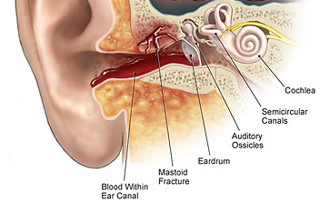 | COMPLICATION  Chronic mastoiditis is a medical emergency that requires prompt hospitalization.  - Antibiotherapy that covers the causative organisms of CSOM (ceftriaxone IM for 10 days + ciprofloxacin PO for 14 days),  - Atraumatic cleaning of the ear canal; surgical treatment may be required.  Before transfer to hospital, if the patient needs to be transferred, administer the first dose of antibiotics.

COMMON COLD
DEFINITION
Common cold is a mild URTI caused by a virus. It is very common and not dangerous. In any community, a lot of people will have a cold at the same time.
SYMPTOMS:

Nasal discharge or block, sore throat, cough, mild fever, lacrimation
TREATMENT:
Paracetamol 3 days, advise when to come back to clinic. No antibiotics needed.

SINUSITIS
- Acute sinusitis is an infection of the sinuses with pus discharge from nose or around teeth. | 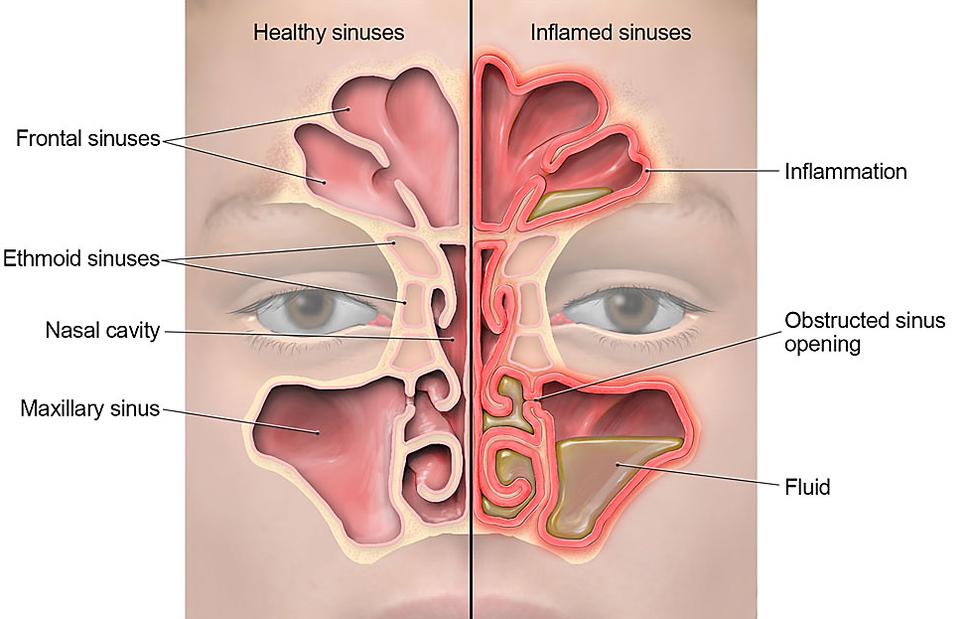
- This may develop into chronic sinusitis. Most acute sinus infections are viral and resolve spontaneously within 10 days.
- Acute bacterial sinusitis may be a primary infection, a complication of viral sinusitis or of dental origin. Especially in children, bacterial sinusitis can spread to the bone, eye or meninges (causing meningitis) so it is important to treat.

SYMPTOMS
- Unilateral or bilateral discharge, nasal obstruction AND

- Facial unilateral or bilateral pain that increases when bending over, painful pressure either side of nose or behind forehead.

- Usually no fever or mild fever
- Sinusitis likely if symptoms:
- Continue for more than 10-14 days AND/OR
- Worsen after 5-7 days AND/OR
- Are severe (severe pain, high fever, deterioration of general condition)
TREATMENT
- Paracetamol and NSS drop
- Amoxicillin PO for 7 to 10 days:
  - Children: 30 mg/kg 3 times daily (max. 3 g daily)
  - Adults: 1 g 3 times daily
- If no response within 48 hours consider switching to co-amoxiclav.
- In penicillin-allergic patients:
  - Erythromycin PO for 7 to 10 days:
    - Children: 30 to 50 mg/kg daily
    - Adults: 1 g 2 to 3 times daily

PHARYNGITIS
Inflammation of the pharynx (throat), it is very common.
SYMPTOMS
- Sometimes a sore throat is the only symptom. It may also be painful to swallow.
- The throat may be red.
- Symptoms typically get worse over 2 to 3 days and then gradually go, usually within a week.

TREATMENT
Analgesia e.g. paracetamol. No antibiotics.
Infectious mononucleosis (caused by Epstein Barr Virus (EBV)) is a type of pharyngitis found in adolescence and young adults. Symptoms are extreme fatigue, generalised adenopathy and often splenomegaly.

TONSILLITIS
Tonsillitis is an infection of the tonsils at the back of the mouth, which is most commonly due to a bacterial or viral infection.
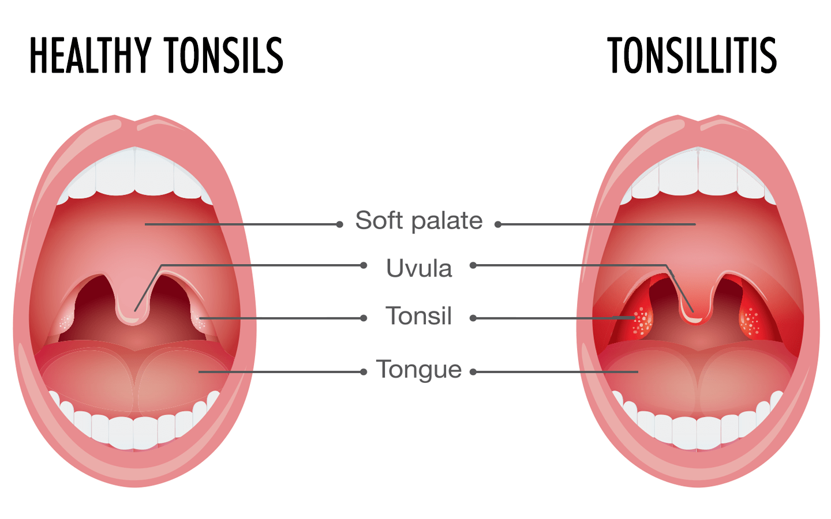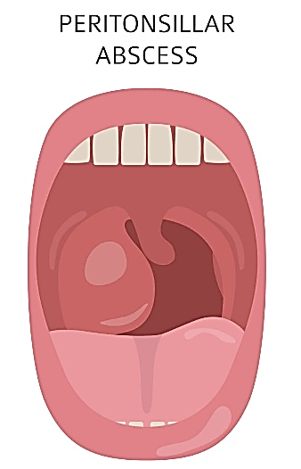
Figure 14 Tonsillitis and Peritonsillar Abscess
SYMPTOMS
Tonsillitis  - Fever  - Sore throat  - Foul breath  - Dysphagia (difficulty swallowing)  - Odynophagia (painful swallowing)  - Tender cervical lymph nodes  Airway obstruction may manifest as mouth breathing, snoring, sleep-disordered breathing, nocturnal breathing pauses, or sleep apnea. | Peritonsillar abscess (PTA)  - Severe throat pain  - Fever  - Drooling  - Foul breath  - Trismus (difficulty opening the mouth)  - Altered voice quality (the hot-potato voice)
The following symptoms make bacterial tonsillitis more common:

- Absence of cough

- Fever >38°C

- At least one enlarged and painful anterior cervical lymph node

- Presence of pus on tonsils.
COMPLICATIONS:
- Peritonsilar abscess

- SYMPTOMS: fever, intense pain, hoarse voice, trismus (cannot open mouth fully), tonsillar swelling on one side which moves uvula to one side
- TREATMENT: need surgical drainage as well as antibiotics as for tonsillitis

- Rheumatic fever

- Acute glomerulonephritis
TREATMENT

Treatment with antibiotics if suspect bacterial cause, can help prevent these complications.
- Treat the fever and advise the patient to drink plenty of fluids.

If the patient can take PO tablets and can eat and drink:
Adult: Penicillin V PO 500mg QID x 10 days
OR Benzathine penicillin IM 1.2 million IU STAT

Child:
Penicillin V PO 15mg/kg QID x 10 days
OR Benzathine penicillin IM 25,000-50,000 IU/kg (max 1.2 million IU) STAT
- In penicillin-allergic patients:
  - Erythromycin PO for 10 days:
    - Children: 30 to 50 mg/kg daily
    - Adults: 1 g 2 to 3 times daily
If the patient cannot take tablets and cannot eat or drink, admit to IPD and give IV fluids and treat with antibiotics as follows:

Adult: Benzathine penicillin IM 1.2 million IU STAT
OR
Benzyl penicillin IV 1.2g QID

OR
Ampicillin IV 1g QID

Child: Benzathine penicillin IM 50,000 IU/kg STAT (max 1.2 million IU)
OR
Benzyl penicillin IV 25mg/kg QID

OR
Ampicillin IV

Change to penicillin V PO when the patient can swallow. Treat for a total of 10 days.

Peritonsillar Abscess
Medical therapy alone for uncomplicated peritonsillar abscess is equally as effective as medical treatment plus surgery. This was particularly true in patients presenting without trismus.
- Medical treatment:
  - intravenous (IV) fluids
  - weight-appropriate IV ceftriaxone, clindamycin, and dexamethasone
  - Discharged with antibiotic for 10 days.
- Surgical treatment consisted of drainage.

LARYNGOTRACHEITIS AND LARYNGOTRACHEOBRONCHITIS (CROUP)
Viral infection in children aged 3 months to 4 years.
SIGNS AND SYMPTOMS
- Typical barking cough, hoarse voice or cry.
- Inspiratory stridor (abnormal high pitched sound on inspiration)
- Croup is considered mild or moderate if the stridor only occurs with agitation.
- Croup is considered severe if there is stridor at rest, especially when it is accompanied by respiratory distress.
- Wheezing may also be present if the bronchi are involved.
TREATMENT
In the absence of inspiratory stridor or retractions, treat symptomatically: ensure adequate hydration, seek medical attention if symptoms worsen (e.g. respiratory difficulty, noisy breathing and inability to tolerate oral fluids).
- If stridor is only present with agitation (moderate croup):
  - Hospitalize for treatment and observation (risk of worsening).
  - Assure adequate hydration.
  - Dexamethasone 1 PO (use IV preparation flavoured with sugar water, 10% or 50% glucose or juice) or IM if child is vomiting: 0.6 mg/kg single dose.
- If danger signs are present (stridor at rest, respiratory distress), admit in intensive care:
  - Oxygen continuously: at least 5 litres/minute or to maintain the SpO2 between 94 and 98%.
  - Insert a peripheral IV line and provide IV hydration.
  - Epinephrine (adrenaline) via nebulizer (1 mg/ml, 1 ml ampoule): 0.5 mg/kg (max. 5 mg) to be repeated every 20 minutes if danger signs persist.
  - Monitor heart rate during nebulization (if heart rate greater than 200, stop the nebulization).
Epinephrine Dose
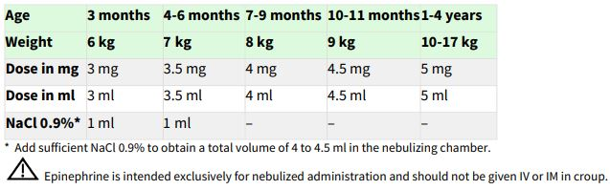
Dexamethasone Dose: IM or IV: 0.6 mg/kg single dose
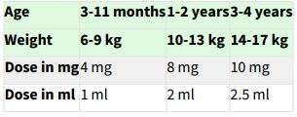
Suspect bacterial tracheitis in a critically ill appearing child with croup who does not improve with the above treatment.
- If wheezing is present:
  - Salbutamol aerosol (using a spacer): 2 to 3 puffs every 20 to 30 minutes as needed
- If the patient has a complete airway obstruction, intubation if possible or emergency tracheotomy
- Administer orally if possible in order to avoid causing agitation in the child as this may worsen symptoms.
- Critically ill appearing child: weak grunting or crying, drowsiness, difficult to arrouse, does not smile, unconjugate or anxious gaze, pallor or cyanosis, general hypotonia.

PERTUSSIS
Pertussis, also known as whooping cough, is a highly contagious disease that is caused by the bacterium Bordetella pertussis. It is transmitted through inhalation of droplets spread by infected individuals e.g. coughing, sneezing. Pneumonia can be a complication.
SYMPTOMS
- Mild ARI systems
- After 1 to 2 weeks, coughing + inspiratory “whooping” sound mostly at night, and vomiting
- Fever: Absent or mild
- Clinical: Normal signs
- Symptoms resolved after weeks or months
TREATMENT
- Isolation
- Antibiotics: During first 3 weeks after onset of cough
  - Azithromycin PO:
    - Adults: 500 mg STAT at Day-1, 250 mg OD for 4 days
    - Child: 10mg/kg STAT (max 500 mg) at Day-1, 5mg/kg OD (max 250 mg) for 4 days.
OR
  - Erythromycin PO
    - Adults: 500 mg QID x 14 Days
    - Child: 30 – 50 mg/kg/day x 10 days
PREVENTION
- Vaccination
- Erythromycin 50 mg/kg/day for 10 days to any infant in the family who is < 6 months old and has fever or other signs of a respiratory infection.
- Isolation of contacts is not necessary.

ACUTE EPIGLOTTITIS
Bacterial infection of the epiglottis in young children caused by Haemophilus influenzae (Hib), it is rare when Hib vaccine coverage is high. It can be caused by other bacteria and occur in adults.
Clinical features
  - Rapid (less than 12-24 hours) onset of high fever.
  - Typical “tripod or sniffing” position, preferring to sit, leaning forward with an open mouth, anxious appearing.
  - Difficulty swallowing, drooling, and respiratory distress.
  - Stridor may be present (as opposed to croup, hoarse voice and cough are usually absent).
  - Critically ill appearing
Allow the child to sit in a comfortable position or on the parent’s lap. Do not force them to lie down (may precipitate airway obstruction). Avoid any examination that will upset the child including examination of the mouth and throat.
Treatment
– In case of imminent airway obstruction, emergency intubation or tracheotomy is indicated. The intubation is technically difficult and should be performed under anaesthesia by a physician familiar with the procedure. Be prepared to perform a tracheotomy if intubation is unsuccessful.
– In all cases:
- Insert a peripheral IV line and provide IV hydration.
- Antibiotherapy
  - Ceftriaxone slow IV (3 minutes) or IV infusion (30 minutes). Avoid IM (may agitate the child and precipitate a respiratory arrest).
  - Children: 50 mg/kg once daily
  - Adults: 1 g once daily
The IV treatment is administered for at least 5 days then, if the clinical condition has improved 3 and oral treatment can be tolerated, change to:
Amoxicillin/clavulanic acid (co-amoxiclav) PO to complete a total of 7 to 10 days of treatment. Use formulations in a ratio of 8:1 or 7:1 exclusively. The dose is expressed in amoxicillin:
- Children < 40 kg: 50 mg/kg 2 times daily
- Children ≥ 40 kg and adult:
  - Ratio 8:1: 3000 mg daily: 2 tablets of 500/62.5 mg 3 times daily OR
  - Ratio 7:1: 2625 mg daily: 1 tablet of 875/125 mg 3 times daily

- Critically ill appearing child: weak grunting or crying, drowsiness, difficult to arrouse, does not smile, unconjugate or anxious gaze, pallor or cyanosis, general hypotonia.
- For administration by IV route, ceftriaxone powder should to be reconstituted in water for injection only. For administration by IV infusion, dilute each dose of ceftriaxone in 5 ml/kg of 0.9% sodium chloride or 5% glucose in children less than 20 kg and in a bag of 100 ml of 0.9% sodium chloride or 5% glucose in children over 20 kg and in adults.
- Improvement criteria include: fever reduction, diminished respiratory distress, improved SpO2, improved appetite and/or activity.

DIPHTHERIA
Diphtheria is an infectious disease caused by the bacteria Corynebacterium diphtheriae. It spreads from person to person by respiratory droplets from the throat through coughing and sneezing. The diphtheria bacteria produce toxins throughout the body.
- Tonsillitis with grey sticky membranes in the throat
- High fever >39°C
- Oliguria, cervical oedema, enlarged cervical lymph nodes
- Signs of haemorrhage e.g. purpuric rash, epistaxis, bleeding gums
COMPLICATIONS:
- Myocarditis
- Neuropathies
- Renal failure
- Pneumonia
TREATMENT
- Immediate strict isolation. Refer ASAP.
- Nose and throat samples for culture (if available)
- Antibiotic treatment for 14 days
  - If the patient can swallow:
Azithromycin PO
Children: 20 mg/kg once daily (max. 500 mg daily)
Adults: 500 mg once daily
Or
Erythromycin PO
Children: 30 to 50 mg/kg daily 1
Adults: 1 g 2 times daily
Or
Phenoxymethylpenicillin (penicillin V) PO
Children under 1 year: 12.5 mg/kg 4 times daily (max. 500 mg daily)
Children from 1 to 6 years: 125 mg 4 times daily
Children over 6 years and adults: 250 mg 4 times daily

  - If the patient cannot swallow, start with one of the treatments below and change as soon as possible to oral route with one of the oral treatments above to complete 14 days of treatment:
Procaine benzylpenicillin IM
Children: 50 000 IU/kg (= 50 mg/kg) once daily (max. 1.2 g daily)
Adults: 1.2 MIU (1.2 g) once daily
Never administer procaine benzylpenicillin by IV injection.
Or, if not available,
Benzylpenicillin IM or slow IV (3 minutes)
Children: 25 mg/kg every 6 hours (max. 2.4 g daily)
Adults: 1 MIU (600 mg) every 6 hours
In penicillin-allergic patients, use erythromycin IV
- Urgent intervention to secure an airway (intubation, tracheotomy) may be necessary in the event of laryngeal obstruction, cardiac or neurologic complications.
- Antitoxin Serum: Administration of diphtheria antitoxin derived from horse serum. Do not wait for bacteriological confirmation any delay can diminish efficacy. Administer according to the Besredka method to assess possibility of allergy.
- Besredka method: inject 0.1 ml SC and wait 15 minutes. If there is no allergic reaction (no erythema at the injection site or a flat erythema of less than 0.5 in diameter, inject a further 0.25 ml SC. If there is no reaction after 15 minutes, inject the rest of the product IM or IV depending on the volume to be administered.
Clinical Signs | Dose in Units | Administration Routes
Laryngitis or pharyngitis  or duration < 48 hourr | 20 000 to 40 000 | IM or IV infusion in 250 ml of 0.9% sodium chloride in 2 to 4 hours for doses of more than 20 000 UI.
Rhinopharyngitis | 40 000 to 60 000
Severe form, cervical  oedema  or duration ≥ 48 hours | 80 000 \to 100 000

PREVENTION
Management of close contacts Close contacts include family members living under the same roof and people who were directly exposed to nasopharyngeal secretions of the patient on a regular basis (e.g. children in the same class, medical personnel). – Throat culture; temperature and throat examination daily (7 days); exclusion from school or work until 48 hours of antibiotics have been completed.
Antibiotics:
Benzathine benzylpenicillin IM
Children under 30 kg (or under 10 years): 600 000 IU single dose
Children 30 kg and over (or 10 years and over) and adults: 1.2 MIU single dose

INFLUENZA
Influenza is a viral infection that can be very contagious. Often there is close contact with someone who has similar symptoms. Different strains of influenza occur such as the avian influenza (H5N1). Common influenza is self-resolving, but some dangerous strains can become pandemics (epidemic that spreads across countries) and have high morbidity and mortality.
SIGNS and SYMPTOMS
- Fever, muscle pain, headache
- Respiratory symptoms: Cough, sore throat and runny nose
- Shortness of breath (Dyspnoea)
- Clinical pneumonia
DIAGNOSIS
- Clinical
- Investigation: rapid influenza diagnostic tests (RIDTs) OR “rapid molecular assays”
TREATMENT
- Fever and Pain: Paracetamol PO
- Encourage hydration
- Antibiotics: Not required
- Severe and complicated illness: Admit IPD OR Refer
PREVENTION
- Vaccination
- Infection prevention behaviors: wearing mask, cover mouth while coughing/sneezing, hand washing
- Hand hygiene

LOWER RESPIRATORY TRACT INFECTIONS (LRTIs)

ACUTE BRONCHITIS
An acute inflammation of the bronchial mucosa, most commonly of viral origin.
- In older children it can be caused by Mycoplasma pneumoniae.
- In children over 2 years of age with repetitive acute bronchitis or ‘wheezing’ bronchitis, consider asthma.
- In children under 2 years of age, consider bronchiolitis.
SIGNS AND SYMPTOMS
- Begin with a rhinopharyngitis that descends progressively: pharyngitis, laryngitis, tracheitis.
- Heavy cough, dry at the beginning then becoming productive
- Low-grade fever
- No tachypnoea, no dyspnoea
- On pulmonary auscultation: bronchial wheezing
TREATMENT
  - Fever: paracetamol PO
  - Keep the patient hydrated, humidify air (with a bowl of water or a wet towel).
  - Children: nasal irrigation with 0.9% sodium chloride or Ringer Lactate, 4 to 6 times daily to clear the airway.
  - Antibiotherapy is not useful for patients in good overall condition with rhinopharyngitis or influenza.
  - Antibiotherapy is indicated only if: the patient is in poor general condition: malnutrition, measles, rickets, severe anaemia, cardiac disease, elderly patient etc.
If the patient has dyspnoea, fever greater than 38.5 °C and purulent expectorations, a secondary infection with Haemophilus influenzae or with pneumococcus is probable.
Amoxicillin PO:
Children: 30 mg/kg 3 times daily (max. 3 g daily) for 5 days,
Adults: 1 g 3 times daily for 5 days

CHRONIC BRONCHITIS
A chronic inflammation of the bronchial mucosa due to irritation (tobacco, pollution), allergy (asthma) or infection (repetitive acute bronchitis). It may develop into chronic obstructive pulmonary disease.
SIGNS AND SYMPTOMS
  - Productive cough for 3 consecutive months per year for 2 successive years.
  - No dyspnoea at onset. Dyspnoea develops after several years, first on exertion, then becoming persistent.
  - On pulmonary auscultation: bronchial wheeze (always exclude tuberculosis).
  - A patient with an acute exacerbation of chronic bronchitis presents with:
    - Onset or increase of dyspnoea.
    - Increased volume of sputum.
    - Purulent sputum.
TREATMENT
- NO Antibiotic for simple chronic bronchitis
- Discourage smoking and other irritating factors.

BRONCHIOLITIS
Bronchiolitis is an epidemic and seasonal viral infection of the lower respiratory tract in children less than 2 years of age, characterized by bronchiolar obstruction.
Respiratory syncytial virus (RSV) is responsible for 70% of cases of bronchiolitis. Transmission of RSV is direct, through inhalation of droplets (coughing, sneezing), and indirect, through contact with hands or materials contaminated by infected secretions.
In the majority of cases, bronchiolitis is benign, resolves spontaneously (relapses are possible), and can be treated on an outpatient basis.
Severe cases may occur, which put the child at risk due to exhaustion or secondary bacterial infection. Hospitalization is necessary when signs/criteria of severity are present (10 to 20% of cases).

SIGNS AND SYMPTOMS
  - Tachypnoea, dyspnoea, wheezing, cough; profuse, frothy, obstructive secretions.
  - On auscultation: prolonged expiration with diffuse, bilateral wheezes; sometimes diffuse fine, end-inspiratory crackles.
- Rhinopharyngitis, with dry cough, precedes these features by 24 to 72 hours; fever is absent or moderate.
Signs of severity:
- Significant deterioration in general condition, toxic appearance (pallor, greyish coloration)
- Apnoea, cyanosis (check lips, buccal mucosa, fingernails)
- Respiratory distress (nasal flaring, sternal and chest wall indrawing)
- Anxiety and agitation (hypoxia), altered level of consciousness
- Respiratory rate > 60/minute
- Decreased respiratory distress and slow respirations (< 30/minute below the age of 1 year and < 20/minute below the age of 3 years, exhaustion). Exercise caution in interpreting these signs as indicators of clinical improvement.
- Sweats, tachycardia at rest and in the absence of fever
- Silence on auscultation (severe bronchospasm)
- Difficulty drinking or sucking (reduced tolerance for exertion)
TREATMENT
Treatment is symptomatic. Obstructive signs and symptoms last for about 10 days; cough may persist for 2 weeks longer.
Hospitalize children with one of the following criteria:
  - Presence of any sign of severity
  - Pre-existing pathology (cardiac or pulmonary disease, malnutrition, HIV, etc.)
  - Consider hospitalization on a case-by-case basis in the following situations:
    - Associated acute pathology (viral gastro-enteritis, bacterial infection, etc.)
    - Age less than 3 months
In all other cases, the child may be treated at home, provided the parents are taught how to carry out treatment, and what signs of severity should lead to re-consultation.
Outpatient treatment
  - Nasal irrigation with 0.9% NaCl before each feeding (demonstrate the technique to the mother)
  - Small, frequent feedings to reduce vomiting triggered by bouts of coughing.
  - Increased fluids if fever and/or significant secretions are present.
  - Treat fever
  - Handle the patient the patient as little as possible and avoid unnecessary procedures.
Inpatient treatment
In all cases:
- Place the infant in a semi-reclining position (± 30°).
- Nasal irrigation, small, frequent feeds, treatment of fever: as for outpatient treatment.
- Gentle oro-pharyngeal suction if needed.
- Monitor fluid intake: normal requirements are 80 to 100 ml/kg/day + 20 to 25 ml/kg/day with high fever or very profuse secretions.
According to symptoms:
- Humidified nasal oxygen (1 to 2 litres/minute).
- When there is vomiting or significant fatigue when sucking, fluid requirements may be administered by nasogastric tube (small volumes on a frequent basis) or the IV route, for the shortest possible time.
- Avoid breastfeeding or oral feeds in children with severe tachypnoea, but do not prolong NG feeds (respiratory compromise) or IV infusions any longer than necessary.
- Bronchodilator therapy: this therapy may be considered after a trial treatment has been given (salbutamol inhaler, 100 micrograms/puff: 2 to 3 puffs with spacer, repeated twice at an interval of 30 minutes). If inhaled salbutamol appears effective in relieving symptoms, the treatment is continued (2 to 3 puffs every 6 hours in the acute phase, then gradual reduction as recovery takes place). If the trial is ineffective, the treatment is discontinued.
- Antibiotics are not indicated unless there is concern about complications such as secondary bacterial pneumonia.
PREVENTION AND CONTROL
The risk of transmission of the virus is increased in hospital settings:
  - Children with bronchiolitis should be grouped together, away from other children.
  - As infection is most commonly transmitted by the hands, the most important prevention measure is hand washing after any contact with patients, and objects or surfaces in contact with patients on which the virus may survive for several hours.
  - In addition, staff should wear gowns, gloves and surgical masks when in contact with patients.
  - Lie the child on his back, head turned to the side and instil 0.9% NaCl into the nose, one nostril at a time.

PNEUMONIA IN CHILDREN UNDER 5 YEARS OF AGE
Pneumonia is caused by viruses or bacteria. It is usually not possible to determine the specific cause of pneumonia by clinical features or chest X-ray appearance. Pneumonia is classified as severe or non-severe on the basis of clinical features, the management being based on the classification. Antibiotic therapy should be given in most cases of pneumonia and severe pneumonia. Severe pneumonia may require additional supportive care, such as oxygen, to be given in hospital.

SEVERE PNEUMONIA
DIAGNOSIS
Cough or difficulty in breathing, plus at least one of the following:
- central cyanosis or oxygen saturation < 90% on pulse oximetry
- severe respiratory distress (e.g. grunting, very severe chest indrawing)
- signs of pneumonia with a general danger sign:
  - inability to breastfeed or drink,
  - lethargy or unconscious,
  - Convulsions.
- In addition, some or all of the other signs of pneumonia may be present, such as:
  - Signs of pneumonia
    - Fast breathing:
      - Age 2–11 months, ≥ 50/min
      - Age 1–5 years, ≥ 40/min
  - Chest indrawing: lower chest wall indrawing (i.e. lower chest wall goes in when the child breathes in)
  - Chest auscultation signs:
- decreased breath sounds
- bronchial breath sounds
- crackles
- abnormal vocal resonance (decreased over a pleural effusion or empyema, increased over lobar consolidation)
- pleural rub

PNEUMONIA
DIAGNOSIS
Cough or diffi cult breathing plus at least one of the following signs:
- Fast breathing:
  - Age 2–11 months, ≥ 50/min
  - Age 1–5 years, ≥ 40/min
- Lower chest wall indrawing
In addition, either crackles or pleural rub may be present on chest auscultation.
Check that there are no signs of severe pneumonia, such as:
  - oxygen saturation < 90% on pulse oximetry or central cyanosis
  - severe respiratory distress (e.g. grunting, very severe chest indrawing)
  - inability to breastfeed or drink or vomiting everything
  - convulsions, lethargy or reduced level of consciousness
  - auscultatory findings of decreased or bronchial breath sounds or signs of pleural effusion or empyema.
Table 2 Classification of the severity of pneumonia (Under 5 children)
Signs and symptoms | Classification | Treatment
Cough or difficulty in  breathing with:  ■ Oxygen saturation < 90%  or central cyanosis  ■ Severe respiratory distress  (e.g. grunting, very severe  chest indrawing)  ■ Signs of pneumonia with  a general danger sign  (inability to breastfeed or  drink, lethargy or reduced  level of consciousness,  convulsions) | Severe  pneumonia | - Admit to hospital.  - Give oxygen if saturation < 90%.  - Manage airway (remove thick secretions by gentle suction)  - Treat high fever if present.  - Encourage breastfeeding and oral fluids  - If wheezing is present, give bronchodilator. (Steroid can be consider.)  - Give recommended antibiotic.  - Monitor by nurse 3 hourly  - Monitor by medic 12 hourly
■ Fast breathing:  – ≥ 50 breaths/min in a  child aged 2–11 months  – ≥ 40 breaths/min in a  child aged 1–5 years  ■ Chest indrawing | Pneumonia | - Home care  - Give appropriate antibiotic.  - Advise the mother when to return immediately if symptoms of severe pneumonia.  - Follow up after 3 days
■ No signs of pneumonia or severe pneumonia | No  pneumonia:  cough or cold | - Home care  - Soothe the throat and relieve cough with safe remedy.  - Advise the mother when to return.  - Follow up after 5 days if not improving  - If coughing for more than 14 days, refer to chronic cough

ANTIBIOTICS TREATMENT
Table 3 Antibiotic treatment in severe pneumonia and pneumonia
Classification | Antibiotic Treatment
Severe Pneumonia | - Ampicillin 50 mg/kg IV/IM QID AND Gentamicin 7.5 mg/kg IV/IM OD for 5 days at least  - If no improvement within 48 hours AND staphylococcal pneumonia is suspected, change the regime as Cloxacillin 50 mg/kg IV/IM QID AND Gentamicin 7.5 mg/kg IV/IM OD for 7 days at least, followed by Cloxacillin P.O for 3 weeks  - Use Ceftriaxone 80 mg/kg IV/IM OD if first line treatment is failed.
Pneumonia (WHO, 2014) | - Amoxicillin 40 mg/kg BD for 5 days (Area with high HIV infection rate.)  - Amoxicillin 40 mg/kg BD for 3 days (Area with low HIV infection rate.)
No Pneumonia | - DO NOT GIVE Antibiotics

WHEN TO DISCHARGE
Children with severe pneumonia can be discharged when:
- Respiratory distress has resolved.
- There is no hypoxemia (oxygen saturation, > 90%).
- They are feeding well.
- They are able to take oral medication or have completed a course of parenteral antibiotics.
- The parents understand the signs of pneumonia, risk factors and when to return.

PNEUMONIA IN CHILDREN OVER 5 YEARS AND ADULTS

The most common causes are viruses, pneumococcus, and Mycoplasma pneumoniae.
SIGNS AND SYMPTOMS
- Cough, with or without purulent sputum, fever, thoracic pain, tachypnea
- On pulmonary auscultation: decreased vesicular breath sounds, dullness, localized foci of crepitation, sometimes bronchial wheeze.
- Sudden onset with high fever (higher than 39 °C), thoracic pain and oral herpes
- SEVERE PNEUMONIA includes signs of serious illness:
  - Cyanosis (lips, oral mucosa, fingernails)
  - Nasal flaring
  - Intercostal or subclavial indrawing
  - RR > 30 breaths/minute
  - Heart rate > 125 beats/minute
  - Altered level of consciousness (drowsiness, confusion)
- Patients at risk include the elderly, patients suffering from heart failure, sickle cell disease or severe chronic bronchitis; immunocompromised patients.
TREATMENT
Classification | Treatment
Severe Pneumonia | Admit IPD  Antibiotics Treatment  First Line of drug  - Ceftriaxone IM or Slow IV over 3 minutes  - Child: 50 mg/kg OD  - Adult: 1 g OD  - If condition is improved, change to Amoxicillin PO  - Child: 30 mg/kg TID (max. 3 g/day)  - Adult: 1 g TID  Total treatment course: Ceftriaxone + Amoxicillin have to complete 7 – 10 days  - Alternative of Ceftriaxone is Ampicillin.  Second Line of drug,  - If the condition is not improved after 48 hours, treatment regime is changed to  - Ceftriaxone (same as above) AND Cloxacillin IV infusion  - Child: 25 to 50 mg/kg QID  - Adults: 2 g QID  - If condition is improved, change to Co-amoxiclav PO  - Child <40 kg: 50 mg/kg BD  - Child ≥40 kg and adults:  Ratio 8:1: 3000 mg daily: 2 tablets of 500/62.5 mg 3 times daily OR  Ratio 7:1: 2625 mg daily: 1 tablet of 875/125 mg 3 times daily  Total treatment course: Ceftriaxone, Cloxacillin + Co-amoxiclav have to complete 10 – 14 days  If failed to second line of drug, consider “Tuberculosis”.  If “Tuberculosis” is not unlikely, consider “Atypical pneumonia” and add “Azithromycin”.
Pneumonia without signs of serious illness | Amoxicillin PO  - Child: 30 mg/kg TID (max. 3 g/day) for 5 days  - Adults: 1 g TID for 5 days  If the condition is not improved after 3 days, consider “Atypical pneumonia” and add “Azithromycin”.
OTHER TYPES OF PNEUMONIA
  - Atypical Pneumonia
Pneumonia caused by bacteria e.g. Legionella, Mycoplasma, Klebsiella that do not respond to routine antibiotics. Alternative antibiotic e.g. gentamicin, doxycycline, erythromycin, azithromycin.

  - Staph Aureus Pneumonia
Particularly if skin infection, patient looks very unwell, CXR shows necrotizing lesions. Treat with IV cloxacillin.

  - Tuberculosis
If there has been good compliance of amoxicillin and an antibiotic to cover an atypical pneumonia, suspect TB (symptoms include coughing for more than 2-3 weeks, weight loss, coughing with blood and/or night sweats).

  - Aspiration pneumonia
Patients with decreased consciousness, or those that have problems swallowing e.g. after a stroke, have high risk of aspiration pneumonia (inhaling acid or vomit from the stomach). To prevent, keep comatose patients in the coma position. If suspect an aspiration pneumonia e.g. a comatose patient develops signs of ARI, treat as per pneumonia + metronidazole.

  - Fungal pneumonia
It is uncommon, but it may occur in patients with immune system problems due to AIDS, immunosuppressive drugs, or other medical problems.

  - Eosinophilic pneumonia
It is invasion of the lung by eosinophils, a particular kind of white blood cell. Eosinophilic pneumonia often occurs in response to infection with a parasite (e.g. paragonimus (see below), intestinal worms, lymphatic filariasis or as inflammatory or allergic reactions. Treat the underlying cause.

PARAGONIMUS
Paragonimus is a ‘fluke’ (short flat worm) that mainly affects the lungs. It is caused by eating infected, undercooked, fresh water crabs and crayfish.
SYMPTOMS
2 most common symptoms are:
- Productive cough >2 weeks
- Intermittent haemoptysis (rusty-brown colour)

Signs and symptoms of very likely pulmonary TB:
- Cough with sputum
- Fever
- Blood in sputum
- Haemoptysis
- Chest pain
- Pleural effusion

DIAGNOSIS
- Microscopy: eggs found in unstained sputum

TREATMENT
- Child > 2 years/ Adults
  - Praziquantal PO 25 mg/kg TID for 3 days
  - Praziquantal can be given in 2nd and 3rd trimester of pregnancy.

CHRONIC RESPIRATORY DISEASES

CHRONIC OBSTRUCTIVE PULMONARY DISEASE (COPD)
Chronic Obstructive Pulmonary Disease (COPD) is a form of chronic lung disease that causes the narrowing of the airways so ventilation is poor. Smoking is the primary cause of COPD. This term covers many respiratory conditions:  - Chronic bronchitis: inflammation of the bronchi. | 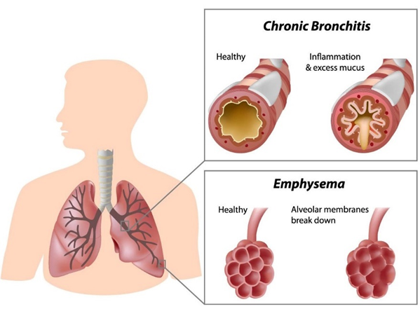  Figure 15 Bronchitis and emphysema
- Emphysema: damage to the smaller airways and alveoli.
- Chronic obstructive airways disease: sometimes caused by allergy and environmental factors.

SIGNS AND SYMPTOMS
The signs and symptoms of COPD are similar to asthma, but in COPD the damage is permanent and the symptoms are persistent:
- Cough with sputum gradually getting worse. (remember TB is also a cause for chronic cough)

- Breathlessness and wheezing on exertion, gradually getting worse. These symptoms will eventually occur even when the patient is at rest.

- Sputum, because the damaged airways create a lot of mucus.

On physical examination,
- Fast RR  - Accessory muscle working on expiration  - Hyperventilation  - Reduced chest expansion  - Resonance or hyper resonance on percussion | - Quiet breath sound  - Wheezing  - Cyanosis  - Signs of heart failure

DIAGNOSIS
- Clinical
- Chest X-ray may show hyper-expansion of the lungs +/- bullae.
- Do not forget to rule out TB.
- The formal diagnosis of COPD is made with spirometry. (for more detail: see in Appendix)
TREATMENT
ACUTE TREATMENT (EMERGENCY TREATMENT)
Most of the medications used in COPD treatment are directed at the following 4 potentially reversible mechanisms of airflow limitation:
- Bronchial smooth muscle contraction
- Bronchial mucosal congestion and edema
- Airway inflammation
- Increased airway secretions
Table 4 Assessment and Treatment of COPD
 | Assess | Treatment
DR | Danger  Response | - Gloves, Safe place, call for help
A | Airway obstruction  Speaking, stridor,  swelling, secretions | - Maintain Oxygen saturations between 88-92%  **Note: too much oxygen can be dangerous in these patients**  Give no more than 5L.
B | RR, SpO2, cyanosis,  Chest indrawing/  tracheal tug  Listen to chest | - Salbutamol Inhaler 10 puffs OR Salbutamol Nebuliser 5mg STAT (If low SpO2/cyanosis/cannot speak)  - Sit up right
C | HR, BP, Cap refill  Urine output, Temp  Listen to HS | - Put in IV cannula – take bloods  - E.g. Hct, CBC, MS, BC, dextrose etc.  - If signs of shock give fluid bolus NSS 500ml
D | Check dextrose,  Any drugs needed e.g.  antibiotics, paracetamol | Antibiotic  - Ampicillin IV/IM 1g OR Amoxicillin PO 500mg  Steroid  - Prednisolone PO 40mg (continue for 7 days)  OR  - Hydrocortisone IV 100mg if unable to take PO  **Note: IV aminophylline is not recommended for COPD attack**  Give dextrose if low
E | AVPU/GCS  Expose and examine all  over body | - Review notes and charts  - History, further investigations, treatment plan
Re-ACCESS (DR. ABCDE)
No response > referral

*Antibiotics for COPD Acute Attack:
Most acute attacks of COPD should be given antibiotics. (Only mild acute exacerbations may improve with inhaled salbutamol and not require antibiotics). Note: This is different to asthma when antibiotics should only be given if there is evidence of infection e.g. temperature, productive cough etc.

POST EMERGENCY (CHRONIC) TREATMENT:
- The changes to the lung are irreversible, and there is little treatment available for chronic COPD in resource poor setting.
1. Post discharge
- Complete 5-7 days of antibiotics.
- Complete 7 days of 40mg prednisolone.
2. Lifestyle and general advice
- Stop smoking, advice family members to not smoke around the patient.
- Exercise as much as possible, as much as their breathing allows.
- Breathing exercises.
- Advise the patient if their breathing or cough changes to seek medical attention quickly.
3. Medication
- Inhaled salbutamol 2 puffs PRN (max QID) when having dyspnoea
- Note: unlike asthma, oral or inhaled steroids are not recommended for chronic treatment of COPD.
- Only slow-release low dose theophylline is recommended (dose depends on the brand of tablet (see specific manufacturer instructions)).
- Mucolytics e.g. bromhexine can be considered but may not be available. These help break down the mucous to make it easier to cough it up.
COMPLICATIONS
- Recurrent chest infection
- Raised haematocrit (polycythaemia)
- Reduced exercise tolerance
- Respiratory failure
- Poor nutrition and weight loss
- Pneumothorax
- Heart failure
- Lung cancer (secondary to smoking)

BRONCHIECTASIS
Bronchiectasis is a chronic disease of the bronchial tubes. The bronchial tubes become widened so mucous stays in the bronchial tubes, resulting in recurrent infections. These infections lead to blockage of the tubes. The blockage causes the alveoli to collapse.  SIGNS AND SYMPTOMS  - Cough with lot of sputum  - Haemoptysis  - Wheezing  - Chronic sinusitis  - Loud crepitation | 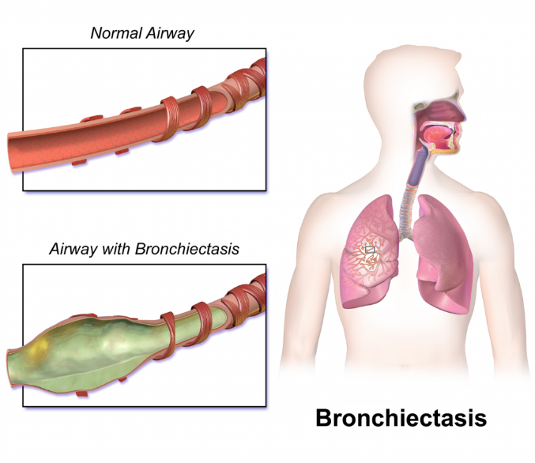  Figure 16 Airway with bronchiectasis
DIAGNOSIS:
- Clinical
- CXR may be helpful
- CT scan (only if available and affordable)
TREATMENT
- There is no specific treatment for bronchiectasis.
- The patient may get recurrent infections so you need to educate them on the symptoms and when they should come in to the clinic to get antibiotics.
- They may need prophylactic antibiotics to stop getting recurrent infections.

INTERSTITIAL LUNG DISEASE
- Interstitial lung disease is a disease of the soft tissue of the lung that causes damage to the walls of the alveoli.  - The alveolar walls become thick, so gas exchange is poor. | 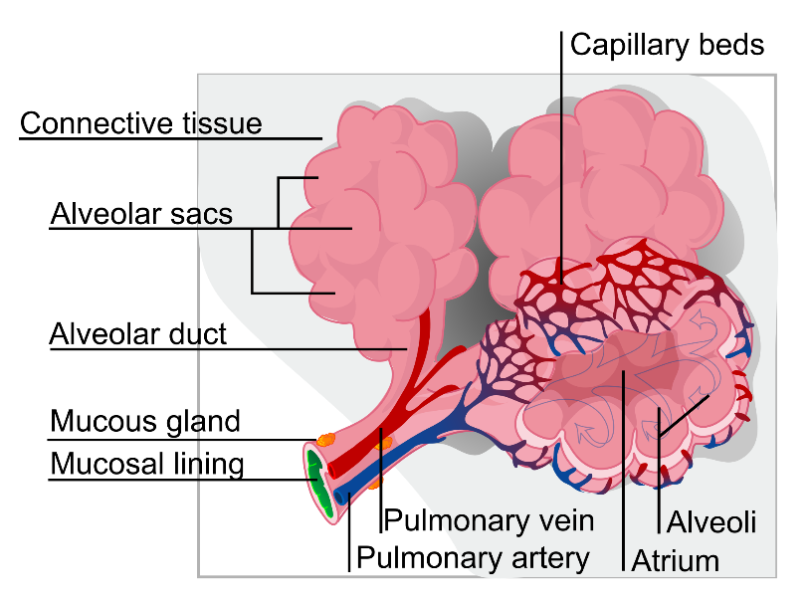
- Small blood vessels in the lung can also be affected, so blood supply to the lungs is poor.
- In most cases the lungs will gradually get worse, and breathing will become more difficult for the patient.
CAUSES
  - No cause (idiopathic fibrosis)
  - Exposure to substances like silicon
  - Some medications e.g. nitrofurantoin, methotrexate, amiodarone
  - Chronic diseases e.g. rheumatoid arthritis
SIGNS AND SYMPTOMS
- In the early stages, no signs and symptoms
- Clubbing (enlarged fingertips and a loss of the normal angle at the nail bed)
- Cyanosis
- Fast respiratory rate at rest
- Reduced expansion of the lung
- Raised jugular venous pressure
- Fine inspiratory crepitation both lungs
DIAGNOSIS  - Clinical.  - CXR can be very helpful if available, it may show reticulo-nodular shadowing in the parts of the lung affected.  TREATMENT  - Some interstitial lung disease may respond to steroids.  - Deworming before giving steroids  - Explain side effects of steroids.  - Start with lowest dose of steroids. | 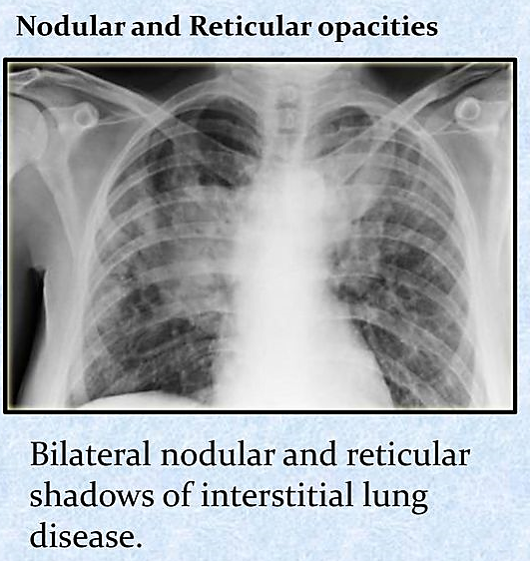

ASTHMA
- Asthma is a chronic inflammatory disorder of the airways associated with airway hyper responsiveness that leads to recurrent episodes of wheezing, breathlessness, chest tightness and coughing. | 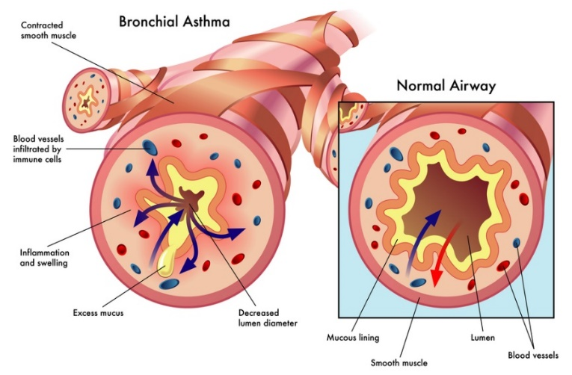  Figure 17 Bronchial Asthma Airway
- These episodes are usually associated with airflow obstruction within the lung, often reversible, either spontaneously or with treatment.
- Factors that precipitate/aggravate asthma include: allergens, infection, exercise, drugs (aspirin), tobacco, etc.
- In young children, most initial episodes of asthma-like symptoms are associated with a respiratory tract infection, with no symptoms between infections.
- Wheezing episodes usually become less frequent with time; most of these children do not develop asthma

ASTHMA ATTACK (ACUTE ASTHMA)
An acute asthma attack is a sudden deterioration in the asthma symptoms.
Table 5 Emergency management on Asthma Attack patient arrival
 | Assess | Treatment
DR | Danger  Response | - Gloves, Safe place, call for help
A | Airway obstruction  Speaking, stridor,  swelling, secretions | Give 10-15L oxygen if saturations low – aim SpO₂ >94%.  Note: if not able to measure saturations then just give oxygen
B | Assess severity of breathing problems?  - Are they breathless at rest?  - What is the RR?  - What are the oxygen saturations?  - Able to speak – words? Full sentences?  - Listen to the chest – any wheeze?  - Silent chest?  - Any chest indrawing? | Salbutamol nebuliser  - Adult/>5yr: 5mg STAT  - Child <5yr: 2.5mg STAT  OR  - Salbutamol inhaler 10 puffs STAT  Sit up right
C | HR, BP, Cap refill  Urine output, Temp  Listen to HS | - Put in IV cannula – take bloods e.g. Hct, CBC, dextrose etc.  - If signs of shock give fluid bolus NSS 500ml
D | Check dextrose,  Any drugs needed e.g.  antibiotics, paracetamol | Steroid  - Prednisolone PO  - Adult: 40mg;  - Child: 1mg/kg (max 30mg) (continue for 7 days)  OR  - Hydrocortisone (if unable to take PO)  - Adult: IV 100mg;  - Child: 4mg/kg  Antibiotic  - Ampicillin IV OR Amoxicillin PO ONLY IF SIGNS OF INFECTION e.g. fever, productive cough  If severe and not improving, discuss with doctor and consider IV  aminophylline, IV magnesium or IM adrenaline  Give dextrose if low
E | AVPU/GCS  Expose and examine all  over body | - Review notes and charts  - History, further investigations, treatment plan
Re-ACCESS (DR. ABCDE)
- No response > referral

Table 6 Assessment of Severity in ASTHMA ATTACK (Frontières., 2018)
 | Mild to moderate attack | Severe attack | Life threatening attack
Speaking and consciousness | Able to talk in sentences | Cannot complete sentences  in one breath  OR  Too breathless to talk or  Feed | - Altered level of consciousness (drowsiness, confusion, coma)  - Exhaustion
Respiratory rate/minute | Respiratory rate (RR)  - Children 2-5 years ≤ 40/ minute  - Children > 5 years ≤ 30/minute | Respiratory Rate (RR)  - Children 2-5 years > 40/minute  - Children > 5 years > 30/minute  - Adults ≥ 25/minute | - Silent chest  - Paradoxical thoracoabdominal movement
Heart rate/minute | Heart rate (HR)  - Children 2-5 years ≤ 140/minute  - Children > 5 years ≤ 125/minute | Heart rate (HR)  - Children 2-5 years > 140/minute  - Children > 5 years > 125/minute  - Adults ≥ 110/minute | - Cyanosis  - Collapse  - Bradycardia in children or arrhythmia/hypotension in adults
O2 | No criteria of severity | SpO2 ≥ 92% | SpO2 < 92%

Table 7 Treatment of ASTHMA ATTACK (Frontières., 2018)
Mild to moderate attack | Severe attack | Life threatening attack
- Half sitting position | - Half sitting position  - Oxygen 5 L/minutes OR maintain SpO2 between 94 – 98%. | - Intensive care  - Oxygen ≥ 5 L/minute OR maintain the SpO2 between 94 and 98%.
Salbutamol (aerosol)  - 2 to 4 puffs every 20 to 30 minutes, up to 10 puffs  - In children, use a spacer to ease administration (use face mask in children under 3 years).  Prednisolone PO:  - One dose of 1 to 2 mg/kg  - If the attack is completely resolved: observe the patient for 1 hour.  Outpatient treatment  - Salbutamol 2 to 4 puffs every 4 to 6 hours for 24-48 hours  - Prednisolone PO for 3 days  - If symptoms worsen or do not improve, treat as severe attack. | Salbutamol (aerosol)  - 2 to 4 puffs every 20 to 30 minutes, up to 10 puffs in children < 5 years, up to 20 puffs in children > 5 years and adults.  - Use a spacer to increase effectiveness, irrespective of age.  OR  - Salbutamol (solution for nebulization)  Prednisolone PO:  - One dose of 1 to 2 mg/kg  - In the case of vomiting, use hydrocortisone IV.  Dose for Hydrocortisone IV  - 1 month to < 5 years: 4 mg/kg every 6 hours (max. 100 mg per dose)  - Children 5 years and over and adults: 100 mg every 6 hours – If the attack is completely resolved, observe the patient for at least 4 hours.  On discharge  - Salbutamol 2 to 4 puffs every 4 to 6 hours for 24-48 hours  - Prednisolone PO for 3 days  If symptoms worsen or do not improve, treat as Life-threatening attack.  OPD care  Reassess after 10 days  consider long-term treatment | Salbutamol nebulizer  - Adult/>5yr: 5mg;  - Child <5yr: 2.5mg  3 times per hour then every 4 hours as needed until full response.  Note: Give salbutamol inhaler with spacer 10-15 puffs only if do not have nebulizer.  Hydrocortisone IV  - 1 month to < 5 years: 4 mg/kg every 6 hours (max. 100 mg per dose)  - Children 5 years and over and adults: 100 mg every 6 hours  Switch to PO prednisolone when can take PO  If no improvement consider:  - Aminophylline Infusion OR  - Magnesium IV OR  - Adrenaline IM  On discharge  - Salbutamol 2 to 4 puffs every 4 to 6 hours for 3 – 7 days  - Prednisolone PO for 5 - 10 days  OPD care  Reassess after 7 days  consider long-term treatment

CHRONIC ASTHMA
SIGNS AND SYMPTOMS
- Wheezing, chest tightness, shortness of breath and/or cough of variable frequency, severity and duration, disturbing sleep, and causing the patient to sit up to breathe.
- These symptoms may appear during or after exercise.
- Chest auscultation may be normal or demonstrate diffuse sibilant wheezes. – Atopic disorders or a personal or family history of atopy (eczema, allergic rhinitis/conjunctivitis) or a family history of asthma increases probability of asthma but their absence does not exclude asthma.
- Patients with typical symptoms of asthma and a history of disease that is characteristic of asthma should be considered as having asthma after exclusion of other diagnoses.
Table 8 Long term treatment of Asthma according to severity
Categories | Treatment
Intermittent asthma  • Day time symptoms < once weekly  • Night time symptoms < 2 times monthly  • Normal physical activity | No long term treatment  Inhaled salbutamol when symptomatic
Mild persistent asthma  • Day time symptoms > once weekly, but < once  daily  • Night time symptoms > 2 times monthly  • Symptoms may affect activity | Continuous treatment with inhaled  beclometasone  +  Inhaled salbutamol when symptomatic
Moderate persistent asthma  • Daily symptoms  • Symptoms affect activity  • Night time symptoms > once weekly  • Daily use of salbutamol | Continuous treatment with inhaled  beclometasone  +  Inhaled salbutamol (1 puff 4 times daily)
Severe persistent asthma  • Daily symptoms  • Frequent night time symptoms  • Physical activity limited by symptoms | Continuous treatment with inhaled  beclometasone  +  Inhaled salbutamol (1 - 2 puffs, 4 – 6 times daily)

GENERAL MANAGEMENT
- Do not restrict exercise.
- If exercise is a trigger for asthma attacks, administer 1 or 2 puffs of salbutamol 10 minutes beforehand.
- In pregnant women, poorly controlled asthma increases the risk of pre-eclampsia, eclampsia, haemorrhage, in utero growth retardation, premature delivery, neonatal hypoxia and perinatal mortality.
- Long-term treatment remains inhaled salbutamol and beclometasone at the usual dosage for adults.
- Whenever possible, avoid oral corticosteroids.
- If symptoms are not well controlled during a period of at least 3 months, check the inhalation technique and adherence before changing to a stronger treatment. If symptoms are well controlled for a period of at least 3 months (the patient is asymptomatic or the asthma has become intermittent): try a step-wise reduction in medication, finally discontinuing treatment, if it seems possible.
- Provide patients with a salbutamol inhaler for any possible attacks.
- Evaluate after 2 weeks. If the results are satisfactory, continue for 3 months and then re-evaluate.
- If the patient has redeveloped chronic asthma, restart long-term treatment, adjusting doses, as required.

TUBERCULOSIS
Tuberculosis is a contagious disease caused by Mycobacterium tuberculosis (and occasionally by Mycobacterium bovis and Mycobacterium africanum), which are also known as TB bacilli.
TB commonly attacks the lungs (pulmonary TB) but can cause disease in any part of the body such as the lymph nodes, pleural cavity, bones and spine, brain, abdomen, eyes, genito-urinary tract and the skin (extra-pulmonary TB).

TB TRANSMISSIONS:
TB infection is transmitted by air. A major source of infection is a patient with pulmonary TB who is coughing and whose sputum smear is positive (i.e. TB bacilli can be seen in sputum microscopy). If an infectious person coughs or sneezes, tiny infectious particles of respiratory secretion, which contain TB bacilli, are produced. These infectious particles can remain in the air for a long period. Therefore, people in close contact with an infectious person breathe in air containing infectious particles of TB bacilli.

TB DISEASE:
A person infected with TB does not necessarily feel unwell and such cases are known as silent or ‘latent’ infections. When the lung disease becomes ‘active’ and symptoms develop, such cases are diagnosed with ‘TB Disease’.
In HIV uninfected populations, only 1 person out of 10 TB-infected people develop TB disease.
In HIV infected populations, the proportion of developing TB disease is much higher. A HIV infected person has a 21-34 times higher risk of developing TB disease than a HIV uninfected individual.

CLASSIFICATION

- Pulmonary TB (lungs) - most common site

- Extra pulmonary TB (outside lungs)
Common | Less common
- Pleural  - Lymphnodes (common in neck)  - Brain  - Abdomen  - Pericardium  - Spine, other bones and joints | - Genital tract  - Kidney  - Adrenal gland  - Skin

SIGNS AND SYMPTOMS
Pulmonary TB (PTB) | Extra Pulmonary TB (EPTB)
- Cough for more than 2 or 3 weeks (with or without sputum production)  - Fever of unknown cause > 2 weeks  - Weight loss in the past three months  - Drenching night sweat  - Other symptoms are:  - Respiratory: coughing up blood, chest pain, breathlessness.  - General symptoms: tiredness, loss of appetite and secondary amenorrhoea  Physical Signs  - The physical signs of pulmonary TB are non-specific and cannot be distinguished from other lung diseases.  - General signs: fever, tachycardia, finger clubbing.  Respiratory signs: often no abnormal signs in the chest, although you may hear crackles, wheeze or bronchial breath sounds | TB outside the lungs may present with the following:  - TB pleural effusion: chest pain, dullness on percussion, reduced or no air entry on the affected side.  - TB lymphadenopathy: enlargement of lymph nodes, usually in the neck and bilaterally.  - TB spine or bone: deformity, chronic bone infection.  - TB brain: signs and symptoms of meningitis (headache, neurological deficit, loss of consciousness).  - TB abdomen: ascites, abdominal mass.

DIAGNOSIS
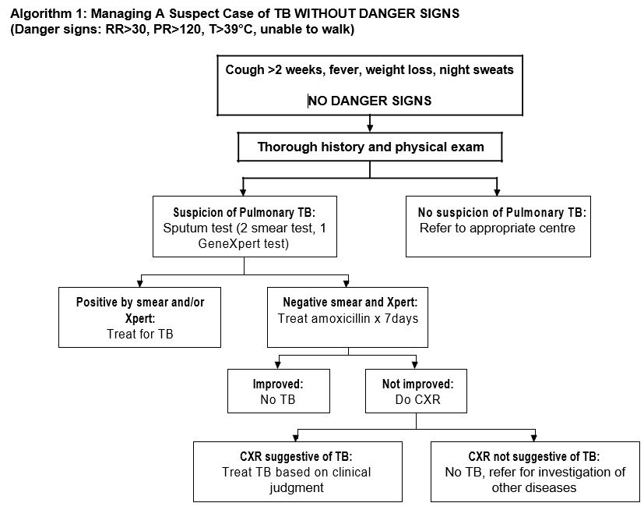

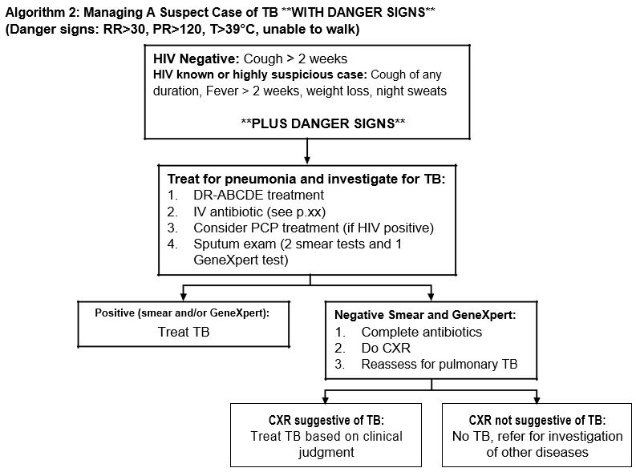

TESTS USED IN THE DIAGNOSIS OF TB
For Pulmonary TB
  - Sputum for microscopic examination of Acid Fast Bacilli (AFB):
    - Called AFB as the bacilli are resistance to losing their colour by acid
    - Need to collect sputum 2 days in a row
    - It is a simple, rapid and reliable test for sputum smear positive cases.

  - Molecular technique (MTB/Rif Assay called GeneXpert test):
    - Rapid result within a few hours if machine is where sample is collected
    - Can be used to see if the Mycobacteria is resistant to rifampicin – if it is resistant it is a sign that it could be a multi-drug resistant TB (MDR TB)

  - Culture (growing bacilli in special media) (if available):
- More specific test but results take longer (4-6wks), needs good technology, skills and is expensive
- Used if:
- Clinically suspect cases of smear positive and GeneXpert negative.
- Confirmation of treatment failure.
- Diagnosis of drug resistant TB (including MDR TB) together with drug susceptibility testing
  - Chest X-Ray: useful for smear negative pulmonary TB like pleural effusion, miliary TB, and TB in children
  - Tuberculin skin test: if positive is a sign of exposure to TB, it does not mean the patient has TB disease

For Extra-pulmonary TB:
- FNAC (fine needle aspiration cytology) for lymphadenopathy.
- Chest X-Ray: TB Pleural effusion, TB Pericarditis.
- Spine and Bone X-Ray: bone and spine TB.
- Thoracocentesis (pleural tap) and examination of pleural fluid: TB pleural effusion.
- Lumbar puncture and examination of CSF: TB meningitis.
- Abdominal paracentesis and examination of peritoneal fluid: TB abdomen.

TREATMENT
TB can be cured by using effective treatment regimens:
- Daily ingestion of anti-TB drugs without interruption.
- Multi drug therapy (4-5 drugs).
- At least 6-8 months duration of drug therapy.
- Use of quality drugs.
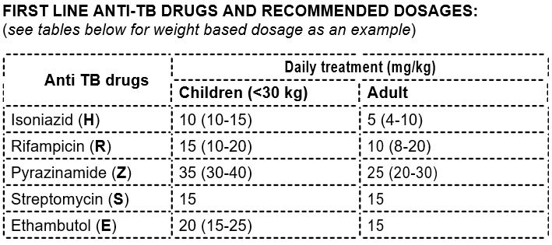
Figure 18 Anti TB Drugs
Note:
Consider age, body weight, existing liver or renal diseases, pregnancy and previous history of TB treatment before choosing a treatment regimen and the dosage

TREATMENT REGIMEN:
Table 9 Anti TB Cat-I
CATEGORY I (Cat I)  For New Case | Initial Phase | Continuation Phase
Sputum (+)ve  Sputum (-)ve  Extra pulmonary | HRZE x 2 months | HR x 4 months
TB Bone/joint | HRZE x 2 months | HR x 7 months
TB Meningitis | HRZE x 2 months | HR x 10 months
H = isoniazid, R = rifampicin, Z = pyrazinamide, E = ethambutol

Table 10 Anti TB Cat-II
CATEGORY II (Cat II)  For Re-treatment case | Initial Phase | Continuation Phase
If less than 5 months of E in the  previous treatment | HRZES x 2 months  Then HRZE x 1 month | HRE x 5 months
If more than 5 months of E in the previous treatment | HRZES x 2 months  Then HRZE x 1 month | 5 HRZE x 5 months
S = streptomycin, H = isoniazid, R = rifampicin, Z = pyrazinamide, E = ethambutol

Special considerations in treatment:
Pregnancy
- Patients should avoid getting pregnant during treatment.
- Rifampicin makes oral contraceptive pills less effective. Use other form of contraceptives e.g. injection Depo-Provera.
- If pregnant: streptomycin is contra-indicated as it can cause deafness to the baby. Use ethambutol instead.

PREVENTION
- BCG Vaccination for children
- Hygienic Practices
- Improve general health

SIDE EFFECTS OF ANTI-TB DRUGS
Table 11 Side effects of anti-TB drugs
Side effects | Anti-TB Drug | Intervention
Orange-red urine | Rifampicin | Explain about color of drugs
Peripheral neuropathy | Isoniazid | Prophylaxis: Vitamin B6 (Pyridoxine) 10mg OD  Treatment: 100-200mg OD
Hepatitis (Jaundice) | - Pyrazinamide  - Rifampicin  - Isoniazid | Stop treatment.  Re-introduce when hepatitis is resolved.  For severe/recurrent hepatitis: SHE2 + HE10 regimen is alternative.
Impaired vision | Ethambutol | 15mg/kg is generally safe.  Symptoms are reversible a few after stopping.  But optic neuropathy is irreversible.
Vestibulo-ototoxicity  And  Renal toxicity | Streptomycin | Reduce dose.  Alternate day injection: 3 days/week.  If severe, stop drug.  Deafness is irreversible.
Skin manifestation (generalized hypersensitivity) | - Streptomycin  - Ethambutol  - Pyrazinamide  - Rifampicin  - Isoniazid | Minor: Chlorpheniramine and calamine lotion  Steven Johnson Syndrome (SJS)*: STOP drugs  Re-introduce when symptoms are resolved.
Joint Pain | Pyrazinamide | Paracetamol or ibuprofen  Usually resolve after 2 weeks
Gastrointestinal upset | Rifampicin | Giver after small meal  Rx: Omeprazole or metoclopramide (2 hours before or 3 hours after TB drugs)
Shock, pupura, acute renal failure | Rifampicin | Stop.  Re-introduce when symptoms are resolved.
*Steven Johnson Syndrome (SJS): FEVER + RASH + MUCOCUTANEOUS INVOLVEMENT

GASTROINTESTINAL DISEASES

Acute abdominal pain
Definition: Sudden onset of severe abdominal pain that may or may not need referral for surgical intervention.
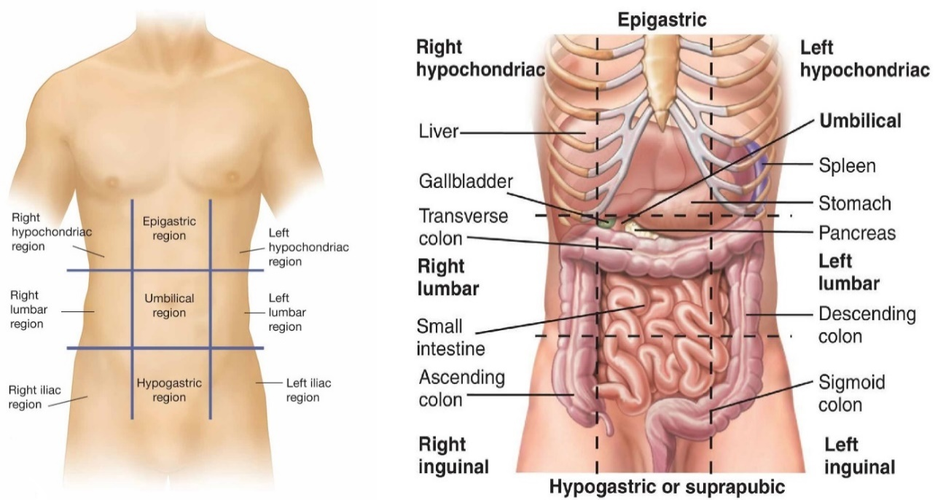
Figure 19 Acute abdominal pain and 9 regions
Figure 20 Anatomy 9 regions and common diseases (Murtagh, 2015)

GASTROINTESTINAL BLEEDING

Bleeding from the GI tract. Symptoms depend on where in the GI tract the blood is coming from. Sometimes the bleeding can be chronic e.g. from a cancer or can be acute e.g. variceal bleed.

If bleeding is acute this is an emergency: patients can become very unwell very quickly.

CAUSES
Upper GI tract (UGI) e.g. stomach, oesophagus:

- Peptic ulcer disease

- Varices (from portal hypertension from liver disease e.g. alcoholism)
- Cancer

Lower GI tract e.g. intestine

- Diverticulitis (pouches in wall of intestine)

- Cancer

- Inflammatory bowel disease

- Dysentery

SIGNS/SYMPTOMS

- Bleeding from the upper GI tract e.g. stomach, oesophagus:
  - Will vomit brown liquid (like coffee) or fresh blood and/or

  - Will have melaena (black sticky smelly stools). (Remember that patients on iron tablets will have black stools).

- Bleeding from the lower GI tract e.g. intestine:
  - Fresh blood from rectum.
- May have signs of shock – tachycardia, low BP, high CRT, fast RR, cold peripheries.

EMERGENCY TREATMENT In case of active bleeding:

 | ASSESS | TREATMENTS
DR | Danger  Response | Gloves  Safe place, call for help
A | Airway obstruction  Speaking, stridor,  swelling, secretions | Suction (if available)  Oxygen
B | RR, SpO2, cyanosis Chest indrawing/ tracheal tug Listen to chest
C | HR, BP, Cap refill  Urine output, Temp  Listen to HS | 2 IV cannulas (biggest size possible 16G or 18G)  Take bloods e.g. Hct, blood group, BUN*, CBC, MS, dextrose etc.  Fluid bolus 1L STAT  Transfuse if signs of shock
D | Check dextrose  Seizures  Pain | If UGI bleeding and suspect PEPTIC  ULCER DISEASE e.g. history of abdominal  pain, no risk factors for liver disease:  Omeprazole 40mg IV (or PO) OR  Ranitidine 50mg IV | If suspect PORTAL HYPERTENSION e.g. high alcohol intake, chronic hep B or C or signs of cirrhosis)  Ceftriaxone IV 1g OD for 5-7 days (varices are often associated with  bacterial infection) +/-  Vitamin K IM 2.5-10mg STAT dose
E | AVPU/GCS  Expose and examine | History, further investigations, treatment plan
Figure 21 Emergency Treatment for Active GI Bleeding

ASSESS RESPONSE – Re-start ABCDE
If no response, refer hospital.

GASTRO-OESOPHAGEAL REFLUX DISEASE

Gastro-oesophageal reflux disease (GORD) is caused by a weak sphincter (muscle) between the oesophagus and the stomach which means that the contents from the stomach reflux into the oesophagus causing a burning pain.

Risk factors
1. | High alcohol intake | 5. | Heavy smoking
2. | Obesity | 6. | Pregnancy
3. | Eating spicy food | 7. | Drugs e.g. NSAIDs, steroids, aspirin and
4. | High caffeine intake |  | doxycycline

SIGNS AND SYMPTOMS

Burning pain in the epigastric area moving to the mouth with acid taste, especially when lie down.

DIAGNOSIS

Clinical diagnosis.

Treatment

Lifestyle advice:
- Try to reduce or stop: alcohol, smoking, spicy food, hot drinks, tea and coffee.
- Avoid eating for 3 hours before bedtime, eat more but smaller meals, and do not lie down after meals.
- Advice overweight patients to lose weight, reduce fatty foods.
- If possible avoid medications that can cause GORD.

PREVENTION

Lifestyle advice (same as for treatment)

GASTRITIS

Gastritis is an inflammation of the stomach surface.

CAUSES

- High alcohol intake

- Heavy smoking

- Eating spicy food.

- H. pylori bacteria in the stomach (see below)

- Prolonged use of some medicines (like aspirin, indomethacin, ibuprofen, high dose ferrous sulphate) can cause or worsen the disease.
SIGNS AND SYMPTOMS
- Burning pain in the epigastric area.
- Nausea, vomiting, bulging, feeling of fullness.

DIAGNOSIS

Clinical diagnosis.

Treatment

Lifestyle advice:
- Try to reduce or stop: alcohol, smoking, spicy food, hot drinks, tea and coffee.
- Advice overweight patients to lose weight, reduce fatty foods.
- If possible avoid medications that can cause gastritis.

PREVENTION

Avoid coffee, alcohol, eating spicy foods, smoking. Avoid prolonged use of medications that cause gastritis e.g. ibuprofen. If long term medication absolutely necessary e.g. steroids for nephrotic syndrome consider omeprazole 20mg OD prophylaxis to prevent gastritis.

PEPTIC ULCER DISEASE

In peptic ulcer disease, epigastric pain can be very severe. Ulcers are often found in the stomach (gastric ulcer) or in the duodenum (duodenal ulcer). Often peptic ulcers are caused by infection with bacteria called H. pylori (see below). Medicines that reduce stomach acid like aluminium hydroxide may make you feel better, but the ulcer may come back.

SIGNS AND SYMPTOMS
- Burning pain in the epigastric area:
  - Gastric ulcer: pain worse with food

  - Duodenal ulcer: worse before meals and in the morning (empty stomach). Pain may reduce with eating, but comes back 1-2 hours after a meal.

- Nausea, vomiting, loss of appetite.
- Weakness and fatigue due to chronic bleeding.

COMPLICATIONS

- Acute bleeding: In some cases acute bleeding can happen. The patient will vomit brown liquid (like coffee) or fresh blood and may have melaena (black sticky smelly stools). See above for emergency treatment.

- Chronic bleeding: if small amount of bleeding occurs over a long time, then the patient will become anaemic.

- Perforation: hole in the stomach wall which can lead to peritonitis (hard, very tender abdomen), sepsis and death. □ DR-ABCDE
- Give nothing to eat or drink.
- IV ampicillin + IV gentamicin + IV metronidazole
- IV fluids NSS
- REFER THE PATIENT TO HOSPITAL IMMEDIATELY

DIAGNOSIS

It is a clinical diagnosis. Examine abdomen to check for any pain/masses. Look for anaemia. Ideally all patients who suffer from peptic ulcer disease should be tested for H. pylori. However, testing is expensive and not done at the border clinics

Treatment

For treatment see algorithm

Note: When giving treatment it is important to do ALL the steps, not just give medication:

- Lifestyle advice
- Stop any exacerbating medications
- De-worm
- Trial medications
- H. pylori eradication if medical treatment fails

Helicobacter pylori (H. pylori):

- H. pylori is a bacteria that is found in many people’s stomachs. This bacteria is resistant to acid and able to survive the highly acidic environment in the stomach. Often people do not know they have the infection, and it does not cause any problems. In some people it can cause gastritis or ulcers. It is not known why and when people become infected. It has also been linked to stomach cancer. Testing for H pylori can be done by a breathing or a stool test which are expensive and not available at most clinics on the border.

- Since the source of H. pylori is not yet known, recommendations for avoiding infection have not been made. In general, it is always wise for persons to wash hands thoroughly, to eat food that has been properly prepared, and to drink water from a safe, clean source.

- If symptoms do not improve with medical management it is possible to try to eradicate H. pylori.

  - Omeprazole 20mg BID for 10 days AND

  - Metronidazole 500mg TID for 10 days AND

  - Amoxicillin 500mg TID for 10 days
  - Follow triple therapy with Omeprazole 20mg OD for 2 weeks

PREVENTION

Avoid coffee, alcohol, eating spicy foods, smoking. Avoid prolonged use of medications that may cause peptic ulcer disease e.g. ibuprofen. If long term medication absolutely necessary e.g. steroids for nephrotic syndrome consider omeprazole 20mg OD prophylaxis.

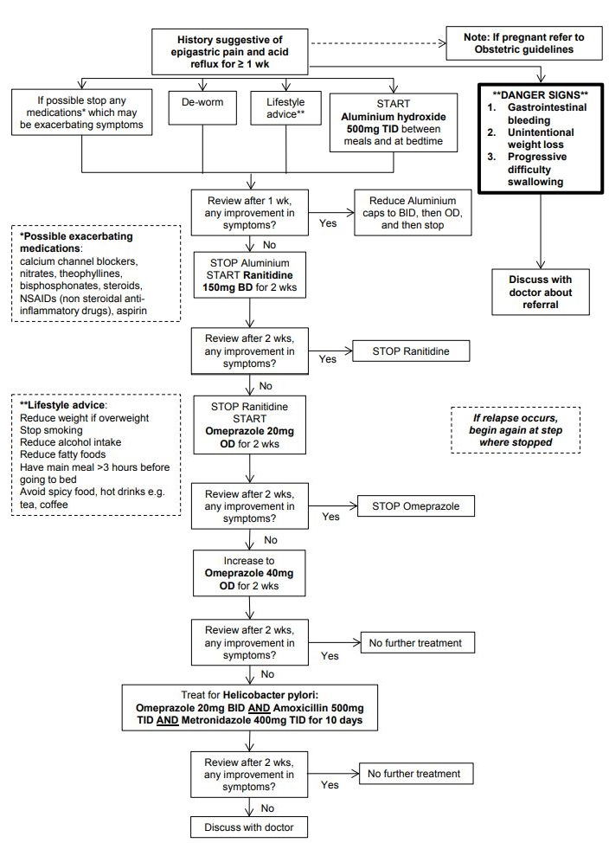
Figure 22 Management algorithm for epigastric pain

You need to rule out other causes of abdominal pain before considering anxiety as the diagnosis.

DIARRHOEA
Diarrhoea is a symptom and not a disease.

Acute diarrhoea = An increase in the number (>3/day) AND loose or watery stools passed over a period of less than 14 days. Acute diarrhoea can have many different causes (gastrointestinal infection, food poisoning, surgical problems, or other diseases).

Chronic diarrhoea = A diarrhoeal episode that lasts more than 2 weeks (Note: causes and treatments for chronic diarrhoea are different than for acute diarrhoea).

The following 2 types of acute diarrhoea are described: (mixed syndromes can occur)

- DIARRHOEA WITHOUT BLOOD

Stools are very liquid (watery diarrhoea), many stools, and clear colour (brown, yellowish). Fever and abdominal pain can exist but there is no blood or mucus in stools. The clinical signs are mostly caused by dehydration. The cause can be viral, bacterial (e.g. Cholera, E. Coli) or parasitic (e.g. Giardia). Note: acute diarrhoea without blood can also be seen in malaria.

- DYSENTERIC DIARRHOEA - DIARRHOEA WITH BLOOD

Stools are soft rather than liquid and are with blood. There is abdominal pain and fever can be high. Most common causes are Shigella and Campylobacter. Parasites like amoeba can also cause dysentery (usually without high fever).

SIGNS AND SYMPTOMS
- How many days has the patient had diarrhoea?
- How many times per day?
- Is it watery or with blood?
- Is there abdominal pain, rectal pain, feeling that haven’t completely emptied bowels (tenesmus), fever or vomiting?

ACUTE DIARRHOEA
Table 12 Acute diarrhoea
 | DIARRHOEA WITHOUT BLOOD | DYSENTERIC DIARRHOEA
Signs | Sometimes fever  Slight abdominal pain  Vomiting | High fever  Moderate to severe abdominal pain  Vomiting
Stools | Watery | Blood
Life-threatening | Dehydration | Sepsis

DIAGNOSIS

It is most important to evaluate and treat dehydration. Diagnosis is made on clinical grounds: diarrhoea without blood or dysentery. To specify between viral, bacterial or amoebic disease you need to carry out a stool-test. Consider the next points:

- For all types: First evaluate the signs of dehydration (see below).

- If there is fever you must also think of associated diseases such as malaria (see malaria guidelines), otitis media (see p. 46), pneumonia (see p.203), meningitis (see p.130) or UTI (see p.99).

- Look for signs of purging watery diarrhoea or repeated vomiting. Think of Cholera (p.88).

- If the patient has abdominal signs: a tender abdomen or abdominal distension, think of surgical causes (obstruction or perforation).

- With chronic diarrhoea (>2 weeks) think of malnutrition (see p.175) and chronic diseases e.g. HIV (see p.119).

TREATMENT OF DIARRHOEA:

Follow these steps to safely diagnose and treat diarrhoea:

- Assess acute or chronic

- Evaluate hydration using the WHO criteria.

- Choose a treatment according to the WHO criteria.

- Recognise the syndrome: diarrhoea without blood or with blood (dysentery).

- Consider cause of diarrhoea and if any antibiotics are needed.

- Evaluate hydration using the WHO criteria

Diarrhoea (mainly diarrhoea without blood) can lead to severe dehydration. First assess your patient for signs of dehydration:

Table 2: Clinical signs for evaluating dehydration plan (WHO)

Table 13 Dehydration assessment
 | PLAN A  No Dehydration | PLAN B  Mild Dehydration | PLAN C  Severe Dehydration
General condition | Normal | Agitated | Very tired or unconscious
Eyes | Normal | Slightly sunken | Deeply sunken
Tears | Present | Absent | Absent
Mouth and Tongue | Moist | Dry | Very Dry
Thirsty | None | Yes | Unable to drink
Skin pinch | Goes back quickly (Normally) | Goes back slowly | Goes back very slowly

- Choose a treatment according to the WHO criteria:

The decision on whether to admit and how to treat the patient is dependent on the WHO classification A, B or C.

Once evaluating the level of dehydration then follow the treatment:

WHO PLAN A:

To treat diarrhoea at home and prevent dehydration

The patient has no signs of dehydration. Do not need to admit to IPD.

Rules of home treatment:

GIVE EXTRA FLUID

How much?
- After each loose stool give:
- Child < 2 yrs: 50-100ml (quarter of a large cup).
- Child 2-10 yrs: 100-200ml (half of a large cup).
- Older child and adults: give patient enough ORS for at least 2L.

What fluid to give?

    - Oral Rehydration Solution (ORS) (can also give salted rice water, salted yoghurt drink or vegetable/ chicken soup with salt).

    - Do not give fluids e.g. carbonated (fizzy) drinks, commercial fruit juices, sweetened tea, tea or coffee.

How to give?

- Tell the mother to give frequent small sips from a cup.
- If the child vomits, wait 10 minutes then continue more slowly.
- Continue to give extra fluids until the diarrhoea stops.

ZINC

Zinc sulphate Child <6m: 10mg OD; Child 6m-5yrs: 20mg OD for 10 days.

Note: no benefit to give if child >5yrs so DO NOT GIVE.
- Infants: dissolve tablet in a small amount of expressed breast milk, ORS or clean water; in a spoon.

- Older children: chew tablets or dissolve in a small amount of clean water in a cup or spoon. Remind the mother to give the zinc supplements for the full 10 days.

CONTINUE FEEDING

Continue to feed normal diet, and increase breast feeding:

    - Infants who are not breastfeeding: continue usual milk formula at least every 3 hours (if possible by cup).

    - Infants who are less than 6 months who are being breastfed and given extra food should try to increase breastfeeding (more times and for longer each feed) and decrease the food (ideally to exclusive breastfeeding).

    - Children older than 6 months that are not taking soft food should be given cereals and vegetables in addition to milk. Educate the parents about giving solid foods.

Recommend food rich in potassium as this can be lost in the diarrhoea/vomiting e.g. banana, green coconut water, fresh fruit juice, tomatoes.

ADVISE WHEN TO COME BACK

You should tell the family/patient that they should return if:
Pass many watery stools | Vomiting a lot | Fever
Very thirsty | Not getter better after 3 days | Does not eat or drink normally
Blood in stool

WHO PLAN B

To treat dehydration

(SEE APPENDIX FOR ORS/RICE WATER)

The patient has signs of dehydration. Needs to be admitted to IPD.

REHYDRATE

Give ORS in the first 4 hours according to the table below.

Vomiting is very common especially in the first 1-2 hours: if the child vomits wait 5-10 minutes and try again more slowly – do not go straight to IV fluids because of vomiting:

Table 14 WHO Guidelines approximate amount of ORS to give in first 4 hours
Weight | Less than 5kg | 5-7.9kg | 8-10.9kg | 11-15.9kg | 16-29.9kg | 30kg or more
Age | <4 months | 4-11 months | 12-23 months | 2-4 years | 5-14 years | 15 years +
ORS | 200-400ml | 400-600ml | 600-800ml | 800-1200ml | 1200-2200ml | 2200-4000ml

REASSESS

Assess for signs of worse dehydration every 1 hour. If at any point the child develops signs of severe dehydration e.g. very tired or unconscious, deeply sunken eyes, not able to drink treat for severe dehydration (Plan C).

After 4 hours reassess fully according to table 2 then decide what treatment plan to continue:
- No signs of dehydration → plan A
- Some dehydration → plan B AND offer food, milk and other fluids (as above)
- Worsening dehydration → plan C

ZINC

Zinc sulphate Child <6m: 10mg OD; Child 6m-5yrs: 20mg OD for 10 days.

Note: no benefit to give if child >5yrs so DO NOT GIVE.
    - Infants: dissolve tablet in a small amount of expressed breast milk, ORS or clean water; in a spoon.

    - Older children: chew tablets or dissolve in a small amount of clean water in a cup or spoon. Remind the mother to give the zinc supplements for the full 10 days.

FEEDING

Should not be given in the first four hours (except for breastfeeding).

After 4 hours if continuing on plan B or plan A give food every 3-4 hours (as per plan A feeding).

If change to treatment plan A children >6m should have some food before they are discharged.

WHO PLAN C

**EMERGENCY** to treat severe dehydration:

DR-ABCDE emergency approach. Needs admission to IPD

REHYDRATE

Give IV hydration with Ringers Lactate:

Table 15 Recommendations how much IV Ringers Lactate fluid to give
 | Whilst waiting for IV access | First give 30ml/kg in: | Then give 70ml/kg in: | When to re-assess
Infants under 12 months | Give ORS | 1 hour | 5 hours | 6 hours
Older than 12 months | Give ORS | 30 minutes | 2 ½ hours | 3 hours
$$\frac{drops}{min}=\frac{ml}{hour} x\frac{drop_{in_{1ml}}}{60}$$

Example: I want to give 500ml in 5 hours. There are 20 drops in 1ml.
Then drops/min = 500/5 x 20/60 = 33 drops/min

If cannot get IV access, give ORS by nasogastric tube (NG tube): 20ml/kg/hr for 6 hours. Check clinical condition as for IV infusion. Continue to try for IV access, it will become easier as the patient becomes more hydrated.

Also give ORS (approx. 5ml/kg/hour) as soon as the patient can drink (usually after 3-4hrs (infants) or 1-2 hrs (children)).

REASSESS

Do vital signs every 15 minutes initially.

After 1-2 hours: if IV hydration is not improving then increase the rate of the fluid.

After 3 hours (children/adults) and 6 hours (infants) re-assess according to Table 2:
- No signs of dehydration → plan A (observe the child for at least 6 hours)
- Some dehydration → plan B (stop IV fluid and give ORS)
- Worsening dehydration → plan C again

ZINC

Zinc sulphate Child <6m: 10mg OD; Child 6m-5yrs: 20mg OD for 10 days.

Note: no benefit to give if child >5yrs so DO NOT GIVE.
- Infants: dissolve tablet in a small amount of expressed breast milk, ORS or clean water; in a spoon.
- Older children: chew tablets or dissolve in a small amount of clean water in a cup or spoon.
- Remind the mother to give the zinc supplements for the full 10 days.

FEEDING

Should not be given until at least the first re-assessment (except for breastfeeding).

If continuing on plan B or plan A give food every 3-4 hours as described above.

If change to treatment plan A, children >6m should have some food before they are discharged.

Consider cause of diarrhoea and if any antibiotics are needed.

DIARRHOEA WITHOUT BLOOD

Patients with watery diarrhoea do NOT need antibiotics.

They only need REHYDRATION

Most cases of acute diarrhoea without blood do not need antibiotic treatment. However, there are (at least) two special cases of watery diarrhoea that do need antibiotics.

Cholera: In cases of acute fulminant watery diarrhoea (‘rice-water stools’) consider cholera (see Cholera p.88). Cholera should be suspected when a child older than 5 years, or an adult, develops severe dehydration from acute watery diarrhoea (usually with vomiting), or if any patient older than 2 years has acute watery diarrhoea when cholera is known to be present in the area. Antibiotics should be given to severe cholera cases, as they have been shown to reduce the volume and the duration of the diarrhoea.

Giardia: This diarrhoea is caused by a parasite (giardia intestinalis). In most of the cases, there are only few clinical

signs: nausea, abdominal pain, weight loss, (watery) diarrhoea. There is no fever. If the diarrhoea becomes chronic

(more than 14 days): treat with metronidazole for 3 days: Adults: 2 g OD; Child: 10mg/kg TID.

DYSENTERY – DIARRHOEA WITH BLOOD

Where possible, a stool sample should be seen by a medic.

There are two types of dysentery:

Bacterial: Several types of bacteria cause dysentery, the most severe form is Shigella.

Associated symptoms: fever, abdominal pain, feeling that haven’t completely emptied bowels (tenesmus), unwell patient.

Amoebic: Often not acute illness, less than 30% of sufferers have fever. Sometimes the amoebae migrate via the blood to form peripheral (e.g. liver) abscesses (see p.96).

It is often not possible to differentiate between amoebic and bacterial diarrhoea without laboratory stool investigation.

Choose the therapy according to patient’s symptoms (especially presence of fever and if patient is at risk):

ADULT PATIENTS AT RISK

- Patient over 65 years old with no support at home to help them.

- Malnourished.

- High fever >39ºC.

- Signs of severe dehydration.

- Signs of confusion, seizures or coma.

- NO FEVER

Admit to IPD if the patient is at risk. If possible treat in diarrhoea ward/area to prevent spreading.

Prescribe metronidazole PO x 5 days (5-10 days if liver amoebiasis:

Adult: 750mg TID

Child: 15mg/kg TID

Note: Metronidazole doses for amoeba are higher than usual. Follow the recommended dose given here.

2. FEVER

Admit to IPD if patient is at risk. If possible treat in diarrhoea ward/area to prevent spreading.

Treat the fever with paracetamol.

Give ciprofloxacin PO x 3 days:

Adults: 500mg BID

Child >1m 15mg/kg BID

Note: if pregnant (ciprofloxacin contraindicated) give ceftriaxone IM 1g OD for 3-5 days.

If not better give metronidazole (dose as above).

Ensure sufficient food intake of normal diet.

Watch for complications: abdominal distension, perforation, sepsis

Note: For all diarrhoea do a stool-test to try to differentiate between amoebic and bacterial diarrhoea. If stool test is negative it does not mean there is no infection, sometimes it is difficult to find with a microscope. When there are an increased number of cases of diarrhoea, take stool samples for laboratory analysis (culture and sensitivity), inform the doctor and prepare for an outbreak of dysentery.

PREVENTION

Give the following education to all patients to prevent diarrhoea:
- Wash hands with soap and water before eating, preparing food and after visiting the toilet.
- Breastfeed babies (exclusive breast feeding if <6m).
- Boil drinking water if not chlorinated.
- Cook food well and keep it covered.
- Use toilets. Clean carefully after passing stools.
- Do not use chronic antacid (like aluminium); gastric acidity helps to fight bacteria.

COMPLICATION

Septicaemia, acute abdomen, amoebic liver abscess and haemolytic uremic syndrome (HUS) (anaemia, low platelets and acute renal failure).

VACCINE

For cholera, only a short-acting vaccine (useful in outbreaks) is available.

CHOLERA

Cholera is very infectious – if suspect a case then use safety precautions

And discuss with the doctor about referral to hospital

DEFINITION

Cholera is an intestinal infection caused by the bacterium Vibrio cholerae. This bacterium produces Cholera Toxin (CT), an enterotoxin which causes a massive outpouring of fluid and salts (electrolytes) into the bowel. Cholera infection is transmitted through contaminated water or food.

Cholera should be suspected when a child older than 5 years, or an adult, develops severe dehydration from acute watery diarrhoea (usually with vomiting), or if any patient older than 2 years has acute watery diarrhoea when cholera is known to be present in the area.

SIGNS AND SYMPTOMS
- Infections range from asymptomatic to acute fulminant watery diarrhoea, often described as ‘rice-water stools’.

- In severe cases, purging watery diarrhoea can rapidly cause the loss of 10% or more of the body’s weight, with hypovolemic shock, metabolic acidosis and potassium loss causing death.

- Vomiting starts after the onset of (always painless) diarrhoea.
- 75% or more of initial infections with V.cholerae may be asymptomatic, depending on the infecting dose.
- People with blood type 0 are more likely to develop severe cholera than those with other blood types.

DIAGNOSIS

Clinical

In outbreaks, in non-epidemic situations stool-sample test for V. cholera can be done, although if suspect a case a referral should be done.

TREATMENT

Note: if suspect cholera – put in IV line, give Ringers Lactate 1L stat and refer to hospital immediately

If unable to refer (only if rural clinic) then follow these steps:

- Rapid replacement of lost fluid and electrolytes through immediate oral or IV rehydration. A patient needs 10-15 litres of fluid the first day. In severely dehydrated patients 50-100ml/kg/hr.

- Rehydrate with Ringers Lactate with careful replacement of potassium after 24h of fluid replacement. Check potassium if possible. If hypokalaemia, add potassium chloride (20-40mmol KCl) in one litre Ringers Lactate. See electrolyte abnormality pg.49.

- Antimicrobial therapy is indicated for severely dehydrated patients 2 years or older.

- Several antibiotics are recommended by WHO (doxycycline, tetracycline, trimethoprim-sulfamethoxazole, erythromycin, chloramphenicol or ciprofloxacin) but different resistance levels are found in different parts of the world. Previous recommendation for the Thai-Myanmar border is ciprofloxacin 1 gram STAT dose. It is recommended to check for resistance in your clinic before starting treatment.

Note: if unable to refer it is VERY important to take precautions to avoid the spread of cholera: Isolate patients in a separate area/room

Make a hole in the bed so the stool falls into a chlorinated bucket
Make sure you wear protective equipment

PREVENTION

Use clean water for hand-washing and for cooking.

Avoid uncooked seafood.

Avoid eating leftovers of rice as this is an excellent growth medium.

VACCINE

There are vaccines for short-term protection (6 months). These vaccines should be given in case of an outbreak situation.

LIVER DISEASES

LIVER FUNCTION TESTS (LFTs)

Liver function tests (LFTs) can be used to help diagnose liver disease. They can also help you distinguish between different types of liver diseases. There are many causes for abnormal LFTs but here is an overall explanation:

Table 16 LFTs (Liver Function Tests)
LIVER ENZYMES | FUNCTION | CAUSES
AST/ALT | Enzymes produced by liver when liver is damaged. | High if: hepatitis, cirrhosis
ALP | Found high amounts in liver, bone and placenta. | High if: bile duct blockage. E.g. Gallstones, bone disease (fractures, tumour), pregnancy and children (as bones growing.)
GGT | Produced with diseases of liver, pancreas and biliary tract. (gallbladder) | High if: Alcohol excess  If GGT high and ALP also high helps to say it is liver problem rather than bone problem
Albumin | Major blood protein in the body that is made in the liver. | Low if:  Malnutrition  Chronic liver disease, Nephrotic syndrome  Burns
Bilirubin | Waste chemical that the body produces when the RBC die. To get rid of the bilirubin from the body the liver ‘conjugates’ the bilirubin (changes it to a form that the body can get rid of in the bile).
Unconjugated (indirect)  bilirubin | Bilirubin that has not been changed by the liver. | High if:  Haemolysis e.g. G6PD, drug  reaction
Conjugated (direct) bilirubin | Bilirubin that has been changed by the liver. | Liver problems e.g. hepatitis

HEPATITIS

DEFINITION

Hepatitis is an inflammation of the liver. It has many causes, but the commonest on the Thai-Myanmar border is viral hepatitis.

Hepatitis can be:

Acute e.g. hepatitis A, most drug reactions: will improve by itself/ stopping drug.

Acute or chronic e.g. hepatitis B: may be acute if the body’s immune system manages to fight the virus, or may become chronic and lead to liver cirrhosis.

Chronic e.g. autoimmune hepatitis: will get worse over time.

CAUSES
  - Viral infection
 | Transmission | Length of infection | Treatment | Complication
Hepatitis A | Faeco-oral route | Acute | Supportive | Severe illness if pregnant
Hepatitis B | Contact with  infected blood  or body fluids,  mother to  child, sexual  intercourse | Acute or chronic:  5% of adults infected  will become chronic  95% neonates infected  will become chronic | Antiviral drugs | Liver cirrhosis  Liver cancer
Hepatitis C | Contact with  infected blood,  congenital | Often chronic | Antiviral drugs | Liver cirrhosis  Liver cancer
  - Drugs: e.g. anti-TB drugs, HIV drugs, leprosy drugs
  - Alcoholic hepatitis
  - Autoimmune hepatitis

SIGNS AND SYMPTOMS

- Jaundice | - Nausea and vomiting
- Malaise | - Right upper quadrant pain
- Mild fever | - Smooth, tender and slightly enlarged liver
- Loss of appetite | - Dark urine, stools not pale.

Note: In some people viral hepatitis infection can cause some symptoms. In other people it may cause fulminant (severe life threatening) liver disease.

DIAGNOSIS

Liver function test (AST/ALT raised)

Hepatitis B testing

Liver ultrasound

Treatment

Supportive treatment only: if the patient is dehydrated, or cannot eat or drink, admit to IPD.

Encourage the patient to drink, or give maintenance IV fluids.

No alcohol should be taken.

If the patient is taking drugs that could affect the liver, stop the drugs and refer to the doctor.

When giving medications be careful to check if safe in liver disease or if a different dose needs to be given.

Unfortunately specific treatment for hepatitis B or C is not available at many clinics on the border.

PREVENTION

Hepatitis A: improvement of sanitation.

Hepatitis B: general precautions for health workers, vaccination (and immunoglobulin) including for PEP, testing of donor blood, condom use, don’t re-use needles.

Hepatitis C: general precautions for health workers, testing of donor blood (although not currently available at most clinics on the border), don’t re-use needles.

VACCINATION

Hepatitis B vaccine (see up to date vaccine schedule).

LIVER CIRRHOSIS

DEFINITION

Cirrhosis is a chronic disease that destroys the cells of the liver and replaces them with scar tissue.

CAUSES

Common causes:

- Chronic alcohol abuse

- Chronic hepatitis B (or C) virus is a common cause

Less common causes

- Auto-immune e.g. primary biliary cirrhosis

- Genetic e.g. Recurrent haemolysis due to blood disorders, biliary atresia (structural abnormality of liver/bile ducts from birth)

- Drugs e.g. isoniazid, steroids, paracetamol overdose

SIGNS AND SYMPTOMS
- Jaundice
- Malaise, weakness, bodily itching
- Red palm side of hands (palmar erythema)
- Slow hand tremor
- Ascites, oedema of the legs and back
- Muscle wasting
- Spider naevi (red spider-like blood vessels on the skin).
- Hair loss, loss of libido (sex drive)
- Peripheral neuropathy
- Hepatic encephalopathy
- Men: Gynaecomastia, testicular atrophy, impotence
- Women: breast atrophy, irregular menstruation, amenorrhea
- Haemorrhage: bruises, purpura, epistaxis
- Portal hypertension: splenomegaly, caput medusa (distended abdominal veins), variceal bleeding
- Clubbing, pigmentation, Dupuytren’s contracture (thickening of tendon of little/ring finger in hand), white nails

COMPLICATIONS
- Hypoglycaemia
- Liver failure +/- encephalopathy
- Portal hypertension +/- oesophageal varices +/- GI bleeding
- Ascites
- Infections (bacterial peritonitis)
- Poor nutrition +/- vitamin deficiencies
- Hepatocellular carcinoma (liver cancer)
- Heart and kidney failure

DIAGNOSIS

Liver function test (AST/ALT raised). Alpha feto-protein is a blood test for liver cancer, discuss with doctor if appropriate.

Ultrasound of liver, if available.

Treatment

It is not possible to cure cirrhosis, only to control the symptoms and to delay liver failure:

General Treatment:
- Strongly advise patients to STOP alcohol – give support in stopping if addicted to alcohol.
- Nutrition: high protein, low salt diet.
- Monitor BP, as HBP is a risk for bleeding.

- If possible vaccinate against Hepatitis B, if not already infected. If Hepatitis B positive give counselling for their partner to get screening/immunisation.

- Avoid drugs that can cause liver toxicity e.g. NSAIDs.
- Adjust dose of medications e.g. paracetamol 500mg TID.

- If alcohol is the cause give prophylactic thiamine (vitamin B1) to prevent Wernicke’s encephalopathy see p.155/188.

Specific treatment:

- Portal Hypertension

DEFINITION

A patient with liver cirrhosis will have scarring in the liver which causes increased pressure in the portal vein (the blood vessel that carries blood form the spleen and GI tract to the liver). This pressure causes the veins in the oesophagus, stomach and rectum to dilate (called varices) and possibly rupture. This will cause bleeding in vomit (fresh haematemesis) or in the stool (melaena or fresh blood).

SIGNS AND SYMPTOMS
- Splenomegaly
- Caput medusa (distended abdominal veins)
- Variceal bleeding

TREATMENT

In case of an acute upper gastrointestinal haemorrhage: DR ABCDE management

- When stable start propranolol 40mg BID to decrease the risk of bleeding from the varices. Increase to 80mg BID according to HR/BP (max 160mg BID).

- Ascites

DEFINITION

Abdominal distension due to the build-up of fluid.

DIAGNOSIS
- Clinical – look for other signs of liver failure.

- Think about other causes of oedema e.g. heart failure, kidney failure, low albumin (consider blood tests e.g. albumin, BUN & Creatinine).

- Abdominal ultrasound – especially to look at liver, kidneys and amount of fluid.

TREATMENT
- Decrease salt intake.
- Diuretics
- Spironolactone 50mg OD (increased to 200 400mg OD if needed)
- Furosemide 20mg OD (increase to 120mg if necessary)
- Increase diuretics by ratio of 2:5 furosemide: spironolactone
**Note: Long term high doses of diuretics should have sodium, potassium, BUN and creatinine monitoring**
- Record weight daily.
- If tense ascites which is not improving with medication consider paracentesis (removing up to 2L of fluid).

- Spontaneous Bacterial Peritonitis (SBP)

DEFINITION

Patients with ascites are at risk of getting infections of the ascitic fluid. Common organisms are Klebsiella, E coli and pneumococcus.

SYMPTOMS
- Abdominal pain
- Fever (although may not have fever)
- Decreased bowel sounds
- Sometimes confusion, drowsiness.

DIAGNOSIS

CBC, blood culture, LFT, creatinine & BUN

If unsure of diagnosis can send sample of peritoneal fluid for culture and cell count (Likely SBP if neutrophils >250cell/mm3). **Note: DO NOT WAIT FOR RESULTS BEFORE GIVING ANTIBIOTICS**

TREATMENT
- Start ceftriaxone IV 1g OD and metronidazole PO 500mg TID.

- Hepatic Encephalopathy

DEFINITION

Liver cirrhosis causes a build-up of toxins (often containing ammonia) in the blood that a normal liver can normally get rid of. The toxins cause changes to brain function. Attacks are often caused by an infection or constipation.

SYMPTOMS
Sleep problems (sleeping too much/too little/ or sleeping during the day), Slurred speech, Mood or personality changes, Coma, Trouble concentrating or thinking clearly, Drowsy

DIAGNOSIS

Clinical, look for an infection, rule out any other causes of confusion e.g. stroke etc.

TREATMENT
  - If available give lactulose 30ml OD or BID (this decreases ammonia production).
  - Stop diuretics/correct electrolyte abnormalities (see p.49).
  - Treat any infection/dehydration/GI bleeding.
  - Remove any sedatives (medications, drugs or alcohol).

- Hepatocellular carcinoma

DEFINITION

Cancer of the liver

RISK FACTORS
- Alcohol excess
- Hepatitis B and C
- Aflatoxin (toxin produced by fungus)
- Liver cirrhosis
- Haemochromatosis (disease with high iron levels)
- Wilson’s disease (disease with high copper levels)

DIAGNOSIS

Ultrasound scan +/- alpha feto-protein

TREATMENT
- No treatment is available at clinics on the border, consider referral to hospital. See palliative chapter (pg.193).

BILIARY COLIC
Biliary colic is severe abdominal pain caused by the passage of a stone through the bile duct. When there is an obstruction of the bile duct, jaundice will occur. The blockage may be caused by gallstones or worms (especially ascaris). During pregnancy, gallstones are more common.  Note: If there is also evidence of infection e.g. fever, high WBC then treat as acute cholecystitis  RISK FACTORS:  Four Fs – Female, Fertile, Fat, Forty | 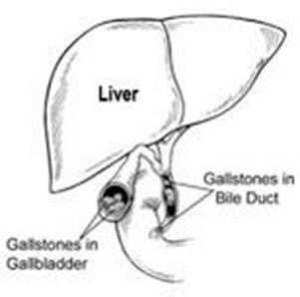

SIGNS AND SYMPTOMS
- Pain comes in waves (colicky) and can radiate to back and right shoulder.

- Guarding in right upper quadrant (RUQ)
- Central abdominal pain moving to RUQ.
- Vomiting.
- No fever, no jaundice.

DIAGNOSIS

Clinical

Ultrasound of gallbladder to reveal stones (if available).

Treatment
- Buscopan IM or IV 20mg QDS (max 100mg/d)
- Strong Analgesia e.g. tramadol PO 50-100mg, not more often than 4 hours (max 400mg/d)
- If the pain persists after two injections of buscopan and tramadol: consult a doctor.
- Worm treatment

PREVENTION

Regular deworming (e.g. of pregnant women)

Intake of a healthy, low fat diet.

Weight loss

ACUTE CHOLECYSTITIS

DEFINITION

Acute cholecystitis is a bacterial infection of the gall bladder mostly due to obstruction of the bile ducts. It may follow an attack of biliary colic. Cholecystitis can also be due to malnutrition or typhoid fever.

SIGNS AND SYMPTOMS

- Pain, tenderness and guarding in right upper quadrant (RUQ)  - Vomiting | - Fever, rigors  - Jaundice (if bile duct obstruction)

DIAGNOSIS

Clinical; specific sign is pain when the patient breathes in deeply when the RUQ is palpated, and no pain if this procedure is performed on the LUQ (Murphy’s Sign).

Ultrasound of the gallbladder to reveal stones, if available.

Complications

Empyema (gallbladder fills with pus), Peritonitis.

Treatment
- Bed rest
- IV fluids, no food or drink
- Buscopan IM or IV 20mg QDS (max 100mg/d)
- Strong Analgesia e.g. tramadol PO 50-100mg, not more often than 4 hours (max 400mg/d)
- Ceftriaxone IV 1g OD and metronidazole PO 500mg TID

- When fever settles switch to oral ciprofloxacin 500mg BID and metronidazole 500mg TID (total 10 days of antibiotics)

- Once the acute infection is over consider referral for surgical removal of gallbladder. Without surgery, recurrence is 25%.

PREVENTION

- Surgical removal of the gallbladder will prevent further attacks of cholecystitis.

- Intake of a healthy, low fat diet.

- Weight loss

ACUTE PANCREATITIS

DEFINITION

Acute pancreatitis is inflammation of the pancreas which can become chronic. Patients can become very unwell, very quickly.

CAUSES

- Alcohol

- Gallstones

- Also less commonly
- Medications e.g. steroids, HIV drugs, metformin
- Trauma
- Infections e.g. Mumps
- Diabetes

SIGNS AND SYMPTOMS
- Severe epigastric pain radiating to back
- Vomiting
- Jaundice
- If chronic pancreatitis: weight loss, fatty stool, diarrhoea

**Note: Jaundice without abdominal pain is often a sign of pancreatic/gallbladder cancer, examine for a mass**

DIAGNOSIS

Clinical: typical history and epigastric tenderness on examination. No signs of peritonitis/bowel obstruction.

If possible consider checking amylase (if pancreatitis will be 3 or more times the normal range).

Ultrasound may show inflamed pancreas (very difficult to see), but may also show cause e.g. gallstones, alcoholic fatty liver disease.

Complications

Chronic pancreatitis, abscess/necrosis of pancreas, pseudocysts, pleural effusion.

Treatment
- Bed rest
- No food or drink until the inflammation has resolved.
- Intravenous fluids – NSS, D5W, careful monitoring of fluid input/output is very important.
- Buscopan IM or IV 20mg QDS (max 100mg/d)
- Strong Analgesia e.g. tramadol PO 50-100mg, not more often than 4 hours (max 400mg/d).
- No surgery is needed.

PREVENTION

Gallbladder removal after cholecystitis, decrease alcohol intake.

LIVER ABSCESS

DEFINITION

One or more collections of pus within the liver. There are two types of liver abscess:

1. Amoebic Three times more common than bacterial.

The patient may report a recent episode of dysentery.

Treat with metronidazole +/- drainage.

2. Bacterial

Mostly from bacteria ascending the bile ducts.

The patient is often more unwell/septic.

Treat with broad spectrum antibiotics +/- drainage.

SIGNS AND SYMPTOMS
- Fever, chills, no appetite, nausea.
- Painful and enlarged liver (hepatomegaly) on palpation or percussion (in 50% of cases).
- Sometimes chest pain with a right-sided pleural effusion.
- Usually no jaundice, no splenomegaly, no ascites (if present think of other diagnoses).

DIAGNOSIS

Clinical

Ultrasound is very helpful to diagnose liver abscess.

Stool test to establish the cause.

Treatment

If the patient is stable (not too unwell/ not septic):

Start metronidazole PO x 5-10 days:

Adults: 750mg TID

Child 15mg/kg TID

If patient not improving after 3-5 days, follow unwell/septic protocol.

**Note: Metronidazole doses for amoeba are higher than usual. Follow the recommended dose given here**

If the patient is unwell/septic:

Start IV ampicillin, gentamicin and PO metronidazole (dose as for stable patient).

Continue for 10-14 days.

**Depending on their size (>6 cm), and response to antibiotic treatment

liver abscesses need to be drained surgically**

PREVENTION

Adequate and early treatment of (amoebic) dysentery could prevent liver abscess.

INTESTINAL WORMS

Intestinal worms are very common (ascaris / hookworm/ trichuris / taenia). The patient is infected by eating with dirty hands, walking without shoes or eating uncooked meat or vegetables.

Worms should be treated to

- Prevent anaemia and malnutrition.

- Prevent the following complications:

  - Intestinal obstruction/obstructive jaundice
  - Cysticercosis (Taenia solium) – lesions in brain and skin

When a patient needs steroid treatment (e.g. prednisolone) for another disease, ALWAYS deworm as the steroids decrease the immune system so the worm infections get worse

SOIL-TRANSMITTED HELMINTHS

DEFINITION

Examples of soil-transmitted helminths are ascaris, hookworm and trichuris. These worms spend part of their lifecycle outside the human body, typically in soil. Infection is direct: eggs are transmitted from anus to mouth by eating or cooking with dirty hands (ascaris, trichuris), or through penetration of the skin by walking with bare feet (hookworm, strongyloides). The worms live in the intestines of the infected person, but can migrate through the body. Children infected with worms can suffer from impaired growth and intellectual development.

SIGNS AND SYMPTOMS
- Worms can be seen in the stool or vomit
- Abdominal pain
- Epigastric pain is very common, especially with hookworm infection
- Enlarged, swollen abdomen
- Itching anus
- Malnutrition
- Chronic anaemia

Complications
- ascaris pneumonitis; intestinal obstruction, jaundice
- Rash from migrating worm: cutaneous larva migrans (hookworm), larva currens (strongyloides)

DIAGNOSIS

Stool microscopy test for worms and/or eggs.

CBC shows eosinophilia.

Treatment

(Note: for pregnant women NOT in first trimester)
Mebendazole |  | Albendazole (If strongyloides give 3 days)
Child > 1yr/Adult: 100mg BID x 3 days  6m-1yr OR <10kg: 50mg BID x 3 days | OR | Child >2yrs/Adult: 400mg STAT  Child 1-2yrs: 200mg STAT
Note: If suspect worms but do not have a stool sample result then use albendazole instead of mebendazole as it kills more types of worms.

Treat any associated anaemia (especially hookworm)

Mass deworming projects are recommended for all schoolchildren and pregnant women in the second and third trimester of pregnancy in areas where worms are endemic
Prevention

Advise people to use latrines, wash hands after passing stools and before eating/cooking, wear shoes.

TAENIA (TAPE WORM)

DEFINITION

This worm is long, flat, made up of many short segments and can be up to 10 meters long. Patients get infected by eating undercooked meat. The eggs of these parasites leave the human body in the stools and can infect animals. You can get infected by eating undercooked meat (e.g. cattle, pigs).

SIGNS AND SYMPTOMS
- Patient sees worm pieces in stools or vomit.
- Abdominal discomfort, epigastric pain, nausea.
- Patient eats a lot, but loses weight.

- In one form of Taenia (T. solium – you get from eating uncooked pork), nodules can be found in the skin or muscles. In neuro cysticercosis, cysts in the brain cause seizures and epilepsy.

DIAGNOSIS

Stool microscopy test.

CBC shows eosinophilia.
Treatment

Praziquantel Child > 2yrs/Adult: 20mg/kg STAT

Note: tablets need to be chewed before swallowing.

Prevention

Advise people to:
- Avoid eating raw or undercooked pork and other meats.
- Wash hands with soap and water after using the toilet and before handling food, use latrines.
- Meat should be inspected for cysts: do not eat pork if it is likely to be infected with tapeworm.

GENITO-URINARY SYSTEM

URINARY TRACT INFECTIONS (UTI)

DEFINITION
- Urinary Tract Infection (UTI): symptoms and bacteria in the urine from an infection somewhere between the kidneys and the bladder.
- Acute uncomplicated UTI: Infections that occur in otherwise healthy, non-pregnant, pre-menopausal women with normal urinary tract anatomy. Some clinicians may also include postmenopausal women and men without urologic abnormalities (e.g. prostatic enlargement)
- Acute complicated UTI: occur in those with risk factors that increase the risk of failing therapy. These risk factors include: pregnancy, urinary tract obstruction, functional or anatomic abnormality of the urinary tract, renal failure, DM, immunosuppression, hospital-acquired infection, renal transplant, and immunosuppression.
- Acute complicated pyelonephritis: upper tract infection that is complicated by an abscess, nephrolithiasis, papillary necrosis, or emphysematous pyelonephritis
- Catheter-associated urinary tract infection (CAUTI): infections that occur in patients with indwelling bladder catheters or within 2 days of catheter removal
- Lower UTI (cystitis): infection in the bladder
- Upper UTI (pyelonephritis): infection in the kidney
- Prostatitis: infection of the prostate

RISK FACTORS
- Female
- Sexual intercourse, exposure to spermicide in female
- Pregnancy
- Menopause
- Immunosuppression: DM
- Urinary tract obstruction
- Obstruction
- Stones
- Catheter
- Malformation

ORGANISM
E. coli is the main organism (75–95% in the community but >41% in hospital). Occasionally other enterobacteriaceae such as Proteus mirabilis and Klebsiella pneumonia, and other bacteria such as Staphylococcus saprophyticus.

SYMPTOMS
- Acute pyelonephritis: High fever, rigors, vomiting, loin pain and tenderness, oliguria (if acute kidney injury).
- Cystitis: Frequency, dysuria, urgency, haematuria, supra pubic pain.
- Prostatitis: Flu-like symptoms, low backache, few urinary symptoms, swollen or tender prostate on PR.
SIGNS
Fever, abdominal or loin tenderness, foul-smelling urine. Occasionally distended bladder, enlarged prostate.

DIAGNOSIS
Neonates and infant
– Symptoms are not specific: fever, irritability, and vomiting, poor oral intake. Palpation of the lower abdomen may show abdominal tenderness. The absence of fever does not rule out the diagnosis. On the other hand, fever –with no obvious cause– may be the only manifestation.
– Neonates may present with fever or hypothermia, altered general condition, altered conscious state, pale/grey colour, and shock.
In practice, a urinary tract infection should be suspected in children with unexplained fever or septic syndrome with no obvious focus of infection.

Older children and adults
Signs of cystitis (burning on urination and pollakiuria, etc.)
AND
Fever > 38.5 °C and flank pain (often unilateral) or abdominal tenderness

INVESTIGATION
Urine Dipstick (Note: Not accurate in diagnosis of UTI)
- Ketones: sign of dehydration, if ketones high check dextrose – if dextrose high may be a sign of diabetic ketoacidosis (diabetic emergency see p.22)
- Glucose: sign of diabetes see p.53
- Protein: if very high may be a sign of renal failure – consider checking BUN/Creatinine
- Blood (erythrocytes): especially if WBC/nitrite negative may be a sign of renal stones or trauma
- Haemoglobin: may be a sign of haemolysis

Microscopy/culture: when a dipstick analysis is positive, it is recommended to carry out urine microscopy/culture in order to confirm the infection and identify the causative pathogen, particularly in children and pregnant women.
Urine Sediment:
- RBC casts, granular casts or waxy casts: consider renal failure, discuss with doctor –check BUN/ Creatinine
- WBC casts: suggest infection or inflammation
- Crystals e.g. phosphate, calcium: consider renal stones

TREATMENT (MSF 2018)
Age group | Antibiotic
< 1 month | Ampicillin slow IV for 10 days  < 2 kg: 50 mg BD  ≥ 2 kg: 50 mg TID  AND  Gentamicin slow IV for 5 days  < 2 kg: 3 mg/kg OD  ≥ 2 kg: 5 mg/kg OD
1 month and Over | Ceftriaxone IM or slow IV 50 mg/kg OD at least 3 days (Then change to oral Antibiotic (if improve))  FOLLOWED BY  PO Amoxicillin/clavulanic to complete 10 days  PO Amoxicillin/clavulanic acid (Calculate with Amoxil dose)  < 40 kg: 25gm/kg BD  ≥ 40 kg: Amoxilclav 875/125 mg BD
Adult | Pyelonephritis with no signs of serious illness  ciprofloxacin PO: 500 mg 2 to 3 times daily for 7 days  or  cefixime PO: 200 mg 2 times daily for 10 to 14 days
Adult | Presence of signs of serious illness (vomiting, patient seen late in disease, sepsis) or patient is in poor general  condition (e.g. malnutrition, presence of other diseases)  ceftriaxone IM: 1 g once daily for at least 3 days,  then change to oral treatment with cefixime PO: 200 mg 2 times daily to complete 10 to 14 days of treatment  (up to 21 days depending on clinical response)  + gentamicin IM: 3 to 5 mg/kg once daily for 3 days (if sepsis)  or, if not available:  ampicillin slow IV (3 minutes): 2 g every 6 hours for at least 3 days  + gentamicin IM: 3 to 5 mg/kg once daily for 3 days  then change to oral treatment with amoxicillin PO: 2 g 2 times daily to complete 10 to 14 days of treatment

PREVENTION
- Drink more water.

ACUTE PROSTATITIS
Acute infection of the prostate, most commonly due to Gram negative bacteria.

SIGNS AND SYMPTOMS
- Signs of cystitis (burning on urination and urinary frequency) with fever in men, perineal pain is common.
- Very painful rectal examination.
- Urinalysis: leucocyturia and pyuria; haematuria may be present.

DIAGNOSIS
- Rectal examination.
- Examine urine: cloudy or bloody urine.
- Urine dipstick and urine sediment positive

TREATMENT
Difficult to treat, the infection may become chronic.
- Increase fluid intake: 3-4 L/day
- Treat Fever
- Treat Pain
- Prolonged Antibiotic: Ciprofloxacin PO: 500 mg BD for 28 days

URINARY STONES
The formation of stones in the urinary system (in bladder or in kidney), can cause partial or complete obstruction.
Stones formed in the kidney can travel down and block the ureters or urethra. Stones in the kidney cause kidney pain.
Stones in the ureter cause renal colic

SIGNS AND SYMPTOMS
- Severe acute lumbar or pelvic pain; intermittent (renal colic: patient cannot lie still and has pain that spreads from flank to pubic area) or constant.
- Blood in the urine (haematuria).
- The patient passes stones in the urine.
- If also has infection may have fever, chills, dysuria etc.

DIAGNOSIS
Urine dipstick: Often positive for blood. If positive WBC/nitrite there could also be an infection.
Urine sediment: Often positive for RBC. If positive WBC/bacteria there could also be an infection.
Ultrasound kidney or bladder to look for stones and any abnormal anatomy which would make stones more likely.
Bladder stones are more common in children and if very big or cannot pass, should refer for surgical removal.

TREATMENT
- Admit to IPD.
- Drink 3-4 litres/day for adults. If unable to drink, give IV fluids.
- If fever and chills (secondary infection) treat as for pyelonephritis.
- Treat the pain
- Buscopan (hyoscine butylbromide) IM/IV depending on severity
Child 6-12 yrs: 5-10mg TID (max 30mg/d)
Child >12 yrs or Adult: 20mg QDS (max 100mg/d)
Repeat the same dose after 30 minutes if still pain
Do not use for pregnant women
Consider referral:
If pain is not relieved with maximal analgesia.
If there are signs of urethral obstruction (e.g. suprapubic pain and no urine output)
If there is chronic obstruction to prevent kidney damage
PREVENTION
Drink plenty of fluids, as dehydration is a risk factor. Avoid food that could cause stones (peppers, cashew nuts, cocoa, grapefruit/orange juice, black tea, Cola).

ACUTE KIDNEY INJURY (AKI)
The term acute renal failure (ARF) has now been changed to acute kidney injury (AKI). This allows us to consider AKI as a spectrum of damage from a mild deterioration in function to severe injury requiring renal replacement therapy (RRT), as even small rises in creatinine increase the risk of mortality.
It is defined as a rapid reduction in kidney function over hours to days, as measured by serum urea and creatinine, and leading to a failure to maintain fluid, electrolyte and acid–base homeostasis.
CRITERIA FOR DIAGNOSING AKI:
- Rise in creatinine >26μmol/L in 48hrs
- Rise in creatinine >1.5 ≈ baseline (best figure in last 3/12)
- Urine output <0.5mL/kg/h for >6 consecutive hours

RISK FACTORS
- Age >75
- Chronic kidney disease
- Cardiac failure
- Peripheral vascular disease
- Chronic liver disease
- Diabetes
- Drugs (esp. newly started)
- Sepsis
- Poor fluid intake/increased losses
- History of urinary symptoms

CAUSES
- Pre-renal (problem before the kidney)
  - Dehydration e.g. from diarrhoea, not drinking enough when unwell (most common cause)
  - Problem with blood vessel supply to kidney
- Renal (problem in the kidney)
  - Drugs causing damage to the kidneys e.g. NSAIDs
  - Acute kidney diseases
- Post-renal (problem after the kidney causing a blockage to the flow of urine)
  - Kidney stones e.g. blocking the ureter
  - Tumours e.g. bladder/urethra
  - Large prostate

DIAGNOSIS
- Urine output
- Ultrasound
  - to rule out any cause of obstruction (e.g. renal stone) or complications e.g. hydronephrosis (swelling of the kidney)
- BUN and creatinine
  - BUN: 5-23mg/dL
  - Creatinine: Males: 0.67-1.17mg/dL; Females: 0.61-0.95 mg/dL (higher in males as higher creatinine with more muscle mass)
Creatinine Clearance

You can use the following equation to help you calculate the estimated creatinine clearance. This is another way that tells you how good the kidneys are working. The lower the creatinine clearance the worse the kidneys are working. This is useful to know when prescribing drugs in renal failure e.g. do not use gentamicin if Creatinine Clearance <20ml/minute or reduce the dose of ampicillin if Creatinine Clearance <10ml/minute.

(140-Age) X weight (kg) X (0.85 if female)

72 X Serum Creatinine

TREATMENT
- If likely due to dehydration then give NSS fluid bolus and assess for response by monitoring the urine output.
- Carefully monitor fluid input and output. Consider inserting a catheter.
- Treat the underlying condition.
- Stop any drugs that may have caused the kidney failure e.g. NSAIDs.
- Do not give any drugs that are contraindicated in renal failure.
- Change doses of drugs according to the creatinine clearance.

ACUTE GLOMERULONEPHRITIS
Acute Glomerulonephritis (AGN) is an inflammation of the filter of the kidneys. There are many causes of this syndrome. One of the common causes that can be treated is Post-Streptococcal Glomerulonephritis. This disease usually follows a skin infection or throat infection (e.g. tonsillitis). It can sometimes follow other infections like pneumonia, typhoid, leptospirosis, malaria, hepatitis C, or measles. It is more common in children over the age of 3 years.
SIGNS AND SYMPTOMS
- 50% of AGN are very mild and the patients do not seek medical care
- In other cases, patient can have:
- Smokey, rusty brown color urine.
- Swelling from fluid retention (edema) especially on the face, but it can be generalized in severe cases.
- Low urine output (oliguria)
- Hypertension: usually mild but it can be severe in 5-10% of cases
- If edema is generalized, there may be sign of pulmonary edema: difficulty in breathing crackles at lung bases

INVESTIGATION
- Urine dipstick: protein (proteinuria), blood (haematuria).
- Urine sediment: Red and white blood cells, hyaline, granular and red blood cell casts.
- If available, check ASO (anti-streptolysin O) titer. If increased, the diagnosis is more likely Post Streptococcal Glomerulonephritis.

TREATMENT
Summary of treatment
Antibiotics: Antibiotics (eg, penicillin) are used to control local symptoms and to prevent spread of infection to close contacts. Antimicrobial therapy does not appear to prevent the development of GN, except if given within the first 36 hours. Antibiotic treatment of close contacts of the index case may help prevent development of PSGN.
Other agents: Loop diuretics may be required in patients who are edematous and hypertensive, in order to remove excess fluid and to correct hypertension.
Vasodilator drugs (eg, nitroprusside, nifedipine, hydralazine, diazoxide) may be used if severe hypertension or encephalopathy is present.
Glucocorticoids and cytotoxic agents are of no value, except in severe cases of PSGN.
- Admit to IPD
- Rest
- Restrict salt
- Restrict fluid intake between 500 ml and 1L/day in adults. (50ml/kg/day) in children
- In case of severe edema
  - Child: furosemide 1-2 mg/kg/day
  - Adult: Furosemide 20-40 mg PO OD
- Treat the complications: hypertension, acute pulmonary edema
- Antibiotics are recommended if you suspected post streptococcal glomerulonephritis
- Amoxicillin or Cloxacillin for 7 days(Or)
- benzathine penicillin stat dose (Or)
- erythromycin if allergic to penicillin
PREVENTION
Effective treatment of tonsillitis or impetigo (see p.200 and p.223). Treatment within 10 days of onset can prevent AGN. Prevent other infections that can cause glomerulonephritis. Control blood sugar carefully in diabetes mellitus, and control blood pressure in hypertension.

NEPHROTIC SYNDROME
In nephrotic syndrome, large amounts of protein are found in the urine (proteinuria) and blood levels of protein decrease (hypoalbuminaemia). This may be due to kidney disease (primary glomerular disease) or can be a complication of other diseases like diabetes mellitus or infection (secondary glomerular disease). The exact cause can only be found by carrying out a renal biopsy. It is most common in children 2-12 years old. In children, the most common cause is Minimal Change Disease and is usually responsive to steroids.

SIGNS AND SYMPTOMS
- Soft, pitting and painless oedema
- Periorbital or facial oedema
- Oedema worsen, may localize to the back or genitals, or generalized and pleural effusions
- Reduced urine output
- Proteinuria
- Low albumin level in the blood
- May have high BP

INVESTIGATION
Urine
- Measure protein with urinary dipstick on three separate voided urine samples (first voided urine if possible). In NS, proteinuria is equal or greater than +++ or equal or greater than 300 mg/dl or 30 g/litre. NS is excluded if heavy proteinuria is not consistently present.
- In case of macroscopic haematuria, or microscopic haematuria ≥ +, consider glomerulonephritis.

Blood tests (if available)
- Serum albumin concentration less than 30 g/litre and hyperlipidaemia.
- Blood urea nitrogen (BUN) and creatinine most often in the normal range.
- Perform all necessary laboratory tests to exclude secondary NS.

TREATMENT (MSF 2018)
- Hospitalize the child for initial therapy.
- Corticosteroids (prednisolone or prednisone) are indicated in primary NS.
- Before starting corticosteroid treatment:
  - Treat any concomitant acute infections such as pneumonia, peritonitis, sepsis, pharyngitis, or cellulitis.
  - Exclude active tuberculosis and/or start Anti-TB treatment for TB +ve.
- Corticosteroid treatment
See algorithm below. Total length of initial treatment is 2 to 4 months.
Table 17 Steoid treatment in Nephrotic Syndrome
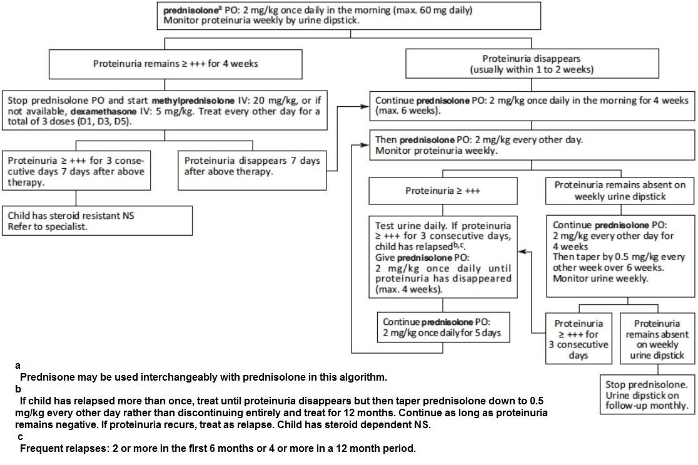

- Nutrition, fluid intake, nursing and follow-up
  - No salt-added diet.
  - Do not restrict fluids (risk of thrombosis due to hypercoagulability). If oedema is very severe, fluids may initially be restricted (e.g. 75% of usual intake) while monitoring urine output.
  - Encourage child to walk and play to prevent thromboembolism.
  - Discharge child when stable, follow-up at least monthly, more frequently if indicated, weight and urine dipstick at each visit.
  - Instruct the parent to continue no salt-added diet and to seek medical advice in case of fever, abdominal pain, respiratory distress or signs of thromboembolism.

- Management of infections
  - Treat infections as soon as they appear but do not routinely give prophylactic antibiotics.

- Immunization
  - Children under 5 years: check that the child has received all EPI vaccines including Haemophilus influenzae type B, conjugated pneumococcal vaccine and (if in an endemic area) meningococcal A conjugate vaccine. If not, administer catch-up vaccines.
  - Children over 5 years: check that the child has received tetanus, measles, pneumococcal conjugate and (if in an endemic area) meningococcal A conjugate vaccine. If not, administer catch-up vaccines.

MANAGEMENT OF COMPLICATIONS
- Respiratory distress due to severe oedema (rare)
This is the only situation in which diuretics should be used and only if there are no signs of intravascular volume depletion or after hypovolaemia has been corrected: furosemide PO: 0.5 mg/kg 2 times daily If not effective, discontinue furosemide. If creatinine is normal, administer spironolactone PO: 1 mg/kg 2 times daily. The dose can be increased to 9 mg/kg daily in resistant cases of ascites. While on diuretics, monitor for dehydration, thromboembolism and hypokalaemia.

- Steroid-resistant Nephrotic Syndrome
In case of steroid-resistant NS, when referral is impossible and as a last resort, the following palliative measure may reduce proteinuria and delay renal failure: enalapril PO: 0.1 to 0.3 mg/kg 2 times daily (start with the lowest dose and increase gradually if necessary until reduction of proteinuria). If available, monitor for hyperkalaemia. This is a palliative measure and the prognosis for steroid-resistant NS is poor in the absence of specialized treatment.

GENITAL INFECTIONS

URETHRAL DISCHARGE
Urethral discharge is seen almost exclusively in men. The principal causative organisms are Neisseria gonorrhoeae (gonorrhoea) and Chlamydia trachomatis (chlamydia).
Abnormal discharge should be confirmed by performing a clinical examination.
. In males, the urethra should be milked gently if no discharge is visible. Furthermore, specifically check for urethral discharge in patients complaining of painful or difficult urination (dysuria).

Management
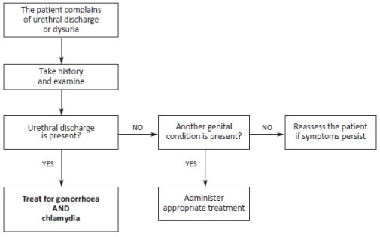

Laboratory
– C. trachomatis cannot easily be identified in a field laboratory. In the absence of validated rapid diagnostic tests, the treatment is empiric.
– In men, a methylene blue or Gram stained smear from a urethral swab may be used to detect gonococci (Gram negative intracellular diplococci).
Treatment of the patient
– In women: same treatment as cervicitis.
– In men:
  - If microscopy of a urethral smear has been performed: in the absence of gonococci, treat for chlamydia alone; in the presence of gonococci, treat for chlamydia AND gonorrhoea.
  - When no laboratory is available, treat for chlamydia AND gonorrhoea as below:

Treatment for chlamydia
Azithromycin PO: 1 g single dose
Or
Doxycycline PO: 100 mg 2 times daily for 7 days
AND
Treatment for gonorrhoea
Ceftriaxone IM: 250 mg single dose
Or,
If ceftriaxone is not available,
Cefixime PO: 400 mg single dose
Or
Spectinomycin IM: 2 g single dose

If urethral discharge persists or reappears after 7 days: – Verify that the patient has received an effective treatment (i.e. one of the combinations above).
  - Gonococcal resistance is a possibility if another treatment (e.g. co-trimoxazole or kanamycin) has been administered: re-treat for gonorrhoea as above (chlamydia is rarely resistant).
  - If an effective antibiotic therapy has been given, consider trichomoniasis (tinidazole or metronidazole PO, 2 g single dose); also consider re-infection.

Treatment of the partner
The sexual partner receives the same treatment as the patient, whether or not symptoms are present.

ABNORMAL VAGINAL DISCHARGE
Abnormal vaginal discharge is defined as discharge that differs from usual with respect to colour/odour/ consistency (e.g. discoloured or purulent or malodorous).
Abnormal discharge is often associated with vulvar pruritus or pain with intercourse (dyspareunia), or painful or difficult urination (dysuria) or lower abdominal pain. Routinely check for abnormal vaginal discharge in women presenting with these symptoms.
Abnormal vaginal discharge may be a sign of infection of the vagina (vaginitis) and/or the cervix (cervicitis) or upper genital tract infection.
Abnormal discharge must be clinically confirmed: inspection of the vulva, speculum exam checking for cervical/ vaginal inflammation or discharge.
Abdominal and bimanual pelvic examinations should be performed routinely in all women presenting with vaginal discharge to rule out upper genital tract infection (lower abdominal pain and cervical motion tenderness).
The principal causative organisms are:
  - In vaginitis: Gardnerella vaginalis and other bacteria (bacterial vaginosis), Trichomonas vaginalis (trichomoniasis) and Candida albicans (candidiasis).
  - In cervicitis: Neisseria gonorrhoeae (gonorrhoea) and Chlamydia trachomatis (chlamydia).
  - In upper genital tract infections

Management
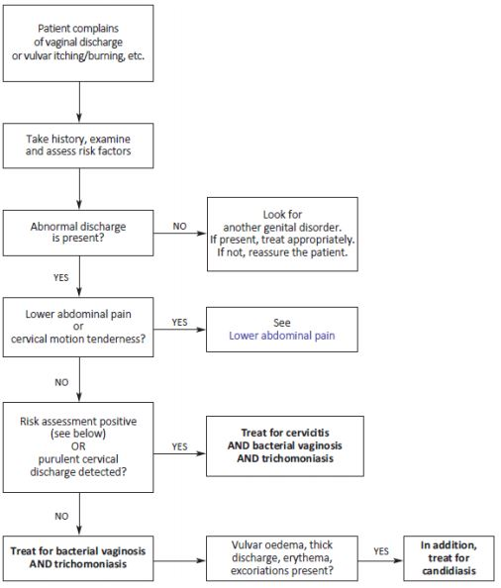

Laboratory
Tests usually available in the field can only identify causes of vaginitis, and thus are of limited usefulness. Microscopic examination of a fresh wet smear may show mobile T. vaginalis, yeast cells and hyphae in candidiasis, and “clue cells” in bacterial vaginosis. – Identification of N. gonorrhoeae by Gram stained smear is not sensitive in women and is not recommended.

Treatment
Cervicitis Treat for both chlamydia AND gonorrhoea.
NON-PREGNANT WOMEN
Azithromycin PO: 1 g single dose
Or
Doxycycline PO: 100 mg 2 times daily for 7 days
AND
Ceftriaxone IM: 250 mg single dose
Or, if not available,
Cefixime PO: 400 mg single dose
Or
Spectinomycin IM: 2 g single dose

PREGNANT WOMEN
Azithromycin PO: 1 g single dose
Or
Erythromycin PO: 1 g 2 times daily or 500 mg 4 times daily for 7 days
AND
Ceftriaxone IM: 250 mg single dose
Or, if not available,
Cefixime PO: 400 mg single dose

Bacterial vaginosis and trichomoniasis

Tinidazole PO: 2 g single dose
Or
Metronidazole PO: 2 g single dose

In the case of treatment failure:
Tinidazole PO: 500 mg 2 times daily for 5 days
Or
Metronidazole PO: 400 to 500 mg 2 times daily for 7 days

Vulvovaginal candidiasis

Clotrimazole (500 mg vaginal tab): 1 tablet inserted deep into the vagina at bedtime, single dose
Or, if not available,
Clotrimazole (100 mg vaginal tab): one tablet inserted deep into the vagina at bedtime for 6 days
Or
Nystatin (100,000 IU vaginal tab): one tablet inserted deep into the vagina at bedtime for 14 days
If the patient has extensive vulvar involvement, miconazole 2% cream (one application to the vulva 2 times daily for 7 days) may be used in combination with the intravaginal treatment above. Miconazole cream may complement, but does not replace, treatment with clotrimazole.

Treatment of the partner
When the patient is treated for vaginitis or cervicitis, the partner receives the same treatment as the patient, whether or not symptoms are present.
In the case of vulvovaginal candidiasis, the partner is treated only if symptomatic (itching and redness of the glans/ prepuce): miconazole 2% cream, one application 2 times daily for 7 days.

GENITAL ULCERS
Genital ulcers, defined as single or multiple vesicular, ulcerative or erosive lesions of the genital tract, with or without inguinal lymphadenopathy, should lead to consideration of sexually transmitted infection. The principal causative organisms are Treponema pallidum (syphilis), Haemophilus ducreyi (chancroid) and Herpes simplex (genital herpes). Chlamydia trachomatis (lymphogranuloma venereum) and Calymmatobacterium granulomatis (donovanosis) are less frequent.

Management
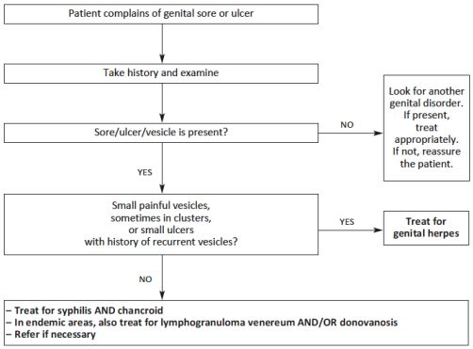

Laboratory
Laboratory testing available in the field is of little value: e.g., in syphilis, a negative RPR or VDRL result does not exclude primary syphilis in early stage, and a positive test may reflect previous infection in a successfully treated patient.

Treatment

Genital herpes
– Local treatment: clean the area with soap and water.
– Antiviral treatment: aciclovir PO In patients with a first episode, treatment may reduce the duration of symptom when given within 5 days after the onset of symptoms: 400 mg 3 times daily for 7 days.
In patients with recurrence, give the same dose for 5 days, but treatment is only effective if initiated during the prodromal phase or within 24 hours after the onset of symptoms.

Syphilis
benzathine benzylpenicillin IM: 2.4 MUI per injection (half the dose in each buttock). Administer a single dose for early syphilis (less than 2 years); one injection per week for 3 weeks for late syphilis (more than 2 years) or if the duration of infection is unknown.
Or, for penicillin-allergic patients:
Azithromycin PO: 2 g single dose
Or
Erythromycin PO: 1 g 2 times daily or 500 mg 4 times daily for 14 days
Or
Doxycycline PO: 100 mg 2 times daily for 14 days

Chancroid

Azithromycin PO: 1 g single dose
Or
Ceftriaxone IM: 250 mg single dose
Or
Ciprofloxacin PO: 500 mg 2 times daily for 3 days
Or
Erythromycin PO: 1 g 2 times daily or 500 mg 4 times daily for 7 days
Fluctuant lymph nodes may be aspirated through healthy skin as required. Do not incise and drain lymph nodes.

Lymphogranuloma venereum

Erythromycin PO: 1 g 2 times daily or 500 mg 4 times daily for 14 days
Or
Doxycycline PO: 100 mg 2 times daily for 14 days 2
Fluctuant lymph nodes may be aspirated through healthy skin as required. Do not incise and drain lymph nodes.

Donovanosis
Treatment is given until the complete disappearance of the lesions (usually, several weeks; otherwise risk of recurrence):
Azithromycin PO: 1 g on D1 then 500 mg once daily
Or
Erythromycin PO: 1 g 2 times daily or 500 mg 4 times daily
Or
Doxycycline PO: 100 mg 2 times daily
In HIV infected patients, add gentamicin IM: 6 mg/kg once daily.

Treatment of the partner
The sexual partner receives the same treatment as the patient, whether or not symptoms are present, except in the case of genital herpes (the partner is treated only if symptomatic).

GENITAL ULCERS AND WARTS IN WOMEN
Genital ulcer: is a lesion on the surface of the mucosa or skin in the genital area.
Genital wart: is a raised portion of skin which can be flat or elongated.
Both ulcers and warts are caused by sexually transmitted infections (STIs).

SIGNS AND SYMPTOMS
- Anal/ genital sores or ulcers
- For herpes primary infection: fever, painful vesicles on the genitals
- Swelling of inguinal lymph nodes
- Single or multiple warts in anal/genital area.

DIAGNOSIS & TREATMENT
Diagnosis and treatment depends on the type of lesion (sore, ulcer, wart):
Type of lesion | Treat for |  | First choice regime |  |  |  | Second choice regime
Genital ulcers | Syphilis |  | Benzathine penicillin IM 2.4 MIU STAT1 |  |  |  | Procaine penicillin IM 1.2 MIU OD
(open sore or lesion) |  |  | Note: If the duration of infection is |  |  |  | x 10 days OR
 |  |  | unknown, take it is as late syphilis (>2 |  |  |  | *Doxycycline PO 100mg BID
 |  |  | years) and give one injection per week |  |  |  | x 14 days
 |  |  | for 3 weeks |  |  |  | If pregnant: erythromycin
 | AND |  | PLUS |  |  |  | PLUS
 | Chancroid |  | Ciprofloxacin PO 500mg BID x 3 days |  |  |  | Ceftriaxone IM 250mg stat
 |  |  | (OR Erythromycin PO 500mg QID x 7
 |  |  | days
 |  |  | OR Azithromycin PO 1g STAT)
Genital ulcers2 | Herpes |  | Wash with soap and water
(small, |  |  | Apply gentian violet x 5 days
painful blisters) |  |  | Paracetamol 1g QID x 5 days
 |  |  | Acyclovir 200mg 5 times/day x 7 days
 |  |  | (give within 5 days of first attack, but
 |  |  | within 24hrs of symptoms if recurrent
 |  |  | attack)
Genital papule | Molluscum |  | Wash with soap and water
(separate, with | Contagiosum |  | Will disappear in about 8 weeks
dimple in centre)
Genital warts | Condyloma |  | Wash with soap and water
(in groups, | Acuminata |  | Paracetamol PO 1g QID x 3 days
like cauliflower) |  |  | External warts <3 cm:
 |  |  | Podophyllotoxin3 0.5% solution – apply
 |  |  | with cotton bud twice daily for 3
 |  |  | consecutive days/week up to 4 weeks
 |  |  | Vaginal warts:
 |  |  | Same as external wart <3cm but
 |  |  | solution must be applied by medical
 |  |  | person only
 |  |  | External warts >3 cm and cervical,
 |  |  | intraurethral, rectal or oral warts:
 |  |  | May need surgical removal or
 |  |  | cryotherapy

PREVENTION
Educate patients about sexually transmitted diseases, promote/provide condom use, promote single sexual partnerships. Treat the patient and the partner.

HAEMATOLOGY DISEASES

ANAEMIA
Anaemia is defined as a low haemoglobin (Hb) concentration, and may be due either to a low red cell mass or increased plasma volume (eg in pregnancy).
Men: Hb < 13.5 g/dL
Women: Hb < 11.5 g/dL

SIGNS AND SYMPTOMS
- fatigue, dyspnoea, faintness, palpitations, headache, tinnitus, anorexia
- Signs of hyperdynamic circulation: Tachycardia, flow murmurs, cardiac enlargement, retinal haemorrhages (rare), anaemic heart failure

CAUSES
- Acute
  - Malaria (acute destruction of RBCs)
  - Acute bleeding (GI tract, genital tract, artery damage in accident)
  - G6PD deficiency
- Chronic
  - Nutritional deficiencies (lack of ferrous and folic acid in diet)
  - Hook worms infestation
  - Repeated pregnancies and prolonged breast-feeding
  - Peptic ulcer
  - thalassemia
  - Chronic bleeding
  - Cancers
  - Chronic infections
  - Liver and kidney diseases
  - Tropical splenomegaly
  - aplastic anemia

INVESTIGATION
- Hb levels
- Rapid test or systematic thick and thin blood films in areas where malaria is endemic.
- Urinary dipstick: check for haemoglobinuria or haematuria.
- Emmel test if sickle cell disease is suspected.
- Blood cell count if available to guide diagnosis

TYPES OF ANAEMIA (Diagnosis with Complete Blood Count)
Low MCV (Microcytic Anaemia)
- Iron-Deficiency Anaemia (IDA)
- Thalassaemia
Sideroblastic Anaemia (very rare)
Normal MCV (Normocytic Anaemia)
- Acute blood loss  - Anaemia of chronic disease  - Bone marrow failure  - Renal failure |  | - Hypothyroidism  - Haemolysis  - Pregnancy
High MCV (Macrocytic Anaemia)
- B12 or folate deficiency  - Alcohol excess or liver disease  - Reticulocytosis (with haemolysis)  - Cytotoxics |  | - Myelodysplastic syndromes  - Marrow infiltration  - Hypothroidism  - Antifolate drugs (e.g. Phenytoin)
Diagnosis with Reticulocytes count

Reduced number of reticulocytes | Deficiency (iron, folic acid, vitamin B12), spinal tumour, renal failure
Increased or normal number of reticulocytes | Haemolysis, sickle cell disease, thalassaemia
Eosinophilia | Ancylostomiasis, trichuriasis, schistosomiasis, HIV infection, malignant haemopathies

Anaemic Heart Failure (symptomatic)
- Symptoms
  - Severe difficulty breathing at rest
  - Extreme weakness
  - Sometimes chest pain
- Signs
  - Severe pallor
  - Acute Pulmonary Edema sign; crep and wheezing
  - Hepatomegaly
  - Engorgement of jugular veins
  - Peripheral edema and sometimes, ascites

TREATMENT
- Treatment dose of ferrous sulphate (FS) and folic acid (FA)
  - Treatment dose
    - FS 200 mg TID, FA 5 mg OD
  - Prophylactic dose
    - FS 200 mg OD, FA 5 mg/week
- A response to oral medication usually appears in <2 weeks (Hb should raise by 1g/dl every 7-10 days). FS should be continued for 3-6 months after the Hb level has returned to normal to refill the body’s iron store. Administration of vitamin C may help the body to absorb iron.
- If Hb <6 /Hct <18, Blood transfusion.
- Anaemic heart failure is very difficult to treat successfully and, if possible, should be prevented by providing treatment before reaching this stage. Treat the pulmonary oedema.
- All patients with anaemia should be dewormed.
- Treat the cause.

THALASSAEMIA
Thalassaemia is a genetic disease caused by abnormal or decreased haemoglobin production. Haemoglobin is found in the red blood cells, and is the part of the cell that carries the oxygen needed for the tissues to work. Haemoglobin is made up of two alpha (α) and two beta (β) chains. Thalassaemia results in decreased or absent haemoglobin chains: In thalassaemia, α chains are affected and in thalassaemia the chains are affected. | 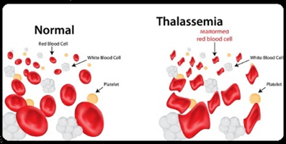
There are many variations of the disease from no chains being produced by the body to minor changes in the chains. So the disease ranges from being extremely severe to patients not even being aware they have the disease. On the Thailand-Myanmar border - /or - thalassaemia occur in approximately 10% of people.

BETA β THALASSAEMIA
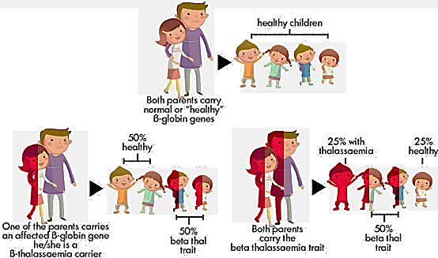

 | Beta Thalassaemia  Minor | Beta Thalassaemia Intermedia | Beta Thalassaemia  Major
Symptoms | Mild, well-tolerated anaemia, often noticed in pregnancy | Well-tolerated anaemia that gets worse with age, splenomegaly | Severe anaemia, starting in the first year of life  Child does not grow and develop well  Child contracts many infections  Abnormal bone growth, especially in the face  Enlarged liver and spleen (hepato-splenomegaly)
Diagnosis | CBC, Thalassaemia test | CBC, Thalassaemia test | CBC, film (target cells), thalassaemia test
Treatment | - Folic acid and vitamin B and C, do not overload with iron | - Folic acid and vitamin B and C, do not overload with iron | - Consider regular transfusions to keep Hb > 8, Hct > 24.  - Transfusion is the only effective treatment, but over time this causes iron levels to increase in the body which damages some organs, causing death (consider giving desferrioxamine at each blood transfusion, which can help reduce iron overload).  - Folic acid, vitamin C.  - If splenomegaly is present, discuss the possibility of having surgery to remove the spleen (splenectomy) but the  - benefit of this is only temporary

Prognosis of Beta Thalassaemia Major and blood transfusion
Without transfusion | Death usually occurs within one year
With adequate transfusion | Child growth and development are usually good, school attendance is improved Infections are reduced, overall health is improved, bone deformities improve  Symptoms of iron overload appear after about 10 years, with liver disease and cardiac toxicity  Death is usually due to cardiac iron overload
With not enough transfusion | Anaemia with reduced growth, slow development and bone deformity. Enlarged spleen (splenomegaly)  Intermittent fever  Bleeding  Death usually occurs at 20-30 years of age from cardiac iron overload

TREATMENT
- FS, FA
- Blood transfusion
- Splenectomy
- Desferrioxamine 1 – 2 g at each blood transfusion.

ALPHA THALASSAEMIA
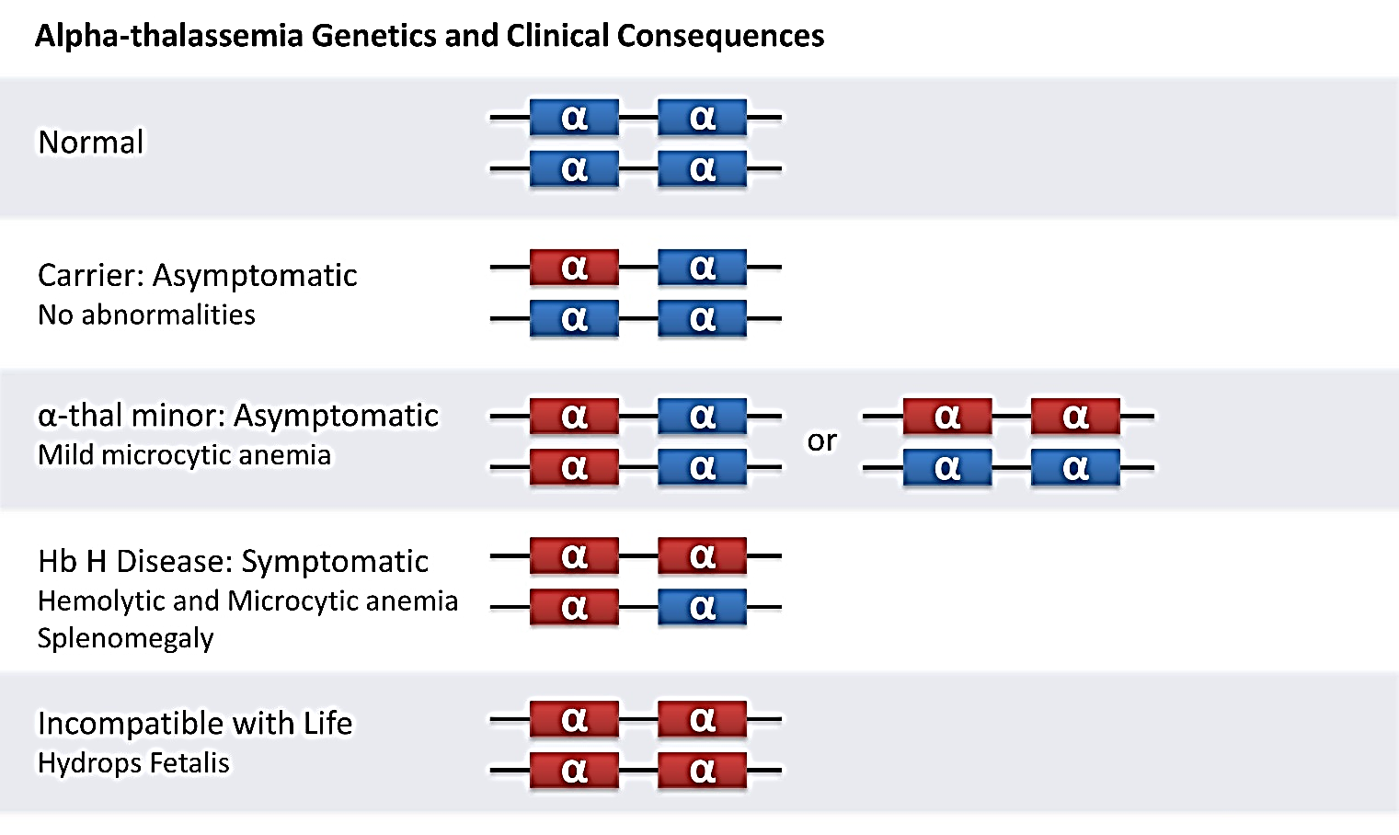

COMPLICATION
- Complications occur in varying degrees and include the following:
- Hepatosplenomegaly
- Leg ulcers
- Gallstones
- Aplastic or hypoplastic crises
- Skeletal, developmental, and metabolic changes due to ineffective erythropoiesis (these resemble the changes characteristic of beta thalassemia intermedia or beta thalassemia major)
- Prominent frontal bossing (due to bone marrow expansion)
- Delayed pneumatization of sinuses
- Marked overgrowth of the maxillae
- Ribs and long bones becoming boxlike and convex
- Premature closure of epiphyses resulting in shortened limbs
- Compression fracture of the spine (which may result in cord compression or other neurologic deficits)
- Osteopenia and fractures
Splenectomy or transfusion support is often necessary in the second or third decade of life.

G6PD Deficiency (Glucose-6- Phosphate Dehydrogenase Deficiency)
This disease is caused by a deficiency of the enzyme G6PD in the red blood cells that is important for these cells to function. It is a genetic disease which is present from birth. It is usually more severe in men, but women can also have G6PD deficiency which can be mild to severe. People with this disease usually have no symptoms, although some have chronic anaemia.

SIGNS AND SYMPTOMS
Most patients have no symptoms. Some have chronic anaemia. Acute haemolytic anaemia occurs after taking certain drugs (see below) or having an infection or acute illness:
- Jaundice, pallor, dark urine, sometimes abdominal and back pain.
- Neonatal jaundice with or without anaemia.
- Symptoms of anaemia: fatigue, difficulty breathing, tiredness, palpitations

DIAGNOSIS
- G6PD test

TREATMENT
- Stop any drug that could have caused the haemolysis
- Treat any infection
- Usually the haemolysis is self-limiting and treatment is not needed
- Blood transfusion can save the life of the patient in severe cases of anaemia
- Check the patient urinates enough, encourage the patient to drink plenty of fluids

DRUGS AND CHEMICALS THAT CAUSE SEVERE HAEMOLYSIS IN G6PD DEFICIENT PEOPLE:

- Dapsone and other sulphones
- Methylene Blue
- Niridazole
- Nitrofurantoin
- Primaquine
- Quinolones (including ciprofloxacin, norfloxacin, ofloxacin, nalidixic acid)
- Sulphonamides (including co-trimoxazole)
Note: mothballs may contain naphthalene which also causes haemolysis

DRUGS WITH POSSIBLE RISK IN G6PD SUBJECTS
- Aspirin
- Chloroquine (acceptable in acute malaria)
- Vitamin K analogue (menadiol sodium phosphate)
- Quinine (acceptable in acute malaria)

PREVENTION FROM HAEMOLYSIS
- Avoid drugs and chemical (above list)
- Please note down “G6PD Deficiency” in patient booklet to aware of any clinician consulting patients.

BLOOD TRANSFUSION

INDICATIONS
- To decide whether to transfuse, several parameters should be taken into account:
- Clinical tolerance of anaemia
- Underlying conditions (cardiovascular disease, infection, etc.)
- Rate at which anaemia develops.
- Hb levels
Table 18 Hb level defining anaemia and transfusion threshold
Patient | Hb level defining Anaemia | Transfusion threshold
Children 2-6 months | < 9.5 g/dl | Hb < 4 g/dl, even if there are no signs of decompensation  Hb ≥ 4 g/dl and < 6 g/dl if there are signs of decompensation or sickle cell disease or severe malaria or serious bacterial infection or pre-existing heart disease
Children 6 months-5 years | < 11 g/dl
Children 6-11 years | < 11.5 g/dl
Children 12-14 years | < 12 g/dl
Men | < 12 g/dl | Hb < 7 g/dl if there are signs of decompensation or sickle cell disease or severe malaria or serious bacterial infection or pre-existing heart disease
Women | < 13 g/dl
Pregnant women | < 11 g/dl (1st and 3rd trimester)  < 10.5 g/dl (2nd trimester) | < 36 weeks  Hb ≤ 5 g/dl, even if there are no signs of decompensation Hb > 5 g/dl and < 7 g/dl if there are signs of decompensation or sickle cell disease or severe malaria or serious bacterial infection or pre-existing heart disease  ≥ 36 weeks  Hb ≤ 6 g/dl, even if there are no signs of decompensation Hb > 6 g/dl and < 8 g/dl if there are signs of decompensation or sickle cell disease or severe malaria or serious bacterial infection or pre-existing heart disease

VOLUME TO BE TRANSFUSED
In the absence of hypovolaemia or shock:
Children < 20 kg: 15 ml/kg of red cell concentrate in 3 hours or 20 ml/kg of whole blood in 4 hours
Children ≥ 20 kg and adults: start with an adult unit of whole blood or red cell concentrate; do not exceed atransfusion rate of 5 ml/kg/hour
Repeat if necessary, depending on clinical condition.
Table 19 Blood group compatability
Donor / Acceptor | can give blood to: | can receive blood from:
O | O-A-B-AB  Group O is universal donor | O
A | A-AB | A-O
B | B-AB | B-O
AB | AB | A-B-O-AB  Group AB is universal acceptor

MONITORING
Monitor the patient’s condition and vital signs (heart rate, blood pressure, respiratory rate, temperature):
During the transfusion: 5 minutes after the start of transfusion, then every 15 minutes during the first hour, then every 30 minutes until the end of the transfusion.
After the transfusion: 4 to 6 hours after the end of the transfusion.
If signs of circulatory overload appear:
- Stop temporarily the transfusion.
- Sit the patient in an upright position.
- Administer oxygen.
- Administer furosemide by slow IV:
  - Children: 0.5 to 1 mg/kg
  - Adults: 20 to 40 mg
- Repeat the injection (same dose) after 2 hours if necessary.
- Once the patient has been stabilized, start the transfusion again after 30 minutes.

RATE OF TRANSFUSION
- The transfusion should usually last approximately 3 hours, with the following exceptions:
- For patients with low BP and acute bleeding (until systolic is >90mmHg): give it over 10 minutes.
- For patients at risk of cardiac failure (e.g. severely malnourished children, old people, people with heart / kidney problems, patients with chronic anaemia) give it over 4 hours and give furosemide 20mg PO half way

When to check vital signs:
- Before starting
- After 5 and 15 minutes
- Then after every hour until 1 hour post transfusion.
- Never mix blood with D5W (this can cause haemolysis) or ringer (this can cause clotting): you can mix blood with NSS.
- Never add medication to the blood.
- Do not shake the blood.

RISKS DURING BLOOD TRANSFUSION

Observe the patient carefully during the blood transfusion. Check vital signs regularly.
It is important to recognize the symptoms of reaction to blood transfusion so you can stop the transfusion and prevent serious complications.

For suspected transfusion reaction:
- Stop the transfusion and disconnect the set from the needle / cannula.
- Using a new infusion set, keep the line open with fluids unless suspect pulmonary oedema.
- Check that the patient received the correct blood / recheck the patient’s blood group.
- Reconsider indication for transfusion.

If the patient’s condition is still severe, find another donor

MOST COMMON CAUSES OF TRANSFUSION REACTION
Table 20 Common causes of transfusion reaction
Haemolysis | Fever, chills, lumbar back pain, anxiety, fast pulse, low BP, dark urine, burning sensation at IV site | Stop transfusion  If shock > Give NSS (Follow Shock guideline)
Pulmonary oedema | Old people, people with known heart / kidney problems, patients with chronic anaemia. | Put the patient in sitting position  Give Oxygen  Give Furosemide IV 40 mg (For adult)
Allergic reaction | Urticaria, big red itching lesions. | Give chlorpheniramine PO (adult 4mg).  • If no other symptoms and the skin rash goes away in ½ hour, ask the doctor if you can start the transfusion again, but observe carefully.
More Severe allergic reactions (Anaphylaxis) | Oedema, difficult breathing, wheezing, high BP, then Low BP  Oedema, difficult breathing, wheezing, high BP, then low BP, sometimes diarrhoea and vomiting. | • Give oxygen  • Give adrenaline 1:1000 IM  • Give NSS fast.  • Give hydrocortisone M/IV  • Give chlorpheniramine IV

INFECTIOUS DISEASES

DEFINITION
Table 21 Definition of infectious disease
VIRUS | A very small and simple infection particle.  They replicate (copy themselves) inside the cells of other organisms e.g. humans.  Examples: HIV, hepatitis B virus, measles.  Antibiotics DO NOT work against viruses, some anti-viral drugs exist (e.g. acyclovir against herpes virus) but these anti-viral drugs are expensive and often don’t work very well as viruses are able to change easily so that they are not killed.
BACTERIA | A complex infection particle that come in a range of sizes and shapes e.g. rods  (E.g. diphtheria), spheres also known as cocci (e.g. streptococcus pneumoniae) and spirals (e.g. leptospirosis).  Antibiotics work against bacteria but changes in the bacteria are causing resistance to drugs.
FUNGUS | Includes yeasts (e.g. candida), mould (e.g. that grows on food that has not been eaten for too long) and mushrooms.  Some antifungal drugs exist e.g. fluconazole, nystatin.
PROTOZOA | Organisms made up of one cell.  Examples: malaria, amoeba, giardia, trichomoniasis
PATHOGENIC ORGANISM | Pathogenic organisms are organisms that cause disease.
NON-PATHOGENIC ORGANISM | Some micro-organisms live in the body and are a normal part of how the body. E.g. your gut has lots of bacteria that live there normally and these are called non-pathogenic. These organisms do not cause disease.
IMMUNE SYSTEM | The process in the body that occurs to fight infection. It does this by increasing the  - Number of white blood cells (WBC).  - WBC have lots of functions including producing antibodies (see below) and toxins to fight the infection.  - In some conditions e.g. HIV, diabetes, malnutrition, cancer, the immune system does not work very well (this is known as being immunocompromised). These people are more at risk of getting infections.
ANTIGEN | Anything that causes the body to make an immune response (i.e. produce antibodies against).
ANTIBODY | The body makes these as part of the immune response to fight against a virus or known as bacteria.
IMMUNOGLOBULIN | IgM (immunoglobulin M) antibodies are produced quickly after an infection.  IgG (immunoglobulin G) antibodies are made later, and may be found in the blood for longer time.  • Sometimes it is possible to give people already made antibodies (immunoglobulins) when they have been exposed to an infection e.g. rabies immunoglobulin.  • Because these antibodies are not made in the body sometimes the body can fight against them which is why they are only used for special cases when there is a high risk of infection.
IMMUNITY | To have immunity means that the body has previously been infected or immunized so that if the body becomes infected again, the body can fight the infection without causing any symptoms/disease.
INFECTIOUS | Means that it is possible for the infection in a person to be transmitted to someone else. E.g. HIV
VACCINATION (IMMUNIZATION) | When you inject a small amount of antigen into the body that is small enough so that the body produces an immune response (i.e. produces antibodies) but not big enough to cause an infection. The antibodies mean that in the future the body can fight against the same infection without causing any symptoms and the person will not become ill.

BACTERIAL DISEASES

BACTERIAL MENINGITIS
Meningitis is an acute bacterial infection of the meninges, which may affect the brain and lead to irreversible neurological damage and auditory impairment. Bacterial meningitis is a medical emergency. The treatment is based on early parenteral administration of antibiotics that penetrates well into the cerebrospinal fluid. Empiric antibiotic therapy is administered if the pathogen cannot be identified or while waiting for laboratory results.
Table 22 Age and related main bacteria
Age | Main bacteiria
Children ≤ 7 days | Gram-negative bacilli (Klebsiella spp, E. coli, S. marscesens, Pseudomona spp, Salmonella spp)  and group B streptococcus
Children > 7 days | : S. pneumoniae accounts for 50% of all bacterial meningitis  L. monocytogenes is occasionally responsible for meningitis during this period.
• Children 3 months-5 years | S. pneumoniae, H. influenza B and N. meningitidis
• Children > 5 years and adults | S. pneumoniae and N. meningitidis

SIGNS AND SYMPTOMS
Children under 1 year | Children over 1 year and adults
- The child is irritable, appears sick with fever or hypothermia, poor feeding or vomiting.  - Other features include: seizures, apnoea, altered consciousness, bulging fontanelle (when not crying); occasionally, neck stiffness and purpuric rash. | - Fever, severe headache, photophobia, neck stiffness  - Brudzinski's sign (neck flexion in a supine patient results in involuntary flexion of the knees) and  - Kernig’s sign (attempts to extend the knee from the flexed-thigh position are met with strong passive resistance).  - Petechial or ecchymotic purpura (usually in meningococcal infections) – In severe forms: coma, seizures, focal signs, purpura fulminans

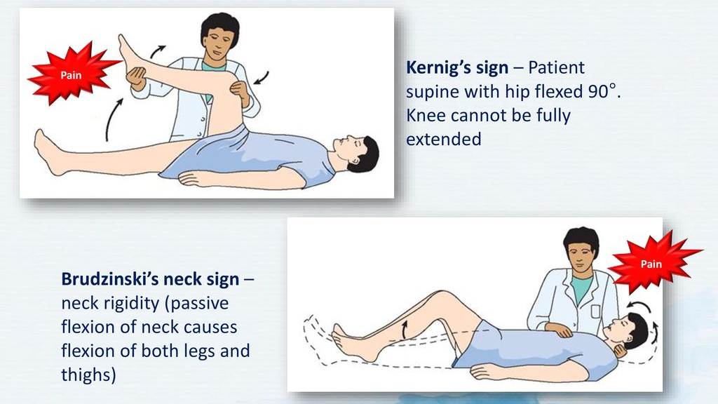
Figure 23 Kernig's sign and Brudzinski's sign

In TB meningitis the fever is not very high, and can be sporadic. Suspect TB meningitis in young patients with neurological signs (e.g. hemiplegia, paraplegia). Usually these have a gradual onset. Often the patient will how changes in their behaviour.
Cryptococcal meningitis is more common in patients who are immunocompromised (e.g. HIV/AIDS) and is also of slow onset. Temperature can be normal or only slightly elevated, and there is a severe persistent headache.

INVESTIGATION
- Lumbar puncture (LP):
  - Macroscopic examination of the cerebrospinal fluid (CSF): antibiotic therapy should be initiated immediately if the LP yields a turbid CSF.
  - Microscopic examination: Gram stain (but a negative examination does not exclude the diagnosis) and white blood cell count (WBC).

Do NOT perform a lumbar puncture if there are signs of raised intracranial pressure or risk of bleeding:
- Unequal pupil size
- Non-reactive pupils
- Very slow heart rate (<50 in adults)
- Irregular breathing
- Severe respiratory distress
- Low platelets or a bleeding disorder
- GCS <15
- Seizure
- Focal Neurological sign
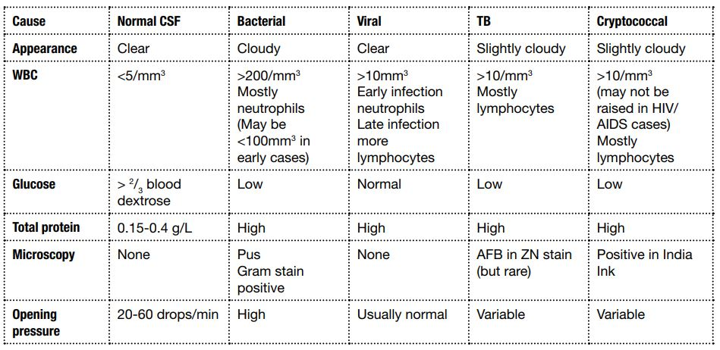
Figure 24 Reading CSF result

TREATMENT
- Admit to IPD.
- Give Antibiotics:
  - If no skin infection: ceftriaxone 2g BID
  - If associated skin infection: Adult: ceftriaxone 2g BID AND cloxacillin 8-12g per day (e.g. 3g QID)
- Dexamethasone:
  - Child >2m and Adults: IV 0.15mg/kg QID (max 10mg) for 2 days (first dose before or together with first antibiotic dose)
  - Dexamethasone improves the outcome in adults and children. (Reduces risk of hearing loss in eningitis caused by the bacteria Haemophilus influenzae or Streptococcus pneumoniae – administer early in these pathogens or when pathogen is not known except in neonates).
- Give supportive treatment: fluids and oxygen.
- Treat the fever with paracetamol.
- Treat the convulsions with diazepam.
- Give special nursing care if the patient is in a coma.

PREVENTION
Preventive vaccination can be used to protect individuals at risk (for example, people without a spleen).
Those in close contact with a patient (family/household) should be given immediate prophylaxis to prevent them from contracting the illness (ciprofloxacin PO STAT Adults: 500mg; Child: 15mg/kg).

VACCINATION
Several vaccines have been proven to be safe and effective with infrequent and mild side effects. In our region there is no routine vaccination for meningitis.

LEPTOSPIROSIS
Leptospirosis is caused by a spiral bacteria (spirochetes) called Leptospira. These bacteria live in animals (especially rats, but also dogs, cats and cattle) and are excreted in their urine. Once excreted, they can remain alive in the soil for months. Leptospira can enter the human body through damaged skin, mucous membranes and conjunctivae following contact with contaminated water (e.g. by animal urine) or through close contact with infected animals.

RISK FACTORS
- Farmers and miners
- Walking without shoes in rivers, sewage and canals
- Swimming in rivers and lakes
- Working in abattoirs (factories where animals are killed for food)

SIGNS AND SYMPTOMS
- Sudden high fever with chills and rigors.
- Conjunctival suffusion (eyes are red, no pus).
- Severe muscle pain (particularly calves) and tenderness.
- Headache.
May have other symptoms: abdominal pain, nausea and vomiting, diarrhoea, cough and pharyngitis, chest pain, arthralgia (joint pain).
This phase lasts 5-9 days and can be very mild or very severe. In many patients the disease stops here.
However, sometimes these symptoms persist or return after stopping for a few days and complications appear.

COMPLICATION
- Meningitis: with severe bitemporal and frontal headache.
- Liver and Kidney failure (Weil’s disease): high fever over 40ºC, jaundice, oliguria/ anuria, (accompanied by: haemorrhagic pneumonia, cardiac arrhythmias and circulatory collapse). In some patients you will find an enlarged liver and spleen (hepato-splenomegaly).
- Haemorrhagic pneumonia with acute respiratory distress syndrome: can happen also without liver and kidney failure. Patient coughs up blood (haemoptysis) and often chest examination is normal (no crackles).
- Uveitis (very red eye, blurred vision, eye pain, irregular pupil, photophobia, headache).
- Liver failure usually gets better, but kidney failure and respiratory distress syndrome have poor prognosis.

DIAGNOSIS
Clinical, but some investigations could be helpful:
- Dipstick: protein and blood in urine.
- Lab (if available): raised CK and bilirubin.
- Definite diagnosis by special blood test (serology), but it is not available.

TREATMENT
Should be started as early as possible, but it is now thought effective also if started late:
- Treat the fever and the pain with paracetamol
- Give IV fluids
- Antibiotics:
Mild infections
- PO doxycycline 200mg OD (OR 100mg BID) x 7 days.
- In pregnant women: PO amoxicillin 1g BID x 7 days
- In children <8yrs: PO amoxicillin 25mg/kg BID x 7 days

Severe infections
- IV ampicillin Adults: 2g TID Child: 100mg/kg/day in 3 divided doses
- Then switch to PO amoxicillin when improving e.g. 48 hours after fever stops (total 7 days of antibiotics)

PREVENTION
- Collection of rubbish to reduce rat population, education of people at risk, doxycycline (200mg weekly) prophylaxis for high-risk groups.

VACCINATION
- There is a vaccine for animals available, but this works only for a few months. There is a vaccine for humans but it is of limited benefit and is not used in our region.

SCRUB TYPHUS
Scrub Typhus is a bacterial disease caused by Orientia Tsutsugamushi, a type of rickettsia. The disease transmitted by the bite of a mite that inhabits moist grasslands and jungle. Rodents are normal carriers. Scrub typhus is common in our region. Scrub typhus is one of the most common causes of ‘Fever Don’t Know’ (Fever DK) in the tropics. Left untreated many people recover, but some will die.

SIGNS AND SYMPTOMS
- Fever
- Severe headache
- Red eyes (conjunctival injection)
- Enlarged, painful lymph nodes (adenopathy) first near the site of the bite, then generalised.
- Skin lesion at the site of the infecting mite’s bite: small, round, hard red papule becoming bigger with a dead (necrotic) centre, covered by a black hard surface (eschar). Look for it especially on the patients’ back, inguinal area and scrotum.
- After a few days of fever, a typical (maculopapular) rash appears, starting on the trunk and extending to the limbs.
- Sometimes signs and symptoms of meningitis/ encephalitis.
- Rarely atypical bronchitis, enlarged spleen, inflamed heart (myocarditis), strange behaviour (neuropsychological signs) and kidney failure.

DIAGNOSIS
The diagnosis is clinical: history and examination findings suggestive of scrub typhus and a negative malaria smear. Many times there is nothing suggestive of scrub typhus on history or examination. In the presence of a negative malaria smear and no other obvious finding on history and examination, think of scrub typhus.

TREATMENT
- Treat the fever and the pain.
- Antibiotic for 5 to 7 days or until 3 days after the fever has disappeared:
  - doxycycline PO (except in pregnant or lactating women)
    - Children over 8 years: 50 mg 2 times daily or 100 mg once daily
    - Adult: 100 mg 2 times daily or 200 mg once daily
Note: doxycycline is usually contraindicated in pregnant or breast-feeding women and
Children under 8 years
    - Azithromycin Pregnant: 500mg PO STAT
    - Child 6mths - 8yrs: 20mg/kg PO STAT

PREVENTION
- Reduction of vector populations and personal hygiene improvement (including de-lousing) are most important.
- Advice people to avoid mite-infested areas, use thick repellents and protective clothing.
- Patients should wash themselves and disinfect their clothes by washing in hot water or impregnate with 1% permethrin.
- Advise doxycycline prophylaxis (200mg weekly) for those working in high-risk areas.
- Regular preventive treatment of medical/nursing staff is recommended in endemic areas.

VACCINATION
There is no vaccine available.

TETANUS
Tetanus is an acute, often fatal, disease characterized by a prolonged contraction of muscles caused by a toxin produced by the bacterium Clostridium tetani. Infection generally occurs through wound contamination, and often involves a cut or deep puncture wound. As the infection progresses, muscle spasms in the jaw develop, hence the common name: ‘lockjaw’. This is followed by difficulty swallowing, general muscle stiffness and spasms in other parts of the body. The toxins (or spores) are widely distributed in soil and animal faeces.
Neonatal tetanus: is a form of generalized tetanus that occurs in newborn infants. It occurs in infants born to mothers who have never been immunized for tetanus. It usually occurs through infection of the unhealed umbilical stump, especially when the stump is cut with a non-sterile instrument.

SIGNS AND SYMPTOMS
Generalized tetanus is the most frequent and severe form of the infection. It presents as muscular rigidity, which progresses rapidly to involve the entire body, and muscle spasms, which are very painful. Level of consciousness is not altered.

Children and adults
- Average time from exposure to onset of symptoms is 7 days (3 to 21 days).
- Muscular rigidity begins in the jaw muscles (difficulty with then inability to open mouth [trismus] preventing the patient from speaking, eating), spreading to the face (fixed smile), neck (difficulty with swallowing), to the trunk (restriction of respiratory muscles; hyperextension of spine [opisthotonus]), to the abdomen (guarding) and to the limbs (flexion of the upper limbs and extension of the lower limbs).
- Muscle spasms, which are very painful, appear at the onset or when muscular rigidity becomes generalized. They are triggered by stimuli (noise, light, touch) or arise spontaneously. Spasms of the thoracic and laryngeal muscles may cause respiratory distress or aspiration.

Neonates
- In 90% of cases, initial symptoms appear within 3 to 14 days of birth.
- The first signs are significant irritability and difficulty sucking (rigidity of the lips, trismus) then rigidity becomes generalized, as in adults. Any neonate, who initially sucked and cried normally, presenting with irritability and difficulty sucking 3 to 28 days after birth and demonstrating rigidity and muscle spasms should be assumed to have neonatal tetanus.

TREATMENT
Hospitalization is needed and usually lasts 3 to 4 weeks. Correct management can reduce mortality even in hospitals with limited resources.
General measures
- Ensure intensive nursing care.
- The patient should be in a dark, quiet room. Blindfold neonates with a cloth bandage.
- Handle the patient carefully, while sedated and as little as possible; change position every 3 to 4 hours to avoid bedsores.
- Teach family the danger signs and instruct them to call the nurse for the slightest respiratory symptom (cough, difficulty breathing, apnoea, excessive secretions, cyanosis, etc.).
- Establish IV access for hydration, IV injections.
- Gentle suction of secretions (mouth, oropharynx).
- Insert a nasogastric tube for hydration, feeding and administration of oral medications.
- Provide hydration and nutrition in feeds divided over 24 hours. In neonates, give expressed breast milk every 3 hours (risk of hypoglycaemia).
Neutralization of toxin
Human tetanus immunoglobulin IM: Neonates, children and adults: 500 IU single dose, injected into 2 separate sites.

Inhibition of toxin production
Metronidazole IV infusion (30 minutes; 60 minutes in neonates) for 7 days
- Neonates:
  - 0 to 7 days: 15 mg/kg on D1 then, after 24 hours, 7.5 mg/kg every 12 hours
  - 8 days to < 1 month (< 2 kg): same doses
  - 8 days to < 1 month (≥ 2 kg): 15 mg/kg every 12 hours
- Children 1 month and over: 10 mg/kg every 8 hours (max. 1500 mg daily)
- Adults: 500 mg every 8 hours

Control of rigidity and spasms, and sedation of the patient
Diazepam should decrease the frequency and intensity of spams without causing respiratory depression. The dose and frequency of administration depend on the patient’s clinical response and tolerance.

There is a high risk of respiratory depression and hypotension when using diazepam, especially in children and elderly patients. Constant and close monitoring of the patient‘s respiratory rate (RR) and oxygen saturation (SpO2) is essential, with immediate availability of equipment for manual ventilation (Ambu bag, face mask) and intubation, suction (electric if possible) and Ringer lactate. A continuous IV infusion of diazepam requires the use of a dedicated vein (no other infusion/injection in this vein); avoid the antecubital fossa if possible. Do not stop treatment abruptly; an abrupt stop can cause spasms.

Treatment of the point of entry
– Search systematically the entry wound. Provide local treatment under sedation: cleansing and for deep wounds, irrigation and debridement.
– Cord infection: do not excise or debride; treat bacterial omphalitis and sepsis, add to metronidazole IV: cloxacillin IV + cefotaxime IV or cloxacillin IV + gentamicin IV (for doses, see Bacterial meningitis).

Tetanus vaccination
As tetanus does not confer immunity, immunization against tetanus must be administered once the patient has recovered.
In case of neonatal tetanus, initiate the immunization of the mother.

PREVENTION
Of critical importance, given the difficulty of treating tetanus once established.
Post-exposure prophylaxis
In all cases:
- Cleansing and disinfection of the wound, and removal of any foreign body.
- Antibiotics are not prescribed routinely for prophylaxis.
- The decision to administer an antibiotic (metronidazole or penicillin) is made on a case-by-case basis, according to the patient’s clinical status.

TYPHOID FEVER
Typhoid fever is a bacterial infection caused by Salmonella typhi. It is transmitted by contaminated food, water or dirty hands. The time between exposure with the bacteria and symptoms is 10 - 15 days.

SIGNS AND SYMPTOMS
Typhoid is suspected in a patient with:
- Prolonged fever >38ºC for more than 7 days.
- Negative malaria smear, no other identified cause of fever and at least one of the following:
- Abdominal pain
- Diarrhoea or constipation
- Relative low pulse (bradycardia).
- Symptoms are non-specific in the first week, so the diagnosis can be difficult.
- Other symptoms that can be present: tiredness, headache, dry cough, patient does not want to eat (anorexia).
In the 2nd week:  - Rash (pink spots on the abdomen and the chest – called Rose coloured spots).  - Relative bradycardia (the pulse does not increase with high fever).  - Enlarged liver and spleen (hepato-splenomegaly). | In the 3rd-4th week:  Complications can happen even when the patient seems to be cured:  • Intestinal perforation/bleeding or peritonitis.  • Septic shock.  • Pneumonia.  • Confusion with signs of meningitis.

DIAGNOSIS
Typhoid is confirmed by a positive blood (or bone marrow) culture for Salmonella typhi. Unfortunately it is not a test available at all clinics on the border. May also get relative leukopenia (normal WCC despite septicaemia).

TREATMENT
- Admit to IPD: give fluids: ORS or IV fluids (NSS or RL)
- Treat the fever with paracetamol.
- Antibiotics: 1st choice:
  - Ciprofloxacin PO: Adult 500mg BID x 5-7days
  - Child 15mg/kg BID x 5-7days
- For severe cases/ those who cannot swallow:
  - Ceftriaxone IV: Adult 1g OD x 7 days
  - Child 50mg/kg OD x 7 days
- Switch to PO ciprofloxacin when condition improving and can take oral antibiotics (total 7 days of antibiotics)
Note: Resistance of Salmonella typhi to ciprofloxacin has been described in our area. In case of suspected resistance (poor response to ciprofloxacin treatment) continue treatment for 10-14 days or switch to azithromycin or ceftriaxone).
- If signs of peritonitis (hard abdomen, severe pain, altered bowel sounds): REFER to hospital.
- For severe presentations (shock, coma): dexamethasone IV loading dose 3mg/kg in 30 minutes, then 1mg/kg every 6 hours for 2 days.

PREVENTION
This disease is contagious. Clean water and clean food are important for prevention. Advise the family and the neighbors to use latrines and to wash their hands after passing stools and before eating. If you notice an increased number of cases, inform the doctor and prevent spreading of the disease in order to avoid an epidemic.

VACCINATION
There is a live oral vaccine available, but in our region there is no routine vaccination for typhoid fever.

MELIOIDOSIS
Infection caused by the bacteria Burkholderia pseudomallei, which is found in soil and water. Infection happens through the skin, contamination of wounds, ingestion and inhalation.

PATIENTS AT RISK

People with diabetes, renal disease, liver disease, chronic lung disease, thalassaemia, immunocompromised person (e.g. HIV) and agricultural workers are at risk.

SIGNS AND SYMPTOMS
- Suspect if pain in chest, bone, joints, cough, skin infections, lung nodules, pneumonia
- Usually get symptoms 9-21 days after becoming infected but may be many years later
- Fever and signs of infection depends on the site of infection e.g. pneumonia, osteomyelitis, septic arthritis, cellulitis, skin abscess & ulcer, meningo-encephalitis, brain abscess
- Most common presentation is pneumonia and septicaemia like signs and symptoms
- Can be mistaken as pneumonia or tuberculosis.

DIAGNOSIS
Blood and/or sputum culture is a reliable diagnostic tool and usually take 2-3 days to see the growth of bacterial in the culture media.

TREATMENT
Treatment
- Admit to IPD: give fluids: ORS or IV fluids (NSS)
- Treat the fever with paracetamol.
- Antibiotics (doses for adults):
  - Immediate Therapy:
    - Ceftazidime: 2g (or 40mg/kg) TID for 2 weeks AND
    - Cotrimoxazole (Trimethoprim+Sulphamethoxazole): 10/50mg/kg (maximum 320/1600mg – 4 tablets of 480mg of cotrimoxazole) BID for 2 weeks
  - Continuation Therapy:
    - Cotrimoxazole (Trimethoprim+Sulphamethoxazole): 8/40mg/kg BID for 12-20 weeks

PREVENTION
• Persons with open skin wounds and those with diabetes or chronic renal disease are at increased risk for melioidosis and should avoid contact with soil and standing water.
• Those who do agricultural work should wear boots, which can prevent infection through the feet and lower legs.
• Health care workers can use standard contact precautions (mask, gloves, and gown) to help prevent infection.

VACCINATION
There is no vaccine available for melioidosis yet.

RESISTANT BACTERIAL INFECTIONS
Antibiotic resistance is when bacteria change so that the antibiotics that we use against them stop working. This is an increasing problem worldwide, but especially in our area. Resistance occurs because health care providers prescribe too many antibiotics (e.g. for viral illnesses when they will not work) and patients do not complete full courses of antibiotics. Being able to buy antibiotics or Yaa Chud in pharmacies and shops without health care advice is also a big problem causing resistance. If we over-prescribe and are not careful with antibiotics there will be no antibiotics that work in the future for our children, grand-children etc. A bacteria may be resistant to a specific antibiotic, or it may have a special pattern of resistance such as ESBL/ MRSA.

ESBL (EXTENDED SPECTRUM BETA LACTAMASE) PRODUCING BACTERIA
Bacteria that produce ESBL are able to break down certain antibiotics that have a beta lactam ring therefore making them resistant. The 2 main bacteria that produce ESBL are E.Coli and Klebsiella. (Therefore ESBL UTIs are common.) The antibiotics most commonly affected are penicillins e.g. ampicillin, and cephalosporins e.g. ceftriaxone.

TREATMENT
• If the patient has bacteria that produce ESBL then the patient could become very unwell. It is important to treat that infection with a sensitive antibiotic (that does not have a beta lactam ring) e.g. meropenem for 7-14 days.

MRSA (METHICILLIN RESISTANT STAPH AUREUS)
MRSA is a type of Staph Aureus bacteria that is resistant to penicillins. This means that it is resistant to cloxacillin which is normally used for Staph Aureus infections e.g. cellulitis.
It is sometimes found on people’s skin and does not cause any harm. However if someone is unwell/ immunocompromised and they get MRSA in the blood they can become severely unwell.

TREATMENT
• Stronger very expensive antibiotics e.g. vancomycin are needed to treat MRSA.

TO STOP BACTERIA FROM BECOMING RESISTANT WE NEED TO:
- Carefully prescribe antibiotics only to those that need them. DO NOT prescribe antibiotics if you suspect a viral infection.
- Educate patients not to buy antibiotics or Yaa Chud from the pharmacy/shop.
- Educate patients that they should complete the course of antibiotics that we prescribe even if they feel better.

PARASITIC DISEASES

LYMPHATIC FILARIASIS
Lymphatic filariasis is a parasitic disease caused by thread-like worms. The clinical signs and symptoms are very variable due to differences in parasites, reaction of the body to the parasites and intensity of the infection. The disease spreads from person to person by mosquito bites (lymphatic filariasis). The parasites (worms) enter the body through the skin, are transported through the lymph system and settle in lymph nodes. Different forms of lymphatic filariasis along the Thailand-Myanmar border are Wuchereria bancrofti and Brugia malayi.

SIGNS AND SYMPTOMS
- May be asymptomatic (no signs or symptoms).
- Fever with headache, lymphadenopathy, itchy skin (dermatitis), and sometimes bacterial super infection.

- Swollen lymph nodes mainly in the groin.
- Arm, breast, leg or scrotal swelling due to lack of lymph drainage.
- Chronic infections lead to:
- Lymph oedema of the legs.
- Ascites.
- Glomerulonephritis with haematuria.
- Chyluria (passing white urine: urine mixed with chyle (lymph fluid) from ruptured lymph vessels).

COMPLICATIONS:
Due to extreme eosinophilia, severe pulmonary inflammation can develop: tropical pulmonary eosinophilia.
Patients present with dry cough (especially at night time), wheeze, dyspnoea, fever and sometimes coughing blood.

DIAGNOSIS
- Blood smear, preferably at night between 9pm to 3am, to see microfilariae (young worms) in the blood.
- Lymph node biopsy in lymphatic filariasis or specific antibody test.
- Urine examination for proteins.

TREATMENT
Acute Attacks: bed rest, elevation of affected limb without bandaging, cooling of limb, analgesia, antibacterial/fungal cream if necessary, paracetamol if fever, hydration.
Note: Do not give medication during acute attack
• Doxycycline 200mg OD for 6 weeks minimum
(Contra-indicated in children <8yrs or pregnant women)
OR
• Diethylcarbamazine (DEC) (is available in Mae Sot Hospital) (be careful for side effects: fever, headache, myalgia, anorexia, abdominal discomfort). DEC is effective against microfilariae and adult worms of Wuchereria bancrofti and Brugia malayi. A single dose kills only 40% of adult worms, but longer dose is no more effective.

Basic principles for filariasis patients:
- Wash the affected parts twice daily with soap and clean, cool water, and dry them carefully.
- Raise the affected limb at night.
- Exercise the limb regularly.
- Keep the nails clean.
- Wear comfortable shoes.
- Treat wounds or abrasions.

PREVENTION
- Prevent mosquito bites: use mosquito nets and repellents.
- Seasonal mass treatment with diethylcarbamazine (DEC) and albendazole are recommended in areas where filariasis is common.
- Vector control.

VACCINE
A vaccine is not yet available and is unlikely to be developed in the near future.

VIRAL DISEASES

DENGUE
– Dengue fever is an arbovirus transmitted to humans by the bite of a mosquito (Aedes). Transmission by transfusion of contaminated blood and transplacental transmission to the foetus have also been reported.
– Four different serotypes of dengue have been described. Infection with one serotype provides a lifelong immunity to that specific serotype, but only partial, short-term immunity to other serotypes. There is no specific antiviral treatment.
– Dengue is a mainly urban disease, present in tropical and subtropical regions, in particular in Asia, Central and South America and the Caribbean. Outbreaks have been described in Eastern Africa.
– Primary infection may be asymptomatic or present as mild dengue fever. Subsequent infections increase the risk of severe dengue.

SIGNS AND SYMPTOMS
Incubation period (4 to 10 days)
The illness occurs in 3 phases:
- Febrile phase: high fever (39 to 40 °C) lasting 2 to 7 days, often accompanied by generalized aches, a maculopapular rash and mild haemorrhagic manifestations.
- Critical phase (between the 3rd and 7th day): decrease in temperature. The majority of patients will have dengue without warning signs and proceed to the recovery phase. Certain patients will develop dengue with warning sign(s) or severe dengue.
- Recovery phase: patient improves, vital signs normalize, gastrointestinal symptoms subside and appetite returns. At times, bradycardia and generalized pruritus.
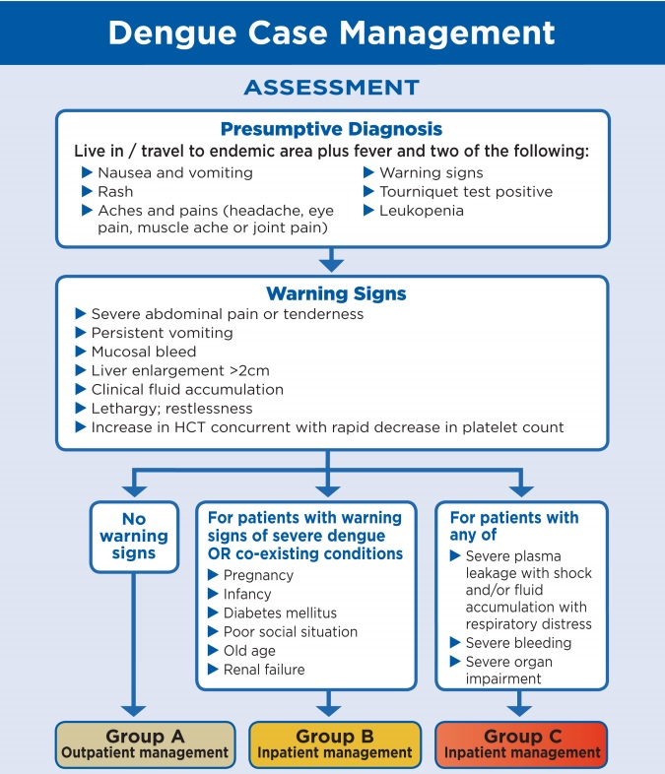
Figure 25 Dengue case management (WHO)

Symptoms according to severity (adapted from the WHO)
Dengue without warning signs
Fever + two of the following symptoms:
- Nausea, vomiting
- Rash resembling measles
- Generalized aches (headache, retro-orbital pain, myalgias, arthralgias)
- Benign mucocutaneous bleeding (petechiae, positive tourniquet test 1
- , epistaxis, gingival bleeding)
- Leucopenia
Dengue with warning signs
Presence of at least one of these symptoms:
- Abdominal pain
- Persistent vomiting
- Fluid accumulation (ascites, pleural effusion)
- Mucosal bleeding
- Hepatomegaly (> 2 cm)
- Agitation or lethargy
- Increasing haematocrit and rapidly dropping platelet count
Severe dengue
- Severe plasma leakage with:
  - Fluid accumulation (ascites, pleural effusion) + respiratory distress
  - Compensated shock: weak and rapid pulse, hypotension, cold extremities, capillary refill time > 3 seconds
  - Decompensated shock: heart rate and blood pressure un-recordable
- Severe mucocutaneous bleeding
- Multi-organ failure e.g.: hepatic or cardiac failure, alter level of consciousness, and coma

INVESTIGATION

Diagnostic tests
– NS1, IgG, IgM

Monitoring the haematocrit (Hct) and complete blood count
- The haematocrit (and not the haemoglobin) is the only test that shows haemo-concentration or increased vascular permeability (plasma leakage). The Hct reflects disease evolution and suggests therapeutic response.
- In children and pregnant women and if possible, in all patients, measure a reference Hct (Hct 0) at the first visit (during the febrile phase or before the critical phase).
- Measure baseline Hct on admission before administering fluid boluses (Hct 1) for all patients in Groups B and C then monitor Hct to determine therapy.
- An increase in the Hct with a rapid drop in the platelet count (≤ 100 000/mm3) is a warning sign.
- In case of hemodynamic instability or signs of shock:
- An increased or a persistently high Hct (> 50% in men or an increase relative to the previous Hct in women and children) indicates severe plasma leakage;
- A decrease in Hct (< 40-45% in men, < 35-40% in women and children 1 year and older, < 30-35% in children under 1 year) may indicate a haemorrhage.
  - Leukopenia (< 5 000/mm3) is frequent.

CASE MANAGEMENT OF DENGUE (WHO, CDC)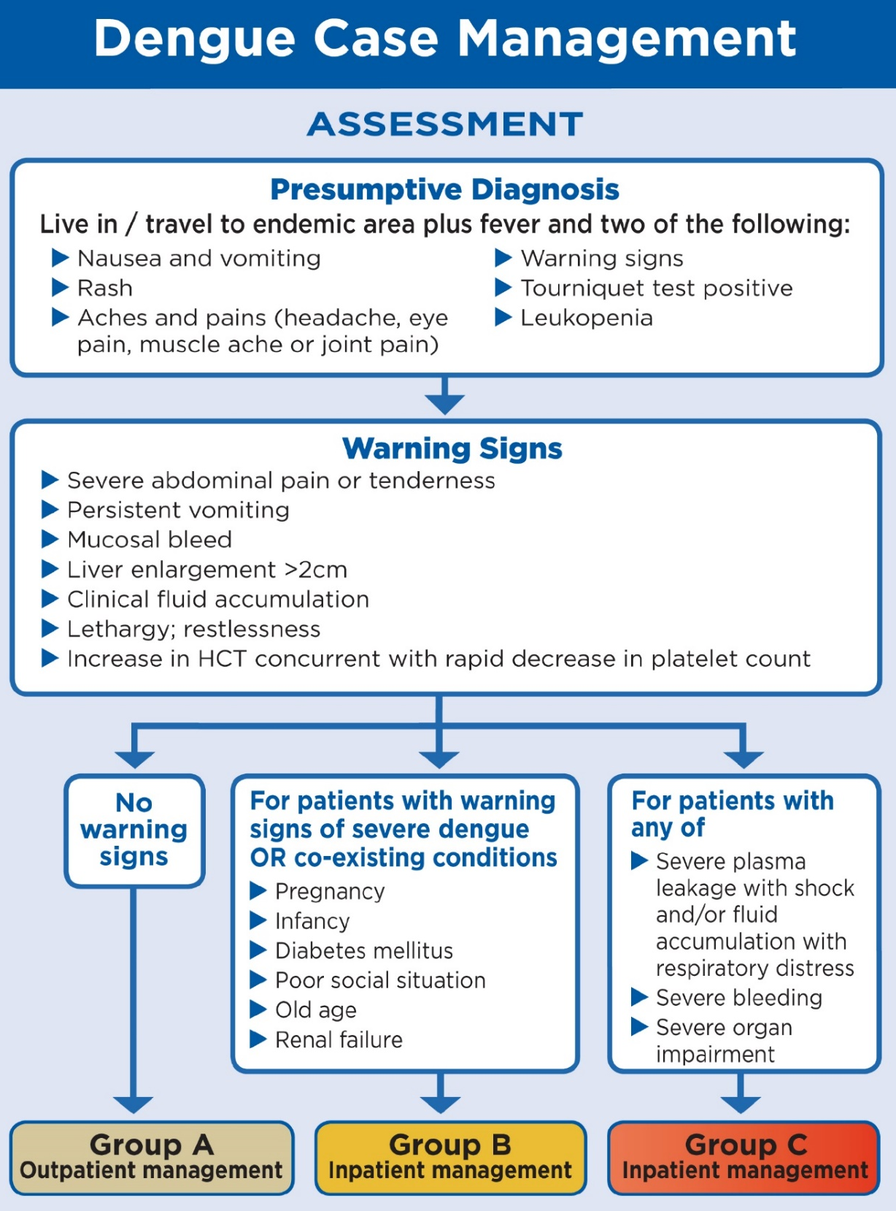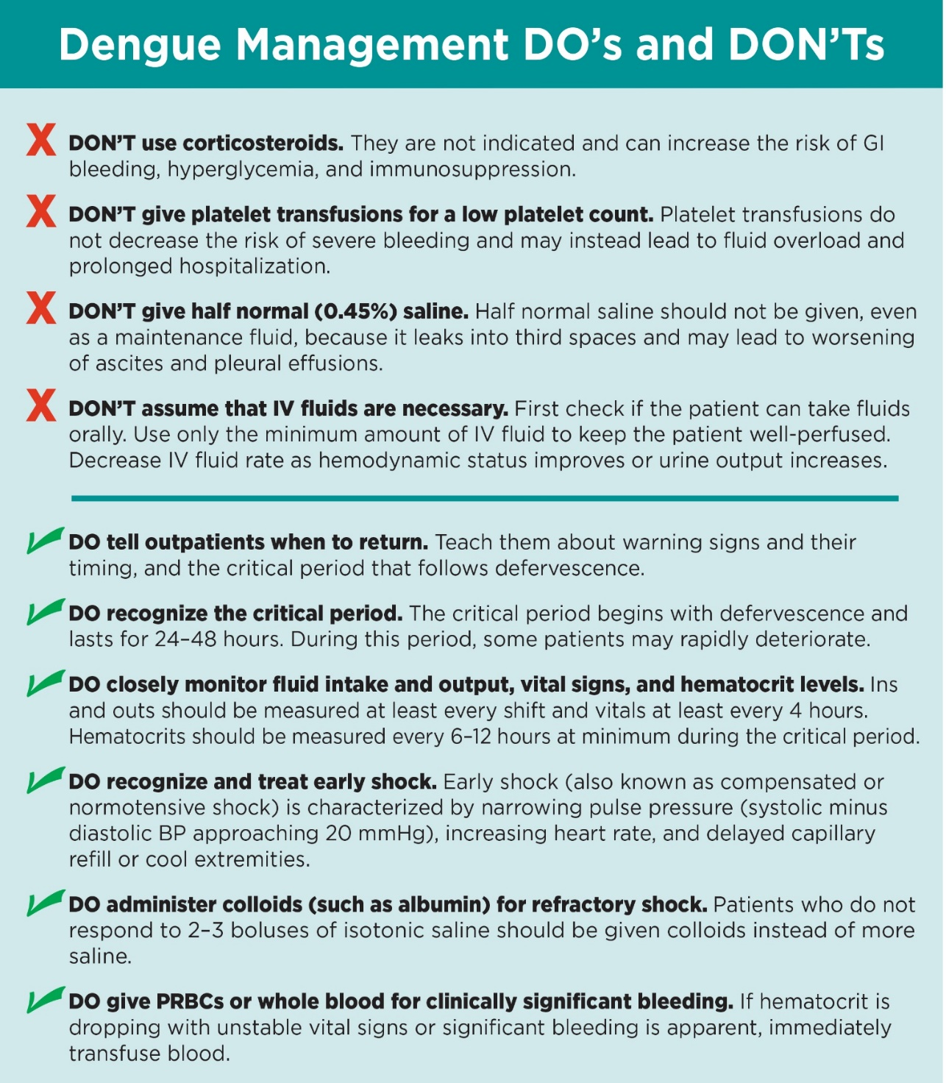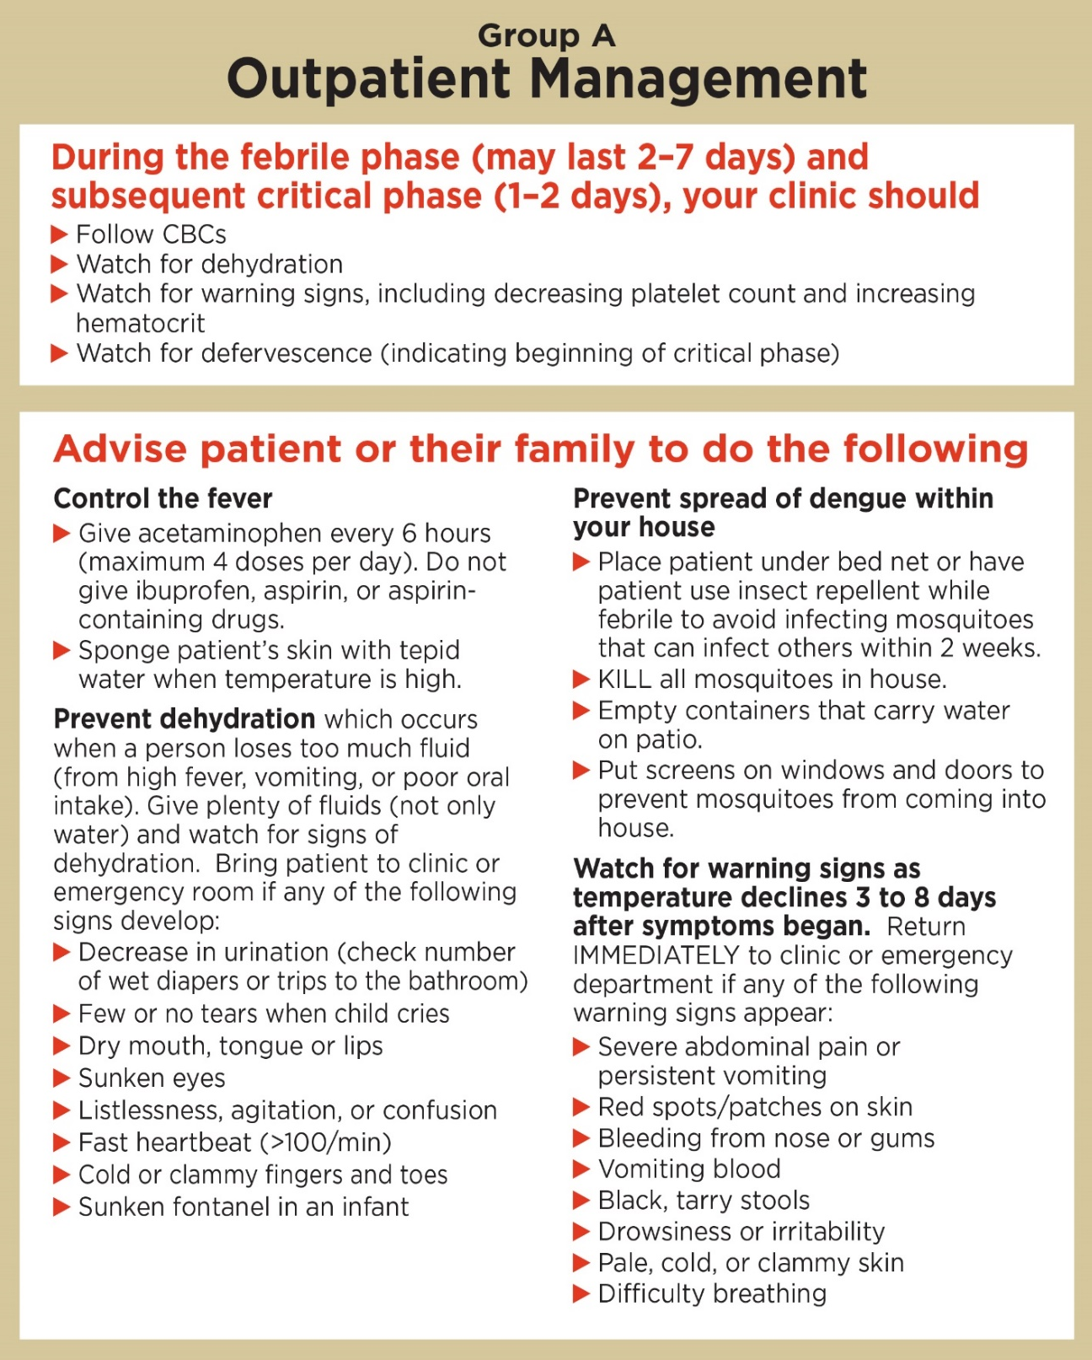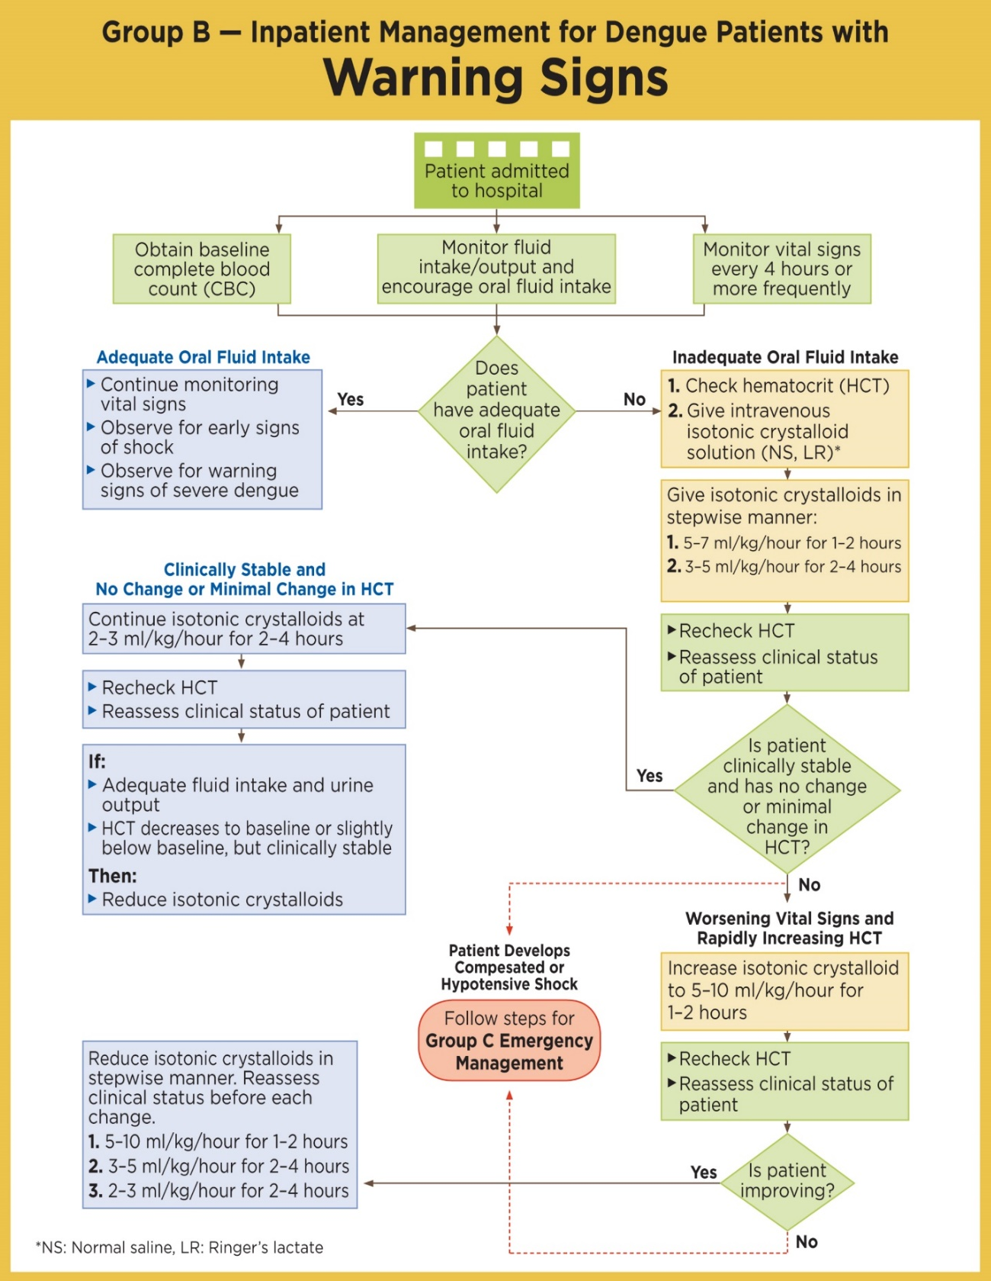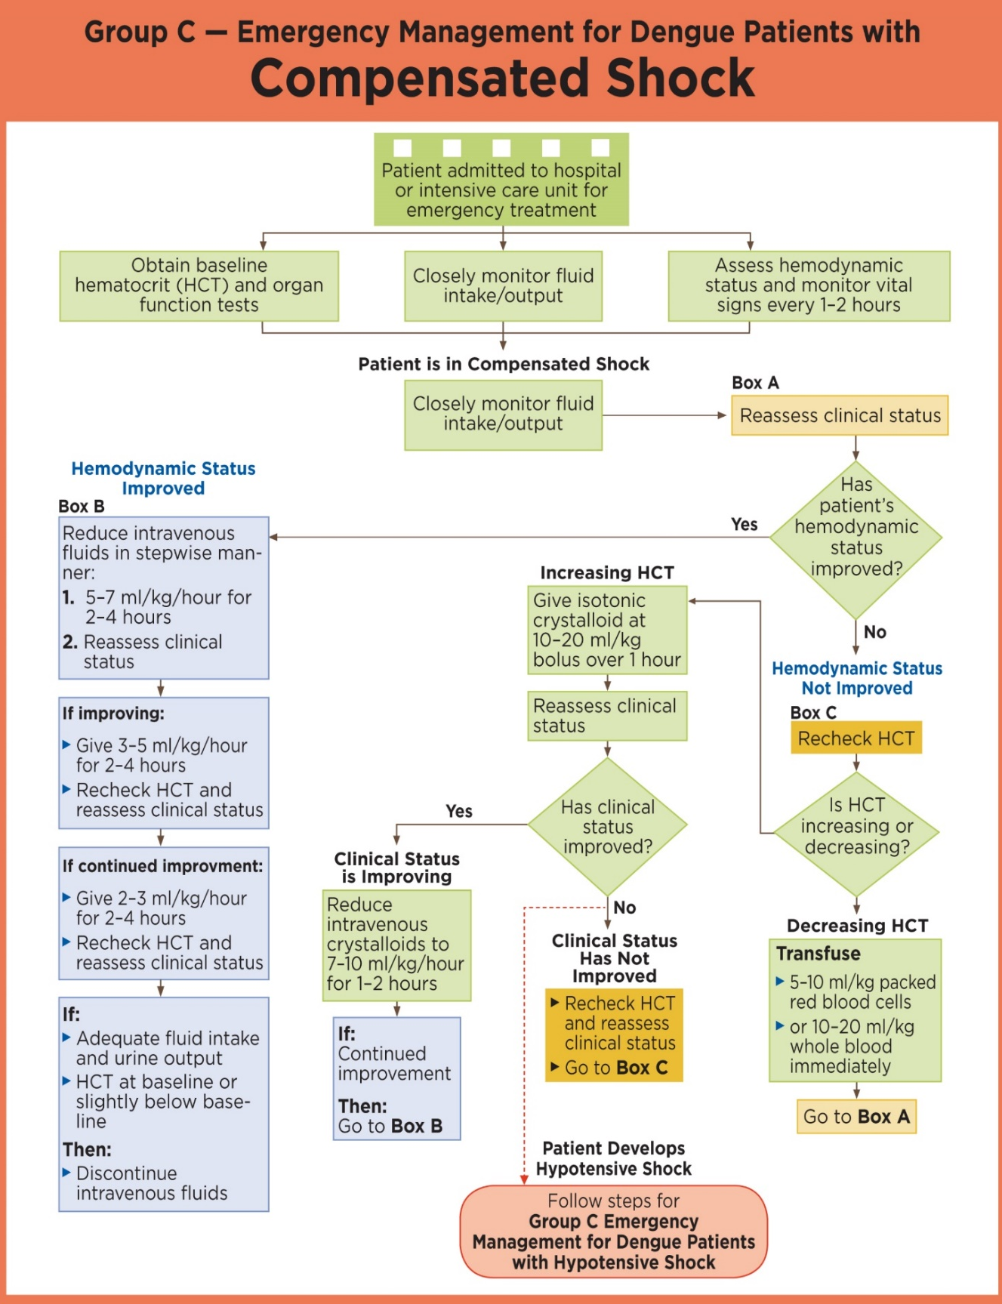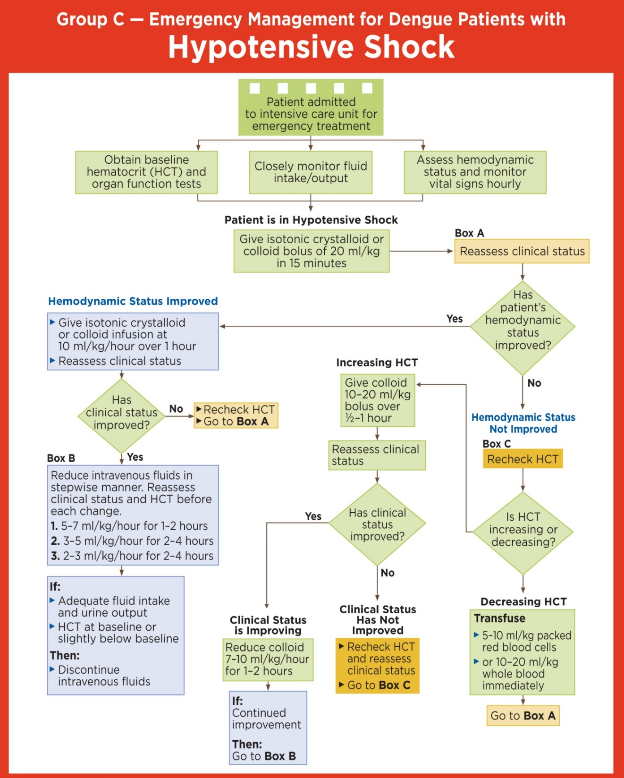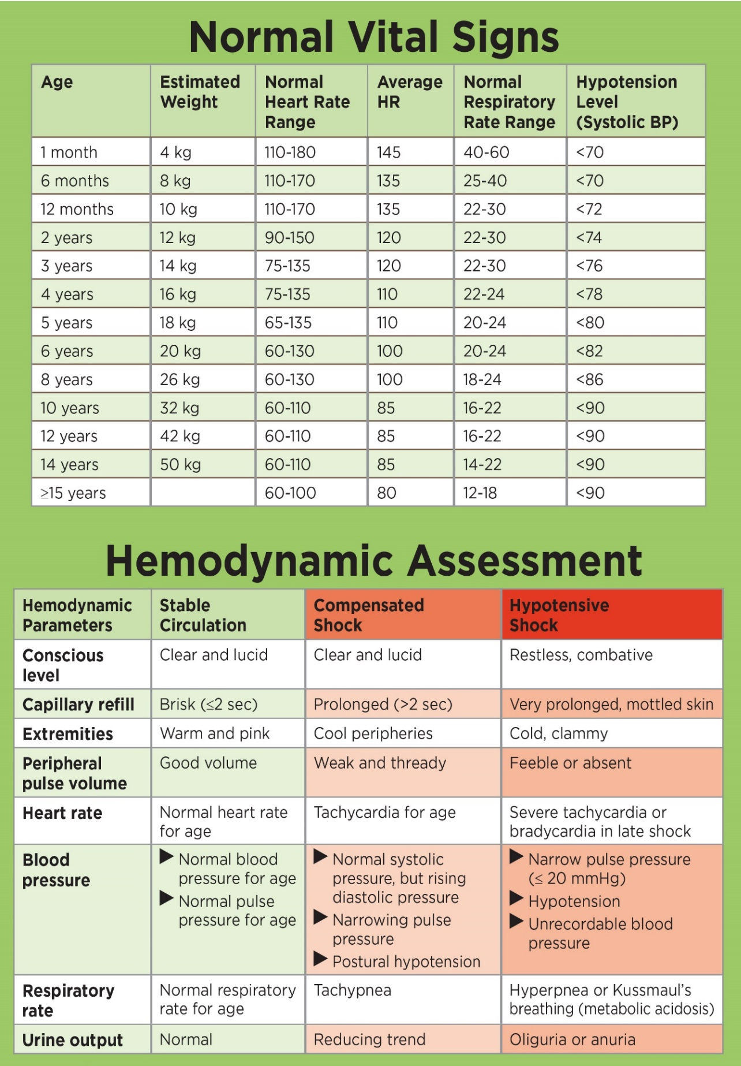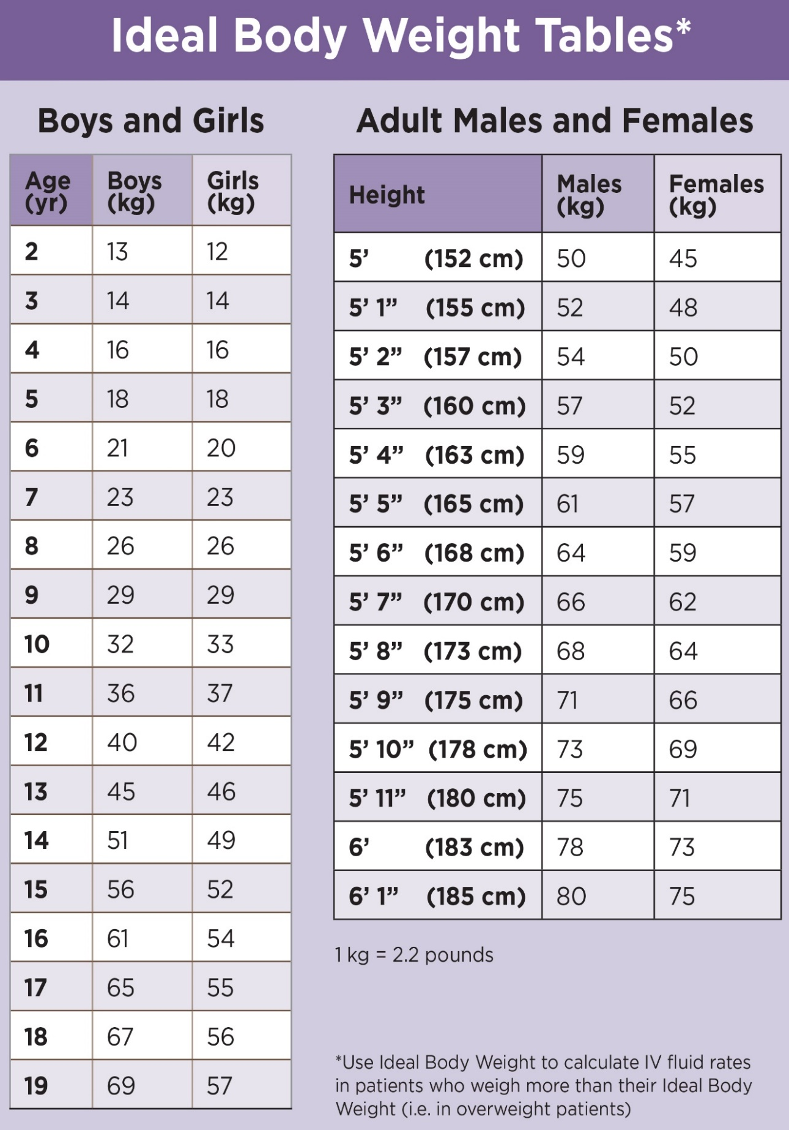

ENCEPHILITIS
Acute inflammation of the brain commonly caused by a viral infection (e.g. herpes simplex). Sometimes encephalitis may be a complication of other infections such as rabies, measles, syphilis or toxoplasmosis.
There is one important form of encephalitis:
Japanese encephalitis is the most important and common encephalitis in South-East Asia including India and areas in the Southern Pacific. Transmission to humans is through the bite of a mosquito, which generally breeds in flooded rice fields. The disease is caused by a flavivirus, which spends most of its lifecycle in birds and pigs.
Every year there are around 30,000-50,000 cases, 30% of which will result in death. For those who survive, 30% will have serious neurological problems. After infection there is lifelong immunity.

SIGNS AND SYMPTOMS
The majority of infections do not cause any symptoms.
- Headache and fever might be the only symptoms for 1-6 days.
- Other signs can be:
  - Photophobia (fear of strong light)
  - Weakness
  - Neck stiffness
  - Convulsions.

The disease can progress to paralysis, seizures, coma and death.
Neurological problems after infection (sequelae): hemiparesis, deafness, mental retardation and emotional lability (changes in emotion that are not predictable).

DIAGNOSIS
Lumbar puncture. Specific antibodies can be found in the CSF (this will need to be investigated in a special laboratory).
Blood glucose, malaria smear (to differentiate from cerebral malaria).
Do NOT perform a lumbar puncture if there are signs of raised intracranial pressure or risk of bleeding:
- Unequal pupil size
- Non-reactive pupils
- Very slow heart rate (<50 in adults)
- Irregular breathing.
- Low platelets or a bleeding disorder
- GCS <15
- Seizure
- Focal Neurological sign
- Severe respiratory distress

TREATMENT
Antiviral treatment:
• If available treat with acyclovir – ideally IV acyclovir but it is very expensive. Other options include PO

valacyclovir (a pro-drug of acyclovir which acts faster than acyclovir) or PO acyclovir

Symptomatic treatment:
- Pain relief.
- For seizures.
- See coma section for treatment of comatose patients.
- Physiotherapy: massage, move the patients limbs to preserve muscle tone and prevent contraction
• If you cannot exclude bacterial meningitis, treat with appropriate drugs for bacterial meningitis until a definitive diagnosis can be made.

PREVENTION
Mosquito (vector) control is not a solution in many areas, as there are too many breeding sites (irrigated rice fields) in our area. In some places alternate wetting and drying of the rice fields have succeeded in reducing vector populations. Personal protection (e.g. using repellents and/or mosquito nets) could prevent transmission of the virus. In outbreaks, one of the measures is to eliminate the pig population.

VACCINE
A Japanese encephalitis vaccine is available, see up to date vaccination schedules.

MEASLES
Measles is a highly contagious acute viral infection, transmitted by the airborne route (inhalation of respiratory droplets spread by infected individuals). The disease mainly affects children under 5 years of age and can be prevented by immunization.

SIGNS AND SYMPTOMS
The average incubation period is 10 days.
Prodromal or catarrhal phase (2 to 4 days)
– High fever (39-40 °C) with cough, coryza (nasal discharge) and/or conjunctivitis (red and watery eyes).
– Koplik’s spots: tiny bluish-white spots on an erythematous base, found on the inside of the cheek. This sign is specific of measles infection, but may be absent at the time of examination. Observation of Koplik's spots is not required for diagnosing measles.
Eruptive phase (4 to 6 days)
– On average 3 days after the onset of symptoms: eruption of erythematous, non- pruritic maculopapules, which blanch with pressure. The rash begins on the forehead then spreads downward to the face, neck, trunk (2nd day), abdomen and lower limbs (3rd and 4th day).
– As the rash progresses, prodromal symptoms subside. In the absence of complications, the fever disappears once the rash reaches the feet.
– The rash fades around the 5th day in the same order that it appeared (from the head to the feet).
The eruptive phase is followed by skin desquamation during 1 to 2 weeks, very pronounced on pigmented skin (the skin develops a striped appearance).

In practice, a patient presenting with fever and erythematous maculopapular rash and at least one of the following signs: cough or coryza or conjunctivitis, is a clinical case of measles.

COMPLICATIONS
Most measles cases experience at least one complication:
  - Respiratory and ENT: pneumonia, otitis media, laryngotracheobronchitis
  - Ocular: purulent conjunctivitis, keratitis, xerophthalmia (risk of blindness)
  - Gastrointestinal: diarrhoea with or without dehydration, benign or severe stomatitis
  - Neurological: febrile seizures; rarely, encephalitis
  - Acute malnutrition, provoked or aggravated by measles (post-measles period)
Pneumonia and dehydration are the most common immediate causes of death.

CASE MANAGEMENT
– Admit as inpatient children with at least one major complication:
- Inability to eat/drink/suck, or vomiting
- Altered consciousness or seizures
- Dehydration
- Severe pneumonia (pneumonia with respiratory distress or cyanosis or SpO2 < 90%)
- Acute laryngotracheobronchitis (croup)
- Corneal lesions (pain, photophobia, erosion or opacity)
- Severe oral lesions that prevent eating
- Acute malnutrition
  - Treat as outpatient children with no major complications, no complications or minor complications:
- Pneumonia without severe signs
- Acute otitis media
- Purulent conjunctivitis (no corneal lesions)
- Diarrhoea without dehydration
- Oral candidiasis that does not interfere with eating
- If in doubt, keep the child under observation for a few hours.
  - Isolation
- Isolation of hospitalised patients
- Measles cases treated as outpatients should be kept at home during this period.

TREATMENT
Supportive and preventive treatment
  - Treat fever: paracetamol.
  - Make the child drink (high risk of dehydration).
  - Give smaller, more frequent meals or breastfeed more frequently (every 2 to 3 hours).
  - Clear the nasopharynx (nose-blowing or nasal lavages) to prevent secondary respiratory infection and improve the child’s comfort.
  - Clean the eyes with clean water 2 times daily and administer retinol on D1 and D2 to prevent ocular complications.
  - In children under 5 years: amoxicillin PO for 5 days as a preventive measure (reduction of respiratory and ocular infections).
  - In the event of watery diarrhoea without dehydration: oral rehydration according to WHO Plan A
  - Insert a nasogastric tube for a few days if oral lesions prevent the child from drinking.

PREVENTION
- No chemoprophylaxis for contacts.
- Vaccination:
  - The first dose is administered at 9 months of age. In situations where there is high risk of infection (overcrowding, epidemics, malnutrition, infants born to a mother with HIV infection, etc.): administer one dose at 6 months of age (between 6 and 8 months) and one dose at 9 months of age, with an interval of at least 4 weeks between injections.
  - Children must receive a second dose before they are 5 years old in order to cover unvaccinated children or children who did not respond to the first dose.

POLIOMYELITIS
Poliomyelitis is an acute viral infection due to a poliovirus. This virus infects the spinal cord cells of a patient, resulting in paralysis. Transmission from human to human is direct (stool-hand-oral) or indirect (eating food or drinking water that is contaminated by stools). The disease can be prevented by a polio vaccine.

SIGNS AND SYMPTOMS
- Most of the infected patients have no symptoms.
- Non paralysis form: fever, muscle pain, headache, vomiting, backbone pain, spontaneous recovery within 10 days so not often diagnosed.
- Paralysis form: rapid flaccid (low tone) paralysis on one side of the body starting at the legs and moving towards the head. The muscles become soft and reflexes disappear. Sensation of the skin remains normal. Patients die if the respiratory muscles become paralysed.

DIAGNOSIS
Clinical. Suspect poliomyelitis in all patients with acute paralysis.
Polio virus can be detected in stool samples, need 2 samples 48 hours apart.

TREATMENT
Paralysis form:
- Keep in IPD, bed rest.
- Treat the pain.
- Prevent sores.
- Physiotherapy to prevent wasting of muscles and stiffness.
Note: Do NOT give any IM injections to a patient with suspected poliomyelitis, it will make the (paralysis) polio worse.

PREVENTION & VACCINATION
- Oral polio vaccine is available, see up to date vaccination schedules.
- Vaccinate all children under 5 years of age living in the same area of a suspected case even when they have been vaccinated before.
- Start a mass vaccination campaign if a case of poliomyelitis is confirmed by laboratory test.

RABIES
Rabies is a fatal viral disease which infects domestic (e.g. dogs or cats) and wild animals (e.g. bats). It is transmitted to other animals and humans through close contact with saliva from infected animals (through bites, scratches, licks on broken skin, and mucous membranes). Once symptoms of the disease develop, both animals and humans will die from the disease. However, if the infection is treated soon after transmission and before the onset of clinical symptoms, rabies can be prevented by post exposure vaccination.

SIGNS AND SYMPTOMS
Average time between exposure to rabies and symptoms is 1-3 months, but may even be a few years.
- Itching, pain or numbness at the site of the bite (starting 20-90 days after the bite – although can be longer or shorter).
- Fever, chills, weakness, headache.
- Furious rabies: signs of hyperactivity, agitation, muscle spasm, fear of water (hydrophobia) or;
- Paralytic rabies: paralysis spreading from the bitten area.
- In both furious and paralytic rabies, partial paralysis progresses to complete paralysis followed by coma and death in all cases, usually due to respiratory failure. Without intensive care, death occurs during the first seven days of illness.

DIAGNOSIS
Clinical. History of an animal bite or contact with broken skin, plus neurological features.

TREATMENT
There is no effective treatment for rabies available to a person who is showing signs and symptoms of a rabies infection. In this case, treatment is symptomatic and palliative (e.g. relieve pain with painkillers or diazepam).

Symptomatic disease can be prevented by:
1. Local wound care.
- Wash and flush a wound or point of contact:
  - For skin: use soap, lots of running water, apply ethanol, or povidone iodine.
  - For mucous membranes e.g. eyes/mouth: rinse with clean water or NSS
- If the wound is a bite: excise the necrotic tissue. Suturing (closing the wound) should be avoided if possible, or should be re-assessed at 48-72 hours, but if necessary, immunoglobulin must be applied first.
- Anti-tetanus treatment and antibiotics should be administered to control infections other than rabies

2. Post exposure prophylaxis: (vaccine +/- anti-rabies immunoglobulin)
Note: If the rabies vaccine or immunoglobulin are not available at your clinic refer to hospital.
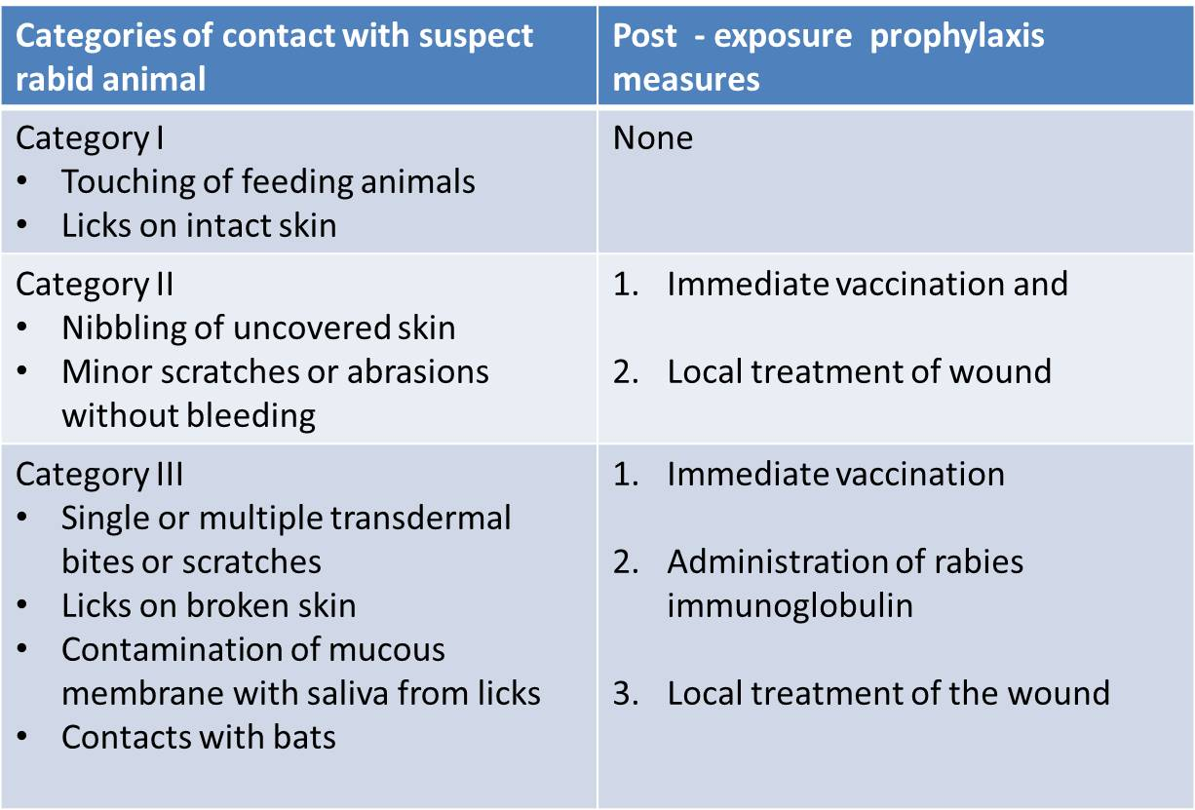

VACCINATION
Schedules for vaccines:
IF NO PREVIOUS FULL RABIES VACCINATION COURSE OR UNSURE
- Intramuscular regime:

Intramuscular vaccines should not be injected into the buttock region.
Use the shoulder muscles (deltoid).

Day 0: | One vaccine per arm | (deltoid muscle of two arms)
Day 7: | One vaccine | (deltoid muscle of one arm)
Day 21: | One vaccine | (deltoid muscle of one arm)

- Intradermal (ID) (into the skin) regime:

Intra dermal injections reduce the volume of vaccine required and vaccine cost by 60% to 80%.

Day 0: | 0.1ml per arm | (two arms)
Day 3: | 0.1ml per arm | (two arms)
Day 7: | 0.1ml per arm | (two arms)
Day 28: | 0.1ml per arm | (two arms)
IF HAS DEFINITELY COMPLETED RABIES VACCINATION COURSE:
* 1-site intramuscular or intradermal method
Day 0: | 1 dose ID or IM | (one arm)
Day 3: | 1 dose ID or IM | (one arm)

When the intradermal route is used, train the staff to give intradermal injections, provide proper conditions for vaccine storage and decide the duration of maximal vaccine storage after use. Make sure you have the 1 mL syringe and short hypodermic needles to give the intradermal vaccine.

HIV/AIDS

Natural history of HIV infection
Three phases of HIV infection:
- Acute Phase: Primary infection (1 to 3 months)
- Chronic Phase: Clinical latency (on average 8-10 years, without antiretroviral treatment, in developed countries)
- Acquired Immune Deficiency Syndrome (AIDS) (on average 2-3 years, without antiretroviral treatment, in developed countries)
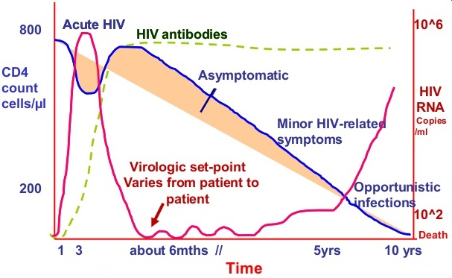
Figure 26 Natural history of HIV/AIDS
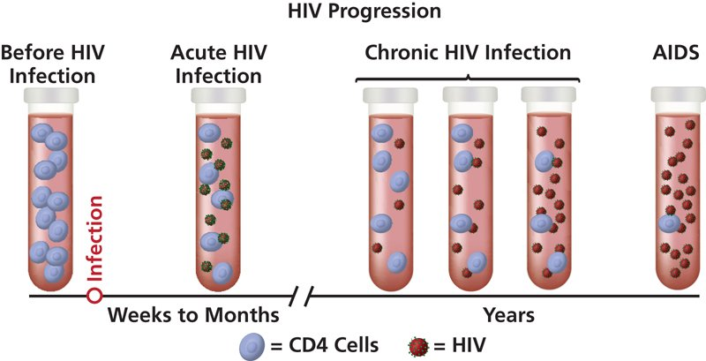
Figure 27 HIV progression in 3 phases

WHO clinical staging of HIV infection
Table 23 WHO clinical staging of HIV infection
Adults and adolescents (>15 years old) | Children (<15 years old)
Clinical Stage I
- Asymptomatic  - Persistent generalized lymphadenopathy | - Asymptomatic  - Persistent generalized lymphadenopathy
Clinical Stage II
- Moderate unexplained weight loss (<10% of presumed or measured body weight)  - Recurrent respiratory tract infections (sinusitis, tonsillitis, otitis media, pharyngitis)  - Herpes zoster  - Angular cheilitis  - Recurrent oral ulceration  - Papular pruritic eruption (PPE)  - Fungal nail infections  - Seborrhoeic dermatitis | - Unexplained persistent hepatosplenomegaly  - Recurrent or chronic upper respiratory tract infections (otitis media, otorrhoea, sinusitis, tonsillitis)  - Herpes zoster  - Lineal gingival erythema  - Recurrent oral ulceration  - Papular pruritic eruption  - Fungal nail infections  - Extensive wart virus infection  - Extensive molluscum contagiosum  - Unexplained persistent parotid enlargement
Clinical Stage III
- Unexplained severe weight loss (>10% of presumed or measured body weight)  - Unexplained chronic diarrhoea for longer than 1 month  - Unexplained persistent fever (intermittent or constant for longer than 1 month)  - Persistent oral candidiasis  - Oral hairy leukoplakia  - Pulmonary tuberculosis  - Severe bacterial infections (such as pneumonia, empyema, pyomyositis, bone or joint infection, meningitis, bacteraemia)  - Acute necrotizing ulcerative stomatitis, gingivitis or periodontitis  - Unexplained anaemia (<8 g/dl), neutropaenia (<0.5 × 10⁹/L) and/or chronic thrombocytopaenia (<50 × 10⁹/L) | - Unexplained moderate malnutrition^{b} not adequately responding to standard therapy  - Unexplained persistent diarrhoea (14 days or more)  - Unexplained persistent fever (above 37.5°C, intermittent or constant, for longer than one 1 month)  - Persistent oral candidiasis (after first six weeks of life)  - Oral hairy leukoplakia  - Lymph node tuberculosis; pulmonary tuberculosis  - Severe recurrent bacterial pneumonia  - Acute necrotizing ulcerative gingivitis or periodontitis  - Unexplained anaemia (<8 g/dL), neutropaenia (<0.5 × 10⁹/L) or chronic thrombocytopaenia (<50 × 10⁹/L)  - Symptomatic lymphoid interstitial pneumonitis  Chronic HIV-associated lung disease, including bronchiectasis
Clinical Stage IV
- HIV wasting syndrome  - Pneumocystis (jirovecii) pneumonia  - Recurrent severe bacterial pneumonia  - Chronic herpes simplex infection (orolabial, genital or anorectal of more than one month in duration or visceral at any site)  - Oesophageal candidiasis (or candidiasis of trachea, bronchi or lungs)  - Extrapulmonary tuberculosis  - Kaposi sarcoma  - Cytomegalovirus infection (retinitis or infection of other organs)  - Central nervous system toxoplasmosis  - HIV encephalopathy  - Extrapulmonary cryptococcosis, including meningitis  - Disseminated nontuberculous mycobacterial infection  - Progressive multifocal leukoencephalopathy  - Chronic cryptosporidiosis  - Chronic isosporiasis  - Disseminated mycosis (extrapulmonary histoplasmosis, coccidioidomycosis)  Lymphoma (cerebral or B-cell non-Hodgkin)  - Symptomatic HIV-associated nephropathy or cardiomyopathy  - Recurrent septicaemia (including nontyphoidal Salmonella)  - Invasive cervical carcinoma  - Atypical disseminated leishmaniasis | - Unexplained severe wasting, stunting or severe malnutrition^{d} not responding to standard therapy  - Pneumocystis (jirovecii) pneumonia  - Recurrent severe bacterial infections (such as empyema, pyomyositis, bone or joint infection, meningitis, but excluding pneumonia)  - Chronic herpes simplex infection (orolabial or cutaneous of more than 1 month's duration or visceral at any site)  - Oesophageal candidiasis (or candidiasis of trachea, bronchi or lungs)  - Extrapulmonary tuberculosis  - Kaposi sarcoma  - Cytomegalovirus infection (retinitis or infection of other organs with onset at age older than one month)  - Central nervous system toxoplasmosis (after the neonatal period)  - HIV encephalopathy  - Extrapulmonary cryptococcosis, including meningitis  - Disseminated nontuberculous mycobacterial infection  - Progressive multifocal leukoencephalopathy  - Chronic cryptosporidiosis (with diarrhoea)  - Chronic isosporiasis  - Disseminated endemic mycosis (extrapulmonary histoplasmosis, coccidioidomycosis, penicilliosis)  - Cerebral or B-cell non-Hodgkin lymphoma HIV-associated nephropathy or cardiomyopathy
For children younger than 5 years, moderate malnutrition is defined as weight-for-height <–2 z-score or mid-upper arm circumference ≥115 mm to <125 mm.
For children younger than 5 years of age, severe wasting is defined as weight-for-height <–3 z-score; stunting is defined as length-for-age/height-for-age <–2 z-score; and severe acute malnutrition is either weight for height <–3 z-score or mid-upper arm circumference <115 mm or the presence of edema.

TB Screening and diagnosis
All HIV-positive people should be assessed for risk factors for having or acquiring TB, just as all patients with active TB disease should be offered HIV testing and counselling. The major reasons for this are:
- HIV-positive people are at higher risk for having or developing active TB
- TB is one of the major opportunistic infections causing death in PLHIV
- HIV infection influences the clinical progression of TB and its treatment
- TB disease influences the clinical progression of HIV/AIDS and its treatment
- TB may be an indicative sign of advanced HIV/AIDS disease.

TB risk assessment and diagnosis in PLHIV
In assessing PLHIV for TB risk, particular attention should be paid to:
- People with respiratory symptoms
- Household contacts of anyone with an active case of pulmonary TB
- Coexisting risk factors and vulnerability-increasing factors (e.g. injecting drug use, alcohol abuse and incarceration).

The initial assessment for TB should include:
- A history of TB exposure (individual and household)
- A history of possibly related symptoms (especially a cough of more than two weeks duration without any clear explanation).

Investigations
- Sputum for AFB (Gold standard investigation to diagnose pulmonary TB)
- Gene Xpert
- CXR
- USG, X Rays (For patients suspected as Extra-pulmonary TB)

Case management and treatment
- See section of Tuberculosis.

Cotrimoxazole prophylaxis
Table 24 Cotrimoxazole prophylaxis criteria
Criteria for initiating, discontinuing and monitoring of Cotrimoxazole prophylaxis
Age | Criteria for initiation | Criteria for discontinuation
HIV exposed infant | - All HIV exposed infants  - Start at 4-6 weeks after delivery | - Until the risk of HIV transmission ends  - HIV negative is confirmed.
Children and adolescents with HIV | - Start all HIV +ve regardless of WHO clinical stage or CD4 count  Priority in  - All child <5 years  - All older >5 years with Clinical Stage III/IV or CD4 <350 cells/mm³ | - Discontinued in 5 years of age and older with clinically stable AND evidence of immune recovery AND/OR viral suppression by ART
All adults and pregnant women | - CD4 <350 cells/mm³ regardless of clinical stage OR  - Clinical Stage III/IV regardless of CD4 | - Discontinued in when clinically stable AND evidence of immune recovery AND/OR viral suppression by ART
Notes:
- Discontinue if Stevens-Johnson Syndrome (SJS), severe liver disease, severe anaemia and severe pancytopenia
- Alternative for Cotri hypersensitive patients: Dapsone 100 mg/day OD dose (Adult), 2mg/kg/day OD dose (Child, Maximum dose 100 mg/day)
- Immune recovery in children when >5 years old: CD4 >350 cells/mm³, with viral load suppression
- Clinically stable adults: ART > 1 year without any new Stage II, III and IV OIs.
- Immune recovery: CD4 >350 cells/ mm³ AND viral load suppression
- Adult dose: Cotrimoxazole 960 mg (Sulfamethaxazole 800 mg/trimethoprim 160 mg)
- Child dose:
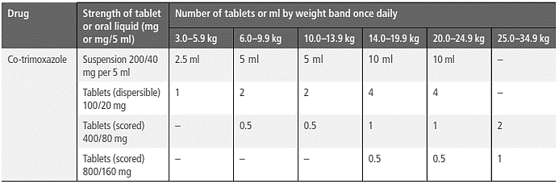

Baseline investigation for pre-ART
Table 25 Baseline investigation before ART initiation
Tests | Purpose
CD4 | OI management, Baseline immunological indicator
Hb | To rule out anaemia
Creatinine | For initiation of TDF
ALT, AST | For initiation of ART
STI screening | For prevention of HIV transmission
HBV serology | For Co-infection and ART management
HCV serology | For Co-infection and ART management

Adherence counseling
Points to discuss
- ART (Benefit of ART, viral suppression, life-long treatment, prevention of ART resistance)
- Side effects (Mild to severe side effects)
- Readiness and commitment of patients for ART
  - Ability to regular follow-up
  - Ability to take drug regularly
- Treatment adherence should be more than 95%. Info: missing 3 doses/month is associated with resistance
- BD dose cannot be late more than 6 hours, OD dose cannot be late more than 12 hours.
- ART patients need to use condom.
- ART checklists in every visit:
  - Number of doses missed in last 3 days
  - Number of doses missed since last visit
  - If correct doses in correct tie
  - Reason for poor adherence
  - Reinforce adherence

Opportunistic Infections (OIs), Prevention, Screening and Management
Major cause of death in PLHA is related with Opportunistic Infections (OIs). So prevention, screening and management of OIs are important role in management of HIV infection. Severe OIs should be screened and treated before initiation of ART. In advanced stage of immunosuppression, the signs and symptoms of infections may be asymptomatic. Specific OIs could be occurred at specific level of immunosuppression. Thus knowledge of CD4 counts can help clinician to consider differential diagnosis of OIs and other associated condition.
The common severe OIs associated with immunosuppressive PLHA.
- Mycobacterium Tuberculosis (TB)
- Pneumocystic Jirovecci Pneumonia (PCP)
- Toxoplasmosis
- Cryptococcosis
- Penicilliosis
- Histoplasmosis

Common infections and co-morbidities

Sexually Transmitted Infections (STIs)
- The untreated STI (ulcerative or non-ulcerative) can increase HIV transmission risk up to 10 times higher.
- Must screen, diagnose and treat STIs, especially among the most vulnerable populations and people living with HIV.
- STI services is an important part of comprehensive HIV care.

Hepatitis B and Hepatitis C
- Viral hepatitis is an increasing cause of morbidity and mortality among people living with HIV
- Prevention, HBV and HCV testing, hepatitis B vaccination and treatment and care for people with HIV who are co-infected with hepatitis B and/or hepatitis C.
- HIV co-infection > rapid progression to cirrhosis and hepatocellular carcinoma, higher liver related mortality and decreased treatment response.

Disorders due to substance use
- Recommend a comprehensive package of nine interventions for HIV prevention, treatment and care for people who inject drugs
  - Needles and syringe programs
  - Opioid substitution therapy (OST)
  - HIV testing and counselling
  - ART
  - Preventing and treating STIs
  - Condom programs
  - Targeted behavioral change communication
  - Preventing and treating viral hepatitis
  - preventing, diagnosis and treating TB
- For case management, please follow mhGAP 2.0 guideline for both pharmacological and psychosocial intervention

Depression
- Prevalence rates as high as 80% among people with HIV. It is less likely to achieve optimal treatment adherence among people living with HIV who have depression.
- For case management, please follow mhGAP 2.0 guideline for both pharmacological and psychosocial intervention

Non-Communicable Diseases (NCDs)
- See section of NCD.

Nutrition
- Low energy intake combined with increased energy demands due to HIV infection and related infections may lead to HIV related weight loss and wasting.
- Nutritional assessment, counselling and support should be an integral component of HIV care.
- In children living with HIV, nutritional assessment is essential to identify malnutrition and growth flattering early.
- Infants and children should undergo initial nutritional assessment and then be weighted and have height measured at each visit, and monitored with the reference to WHO or national growth curves. Growth monitoring should be integrated into the assessment of ART response.

Anti-Retroviral Therapy (ART)

Notification:
The ART Drugs list/regime are based on ART drugs available in Mae Tao Clinic.
Be aware that there are different options for drugs of choices/alternatives.

Goals of ART
- Improvement of quality of life and prolongation of life
- Reduction of HIV related morbidity and mortality
- Reduction in viral load (< 50 copies/ml)
- Restoration and preservation of immune function
- Minimization of drug side effects
- Reduction of HIV transmission

Anti-Retroviral (ARV) drugs, Dosage, Toxicity and Management
Table 26 ARV, dosage, toxicity and management
Generic Name | Dosage | Toxicity | Management
Nucleoside reverse-transcriptase inhibitors (NRTIs)
Abacavir (ABC) | 300 mg twice daily or 600 mg once daily | Hypersensitivity reaction | Substitute with AZT or TDF.
Emtricitabine (FTC) | 200 mg once daily
Lamivudine (3TC) | 150 mg twice daily or 300 mg once daily
Zidovudine (AZT) | 250-300 mg twice daily | Severe anaemia, neutropaenia | Substitute with TDF or ABC. Consider use of low-dose zidovudine
Nucleotide reverse-transcriptase inhibitors (NtRTIs)
Tenofovir (TDF) | 300 mg once daily
Non-nucleoside reverse-transcriptase inhibitors (NNRTIs)
Efavirenz (EFV) | 400-600 mg once daily | Persistent central nervous system toxicity (such as dizziness, insomnia, abnormal dreams) or mental symptoms (anxiety, depression, mental confusion)  Convulsions  Hepatotoxicity  Severe skin and hypersensitivity reactions  Gynaecomastia | For CNS symptoms, dose at night-time. Consider using EFV at a lower dose (400 mg/ day) or substitute with NVP or integrase inhibitor (DTG) if EFV 400 mg is not effective in reducing symptoms. For severe hepatotoxicity or hypersensitivity reactions, substitute with another therapeutic class (integrase inhibitors or boosted PIs).
Etravirine (ETV) | 200 mg twice daily | Severe skin and hypersensitivity reactions | Substitute with another therapeutic class (integrase inhibitors or boosted PIs).
Nevirapine (NVP) | 200 mg once daily for 14 days, followed by 200 mg twice daily | Hepatotoxicity Severe skin rash and hypersensitivity reaction, including Stevens-Johnson syndrome | If hepatotoxicity is mild, consider substitution with EFV, including in children 3 years and older. For severe hepatotoxicity and hypersensitivity, and in children under the age of 3 years, substitute with another therapeutic class (integrase inhibitors or boosted PIs).
Protease inhibitors (PIs)
Lopinavir + ritonavir (LPV/r) | 400 mg/100 mg twice daily | Electrocardiographic abnormalities (PR and QRS interval prolongation, torsades de pointes)  Hepatotoxicity  Pancreatitis  Dyslipidaemia  Diarrhoea | Use with caution in people with pre-existing conduction disease or those on concomitant drugs that may prolong the PR or QRS intervals.  If LPV/r is used in first-line ART for children, substitute with NVP or RAL for children younger than 3 years and EFV for children 3 years and older. ATV can be used for children older than 6 years. If LPV/r is used in second-line ART for adults, and the person has treatment failure with NNRTI in first-line ART, consider integrase inhibitors.

Initiation of ART
Table 27 Summary for ART initiation
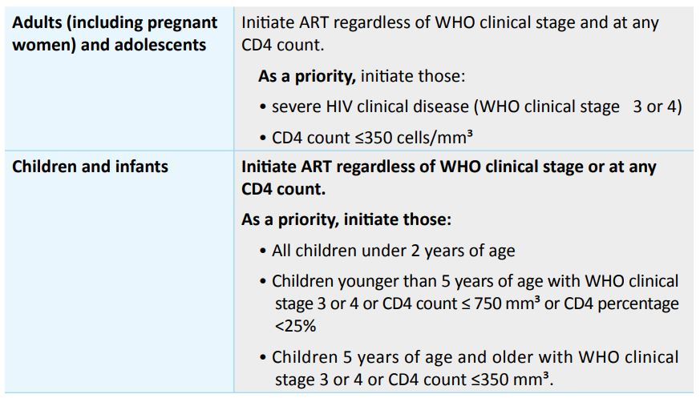
ART initiation in pregnant women: reference to MTC’s PMTCT Protocol.

Initiation of ART in co-infections
- ART should be started in all TB patients living with HIV, regardless of CD4 count.
- TB treatment should be initiated first, followed by ART as soon as possible within the first 2 to 8 weeks of treatment.
- HIV positive TB patients with profound immunosuppression (e.g. CD4 count less than 50 cells/mm³) should receive ART within the first 2 weeks of initiating TB treatment.

First Line ART
Table 28 First Line ART regiem for child, pregnant and Adults
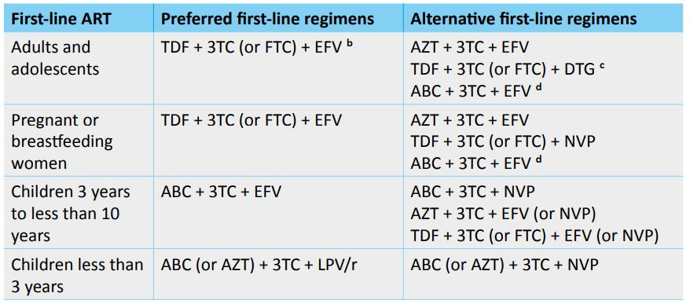
a ART regimens for HIV+ TB cases are same as the regimens for HIV+ cases without TB
b TDF should be avoided for HIV+ MDR-TB cases who receive standard MDR-TB regimen including Amikacin.
c Safety and efficacy data on the use of DTG in pregnant women, people living with HIV/TB coinfection and adolescents younger than 12 years of age are not yet available.
d ABC based regimen may be considered for pregnant women under special circumstances which may include situations where preferred or alternative regimens may not be available or suitable because of significant toxicities, anticipated drug-drug interactions, drug procurement and supply management issues, or for other reasons.

Drug interactions
Table 29 Drug Interaction and management
Drugs | Interaction | Management
Anti-tuberculosis drugs | SMRU will manage. | SMRU will Manage
Drugs for Hepatitis C | MTC doesn’t treat Hep C. | MTC doesn’t treat Hep C.
Antifungal agents | ARV decrease concentration of Itraconazole and ketoconazole. | Use fluconazole.
Opioid substitution therapy | MTC doesn’t run OST program. | MTC doesn’t run OST program.
Hormonal contraceptives | ARV drugs either decrease or increase the levels of steroid hormones in hormonal contraceptives.  (NNRTIs and RTV-boosted PIs with hormonal contraceptives) | Increase OC Pill dose.
Statins | Boosted PIs increased concentrations of lovastatin and simvastatin, which may increase the risk of serious adverse events such as myopathy, including rhabdomyolysis. | Alternative cholesterol-lowering agents should be used to prevent severe toxicity in people with HIV.

Routine investigations in ART patients
Table 30 Routine investigation in ART patients
Management phases | Recommended | Optional
HIV Diagnosis | HIV testing (serology for adults and children 18 months or older  Early Infant Diagnosis for children younger than 18 months)  CD4 cell count  TB symptom screening | HBV (HBsAg)  HCV serology  Cryptococcus (if CD4 ≤100 cells/mm³ )  Screening for STIs  Pregnancy test  Assessment for major non-communicable chronic diseases and co-morbidities
Follow-up before ART | CD4 cell count (every 6–12 months in circumstances where ART initiation is delayed)
ART initiation |  | Haemoglobin (for AZT)  Serum creatinine (for TDF)  ALT (for NVP)  Pregnancy test  Baseline CD4 cell count
Receiving ART | HIV viral load (at 6 months and 12 months after initiating ART and every 12 months thereafter). | Serum creatinine (for TDF)  Pregnancy test
Suspected treatment failure | Serum creatinine ( for TDF)  Pregnancy test | HBV (HBsAg)

Immune Reconstitution Inflammatory Syndrome (IRIS)
After starting ART especially in late HIV disease, some patients experience clinical deterioration. This is because the body’s immune system has recovered and starts to react to infections or antigens to which it was not reacting before. The reaction can be sometimes very severe and can cause significant morbidity and mortality if it is not recognized. The reaction is towards viable or dead microbial antigens and sometimes host antigens. The antigenic load of the OI is also important. IRIS is most commonly seen with TB, cryptococcal meningitis, CMV (which could cause blindness after starting ART), hepatitis B, hepatitis C, herpes zoster and other conditions. In resource poor countries, Mycobacterium tuberculosis and Cryptococcus neoformans are the most significant pathogens causing IRIS
IRIS may be associated with paradoxical exacerbation of the OI that is being diagnosed and treated usually within 3 months of ART initiation, re-initiation, or regimen change because of treatment failure.
IRIS may also unmask an OI which was not recognized because it remained silent with advanced immunosuppression.
Autoimmune diseases sometimes appear after starting ART and this is known as autoimmune IRIS (thyrotoxicosis, SLE, sarcoidosis and other autoimmune disorders have been described after starting ART). IRIS usually starts within 2 to 3 months of starting ART but it may also be delayed for many months. Risk factors for IRIS include:
- Very low CD4 count at start of ART
- Very high VL and very rapid fall in VL after ART
- Short interval between OI treatment and ART
- In late disease with very low CD4 counts usually < 50/mm³ delaying ART too long could be dangerous because of the risk of disease progression and this has to be balanced against the risk of IRIS.
- HIV-positive TB patients with profound immunosuppression (e.g. CD4 counts less than 50 cells/mm³) should receive ART within the first two weeks of initiating TB treatment.
- Caution is needed in people living with HIV with TB meningitis, as immediate ART is significantly associated with more severe adverse events. Immediate ART initiation is not recommended in HIV infected patients with cryptococcal meningitis due to the high risk of IRIS that may be life threatening IRIS. ART should not be started within first 1-2 weeks of Amphotericin initiation. It can be started within 2-5 weeks of induction and consolidation treatment with amphotericin B–containing regimens until there is evidence of a sustained clinical response to antifungal therapy.
- When the underlying condition has no specific treatment however ART can be started immediately.
- Cryptosporidiosis, HIV associated dementia and progressive multifocal leukoencephalopathy are examples where ART is indicated immediately.
- The excessive inflammatory response is controlled with NSAIDs or steroids if necessary which are gradually tapered according to symptoms.
- It may be necessary to stop ART only very rarely in life-threatening IRIS.
- Differential diagnosis of IRIS includes – - Treatment failure of the OI (e.g. MDR TB) - Adverse drug reaction - A new OI (which is unmasking IRIS)

Failures
Table 31 Algorithm for ART Failures

Second-line and Third-line ART regimens
Table 32 Second Line ARTs
Patients | Preferred 2nd Line Regime
Patients | 1st Line Drugs | Recommended 2nd Line
Adults and adolescents,  Pregnant or breastfeeding women | If d4T or AZT was used in first-line ART | TDF + 3TC (or FTC) + LPV/r
Adults and adolescents,  Pregnant or breastfeeding women | If TDF was used in first-line ART | AZT + 3TC + LPV/r
HIV and HBV co-infection | AZT + TDF + 3TC + LPV/r (4 drugs regime)
Children (< 3years) | ABC + 3TC + LPV/r | AZT + 3TC + RAL
Children (< 3years) | AZT + 3TC + LPV/r | AZT + 3TC + RAL
Children (3 years and older) | ABC + 3TC + LPV/r | AZT + 3TC + EFV
Children (3 years and older) | AZT + 3TC + LPV/r | TDF + 3TC + EFV  (TDF can replace with ABC)  (RAL can replace with EFV)
Children (All age up to adolescents) | ABC + 3TC + EFV (or NVP) | AZT + 3TC + ATV/r or LPV/r
Children (All age up to adolescents) | TDF + 3TC (or FTC) + EFV (or NVP) | AZT + 3TC + ATV/r or LPV/r
Children (All age up to adolescents) | AZT + 3TC + EFV (or NVP) | ABC or TDF + 3TC (or FTC) + ATV/r or LPV/r

Table 33 Third Line ARTs
3rd Line Regime
Third-line regimens should include new drugs with minimal risk of cross-resistance to previously used regimens, such as INSTIs and second-generation NNRTIs and PIs. Patients on a failing second-line regimen with no new options should continue with a tolerated regimen.
Examples of 3rd Lines (Since MTC doesn’t manage on advanced ART regime, 3rd line is just to know.)
Adults and adolescents (>10 years)  Pregnant or breastfeeding women | DRV/r b + DTGc (or RAL) ± 1–2 NRTIs  OR  DRV/r + 2 NRTIs ± NNRTI
Children (0–10 years) | RAL (or DTG) + 2 NRTIs DRV/r + 2 NRTIs DRV/r + RAL (or DTG) ± 1–2 NRTIs

Atlas of HIV related conditions and opportunistic infections

WHO clinical stagings in HIV/AIDS Adults
Stage 1
- No symptoms
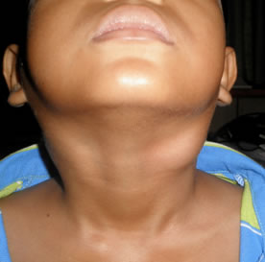
Stage 2
Figure 28 Lymphadenopathy [lymph nodes that you can feel because they are bigger than normal]
- Weight loss [<10%]
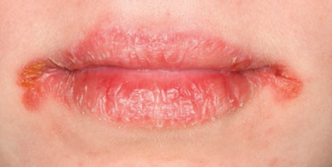
Figure 29 Angular chelitis
Figure 30 Recurrent [for a long time or keeps happening] oral ulcer

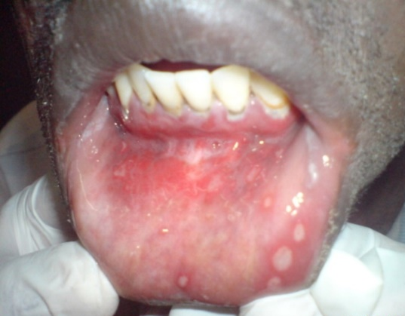

- Recurrent [for a long time or keeps happening] respiratory infection
- Otitis media – ear infection
- Tonsillitis / pharyngitis – throat infection
- Sinusitis – sinus infection
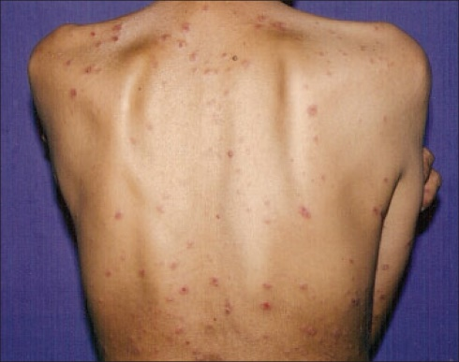
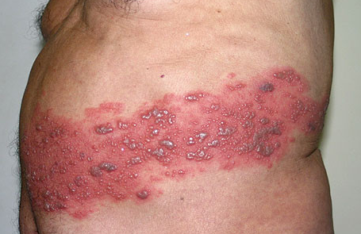
- Skin problem:
Figure 31 Herpes zoster
Figure 32 Papular pruritic eruption = itchy rash

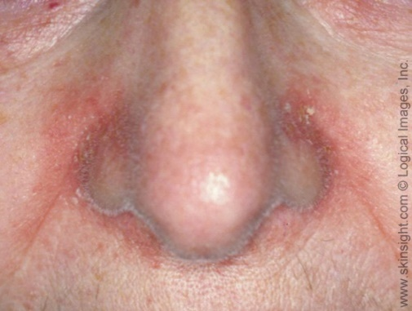
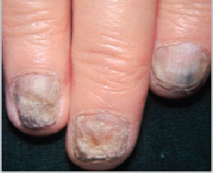
Figure 33 Seborrheic dermatitis = dry skin round the nose
Figure 34 Fungal nails

Stage 3
- Weight loss >10%
- Diarrhoea > 1 month
- Fever > 1 month
- Pulmonary TB
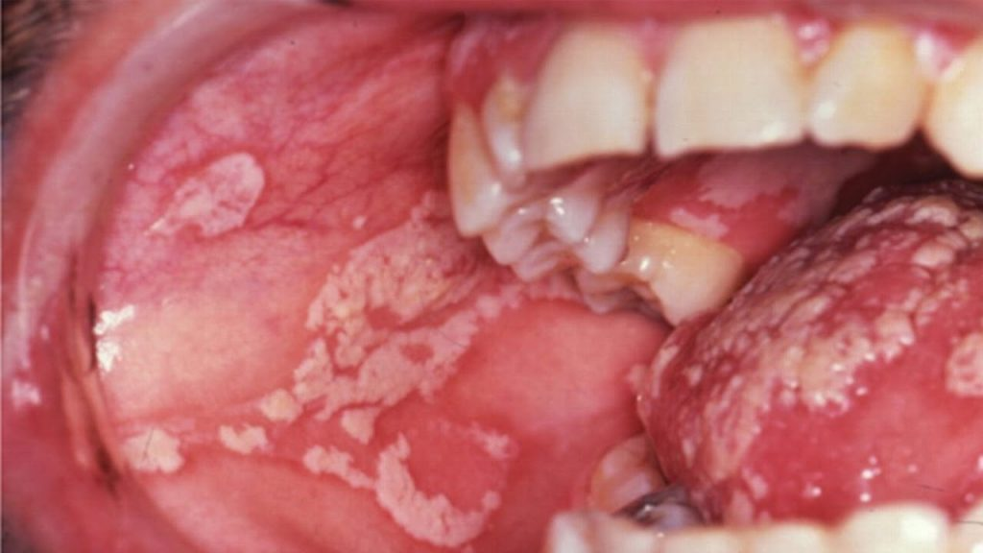
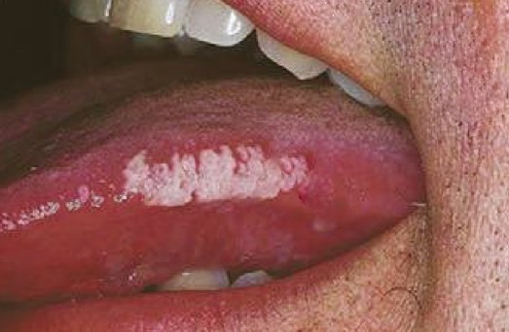
Severe bacterial infection of chest [pneumonia or empyema] / muscle / bone / joint / meningitis
Figure 35 Oral candida [thrush]
Figure 36 Oral hairy leukoplakia = white on the side of the tongue
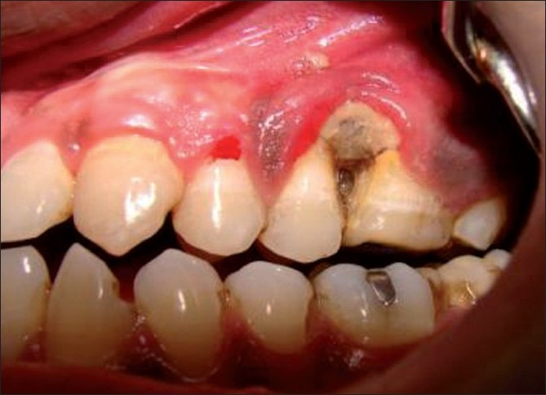
Figure 37 Acute severe necrotising gingivitis [gums] or periodontitis [around the teeth]

- Abnormal CBC with no other cause: [for example if they have dengue and low platelets this does not count!]
  - Hb <8
  - Platelets <50
  - Neutrophils <500
Stage 4
- HIV WASTING SYNDROME = 10% weight loss AND: Fever > 1 month Or diarrhoea > 1 month
- Extra pulmonary TB
- PCP [pneumocystis lung infection] – dry cough, low oxygen especially when walking, chest sounds normal
- Recurrent [for a long time or keeps happening] severe pneumonia
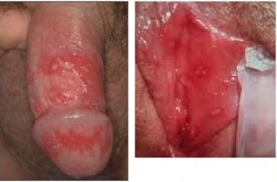
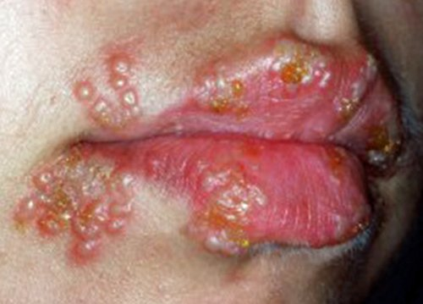
- Oesophageal candida [suspect if oral candida and pain on swallowing]
Figure 38 Chronic herpes simplex (Oral or Genital)
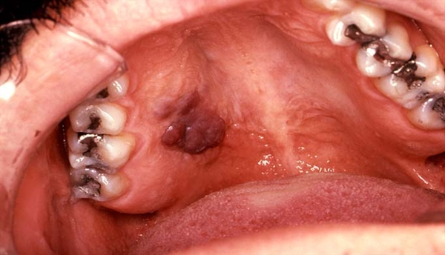
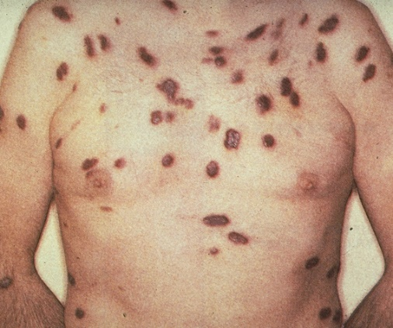
Cryptococcal meningitis – suspect if headache CSF India Ink test for diagnosis. Toxoplasmosis – suspect if fever + headache + one-side weakness + fit
Figure 39 Kaposi sarcoma [type skin cancer – on the skin or in the mouth
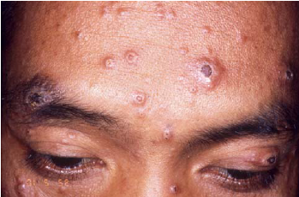
Figure 40 Severe fungal infection like penicilliosis – suspect if rash + lymph nodes + unwell:

ELECTROLYTE ABNORMALITIES
Our bodies carefully control the amount of electrolytes. If they are too high or too low, this can be dangerous. This can happen because of diseases, for example hyperkalaemia (high potassium) because of renal failure. It can also happen because of medication that we give, for example hypokalaemia (low potassium) because of furosemide. Sometimes abnormal electrolytes can be an emergency. The most common causes seen at clinics on the border are listed below.
HYPO = too low
HYPER = too high
Note: It is important to check individual reference ranges for each lab and machine as they can be slightly different.

POTASSIUM
(Normal 3.5-5.1mmol/L)
Potassium is important for the heart to work.

HYPERKALAEMIA
= HIGH POTASSIUM (>5.1mmol/L)
High potassium can be an emergency as it can cause abnormal rhythms in the heart.
Do ECG > 6.5 is an emergency or >6 with changes on the ECG

CAUSES
- Renal Failure
- Medications e.g. ACE-inhibitor (e.g. enalapril), spironolactone
- Endocrine diseases e.g. Addison’s disease (failure of adrenal gland)
- Haemolysis (breakdown of red blood cells that release potassium)
- Pseudohyperkalaemia (if red blood cells break down when taking blood then the level of potassium can be falsely high)

SIGNS AND SYMPTOMS
- Non-specific tiredness, muscle weakness
- Abnormal heart rhythm – may cause tachycardia, palpitations, chest pain
- ECG shows peaked T waves

TREATMENT
- Stop any medications that may be causing the problem
- If renal function is normal and no other obvious cause consider repeating the potassium as it may be falsely high from the breakdown of the red blood cells when taking blood.
- If potassium >6.5 or >6 with changes on ECG: there is a high risk of sudden death:
- Salbutamol nebuliser 5mg (this helps to lower the potassium)
- Calcium Gluconate 10% 10ml SLOW IV over at least 10 minutes (this protects the heart)
- To lower the potassium this patient needs insulin → this is not available at many clinics so this patient needs IMMEDIATE REFERRAL

HYPOKALAEMIA
= LOW POTASSIUM (<3.5mmol/L)

CAUSES
- Medications e.g. furosemide, hydrochlorothiazide
- Gastrointestinal loss e.g. diarrhoea (also vomiting)
- Loss through skin e.g. burns
- Low intake in diet e.g. malnutrition
- Endocrine diseases e.g. Conn’s syndrome (too much aldosterone production)
- Low magnesium

SIGNS AND SYMPTOMS
- Severe hypokalaemia will cause muscle weakness, myalgia, muscle cramps and constipation
- Paralysis can occur

TREATMENT
- Stop any medications that may be causing the problem
- Encourage patient to eat bananas, tomatoes, leafy green vegetables, coconut water, lemons, limes, oranges
- Potassium can be replaced by tablets (swallow tablets whole during meals with lots of fluid) or IV depending on level of potassium:
Mild Hypokalaemia | 3.0-3.4 | PO one tablet* BID for 1 week and re-check potassium
Moderate hypokalaemia | 2.5-3.0 | PO two tablets* TID for 3 days and re-check potassium  If not increasing, give magnesium, then try two tablets QID and consider admission for IV potassium
Severe hypokalaemia | <2.5 | Potassium IV replacement and magnesium IV, repeat potassium daily  Note: IV replacement is dangerous and should be done with cardiac monitoring.
*Dose for Slow K (600mg tablet = 8mmol potassium)

IV potassium for adults
- Put 40mmol potassium chloride (KCl) (3 x 1.34mmol/ml 10ml Ampoules) in 1 litre 0.9% NSS (or 1.5 KCl ampoules in 500ml NSS) and mix bag well.
- Maximum rate is 250ml per hour (10mmol potassium per hour).
- If magnesium unknown/cannot be measured and severe hypokalaemia add 1g IV magnesium for each 500ml NSS (Magnesium and KCl can be added to same bag NSS).
- If possible use paediatric metroset or burette to ensure that do not accidentally give faster than 10mmol/hour.
- IV potassium given too quickly can kill.
- IV potassium should only be done with close and good medical supervision.
- Maximum rate = 10mmol/hour and maximum concentration for peripheral IV is 40mmol/litre (to prevent cardiac arrhythmias and minimise phlebitis (inflammation of the vein)).
If cannot correct the potassium, then the magnesium may be low, you need to correct the magnesium first before the potassium can be corrected.

CALCIUM
(Normal 2.15-2.55mmol/l)

HYPERCALCAEMIA
= HIGH CALCIUM (>2.55mmol/l)
Mild Hypercalcaemia | 10.5-11.9mg/dL | 2.6-2.9mmol/L
Moderate Hypercalcaemia | 12-13.9mg/dL | 3-3.5mmol/L
Severe/Crisis | >14mg/dL | >3.6mmol/L

CAUSES
  - Medications e.g. hydrochlorothiazide
  - Renal failure
  - Cancers e.g. bone, lung
  - Endocrine disorder e.g. hyperparathyroidism

SIGNS AND SYMPTOMS
- Stones – kidney stones or gallstones
- Bones – bone pain
- Abdominal moans – constipation, nausea and vomiting, abdominal pain
- Psychic groans – depression, confusion

TREATMENT
- Stop any medications that may be causing the problem
- The most important treatment is to rehydrate with IV fluids (NSS)
- Diuretics e.g. furosemide can also help to decrease the calcium (discuss with doctor)
- More complex medications e.g. bisphosphonates can be used but may not be available at clinics on the border

HYPOCALCAEMIA
= LOW CALCIUM (<2.15mmol/L)

CAUSES
  - Low oral intake
  - Medications e.g. diuretics
  - Low vitamin D

SIGNS AND SYMPTOMS
- Tingling around the mouth and lips and in the hands and feet
- Tetany (strong contractions of the hands and large muscles)

TREATMENT
- Stop any medications that may be causing the problem
- Increase dairy products e.g. milk
- Calcium PO replacement
- Calcium carbonate (Calcium carbonate 500mg/1000mg tablets) OR
  - Calcium carbonate combined with Vitamin D3 (Calcium carbonate 500mg +Vitamin D3 200IU)
  - If severe low calcium (<1.9mmol/l) OR patient has symptoms. (Refer/Discuss)
- Calcium Gluconate 10% 10ml SLOW IV over 10 minutes – can repeat until patient symptoms stop

SODIUM
(Normal 136-145mmol/L)
It is very important to correct the sodium to normal very slowly. A rapid increase in the sodium can cause brain damage

HYPERNATRAEMIA
= HIGH SODIUM >145mmol/L

CAUSES
- Dehydration
- Endocrine disorder e.g. diabetes insipidus (problem with controlling water balance in the body)

SIGNS AND SYMPTOMS
- Lethargy, weakness, irritable
- Oedema
- Seizures, coma

TREATMENT
- Careful rehydration with D5W

HYPONATRAEMA
= LOW SODIUM <136mmol/L

CAUSES
- Fluid overload e.g. heart failure, ascites
- Medications e.g. furosemide
- Endocrine problems e.g. SIADH, hypothyroidism
- Prolonged vomiting & diarrhoea
- Drinking too much water (psychogenic polydipsia)

SIGNS AND SYMPTOMS
- Nausea, vomiting, headache, loss of appetite
- Lethargy, confusion, memory loss
- Convulsions, coma

TREATMENT
- Stop any medications that may be causing the problem
- Treatment depends on the cause, discuss with the doctor
- Sodium levels should not rise by more than 8mmol/l over 24hours

ENDOCRINE DISEASES

DIABETES MELLITUS
Diabetes Mellitus is a syndrome caused by lack of insulin from the pancreas or reduced effectiveness of insulin in the body. This causes high blood sugar levels (hyperglycaemia).
There are two types of diabetes:
- Type 1 (about 10% of cases) usually starts in childhood and can only be treated with insulin (oral tablets do not work).
- Type 2 usually starts in adult life (>30 years), often have risk factors (see below), can usually be managed with tablets. If severe, may need insulin treatment.
Risk Factors associated with type 2 Diabetes are: positive family history, BMI > 23 and obesity, history of diabetes in pregnancy, history of malnutrition or low birth weight in the first year of life.

SIGNS AND SYMPTOMS
- Increased thirst
- Increased infections: especially skin infections,
- Increased urine output
- UTIs, vaginal infections (candidiasis) and TB
- Tiredness
- Weight loss
- Symptoms of diabetic complications

DIAGNOSIS
If someone has the above symptoms, you should check dextrose and check the urine dipstick for glucose.
To confirm the diagnosis in patients with positive glucose in the urine, check glucose level in the venous blood.
TEST |  | PATIENT HAS DIABETES IF:
RANDOM BLOOD GLUCOSE (FBS) | Check Glucose level at any time of the day. It is NOT important if the patient has eaten or not. | > 200mg/dL  (> 11.1mmol / L*)
FASTING BLOOD GLUCOSE (FBS) | Check Glucose level in the morning: advice patient not to eat food or sugary drink in last 8 hours (can have water). | 126mg/dL  (> 7mmol / L)
ORAL GLUCOSE TOLERANCE TEST (2HPP) | Check glucose 2 hours after drinking 75g of glucose | or equal to 200mg/dL  (> or equal to 11.1mmol/l)
Figure 41 Diagnosis for Diabetes
*Conversion 1mmol/L = 18mg/dL, 1mg/dL= 0.055mmol/L.

Investigations (if available)
- Fasting blood glucose
- Oral glucose tolerance test (for pregnant women only)
- Urine dipstick – protein, glucose
- Biochemistry – BUN, Creatinine
- Examine for foot pulses and sensation

COMPLICATIONS
EMERGENCY COMPLICATIONS:
A diabetic patient can present unwell or in coma because the blood sugar is too high or too low.
**Remember that patients may present as an emergency without being diagnosed with diabetes before.**
HYPOGLYCAEMIA <70mg/dL (=3.8mmol/l) Note: <45mg/dL(=2.5mmol/l) is severe

SIGNS AND SYMPTOMS:
• Sweating, hunger, tremor, dizziness, drowsiness, aggressive/irritable, confusion, convulsion, coma

TREATMENT:
• If dextrose 45-70mg/dL:
- Give oral sugar solution (water mixed with sugar) or sweet drink to prevent severe hypoglycaemia.
• If dextrose <45mg/dL:
- If able to drink: give oral sugar solution (water mixed with sugar) or sweet drink
- If unable to drink e.g. in coma: insert IV cannula and give Adult/Child: 5ml/kg 10% dextrose bolus, Neonate 2ml/ kg 10% dextrose
• After giving oral/IV dextrose re-check blood dextrose after 15 minutes to make sure it is >70mg/dL

HYPERGLYCEMIA
There are two conditions that occur if the dextrose is high. Both conditions are emergencies:

Diabetic Ketoacidosis (DKA)
An emergency complication that occurs in type 1 diabetes (rarely in type 2 diabetes). It can be caused by infection, not using insulin correctly, or other illnesses that put a stress on the body. DKA can be life-threatening.

SIGNS AND SYMPTOMS
Nausea, vomiting, ketones smell (fruity smell on breath), dyspnoea, abdominal pain, confusion, coma, death

DIAGNOSIS
To diagnose DKA there must be all 3:
- Hyperglycaemia: blood dextrose >200mg/dL (>11.1mmol/L)
- Ketones on urine dipstick
- Metabolic acidosis (bicarbonate <15) (if available).

TREATMENT:
- Give NSS:
  - Adult 1L in 1 hour
  - Children 10ml/kg in 1 hour (the risk of fluid overload is higher in children)
- Need insulin: discuss with doctor about referral to hospital
- Treat any underlying infections as a precipitating factor

Hyperosmolar Hyperglycaemia State (HHS)
An emergency complication that occurs in type 2 diabetes. It can be caused by illness, dehydration or not taking normal diabetes medication e.g. because of illness. It causes severe dehydration of the cells of the body, and can be life threatening.

SIGNS AND SYMPTOMS
- Generalized weakness, leg cramps, visual problems, nausea/vomiting (less than in DKA)
- Progresses to confusion, neurological signs, seizures, coma

DIAGNOSIS
To diagnose HHS there must be: Hyperglycaemia: very high blood dextrose
e.g. >600mg/dL (>33mmol/L)

TREATMENT
As per DKA

NON-EMERGENCY (CHRONIC) COMPLICATIONS:
Diabetes Mellitus causes long-term damage to the body if it is not treated well:
  - Blood vessel (vascular) disease: stroke, heart disease, heart attack, peripheral vascular disease (poor blood supply causing cold or painful feet), ulcers that heal slowly.
  - Kidney failure: protein positive on urine dipstick.

- Eye disease: cataracts, glaucoma, damage to the retina (patient complains of blurred vision).
- Nerve damage: numbness, tingling and sometimes pain in the hands and feet (worse at night).
- Feet problems: due to poor blood supply and numbness, diabetic feet are at increased risk of infections and wounds.

TREATMENT
The aim of diabetes treatment is to lower the blood sugar to normal levels, which will make the patient feel better and prevent long term damage.
Normal random blood sugar levels are between 70 – 140 mg/dL (3.8 – 7.8 mmol/L)

1. Explanation and advice
When you have made the diagnosis of diabetes, explain to the patient what diabetes is. Tell them that there is no cure for diabetes and that they will have this disease for life (except when diabetes is present only in pregnancy – see obstetric guidelines). Diabetes can be controlled. Explain that there are drugs which can lower the blood sugar and that there are also some things that the patient can do to help lower the blood sugar level.

2. Life style treatment
It is important for all diabetics to make changes to their lifestyle. Some diabetics can bring their blood sugar level back to normal just by lifestyle treatment.
Diet:
Carbohydrate
- Eat starchy foods (lentils, beans, oats)
- Be aware that rice and noodles raise the blood sugar.
- If you can, choose wholegrain varieties (like brown rice if available/ affordable), or eat potatoes with their skins on
Vegetables and Fruit
- Eat lots of vegetable e.g. cabbage, pumpkins, cauliflower, mushroom, watercress □ Eat fruits that are less sweet e.g. pomelo, apples, lime
Reduce Fat:
- Try to steam instead of fry
- Use chicken > beef > pork – remove fatty part and skin
Reduce Sugar
- e.g. sweets, biscuits, fruit juices, soft drinks like coca cola, sugar cane, honey, 3 in 1, sweet tea, Ovaltine/ milo
• Reduce Salt
Reduce salt in cooking, less dry salty fish
- Alcohol: Advise the patient to stop or if unable to stop at least to reduce
- Smoking: Advise the patient to stop or if unable to stop at least to reduce
- Exercise: Advise the patient to do some exercise – try to do at least 30 minutes every day: e.g. walking, playing football, gardening.
If, at the time of diagnosis, the random blood sugar is mildly elevated, 140-200 mg/dL (7.7-11.1 mmol/L), you could try lifestyle treatment first. If it does not work after one month, then start medication.

3. Foot care advice
People with diabetes often have problems with the nerve and blood supply to their feet. This means that they may not be able to feel if they have trauma to their feet and if they get a trauma/infection it will be difficult to treat and may heal very slowly. Therefore it is important for patients to check their feet each day to look for sores, cuts, redness or any signs of infection. If there is any trauma that is not healing or any signs of infection they should come to the clinic so that any infection can be treated early. To prevent trauma make sure nails are cut, wear shoes, particularly comfortable ones, if possible.

4. Medication
DIABETIC MEDICATION
Start diabetic medication if the dextrostick >200 mg/dL (11.1 mmol/L), or lifestyle treatment is not working. Make sure that the creatinine and BUN is normal before starting. The aim is to make sure that the random blood sugar levels are brought within the normal range.

Name of Drug | START DOSE | MAX. DOSE | NOTES | Contraindications | Side effects
METFORMIN | 500mg BID | 1g BID | Give with meals. | Liver disease, renal failure, hypoxia | GI side effects
GLIBENCLAMIDE | 5mg OD Elderly: 2.5mg OD | 15mg OD | Give with breakfast. | Patients who do not eat meals regularly, liver/renal failure, pregnancy | Hypoglycaemia if the patient does not eat 3 regular meals.
- Start with metformin 500mg BID
- After 1-2 weeks increase to metformin 1g BID
- If after 1-2 weeks the blood sugar is not normal ADD glibenclamide 5mg OD with breakfast
- If after 1-2 weeks the blood sugar is not normal increase to glibenclamide 10mg OD
- If after 1-2 weeks the blood sugar is not normal increase to glibenclamide 15mg OD
- If blood sugar not controlled this patient is at high risk of diabetes complications and may need insulin which is not available in many clinics
  - Discuss with the doctor about referral
  - Explain to the patient that they must seek healthcare at hospital if they are able to. This is to avoid becoming unwell and to avoid complications in the future
  - If they cannot get insulin, continue the oral medication, but advise the patient that they are at risk for complications of diabetes as their dextrose is poorly controlled.
If the patient takes diabetic medication but does not eat, or does not eat regularly, he will be at risk of hypoglycaemia (too low blood sugar): explain this very carefully to the patient, teach them and the family how to recognise symptoms of hypoglycaemia and how to treat it (eat sugary drink/food).

BLOOD PRESSURE MEDICATION
- In diabetic patients should aim for SBP less than 130 and DPB less than 80 (BP <130/80mmHg)
- ACE inhibitor e.g. enalapril recommended first line anti-hypertensives in diabetes (beta blockers are not recommended)

5. Follow up consultation
The aim is to educate, achieve good blood sugar levels (normal range 70-140mg/dL) and check for complications that are treatable.
- When starting medication review the patient weekly until blood sugar level is stable. Continue to inform the patient about diabetes and remind him/her about diet and medication.
- When blood sugar level is stable, review every month.
- Educate the diabetic patient about eating frequent meals with solid foods to avoid hypoglycaemia.
- Warn every patient who is on medication about the symptoms of hypoglycaemia and how to treat at home.
- Educate the patient how to treat low blood sugar (drink a sugary drink/water mixed with sugar)
- Educate the patient on foot hygiene, make sure nails are cut, wear shoes particularly comfortable ones if possible. Examine feet daily for wounds, infection, if there is any trauma that is not healing or any signs of infection they should come to the clinic so that any infection can be treated early.
Ask if:
- Symptoms: have they improved?
- Complications: cold feet, numbness, vision problems (if present: show to doctor).
- Have they had hypoglycaemia? Describe the symptoms (see below) and explain this is because of low blood sugar.
Examine:
Every month:
- BP, start hypertensive medication if high
- Look at feet for infection, wounds, test for numbness
Every 12 months:
- Urine dipstick for protein (kidney damage).
- Look for signs of heart failure.
If possible test vision in Eye Clinic; look for cataract.

Check random blood sugar level:
BLOOD SUGAR LEVEL | VERY GOOD | GOOD | TOO LOW | TOO HIGH
BLOOD SUGAR LEVEL | 70 - 140mg/dL  (3.8 - 7.7mmol/L) | < 180mg/dL  (< 10mmol/L) | < 70mg/dL  (< 3.8mmol/L) | > 180mg/dL  (> 10mmol/L)
WHAT TO DO | Continue same treatment |  | Treat hypoglycaemia.  Check if patient is eating regularly.  If yes: reduce medication  If not: give education | Consider if patient has diabetes emergency.  Increase medication.  Find and treat infections.  Give diet education.

DIABETES in PREGNANCY
Pregnant diabetic women have higher rates of stillbirth, pre-eclampsia, premature labour and very large babies (or less commonly, very small babies) – see obstetric handbook for treatment
PREVENTION See lifestyle treatment.

HYPOGLYCAEMIA
Hypoglycaemia: blood dextrose <70 mg/dL (3.8mmol/L)
Severe hypoglycaemia: blood dextrose <45mg/dL (2.5mmol/l)
(Note: for cases of acute severe malaria, a dextrose < 40mg/dL (2.2mmol/L) is diagnosed as hypoglycaemia. (See malaria guidelines))
Causes
  - Diabetic medication dose is too high.
  - A diabetic person took his/her medication but then did not eat.
  - Malaria (especially in pregnant women and/or undergoing quinine treatment).
  - Other infections.
  - Non diabetic medications e.g. beta blockers
SIGNS AND SYMPTOMS
- Sweating, hunger, tremors, dizziness.
- More severe: drowsiness, aggressive or irritable behaviour, convulsions and coma.
DIAGNOSIS
- Check blood sugar to confirm diagnosis.
- Find the underlying cause (malaria or other infection).
TREATMENT
- If dextrose 45-70mg/dL:
- Give oral sugar solution (water mixed with sugar) or sweet drink to prevent severe hypoglycaemia.
- If dextrose <45mg/dL:
- If able to drink: give oral sugar solution (water mixed with sugar) or sweet drink
- If unable to drink e.g. in coma: insert IV cannula and give Adult/Child: 5ml/kg 10% dextrose bolus, Neonate 2ml/ kg 10% dextrose
- After giving oral/IV dextrose re-check blood dextrose after 15 minutes to make sure it is >70mg/dL.
- If on diabetic medication review the dose with a doctor or senior medic.
- Treat any other cause e.g. malaria, infection.
PREVENTION
Educate diabetic patients about eating frequent small meals of solid food to avoid hypoglycaemia.

ENDOCRINE DISEASE

THYROID DISEASE
The thyroid is a small hormone-producing gland located just below the Adam’s Apple in the neck. It produces two thyroid hormones (thyroxine/T4 and triiodothyronine/T3), which circulate in the bloodstream and control the metabolism. Thyroid hormones influence almost every other organ system in the body. They tell the organs how fast or slow they should work, and tell the body systems when to use energy (e.g. consume oxygen and produce heat). The amount of hormones the thyroid produces is controlled by the Thyroid-Stimulating Hormone (TSH) which is produced by the pituitary gland.
You can detect the two main thyroid disorders by measuring TSH and F-T4 (free T4) in the blood of a patient.
TSH | FT4 | Conclusion
Normal | Normal | No thyroid disease
↑ | ↓ | Hypothyroid
↑ | Normal | Sub clinical hypothyroid
↓ | ↑ | Hyperthyroid
↓ | Normal | Sub clinical hyperthyroid

HYPOTHYROIDISM
Underactivity of the thyroid gland.

SIGNS & SYMPTOMS
- Constipation
- Hoarse voice
- Tiredness and depression
- Hair loss
- Dry and cold skin
- Oedema of the face.

DIAGNOSIS
- Clinical: Feel the thyroid gland (goitre, nodules), pulse, look for dry skin, oedema
- Laboratory test: TSH, FT4 for diagnosis, TSH only for follow up of treatment.

TREATMENT
- SUB CLINICAL HYPOTHYROID (high TSH, normal F-T4)
  - Wait and see, repeat blood tests every year.
- HYPOTHYROID (high TSH, low F-T4):
If <50 years AND no history of ischaemic heart disease (angina):
  - Start thyroxine 50mcg OD
  - Increase after 4 weeks to 100-150mcg OD depending on improvement in signs and symptoms
  - Re-check only the TSH after 4 weeks (total 8 weeks after starting thyroxine) and change the dose according to the results
If >50 years OR history of ischaemic heart disease (angina):
  - Start thyroxine 25mcg OD
  - Increase after 4 weeks to 50mcg OD depending on improvement in signs and symptoms
  - Re-check only the TSH after 4 weeks (total 8 weeks after starting thyroxine) and change the dose according to the results
Note: thyroxine dose is micrograms (mcg) not milligrams (mg) e.g. 50mcg = 0.05 mg

Follow up TSH check:
- If TSH high: increase the dose by 25-50mcg
  - Re-check the TSH in 4 weeks
- If TSH normal: continue the same dose
  - Re-check TSH in 6 months OR in 12 months if 2nd time TSH is normal
  - If symptoms begin again check before
- If TSH is low: decrease the dose by 25-50mcg
  - Re-check the TSH in 4 weeks.
Note – thyroid medication will take at least 4 weeks to work so when changing medication do not check the TFT before 4 weeks
Note: Hypothyroidism in pregnant women should be monitored carefully, with frequent thyroid function tests.
Delivery should not take place at home and the neonate should be observed carefully for signs of thyroid disease.

PREVENTION
- Patients should take their medication regularly and come to the clinic for consultation.
- They should be able to recognise the signs or symptoms of too much or not enough thyroid hormone.
- They should be made aware that some other medications could interact with their thyroid medication.
- They should discuss all new medications with their doctor.

HYPERTHYROIDISM
Over activity of the thyroid gland.

SIGNS AND SYMPTOMS:
- Diarrhoea
- Sweatiness
- Nervousness
- Exophthalmia (protruding eyes)
- Weight loss
- Tachycardia, palpitations
- Feel warm
- Tremors in the hands.

DIAGNOSIS
- Clinical: check pulse rate, feel thyroid gland (goitre, nodules).
- Laboratory test: TSH and FT-4 (after 1 month then every 3 months).
- Hydatidiform molar pregnancy can cause symptoms that look like.

TREATMENT
- For treatment in pregnant women, refer to obstetric guidelines. Hyperthyroidism in pregnancy can cause irreversible mental retardation in the fetus/infant.
- Check liver function tests (ALT, ALP, Bil) before starting propylthiouracil
Propylthiouracyl (PTU) 50mg tablet (this is an anti-thyroid drug which will stop the thyroid malfunction.
- Start PTU 200-400mg per day in divided doses e.g. 2 tablets BID – 4 tablets BID
- Check thyroid function (TSH, FT-4) and liver function tests after 1 month, then every 3 months.
- When TSH and clinical signs are becoming normal: slowly decrease dose by 50mg every 2 months to 50 -150mg daily in divided doses.
- Continue maintenance treatment for 12 to 24 months, then discontinue treatment to see if the patient is not hyperthyroid anymore. Follow clinical.
- There is a risk of hepatotoxicity. Advise patients on how to recognise symptoms of liver disease (anorexia, nausea, vomiting, fatigue, abdominal pain, jaundice, dark urine, itching)
- For rapid symptomatic treatment of tachycardia and palpitations give propranolol 40mg OD then increase to 40mg TID if required.

FOLLOW UP
- Initial phase (3 months): every month.
- After initial phase: every 2 -3 months.
Note: Hyperthyroidism in pregnant women should be monitored carefully, with frequent thyroid function tests. Delivery should not take place at home and the neonate should be observed carefully for signs of thyroid disease.

PREVENTION
- Patients should take their medication regularly and come to the clinic for consultation.
- They should be able to recognize the signs or symptoms of too much or not enough thyroid hormone.
- They should be made aware that some other medications could interact with their thyroid medication.
- They should discuss all new medications with their doctor.

GOITRE
A goitre is an enlargement of the thyroid gland, which appears as a large swelling at the front of the neck. Endemic goitre occurs in areas where iodine in the diet is deficient. Iodine is essential for the production of thyroid hormone and deficiency impairs the making of it. To compensate, the gland increases in size. Hyper- or hypothyroidism may occur. Regular consumption of foods such as cassava, cabbage or turnips also cause goitre; it is also made worse by smoking and pregnancy.

SIGNS AND SYMPTOMS
- Swelling of the thyroid.
- Hypo or hyper thyroidism.
- Iodine deficiency in pregnancy: increased fetal and perinatal mortality.
- In children: physical and mental retardation

Clinical (WHO classification)
Group 0: normal thyroid, no palpable or visible goitre.
Group 1: palpably enlarged thyroid, but not visible with the neck in a normal position.
Group 2: thyroid clearly visible with the neck in a normal position.

INVESTIGATION
- TSH and FT-4 if symptoms of hyper or hypo thyroidism.

COMPLICATION
Pain or a sense of fullness in the neck is common. Frequently, there is no pain. Compression of the trachea and/or oesophagus leading to dyspnoea and/or dysphagia (rare) is a reason for surgical intervention.

TREATMENT
- Encourage eating salt with iodine added to it
- If available you can give iodised oil
- In children, goitre disappears slowly after several months. In adults, it disappears more slowly or never, despite improvement to normal thyroid function.
- A few patients will develop hyperthyroidism and require treatment for that condition.
- Surgery is only indicated if the goitre makes local compression on the neck (airway or blood vessels).
DANGER SIGNS: If the swelling is irregular, you can feel one solitary nodule, there is a change in the voice or there is also cervical lymphadenopathy then these may be signs of thyroid cancer – discuss with a doctor.

PREVENTION
The best way to prevent goitre or iodine deficiency is to encourage consumption of iodized salt (note: this is available in the food basket supplied by TBBC). If there is no iodised salt available, provide people living in iodine deficient areas with iodised oil.

MUSCULOSKELETAL DISORDERS
Disorders of the joints can be due to infection (septic arthritis), non-infectious causes (inflammatory diseases), or injury (strains and sprains).

INFECTIOUS ARTHRITIS

SEPTIC ARTHRITIS
Acute bacterial infection of the joints which commonly affects a single joint but can also affect more than one joint (usually not symmetrical). It is most often spread from the blood into the joint. The most common organism causing septic arthritis is Staphylococcus Aureus. However, Gonococcus can also cause infection in sexually active young adults and Haemophilus influenza infection can occur in unvaccinated children. Patients with other joint problems such as rheumatoid arthritis have a higher chance of getting septic arthritis.

SIGNS AND SYMPTOMS
Newborn or infant:
- Voluntary immobility of the limb with the infected joint (pseudo paralysis)
- Cries when the infected joint is moved
- Irritability
- Fever

Child or adult:
- Intense joint pain
- Joint swelling and redness
- Voluntary immobility of the limb with the infected joint (pseudo paralysis)
- Limping/ non weight bearing (lower limbs)
- Fever

Consider gonococcal arthritis:
- Migrating joint pain
- Fever
- Skin rash (papular, pustular or vesicular with red base)
- Pain in the back of hands/wrists and ankles (due to tendon inflammation).
Consider especially in patients with symptoms of STI e.g. urethral or vaginal discharge, lower abdominal pain

DIAGNOSIS
Clinical
CBC, CRP - WBC/CRP usually raised in septic arthritis
Aspiration of pus from the joint (where possible) - pus culture, gram stain
Blood culture

TREATMENT
Successful treatment of septic arthritis requires early drainage of infected joint fluid, resting of affected joint and use of appropriate antibiotics
Children < 5 years:
- Admit to IPD
- Give IV cloxacillin for 2 weeks AND IV gentamicin for 5 days followed by oral cloxacillin for a minimum of 2 weeks.
- If any blood or aspiration cultures grow any organisms then treat as per sensitivities.
- If do not have culture available and no improvement at day 3 consider adding IV ceftriaxone.
- Drain infected joint fluid with needle as soon as possible (may need multiple drainage)
- Try to splint and rest the joint until signs of inflammation improve especially if it is a weight-bearing joint like the hip or knee.
Children > 5 years/Adults:
- Admit to IPD
- Give IV cloxacillin for 2 weeks, followed by oral cloxacillin for a minimum of 2 weeks.
- If any blood or aspiration cultures grow any organisms then treat as per sensitivities.
- If do not have culture available and no improvement at day 3 consider adding IV gentamicin for 5 days +/-ceftriaxone.
- Drain infected joint fluid with needle as soon as possible (may need multiple drainage)
- Try to splint and rest the joint until signs of inflammation improve especially if it is a weight-bearing joint like the hip or knee.
If signs of gonococcal arthritis:
- IV ceftriaxone until 2 days after joint improvement begins.
- Then switch to oral ciprofloxacin for 2 weeks.
- Add azithromycin 1g STAT dose OR doxycycline 100mg BID for 7 days (for empirical treatment of chlamydia)
To prevent muscle wasting and joint stiffness, start physiotherapy (moving the limb) early

PREVENTION
Preventive antibiotics may be helpful for high-risk people (e.g. recent land mine injury).

NON-INFECTIOUS ARTHRITIS
There are many causes of non-infectious arthritis.
The most common are osteoarthritis, rheumatoid arthritis and gout.
It can be very difficult to decide if the joint is infected or inflamed. It is very important to get a clear history.
If in doubt, treat for both infection and inflammation.

OSTEOARTHRITIS
Osteoarthritis is chronic inflammation of the joints. This is caused by damage to the cartilage which is a cushion that protects the bony surfaces of joints. Once this cushion is damaged, the bony surfaces rub together and cause the patient pain when the joint is used. Osteoarthritis is caused by overuse of joints and so it commoner in older people. The most common joints affected are the hips, knees, spine, feet and hands.

SIGNS AND SYMPTOMS
- Chronic joint pain and stiffness
- Muscle wasting
- Joint swelling and deformity
- Joint pain gets worse the more they are used
- Crackling noise on joint movement throughout the day

DIAGNOSIS
- Clinical diagnosis.
- X-ray of the affected joint could confirm the diagnosis, discuss with doctor if appropriate.

TREATMENT
Medication treatments:
- Paracetamol
- Anti-inflammatory medication e.g. ibuprofen, aspirin (see p.28).
- Often pain relief is needed long-term: be careful of side-effects, especially in older people.
Non-medication treatments:
- Regular gentle exercise is important for reducing stiffness and strengthening muscles and joints (swimming and riding a bicycle can take the weight of joints whilst exercising muscles).
- Weight loss
- Applying local heat before, and cold packs after exercise, can help relieve pain and inflammation, as do relaxation techniques.

RHEUMATOID ARTHRITIS
In rheumatoid arthritis, the body’s immune system attacks the lining of the joint and this causes chronic inflammation of the joints. This often leads to severe destruction and deformity of the affected joints. Frequently more than one joint is affected in a symmetrical fashion (which means that if one knee or wrist is affected, the other knee or wrist will also be affected). Hands, feet, wrists, elbows, knees and ankles are commonly involved and symptoms usually start after 40 years of age. (However, rheumatoid can begin in childhood).

SIGNS AND SYMPTOMS
- Joint stiffness, worst in the morning, which gets better the more they are used throughout the day.
- Joint deformity (usually obvious in hands)
- Active and passive movements are painful and restricted.
- Swollen and warm joints

Other features:
- Anaemia, skin nodules, pericarditis, lung fibrosis, inflammation of the eye (which can lead quickly to blindness).
- Still’s disease; joint inflammation together with skin changes and spleen enlargement.

DIAGNOSIS
- Clinical diagnosis.
- X-ray of the affected joint could confirm the diagnosis.
- CRP can be used to monitor disease response to treatment.
- Check Hct to rule out associated anaemia.

TREATMENT
The aims of treatment are to:
  - Relieve pain
  - Slow down/ stop joint destruction
Medication treatment:
- Analgesia (see p.28) e.g. paracetamol, tramadol; Anti-inflammatory medication such as ibuprofen or aspirin
- Anti-inflammatory medication should not be used for long periods of time if possible.
- Try to avoid using high doses of anti-inflammatory medication if the patient’s pain is better with lower doses.
- Methotrexate OR chloroquine OR penicillamine (if available).
- These are called Disease Modifying Anti-rheumatic drugs (DMARDs) and they suppress joint destruction in rheumatoid arthritis. (Always discuss with a doctor before giving these drugs).
- Treatment with DMARDs is usually required for a long time (at least 6 months). Doses should be adjusted up or down depending on patient response to treatment.
- Prednisolone – short course
- Should be given when initially starting DMARDS
- Should be given during flare ups of rheumatoid arthritis.
- Remember: Use the lowest dose possible. De-worm before starting, never stop steroids suddenly, explain to the patient the possible side effects of long-term steroid use (e.g. peptic ulcer, osteoporosis, glaucoma, more infections).
If a steroid needs to be given together with ibuprofen or indomethacin, add omeprazole in order to prevent gastric bleeding.

Non medication treatment:
• Regular gentle exercise to reduce stiffness and strengthen muscles.
• Wrist splints may give symptomatic help and may improve the function of the joint.
• Applying heat and cold packs can help reduce pain and inflammation.

GOUT
Inflammation of the joints caused by formation of crystals within the joint. These crystals are made of a substance called urate. People with gout often have high levels of urate in their blood which can be caused or made worse by certain risk factors (see below). Patients often complain of very severe pain, redness and swelling; commonly affecting the big toe. Gout is often misdiagnosed as septic arthritis or cellulitis because attacks occur suddenly. The knees and other joints in the feet are also commonly affected. Some people get only one attack whilst others might get many attacks throughout their life. Most people are older than 30 years at the time of their first attack.

RISK FACTORS
The following risk factors cause levels of urate in the body to be high:
- Alcohol
- Obesity
- Certain foods e.g. red meat, seafood
- Medications e.g. hydrochlorothiazide, low dose aspirin

SIGNS AND SYMPTOMS
- Severe acute joint pain
- Red, hot and swollen joint
- Fever
- Nodules on fingers, toes and elbows (called tophi) - these happen late in gout and can cause pain, press on nerves and damage joints

COMPLICATIONS
Deformity of the affected joints, kidney stones (common), renal failure.

DIAGNOSIS
- Clinical
- Serum uric acid often high (only if available – although can still have gout even if levels are low).

TREATMENT
Medication treatment
- Anti-inflammatory drugs such as ibuprofen (Note: do NOT use aspirin).
- If no response, consider treating with prednisolone after consultation with doctor
- In patients with recurrent attacks, tophi or renal stones: consider starting allopurinol 100-300mg OD (can be increased slowly to a max of 900mg OD). If available aim to reduce blood uric acid levels to < 6mg/dl (0.36mmol/L).
- Note: Do NOT use allopurinol during an acute attack. Only start 3 weeks after attack. Important to take NSAIDs e.g. ibuprofen during the first 3 months of taking allopurinol because allopurinol can increase risk of acute gout attack.
- If on hydrochlorothiazide for high BP change to other medication as this can be a cause of gout

Non-medication treatment:
- Rest and elevate joint, ice pack may be useful
- Drink lots of water

PREVENTION
- Weight loss
- Avoid alcohol.
- Reduce amount of red meat and seafood in diet.
- Eat lots of vegetables.

DISORDERS OF THE BONES

OSTEOMYELITIS
Osteomyelitis is an infection of the bone which occurs most commonly in children. Bacteria spread through the blood stream to the bone from an infection in another location, such as the lungs (pneumonia). Bacteria can also come from local areas of infection, such as cellulitis, ulcers or penetrating wounds. The most common bacteria in osteomyelitis is Staphylococcus aureus. When an acute infection has not been treated well, osteomyelitis can become chronic leading to bone sclerosis and deformity. Common sites of infection are the tibia, femur, humerus, and the vertebral bodies. Osteomyelitis involving the vertebral bodies can also be caused by tuberculosis.

SIGNS AND SYMPTOMS
- Pain in the bone
- General discomfort, uneasiness, or ill feeling
- Local swelling, redness, and warmth (malaise)
- Fever
- Fracture without trauma
- Back pain
- Drainage of pus through the skin (in chronic osteomyelitis)

DIAGNOSIS
- CBC shows elevated WBC.
- Blood cultures when the fever is high may help identify the causative organism.
- Collect pus for culture from the area around infected bones by needle aspiration.
- X-ray does NOT give diagnosis in the acute stage but may help in the diagnosis in later stages.

TREATMENT
Osteomyelitis always requires prolonged antibiotic therapy, usually at least 4 weeks (minimum 2 weeks IV), and may require surgical debridement. Severe cases may lead to the loss of a limb. Never forget pain treatment.

Infant <4months:
- Admit IPD
- Give IV cloxacillin AND IV ceftriaxone for 4 weeks
- If no improvement consider adding in gentamicin IV for 5 days
- After 4 weeks, if the patient’s condition is much better, there is no more fever, and clinical signs are much improved, switch to oral cloxacillin.
- If any blood or aspiration cultures grow any organisms then treat as per sensitivities.

Child >4months/ Adult:
- Admit IPD
- Give IV cloxacillin for 4 weeks
- If no improvement consider adding in gentamicin IV and/or ceftriaxone IV
- After 4 weeks, if the patient’s condition is much better, there is no more fever, and clinical signs are much improved, switch to oral cloxacillin.

- If any blood or aspiration cultures grow any organisms then treat as per sensitivities.
- If associated with wounds, diabetes mellitus or ulcer:
- Clindamycin AND Ciprofloxacin
OR
- Cloxacillin AND Ciprofloxacin AND Metronidazole.
Note: Longer courses may be needed – even a year may be required
For all age groups after initial weeks of treatment (5-6 weeks), review need to continue antibiotics based on clinical examination, CRP and WBC.

Surgical Treatment:
- Always evaluate the need for surgical debridement in acute osteomyelitis, consider referral for orthopaedic consultation for advice and treatment.
- Note: All cases of chronic osteomyelitis should be referred for surgical debridement if possible.

PREVENTION
- Appropriate diagnosis and treatment of primary bacterial infections will reduce the chance of spread of infection from other sites into bones.
- Direct inoculation osteomyelitis can be best prevented with appropriate wound management and consideration of prophylactic antibiotic use at the time of injury (particularly in immunocompromised patients e.g. diabetes, steroid use).

NEUROLOGICAL DISORDERS

HEADACHE
Headache is a symptom and not a disease. Look for the cause. Only after a specific cause has been found should treatment be given.

CAUSES
- Tension (stress)
- Infections:
  - Localised
    - e.g. meningitis/encephalitis, sinusitis
  - Systemic:
    - Bacterial e.g. TB, leptospirosis, typhoid
    - Viral e.g. dengue fever
    - Parasitic e.g. malaria
- Depression
- Migraine
- Trauma related
- Temporal arteritis
- Cervical arthritis
- Glaucoma
- Drugs: alcohol, nifedipine, caffeine withdrawal.
- Brain tumours
- Stroke
- Subarachnoid haemorrhage

DIAGNOSIS
The most important part of the evaluation of headache is the HISTORY. You should ask:
- How bad is the pain?
- Where is the pain? (ask the person to draw the shape of the headache on his/her own head).
- Is it a new onset or a chronic headache?
- When does it start and how long does it last?
- Any thing that makes the headache worse e.g. coughing, poor sleep?
- Are there any associated systemic signs and symptoms?

DANGER SIGNS
- Acute severe headache.
- New onset, never had headache before.
- Progressive (increasing in intensity and severity).
- Caused by, or worsens with coughing, sneezing, exercise.
- Associated neurological signs and symptoms (e.g. mental disturbance, loss of memory, convulsions, abnormal reflexes, loss of sensation, and loss of muscle power).
Treat the underlying disease (e.g. infections) and relieve headache with paracetamol. For specific causes of headache see below.

EMERGENCY CAUSES

MENINGITIS/ENCEPHALITIS
Acute inflammation of the membranes covering the brain (meninges) or the brain itself (encephalitis), often caused by infection.

SIGNS AND SYMPTOMS
Severe headache developing over a few hours associated with fever and decreased consciousness. Usually there are no neurological signs (although may have in encephalitis). TB meningitis may be much less acute and is seen on Thai-Myanmar border.
Treatment
Immediate antibiotic treatment. Viral encephalitis will not respond to IV antibiotics. If possible do an LP before treatment (if there are no contraindications). Do not delay treatment if waiting for someone to do an LP.

SUBARACHNOID HAEMORRHAGE
Bleeding on the surface of the brain into the subarachnoid space.

CAUSES
  - Trauma
  - Aneurysm (weakness of the wall of blood vessels)
SIGNS AND SYMPTOMS
- Sudden onset of an extremely severe headache. Often starts at the back of the head and described as being hit/ kicked on the back of the head.
- May have nausea, vomiting, decreased consciousness and occasionally neurological signs.

Treatment
Immediate referral to hospital. This patient needs a CT scan of the head +/- lumbar puncture and may need brain surgery.

STROKE
Death of brain cells because of a problem in the blood supply to a region of the brain. A stroke has specific signs and symptoms but may be accompanied by a headache.

ACUTE (CLOSED ANGLE) GLAUCOMA
When the pressure of the eye suddenly increases which can lead to blindness.

SIGNS AND SYMPTOMS
- Rapid onset severe pain of the eye and surrounding the eye
- Patient looks unwell
- Red eye
- Blurred vision
- Hazy cornea
- Nausea
- Non-reactive mid-dilated pupil usually only one eye
- Vomiting

TREATMENT
Immediate treatment with acetazolamide and pilocarpine then IMMEDIATE referral to hospital. NON-EMERGENCY CAUSES:

TENSION HEADACHE
Most common form of headache which occurs because of chronic tension of head and shoulder muscles. It is a benign headache, often caused by stress, poor sleep or straining eyes.
SIGNS AND SYMPTOMS
- The headache is usually bilateral (both sides of the head are involved), may be worst around the neck or back of the head and not associated with any neurological signs or symptoms.
- Generally daily and described as ‘tight’ or ‘band like’.
- The pain does not worsen with coughing, sneezing or exercise.

Treatment
• Explain to the patient that the headache is caused by chronic tension of head and shoulder muscles due to stress or to worry.
• Try to reduce tension by getting enough sleep, reducing stress at work or in the home environment and make time for exercise e.g. swimming, massages and/or hot baths.
• Use simple analgesics such as paracetamol. Note: overuse of painkillers e.g. paracetamol can also make the headaches worse.

MIGRAINE
Chronic episodes of headache that are moderate to severe, which may have a trigger, and may be associated with neurological findings.

SIGNS AND SYMPTOMS
- The typical migraine attack is a one-sided (sometimes both sides) beating or dull headache that can be worsened by activity.
- Commonly associated with nausea, vomiting, photophobia (not liking light), blurred vision and the sensation of a blocked nose on the side of the pain.
- Pain builds up gradually over hours and may last for several days.
- Visual disturbances (light flashes, zigzags, and/or vision field defects) occur quite commonly and can occur before onset of the headache
- There may be other neurological findings such as aphasia (cannot speak), numbness, tingling or weakness.
- Some people experience symptoms (e.g. change in mood, tiredness, yawning, stiff muscles, strange smell) a few hours or days before the migraine attack take place.
- Symptoms that occur before the headache that can help the patient know that a migraine headache will start are known as an ‘aura’.
- There is usually a family history and attacks may have triggers e.g. stress, certain foods, alcohol, menstruation and contraceptives.

Treatment
- Staying in a quiet dark room is often helpful.
- Acute attack: (doses for adults)
- Aspirin 300-900mg QID (max 4g/day) **Note: do not give aspirin to children** OR
- Ibuprofen 400mg TID (max 2.4g/day) OR
- Diclofenac (50mg at beginning of headache, repeat after 2 hours if needed then after 4-6 hours (max 200mg/d)
- If the attacks are frequent, refer to doctor for prophylaxis medication: (doses for adults)
- Propranolol: start at 40mg OD, increase by 40mg every week until good response (maintenance 80-240mg in divided doses). Monitor HR and BP. Advise do not stop suddenly as this can be dangerous.
OR
- Amitriptyline: start at 10mg OD at night; increase to maintenance dose 50-75mg OD at night, max 150mg OD at night.

DEPRESSION
Headache is very common in depressed people, if there is no obvious cause for the headache then assess the patient’s mental health to rule out depression.

TRAUMA RELATED
Headache that occurs after trauma

SIGNS AND SYMPTOMS
- Non-specific symptoms including headache may often occur after a head injury, regardless of the severity of the injury.
- Headache usually starts within a day or so after the injury and worsens over the next few weeks and then gradually gets better.
- Usually a dull constant ache with pulsating pain that may be localized.

DANGER SIGNS OF BLEEDING IN THE BRAIN
Nausea, vomiting, visual disturbances, impaired memory, difficulty concentrating and unstable emotions.

Treatment
If suspect bleeding in the brain, discuss with the doctor whether need to refer to hospital for more investigation (may need a brain CT/MRI scan).
Exercise of neck muscles, simple analgesics and occasionally amitriptyline.

TUMOURS
Mass in the brain that can be benign or cancer

SIGNS AND SYMPTOMS
- Headaches
- Vary from mild to severe
- Described as different from any previous headache
- May be of new onset and worsen over time.
- If the headache is worsened by exertion and position, and associated with nausea and vomiting, this maybe a sign of increased intracranial pressure due to a mass.
- Neurological signs.
- Other symptoms depending on where in the brain the mass is e.g. personality change, decreased intelligence, emotional change, seizures.

DIAGNOSIS
Brain CT/MRI

Treatment
Treatment for tumours is mostly not available on the Thai-Myanmar border. Discuss with a doctor about providing symptomatic treatment of the headache.

TEMPORAL ARTERITIS
Inflammation of the blood vessels of the head that can lead to blindness. Very rarely occurs in people less than 50 years.

SIGNS AND SYMPTOMS
- Elderly patients (50 or older) with a one-sided headache (although both sides can also occur)
- May be associated with malaise, fever, muscle pain, anorexia and weight loss.
- Palpation of the head reveals sensitive and thick (temporal) arteries with or without pulsation.

DIAGNOSIS
Clinical history and examination.
In 95% of cases the CRP is raised (above 90).

Treatment
Prednisolone:
- Always deworm before starting steroids.
- Start at 1mg/kg OD (max 60mg)
- After 1-2 weeks decrease the steroid by 10mg every 1-2 weeks depending on the response to treatment.
- Once below 30mg the dose can be dropped by 2.5mg every 2 weeks.
- From 10mg OD reduce slowly over months until the lowest effective dose is reached.
- Increase the dose again if the symptoms get worse.
- After 2 years of steroids you can try to stop them but for 25% of patients a longer time is needed (some cases for life).

OTHER
DENTAL, OCULAR, SINUSITIS, CERVICAL ARTHRITIS OR COUGH HEADACHE
Dental problems, sinusitis or eye problems can cause headaches. Muscle or bone problems in the neck e.g. arthritis of the neck often result in headache. Also sudden increase of abdominal muscle tension (e.g. defecation) can cause headache. This pain lasts only a few seconds/minutes and disappears. The cause for cough headache is not known; it may persist for several years.

Treatment
Find and treat the cause. Give painkillers according to cause.

EPILEPSY
An epileptic seizure is a sudden onset event where there is a disturbance of consciousness, posture, movement or behaviour due to increased electrical activity in the brain. It is diagnosed ONLY after a person has had more than two epileptic seizures. There are many different types of seizure.
Status Epilepticus = several separate seizures where the patient does not become completely conscious in between or an uninterrupted seizure lasting more than 10 minutes.
The most common types of epileptic seizures are:
GENERALISED (TONIC CLONIC) CONVULSIONS
- In this type of seizure there is a sudden loss of consciousness with or without cyanosis and strong jerking movements of the arms and legs (sometimes the patient also passes urine or bites their tongue). When the movements stop, the patient may be very sleepy.
- In small babies, obvious arm or leg movements might be absent but their eyes may blink, and they may smack their lips together or clench their hands.
**Note: If the patient is still conscious during the episode, it is not a generalized convulsion but it could be a different type of convulsion**
CHILDHOOD ABSENCES ATTACKS
- In this type of seizure the child suddenly stops talking or playing for a few seconds and then starts again to do what he was doing. The child does not remember the attack.
If a patient presents with a history of strange sensations or movements of their limbs, or suddenly going floppy or stiff, epilepsy should be considered.

DIAGNOSIS
- The most important step in diagnosing epilepsy is to take a good history of the episode from an eye-witness (someone who has seen the seizure). Not all seizures are due to epilepsy: you must consider other diagnoses:
Seizures with fever: | E.g. malaria, meningitis, hyperthermia, encephalitis.
Seizures with or without fever: | E.g. hypoglycaemia, severe dehydration, head trauma, amphetamines, alcohol, renal failure (uraemia).
Seizures in pregnant women: | E.g. eclampsia.
Repeated seizures without fever: | E.g. brain tumour, cysticercosis.
- Every patient presenting with a seizure should have a full neurological examination performed.
- If possible do an ECG as some cardiac arrhythmias can present as a seizure.

Treatment
- Treat as convulsion
- Drugs given in order of preference.
Seizure type | Medication to treat | Medication to avoid
Infant (<1year)  Generalized tonic clonic seizures | Phenytoin  Phenobarbitone | Sodium valproate
Child  Generalized tonic clonic seizures | Sodium valproate  Carbamazepine
Child  Absence seizures | Sodium valproate | Phenytoin  Carbamazepine  Phenobarbitone
Adult  Generalized tonic clonic seizures | Carbamazepine  Sodium valporate

- Consider starting patients on medication if the patient is having more than two convulsions in one year.
- Explain to the patient that this therapy is long-term and stopping suddenly could cause severe convulsions.
- Talk to the patient about epilepsy and explain to him/her that it is a disease that can be controlled.
- If the patient agrees to treatment, treat with one medication only.
- If the seizures are not controlled on one medication at the maximum dose, discuss the case with a doctor. It may be dangerous to stop one medication and switch to another one very quickly.
- Start with a small dose and then increase the dose until convulsions are controlled or the patient has side-effects.
- Encourage the patient to come back every month. If possible ask them to write a diary of when they are having seizures and what they were doing at the time.
Anti-epileptic drugs:
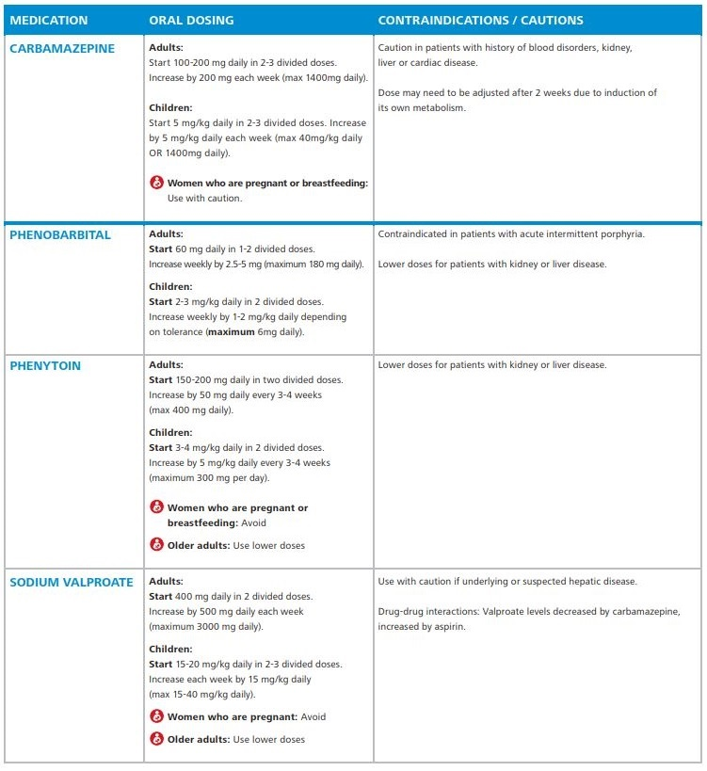

STOPPING EPILEPSY MEDICATION
The majority of patients will have no more convulsions after a few years on medication.
Consider stopping medication if the patient has had no convulsions for more than 2 years
AND has a normal neurological examination
Discuss the possibility with the patient and take the decision together. Some patients will be too afraid of having convulsions if medications are stopped, other patients will wish to stop as soon as possible.
- More than 60% will have no more convulsions if medication is stopped.
- Less than 40% will start having convulsions again after medication is stopped.
If you and the patient decide to stop the medication, you must gradually decrease the medication every 4 weeks.

Schedule for adult patients:
- Decrease carbamazepine by 100mg every 4 weeks.
- Decrease phenobarbitone by 30mg every 4 weeks.
- Decrease sodium valproate by 200mg every 4 weeks.
If switching anti-epileptic medication do not stop any of the medications suddenly.

PREVENTION
- Take long-term epilepsy treatment to prevent new seizures.
- Teach families about the coma position and how to prevent aspiration after a seizure. If seizure not stopping by itself after a few minutes must go to the clinic.

STROKE
A stroke, also called a cerebro-vascular accident (CVA), is the sudden death of cells in a specific area of the brain due to a problem in the blood supply to a region of the brain. The brain tissue beyond that artery is damaged or dies. (Brain cells need blood to supply oxygen and nutrients and to remove waste products.)
The effects of a stroke depend on how much damage occurs, and which part of the brain is affected.
**STROKE IS A LIFE THREATENING EMERGENCY**
Using FAST technique can be very helpful.
F - Facial weakness: Has their face fallen on one side? Can they smile?
A - Arm weakness: Can the person raise both arms and keep them there? Is there weakness on one side?
S - Speech and communication difficulties: Is their speech slurred?
T - Time: Time is important, needs URGENT to transfer to the hospital if you see any single one of these signs.

**Note: hypoglycaemia can also cause these symptoms. Treat hypoglycaemia if the dextrose is low. If the patient does not recover when the dextrose is normal, then think of stroke.**

CAUSES
1. Ischaemic stroke: caused when a blood vessel supplying the brain becomes blocked. This can happen due to hardening of the arteries (arteriosclerosis), fatty plaques that build up in the arteries (atherosclerosis) or a clot that travels from another part of the body (embolism). Responsible for 80% of all strokes.
2. Haemorrhagic stroke: caused when an artery in the brain ruptures. Responsible for 20% of all strokes. Hypertension is the most common cause of brain haemorrhage. Other causes: aneurysms (weakness of the wall of blood vessels) and arteriovenous malformation (an abnormal connection between arteries and veins)
3. Transient ischaemic attack (TIA): also known as temporary or mini stroke causes symptoms similar to those of a complete stroke, however the symptoms disappear completely within 24 hours as the disruption of blood supply is only temporary (in a stroke, the symptoms are usually more permanent). It is a serious warning sign of worsening cerebrovascular disease. A complete stroke may follow a TIA in a matter of hours or weeks to months.
A stroke may also be caused by different infections: malaria, tuberculosis, cysticercosis and syphilis.

RISK FACTORS
Age The risk of stroke increases with age, especially after age 55.
Sex Men are at greater risk than women.
Family People with a family history of stroke have an increased risk of stroke themselves.
Diseases People with diabetes, heart disease especially atrial fibrillation (irregular heart beat), high BP, HIV or prior stroke are at greater risk of stroke.
Lifestyle Stroke risk increases with obesity, cigarette smoking, alcohol consumption and use of IV drugs.

DIFFERENTIAL DIAGNOSIS
1. Hypoglycaemia 5. Brain abscess
2. Cerebral malaria 6. Brain tumour
3. Complex migraine 7. Head trauma
4. Meningitis/encephalitis

SIGNS AND SYMPTOMS
Depending on the region of the brain affected. Strokes on the left side of the brain primarily affect the right half of the body, and vice versa. In addition, in left brain-dominant people, left-brain strokes usually lead to speech and language deficits. A stroke can cause:
- Limb weakness – usually one sided
- Acute severe headache – described as ‘worst headache of my life’
- Facial weakness – drop of one side of the face
- Speech impairment
- Memory loss and reduced reasoning
- Loss of vision
- Initial low tone followed by high tone and
- Reduction in sensation increased reflexes and up going plantars on side affected
- Haemorrhagic stroke: more likely to get loss of consciousness, seizure, vomiting, very high BP
  - Coma
  - Death

DIAGNOSIS
Clinical diagnosis
- If acute symptoms then refer to hospital immediately
- If chronic symptoms: careful medical history, especially about when the symptoms started and what parts of the body are affected, and the presence of risk factors. Ask about any previous similar symptoms to see if the patient has had TIAs before.
- Perform a neurological examination.
- Ideally a CT scan or MRI scan should be done to confirm stroke and rule out other causes e.g. tumour
- ECG is important to look for abnormal heart rhythms or heart abnormalities which can make people more at risk of stroke.
- Check dextrose to rule out diabetes
- If available: ultrasound scan of the carotid arteries to see if there is any blockage.

TREATMENT
Treatment of Acute stroke:
Table 34 General Management of Patients with Acute Stroke
Blood glucose | Treat hypoglycemia with D50  Treat hyperglycemia with insulin if serum glucose >200 mg/dL
Blood pressure
Cardiac monitor | Continuous monitoring for ischemic changes or atrial fibrillation
IV fluids | Avoid D5W and excessive fluid administration  IV isotonic sodium chloride solution at 50 mL/h unless otherwise indicated
Oral intake | NPO initially; aspiration risk is great, avoid oral intake until swallowing assessed
Oxygen | Supplement if indicated (Sa02< 94%)
Temperature | Avoid hyperthermia; use oral or rectal acetaminophen and cooling blankets as needed

Long-term treatment:
- Fever: sometimes a stroke can cause a mild fever, but need to rule out other causes as a stroke makes people more at risk of infection.
- Fluids: in an acute stroke do not give D5W as this can worsen the blood flow to the brain.
- Medication to lower the BP should be used very cautiously as it can cause more damage – discuss with a doctor.
- Check dextrose BID and correct if low
- Start feeding as soon as possible. Strokes can affect the nerves that make the muscles of swallowing work. This means that there is a risk of food and liquid ending up in the lungs which can cause an aspiration pneumonia. When patients feed they should be sitting up right, try to have thickened fluid, and they may need a soft diet. If the patient starts to cough when eating, stop and re-start again when stop coughing. Explain this to the family.
- Encourage the patient to move their limbs especially the weak side to try to re-gain the strength. Encourage the family to help massage and move the limbs.
- Long term aspirin might be beneficial in some patients – discuss with a doctor.
- If available patients may benefit from a rehabilitation programmes for strokes which include physical, speech, language and mental therapy.

PREVENTION
- Treat diseases that put patients at risk e.g. medications for high BP, diabetes
- Give prophylactic aspirin treatment for conditions e.g. angina).
- Advise your patients about lifestyle advice - to stop smoking, do regular exercise, eat healthy diet and avoid excessive alcohol consumption.
- Education of the community about early recognition of stroke symptoms is important: early treatment depends on the victim, family members or other bystander.

NUTRITION

Six essential nutrients
- Carbohydrates
- Protein
- Fats
- Minerals
- Vitamins
- Water

Carbohydrates

Breads | Fruits | Cereals
Pasta/Grains | Milk/Yogurt | Vegetables/Beans
Soups | Snacks | Sweets
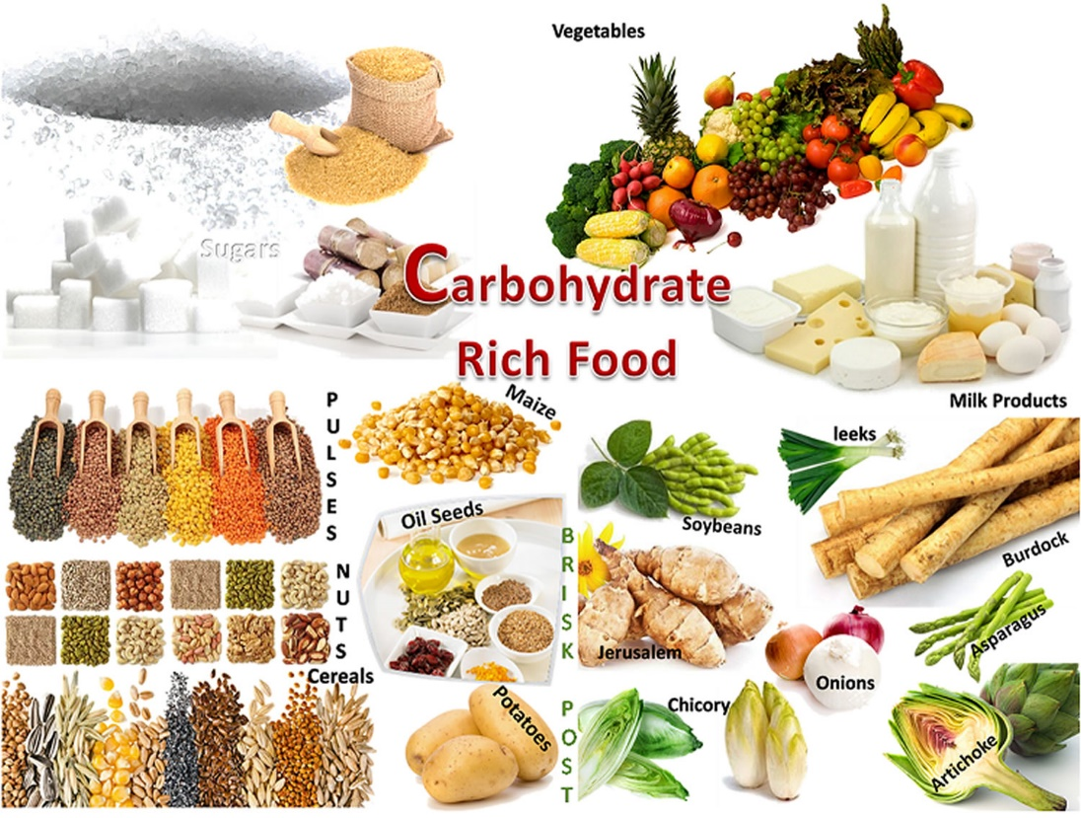
Figure 42 Carbohydrate rich foods

Proteins
Proteins are body-building foods. They are necessary for proper growth for making healthy muscles, brain, and many others parts of the body. To grow and to be strong, everyone should eat enough proteins every day.
Food rich in proteins  - Beans  - Milk products  - Meat  - Eggs  - Fish  - Nuts | 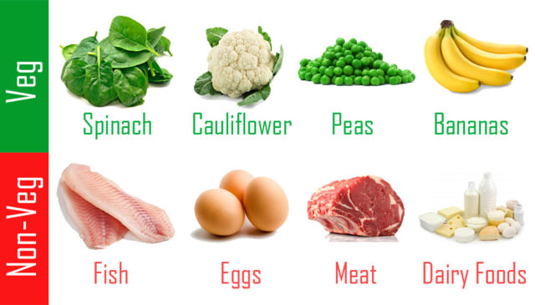  Figure 43 Protein rich foods

Fats
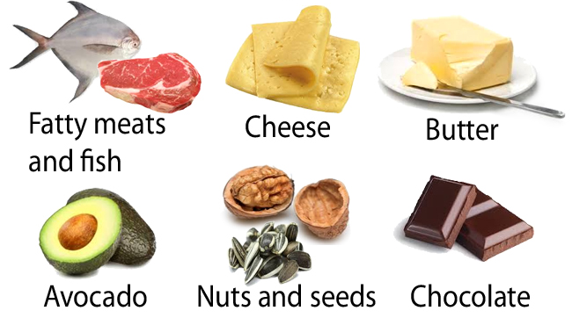
Figure 44 Fats rich foods

Important vitamins and minerals
Important vitamins and minerals: iron, folic acid, calcium, iodine and vitamin A.
Iron:
Iron is needed to make blood healthy and to help prevent anemia. A woman needs to get a lot of iron, especially during her pregnancy.
Table 35 Iron rich foods
Foods rich in iron | Foods with a little of iron
Liver, heart, kidney  Blood  Chicken  Eggs  Fish  Beans  Grasshoppers, crickets, termites  Peas | Cabbage with dark colored leaves  Potatoes  Cauliflower  Lentils  Sunflower, sesame and pumpkin seeds  Dark green vegetables  Pineapples  Dried fruits

Folic acid:
Folic acid is needed to make healthy the RBC. Lack of folic acid can lead to anemia in women, and severe problems in newborn babies. Getting enough folic acid is especially important during pregnancy.
Table 36 Folic acid rich foods
Food rich in folic acid
Dark green leafy vegetables
Whole grains
Mushrooms
Liver / Peas and beans
Meats / Eggs
Fish / Nuts

Calcium:
Calcium is needed to make bones and teeth strong, especially needed for growing children, pregnant and lactating women and elderly people.
Table 37 Calcium rich foods
Food rich in calcium
Milk, curd, yogurt, cheese
Ground sesame
Bone meals
Green leafy vegetables
Almonds, beans, especially soy
Shellfish, Lime

Iodine:
Iodine is needed to prevent a swelling on the throat called goitre, and other thyroid problems.
Easiest way to get enough iodine is to use iodized salt instead of regular salt.
Or if available, you can eat:
- shellfish
- fish, fish paste
- seaweed
- cabbage

Vitamin A:
Vitamin A is needed to prevent night blindness and helps fight against some infections. It’s essential for healthy skin. A lack of vitamin A also caused blindness in children.
By eating foods rich in vitamin A during pregnancy, a woman can increase the amount of vitamin A her baby will get in breast milk.
Table 38 Vitamin A rich foods
Food rich in vitamin A:
Dark green leafy vegetables  Yellow and orange fruits  Red palm oil  Eggs  Liver, kidney  Fish liver oil  Carrot and yellow colored vegetables and  fruits (pumpkin, ripe mango, ripe papaya) | 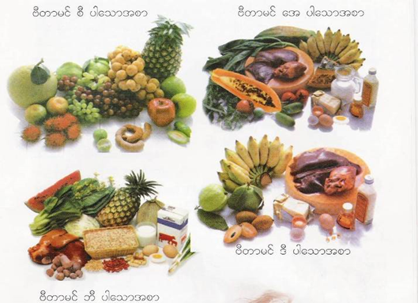

Others vitamins:
Table 39 Other vitamin rich foods
Name | Food sources | Function
Vitamin B1 | Brown rice  Green leafy vegetables  Beans and banana | To prevent Beri-Beri,  depression, anorexia  Needed especially in pregnant and lactating women and their babies
Vitamin C | Citrus fruits  Pineapple, melons  Dark green leafy vegetables | Needed for the proper healing  of wounds and health of the  body tissues
Vitamin D | Dairy products  Fish liver oil, eggs  Sunlight | Needed to help the body to  Absorb calcium from food.

Water
Water is your body's most important nutrient, is involved in every bodily function, and makes up 70- 75% of your total body weight. Water helps you to maintain body temperature, metabolize body fat, aids in digestion, lubricates and cushions organs, transports nutrients, and flushes toxins from your body.
Everyone should drink at least 64 ounces per day, and if you exercise or are overweight, even more. Your blood is approximately 90% water and is responsible for transporting nutrients and energy to muscles and for taking waste from tissues.

MALNUTRITION

Causes of malnutrition
Table 40 Causes of malnutrition (ref: TBC)
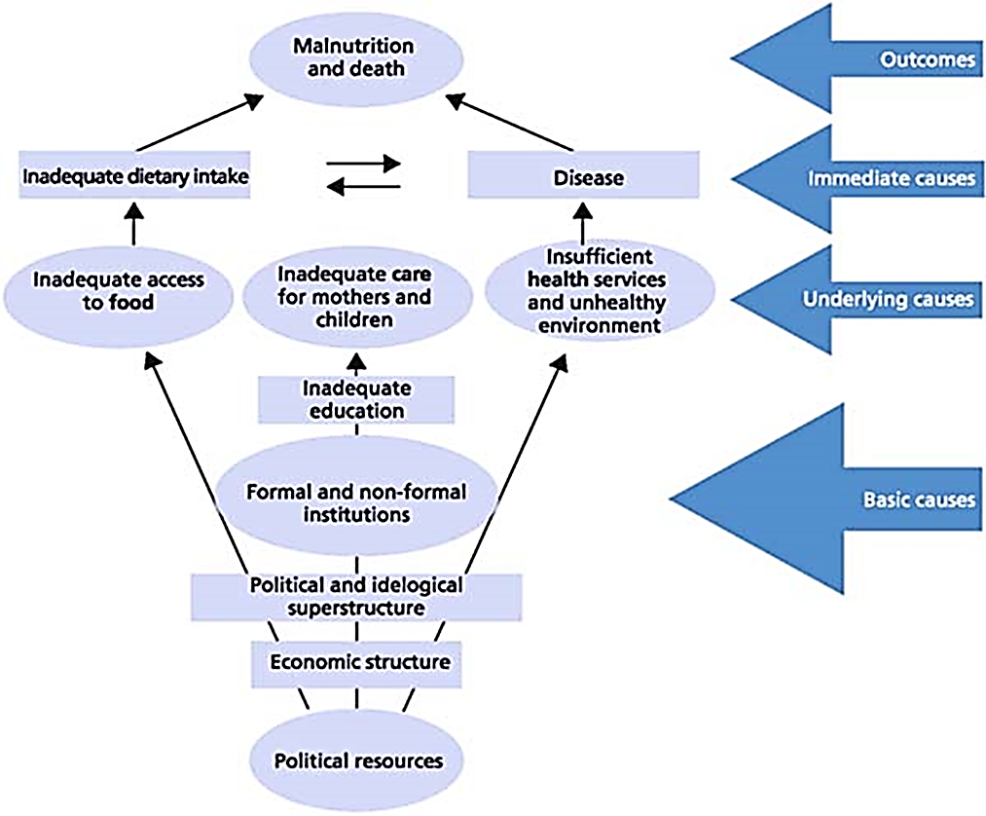
Children under age 5 can become easily malnourished if they are not given enough, various and frequent meals, especially at the time of weaning.

How to prevent malnutrition?
Any child malnourished during his growth may have consequences in his/her development (physical and/or mental). To prevent malnutrition, nurse duty is to inform people about appropriate nutrition and especially to educate mother and future mothers on how to nourish their children:
- Nurse explains to the people the best foods for health.
- Nurse explains to the mother that breastfeeding is the best way to give food to her baby. She should breastfeed as long as possible.
- Nurse explains that when the baby is 4 months old, mother must give some extra food. The mother’s milk is still very good for the baby, but the baby needs more food.

Mother can continue breastfeeding and starts to give to the baby some meals: e.g. some vegetables that she washed then mixed and boiled, then mash them and add the water from the cooking which will be full of vitamins and proteins. Chicken soup is also very healthy.
Nurse should always advise a mother on nutrition even if the baby is not malnourished. Take each opportunity to do preventive education about hygiene, diarrhoea, or nutrition when you receive a patient.
In prevention and to detect early malnutrition:
- All children < 5 years coming to IPD or OPD should have their weight for height (Z-score) routinely checked.
- Children from 0 to 3 years are checked monthly during growth monitoring day
- Children from 3 to 5 years are checked every 6 months

Types of acute malnutrition
There are different kinds of malnutrition: chronic and acute. It can be severe or moderate in each category. Acute malnutrition can be moderate or severe according to ‘Weight for Height’ measures. Different tools exist in order to measure it.
Moderately malnourished children (Moderate Acute Malnutrition – MAM) will be followed in OPD in a Supplementary Feeding Program (SFP).
Severely malnourished children (Severe Acute Malnutrition – SAM) will be admitted in emergency in IPD to a Therapeutic Feeding Programme (TFP).
The severe acute malnutrition is divided among marasmus and kwashiorkor.
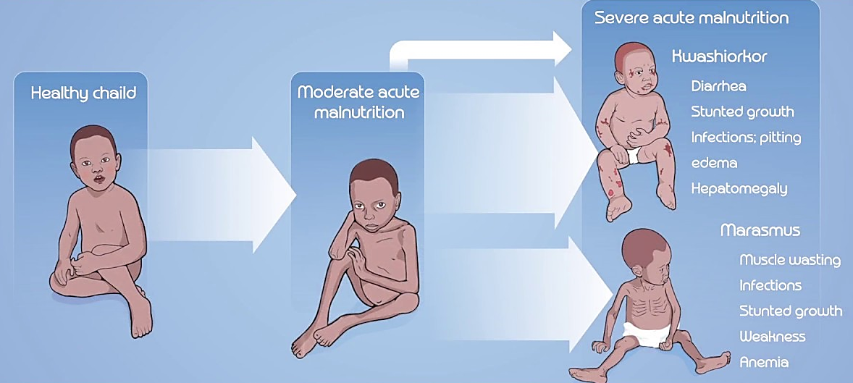
Figure 45 Kwashiorkor and Marasmus

Dry malnutrition: MARASMUS malnutrition.
This happens when a person doesn't eat enough all kinds of food (like protein, energy food, energy storage food...). It often happens when the weaning (stop breastfeeding) is too early (= before 1 year) and the baby doesn't receive enough milk. It can also happen when the baby gets diarrhoea or has a mouth disease.
Signs and symptoms  - Very underweight and undergrowth, very weak  - Only skin and bones, no more muscle  - Swollen belly  - Face of an old man  - Always hungry but often vomits | 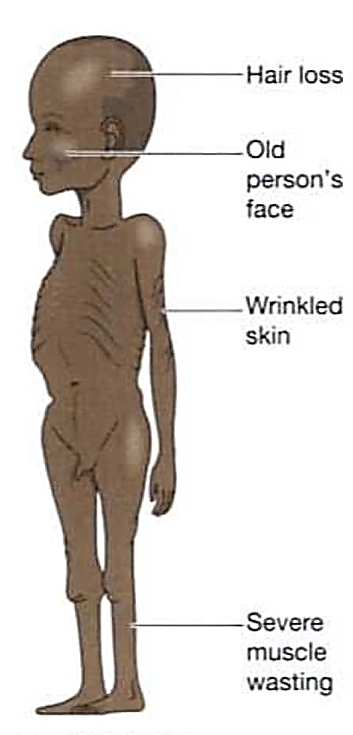  Figure 46 Marasmus

Wet malnutrition: KWASHIORKOR malnutrition
This is due to not enough protein.
It often happens when the weaning is at the normal age but only with rice and no vegetables, fruits or meat. It can also be caused by infectious or parasite disease.
Signs and Symptoms  - Underweight and undergrowth  - Swollen hands and feet  - Thin upper arms  - Moon face: oedema on the face  - Sores and peeling skin  - Loss of appetite (doesn't want to eat) | 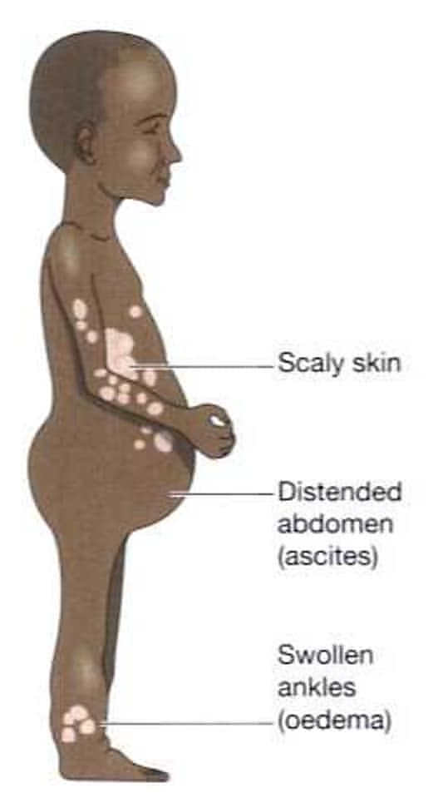  Figure 47 Kwashiorkor

Complications of acute severe malnutrition
Dehydration
Can be caused by not drinking enough, no food, or because of diarrhoea
Diarrhoea
Poor nutrition decreases immunity system and so the body reactions against infection. A malnourished child can more easily get diarrhoea.
Infectious disease
Small diseases like common cold are worse and last longer. A malnourished child can die easily from a small disease.
Parasitic diseases
Vitamin A deficiency
This will cause dryness of the eyes and skin disease
Anemia
Cardiac failure
Cardiac failure is a complication of the medical treatment: too quick rehydration by IV fluids or many foods at the same time. It's suddenly too much work for the heart.

How do we check malnutrition?

MUAC
The MUAC (Mid Upper Arm Circumference) measures rapidly acute malnutrition in children or in pregnant and lactating women (See in appendix). The nurse should always use it with arm hanging down and left arm

Weight for Height for children from 6 months to 10 years old (Z score)
For children from 6 months to 10 years (or under 130 cm), the best way to evaluate the malnutrition is to measure the weight and height. All children <5 years old coming to OPD or IPD should have their W/H% checked.
- Take the child's weight with the baby scale and measure the height
- Define the Z score using the Z score table (See in appendix)
- Compare with the previous weight registered on the lema

Weight for Height for Adolescents and adults
For adolescents from 10 to 18 years old (or over 130 cm), we measure weight and height and use a chart with ‘percentage of median.’ (See in appendix).
For adult, we check BMI (Bio Masse Index) (See in appendix).

MODERATE ACUTE MALNUTRITION MANAGEMENT

Nutrition assessment
Remember if they have oedema they have Severe Acute Malnutrition (SAM) even if their W/H Z-Score is ≥ -3 SD – they need admission to IPD.

Management
Do not get distracted and only treat the presenting complaint (which is unlikely to be malnutrition!)
Moderate acute malnutrition is a serious condition as the child will be at high risk of losing more weight and becoming severely malnourished (SAM).
Optimal management of MAM requires a special supplementary feeding program. Assess for the possible cause of acute malnutrition
- Focused health education +++
- Systematic supportive treatment
- Dry food for children within criteria
- Regular follow up

Assessing for possible causes and Health Education
When assessing the child it is important to look for a cause for the MAM.

Possible causes | Questions to ask | To do/advise
Social situation | Is the child living in stable home, has the carer recently changed? | Ask carer to contact parents and if possible come to clinic for next visit
Social situation | Is there a new younger child in the family or lots of children? | Give education about weaning and family planning
Social situation | Is the parents’ income unstable?  Not enough food for family? | Health education about nutritious food with low income
Diet/feeding | Does the carer know about nutritious food? | Ask feeding history  Give education
Diet/feeding | Feeding patterns – how often does the child eat? | Give education
Diet/feeding | Has the child recently stopped breastfeeding? | Give education about weaning
Diet/feeding | Does the child have a feeding difficulty? | Assess swallow and give safe feeding advice  Consider admitting for safe feeding assessment and training especially if history of pneumonia  Does the child fit criteria for dry food?
Other disease | Does the child have any acute illness | Complete IMCI chart and consider admission  Check Hb and malaria smear in all patients with MAM
Other disease | Does the child have signs of TB or HIV | If suspect discuss with senior staff and consider TB screening and referring to VCT for HIV test  Remember TB is common

Investigations
- Hb and malaria smear for all patients

Systematic supportive treatment
Treatment | Age/weight | Drug and dose | Duration
Deworming | 12-23 months | Albendazole 200 mg OD | 3 days
Deworming | ≥ 2 years | Mebendazole 100 mg BD | 3 days
Vitamin A* | < 6 months | 50,000 IU | D1, D2, D8
Vitamin A* | 6-11 months (< 8 kg) | 100,000 IU | D1, D2, D8
Vitamin A* | ≥ 1 year (≥ 8 kg) | 200,000 IU | D1, D2, D8
Vitamin B1 |  | 10 mg OD | 6 weeks
Folic acid |  | 5 mg once per week | 3 months
Ferrous sulphate | < 5 kg | 50 mg OD | 3 months
Ferrous sulphate | 5-9 kg | 100 mg OD | 3 months
Ferrous sulphate | ≥ 10 kg | 200 mg OD | 3 months
Zinc | < 6 month | 10 mg OD | 2 weeks
Zinc | ≥ 6 month | 20 mg OD | 2 weeks
*Do not give vitamin A if they have received a dose in the last 1 month

Immunisations
- Remember to check the immunisation status and refer to immunisation department.

Follow up
Explain to parents that follow up is important, if they are able to come back. Arrange 2 weekly follow up if the family’s social situation is able to manage this.
Follow up for MAM should continue if possible until the weight for height is > -1.5 SD.

SEVERE ACUTE MALNUTRITION MANAGEMENT

Important background information to remember before treating SAM
Children with SAM have to be managed differently from other patients because their body has started to shut down their cells and organs changing the physiology. They will not respond to treatment in the same way as a patient with normal nutrition. This process is called:

Reductive Adaption

In severe acute malnutrition the body conserves energy by:
- reducing physical activity and growth
- reducing metabolism
- reducing inflammatory and immune responses
Liver is less able to:
- make glucose - risk hypoglycaemia/hypothermia
- make albumin, and other transport proteins
- excrete excess dietary protein and toxins
Kidneys are less able to:
- excrete excess fluid and Sodium (Na) - risk of fluid overload
Heart
- smaller, weaker, reduced output - risk of cardiac failure
Gut
- Less gastric acid, less enzymes, less motility, damaged mucosa - limited digestion and absorption
Na leaks into cells
- Too much Sodium (Na), fluid retention
K leaks out of cells
- electrolyte imbalance, anorexia, fluid retention, heart failure
Loss of muscle
- loss of Potassium (K), Magnesium (Mg), Zinc, Copper; less glycogen (stored sugar)
Number of red blood cells is reduced
- liberates ‘free’ iron; ‘Free’ iron makes infections worse; generates free radicals.

Stages of treatment:
There are 3 main stages of treatment:
- Phase 1 (stabilisation)
This is the time during which the child has infection treated, and is stabilised. The child will not gain weight during this time.
- Transition
Once the child’s apetite has returned they will go through transition period. During this time they will change to a higher energy feed.
- Phase 2 (rehabilitation)
This is the time of catch up growth where the child will rapidly gain weight.

The WHO advises there are 10 steps for acute management:
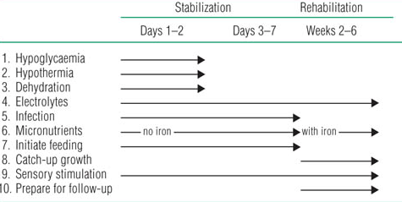

Hypoglycaemia
Increased risk of hypoglycemia in SAM due to:
Reduced glucose supply:
- Less food intake
- Reduced gluconeogenesis in liver
- Less glucose stored in muscle
Increased glucose demand:
- Used to fight infections
- Used to try to keep warm
Hypoglycamia = Blood glucose < 3 mmol/l (< 54 mg/dl)
Check blood glucose immediately on admission.
If no blood glucose test available treat for hypoglycaemia.

Treatment
- If possible give oral or Nasogatsric (NG) 50 ml 10 % dextrose
- If severe give IV 5 ml/kg 10 % dextrose bolus
- Then start regular F-75 feeds
(may need hourly or 2 hourly at the start)
- Repeat the blood glucose test after 1 hour
- If still low repeat either oral or IV bolus as above
- Consider checking blood glucose TID for first 2 days
- Repeat blood glucose if temp falls < 35.5⁰C or becomes drowsy or seizure
All SAM new admissions must have their F-75 feeds day AND night.
Hypoglycaemia at night is a common cause of death with SAM.

Hypothermia
Increased risk of hypothermia in SAM due to:
- Less insulation from fat
- Less food intake, so less energy and heat from food
- Lethargic, so less heat produced from movement
Note: Hypoglycemia and hypothermia usually co-exist
Definition - Hypothermia is:
- rectal temperature < 35.5 °C (95.9 °F)
- or axilla temperature < 35 °C (95 °F)
Actively re-warm the child:
- ‘Kangaroo care’ – skin to skin contact between child and mother and keep child’s head covered – safest method
- OR use heater or hot water bottles
(must be wrapped in blankets to avoid burns).
Monitor every 30 min to avoid overheating. Stop re-warming when temp is normal
Start regular feeds – this will provide the energy for the child to make heat and warm up.
Always be aware of risk of hypothermia – take action early to prevent temperature falling:
- Keep warm especially at night
- Keep dry – change wet clothes and blankets regularly
- Don’t expose for long periods
- Feed regularly – 2 hourly
- Avoid keeping child near open window or door
Prevent pressure sores:
- If the child is very weak and not able to sit, they should have their position changed at least every 2 hours to prevent pressure sores.
- Make sure they are lying on a soft dry blanket or mattress. Use cushions to relieve pressure, particularly if the skin is broken.

Dehydration
It is very difficult to assess clinical signs of dehydration with SAM because many of the signs are present even with no dehydration. If the child has watery diarrhoea you can assume they are dehydrated.

SAM patients need special Oral Rehydration Solution (ORS) with less Na and more K, that is called Rehydration Solution for Malnutrition (ReSoMal). Never use the normal ORS unless cholera is suspected.
Do not use IV fluid unless patient is in shock or cannot tolerate ORS.
If dehydration:
- Give 5-10 ml/kg/hour ORS for the first 4-10 hours.
- Adjust the amount according to how much diarrhoea and vomiting and the response.
- Once dehydration improved replace the ORS with F-75 for example at hours 4,6,8 and 10 and then continue 2 hourly F-75
- Use severe chart for 1-2 hourly observations until stabilised

Electrolyte imbalance
Do not give fluid with high Na, or food with salt.
All children with SAM have too much Na in their body (even if their blood level is low).
They will have low K and Mg.
It may take 2 weeks for the electrolytes to become normal.
Do not give diuretics for oedema.

Give systematic K and Mg to all children:
Potassium: < 5 kg give ½ tab (250 mg) BD for 2 weeks
≥ 5 kg give 1 tab (500 mg) BD for 2 weeks
Magnesium: Give 50 % magnesium sulphate intramuscularly stat
(0.3 ml/kg max 2 ml)

Infection
- Check malaria smear
Children with SAM often will not have fever or inflammation so infection is easy to miss
- Start antibiotics even if no obvious sign of infection
See box below
- Check HIV test
- Take history for TB and consider Chest X-Ray (CXR) or /NG aspirate.
- If immunisations not up to date refer to immunisation department when the patient’s condition is stable

Patient condition | Antibiotic | Duration
If stable | PO amoxicillin 25 mg/kg TID | Give for 5 days  If at 5 days patient still has no appetite, continue antibiotics for 10 days
If unstable | IV/IM ceftriaxone 50 mg/kg/day OD  (80 mg/kg/day if suspect meningitis)
If suspect aspiration pneumonia  or abdominal infection | Add PO metronidazole 7.5 mg/kg TID

Micronutrient deficiencies
All children with SAM will have micronutrient deficiency.
Iron should not be started until child is in phase 2 because iron can make infections worse at the start of treatment.

Give the following supplements:
 | Age | Dose | Duration
Vitamin A* | < 6 months | 50,000 IU | D1, D2, D8
Vitamin A* | 6-11 months (< 8 kg) | 100,000 IU | D1, D2, D8
Vitamin A* | ≥ 1 year (≥ 8 kg) | 200,000 IU | D1, D2, D8
Vitamin B1 |  | 10 mg OD | 6 weeks
Folic acid |  | 5 mg on admission and then once per week | 3 months
Zinc | < 6 month | 10 mg OD | 2 weeks
Zinc | ≥ 6 month | 20 mg OD | 2 weeks
Multivitamin |  | 1 tsp OD | 2 weeks
Iron | (start in phase 2) See dose in chapter 2

Severe anaemia
It is common for children with SAM to have a low Hb, however due to the risk of infection iron supplements should not be started until phase 2
Give blood transfusion if Hb is:
- < 4 g/dl or
- 4-6 g/dl with difficult breathing or clinical signs

If you give transfusion:
- Give 10 ml/kg slowly over 4 hours.
- Give 1 mg/kg furosemide with the transfusion.
- Do not repeat the transfusion within 4 days even if Hb is still low. Repeated blood transfusion will increase the risk of heart failure.
- Once in phase 2 start iron supplements ferrous sulphate 3 mg/kg/day for 3 months.

Initiate feeding - start milk feeds

Phase 1 (stabilisation)
The priority during phase 1 is:
F-75 milk has 75 kcal / 100 ml
and 0.9 g protein / 100 ml
- treat infections
- correct electrolyte imbalance
- get rid of oedema
- get organs and cells working
Phase 1 (stabilisation phase) may take 2-7 days – during this time there may not be any weight gain.
During phase 1 the child’s intestines cannot tolerate complex foods. The child should not be given other foods until they are stable. If the child is breastfed, the mother should be encouraged to continue breastfeeding, but also give the F-75.
F-75 milk is designed to provide the right balance of protein (1-1.5 g/kg/day) and carbohydrate (100 kcal/kg/day).
The carer will need good education and demonstration how and why to give the feeds regularly. They will need to be observed to make sure they are feeding correctly.
- Start 130 ml/kg/day (or 100 ml/kg/day if oedema +++)
- If very unwell give 1-2 hourly feeds
- Once stable can start 3 hourly feeds
- Always try to give by spoon/cup/syringe
- Check for a safe swallow
- If too weak to take milk or swallow not safe, insert NG tube

Nasogastric feeds
- Insert NG tube if:
- Intake is < 80 % for 2 or 3 feeds
- Remove NG tube if:
- Child takes 80 % of day’s amount orally OR
- 2 consecutive feeds fully by mouth
- Always offer orally first if the child can swallow safely
- Always aspirate the NG tube before giving feed to check position and check absorption of previous feeds
Example: A child weighs 5.4 kg. Total milk for 1 day = 130 x 5.4 = 702 ml.
To calculate 80 % of the intake = (total feed/100) x 80
= (702/100) x 80
= 7 x 80
= 560 ml
So if she takes less than about 560 ml in one day the intake is not enough.

F-75 – isotonic – for diarrhoea
This is a special F-75 with rice powder. It is good for children with diarrhoea. In MTC it is the most common F-75 used.

Transition
F-100 milk has 100 kcal / 100 ml
and 2.9 g protein / 100 ml
The main sign that the child is improving and ready to move to phase 2 is if they have an appetite and any oedema is better.
Some children with neurological disorders may not be easy to assess. Change to phase 2 if clinically they are improving and they are tolerating the F-75 (not vomiting/diarrhoea).
- Change to F-100 130 ml/kg/day
- Give this volume for 48 hours
- Then increase by 10ml/kg/day until the child does not eat all the milk
i.e. 140 ml/kg/day, then 150 ml/kg/day, then 160 ml/kg/day …
- Usually the child will take 200 ml/kg/day
- If at any time the child does not tolerate the transition either try decreasing the volume, or go back to F-75 130 ml/kg/day until condition is stable.

Catch up growth

Phase 2 (rehabilitation)
This is the time when the child will gain weight quickly. They should have unlimited milk.
- Feed freely up to 220 ml/kg/day
- Minimum intake 150 ml/kg/day
- Feed 3 hourly
- Do not leave child alone to eat
- Actively encourage eating
- Record amounts offered and taken to decide if intake is enough
- Senior staff should review daily the milk volumes

Monitoring weight gain
Weigh the child every day.
If weight gain is:
- Poor (< 5 g/kg/d), child requires full reassessment including looking for infection, TB, HIV.
Check child is being given all feeds (espacially all night feeds).
- Moderate (5-10 g/kg/d), re-calculate weight gain within next week. If not improving, fully reasess the child as for poor.
- Good (≥ 10 g/kg/d), carer and staff are doing a good job – continue!
Example: g/kg/d = Weight gain/weight/number of days
Day 10 weight 4.8 kg, Day 17 weight 5.1 kg
The child has gained 300 g (5.1 kg - 4.8 kg = 0.3 kg = 300 g)
Weight gain 300 g. Weight = 5.1 kg. Number of days = 7
(300 / 7) / 5.1 = 8.4 g/kg/d = moderate weight gain

Discharge planning and follow up
Before discharge the carer should have a plan about what and how to feed the child at home. Discuss with the carer and give suggestions, how in their situation they will manage to feed the child each day – who will cook, how often, what food.
Before discharge the child should have:
- Weight for height ≥ 2 SD
- Good appetite
- No untreated infections
- Immunisations up to date
- Plan for follow up
- Recheck height before discharge

VITAMIN DEFICIENCIES

VITAMIN A DEFICIENCY
Vitamin A deficiency is a major cause of blindness, and is a significant factor in many childhood illnesses, especially diarrhoea and pneumonia. Vitamin A deficiency mostly affects small children but can also affect adults, especially women of reproductive age.

SIGNS AND SYMPTOMS
The signs and symptoms of vitamin A deficiency are found in the eyes. These include night blindness (‘chicken blindness’), Conjunctival dryness, Bitot’s spots (grey-white spots on conjunctiva), dry cornea and some types of cornea damage.

DIAGNOSIS
Early clinical recognition and treatment are important to avoid severe complications and permanent blindness.

TREATMENT
Children less than 6 months  Day of diagnosis (D 1) - 50,000 IU  Next day (D 2) - 50,000 IU  One week later (D 8) - 50,000 IU | Children age 1 year and older and adults (>8 kg)  Day of diagnosis (D 1) 200,000 IU  Next day (D 2) 200,000 IU  One week later (D 8) 200,000 IU
Children between 6 and 11 months (<8 kg)  Day of diagnosis(D 1) 100,000 IU  Next day (D 2) 100,000 IU  One week later (D 8) 100,000 IU | Women of reproductive age  25,000 IU once a week for 8 weeks

Vitamin A capsules are available in two sizes: 200,000 IU (International Units) and 25,000 IU capsules. Read the bottle for the strength of the capsules. Write down carefully on the record the date and dose of treatment.
Treatment for pregnant woman:
- In case of night blindness and Bitot’s spot: Vitamin A 10,000 IU PO daily OR 25,000 IU PO per week for at least 4 weeks
- In case of corneal dryness and corneal ulcer/ keratomalacia risk of blindness outweighs risk to baby:
  - Day of diagnosis (day 1) 200,000 IU
  - Next day (day 2) 200,000 IU
  - 1 Week later (day 8) 200,000 IU

Give a treatment dose of vitamin A even if they have received a recent prevention dose to:
- All patients with confirmed signs or symptoms of vitamin A deficiency
- All cases of moderate and severe malnutrition
- All children with measles
- All children with severe respiratory infections and severe diarrhoea requiring admission to IPD

PREVENTION
The cause of vitamin A deficiency is a lack of food containing vitamin A. This is found in leafy green vegetables, eggs, many kinds of meat, mango, papaya, pumpkin and many fruits. The mother’s breast milk is a very important source of Vitamin A. Rice, bananas and oranges contain little or no vitamin A.
As many people cannot afford meat, eggs and other foods with vitamin A, capsules need to be distributed to children to prevent deficiency. A single dose of 200,000 IU will provide one child with enough vitamin A to last for four to six months.

New born | 50,000 IU | at birth
Less than 6 months (if not given at birth) | 50,000 IU
Children 6 months to one year | 100,000 IU | every 4-6 months
Children one year and older | 200,000 IU | every 4-6 months
Mothers (within 1 month of delivery) | 200,000 IU | at delivery of baby and 200,000 the next day

Most capsules are 200,000 IU (International Units) in strength. If you need to give a smaller dose, such as 100,000 IU cut the capsule with scissors and give 3 drops to the child.

Do NOT give a high dose to a woman who is pregnant or could be pregnant (age 15 – 50 years).

If a treatment dose has been given in the past 1 month, do not treat again. Wait for one month to pass between treatments and re-evaluate.

VITAMIN B1 DEFICIENCY
Vitamin B1 deficiency occurs when there is not enough vitamin B1 in the body due to an insufficient diet. This is prevalent on the Thailand/ Myanmar border, especially in pregnant and breastfeeding women and their babies. The disease may present in different ways, known as ‘Dry Beriberi,’ and ‘Wet Beriberi,’ or in combination. In alcoholics or very severe malnutrition, low vitamin B1 levels can cause Wernicke’s Encephalopathy or Korsakoff’s syndrome. Most vitamin B1 deficiency seen on the border is mild.

BERI BERI

IN ADULTS

SIGNS AND SYMPTOMS

A. Dry Beriberi
- Mild
  - Numbness.
  - Burning sensation or tingling in lower legs or hands.

- Severe
  - Weakness: the person cannot walk alone or stand up from squatting position.
  - Reduced tendon reflexes.

B. Wet Beriberi

- Oedema (legs, trunk, face), hepatomegaly.
- Difficulty breathing.
- A rapid pulse that can lead to heart failure.

TREATMENT
Note: take vitamin B1 tablets 1 hour before meals.

For mild deficiency (Mild dry Beriberi)

- Vitamin B1 PO 100mg OD x 7 days. Then 10mg OD x 6 weeks.

For severe deficiency
(Wet Beriberi and Dry Beriberi with severe signs)
- Admit to IPD.
- Vitamin B1 IM 100mg TID for 1 day, then:
- Vitamin B1 PO 100mg OD x 7 days. Then PO 10mg OD x 6 weeks.
- Consider giving B-Complex or multivitamins, as other B vitamins may be deficient in the patient as well.

PREVENTION
Patients should be advised to do the following to prevent vitamin B1 deficiency:
- Eat a variety of foods (for example yellow beans, meat, fruits and vegetables).
- Do not chew betel-nut or lepetho (fermented tea-leaf salad) just before or after eating – wait several hours.
- Wash rice only once before cooking and use the cooking water to make other food
- Advise to eat unpolished rice and to cut down fish paste if possible.

IN INFANTS
Beriberi is common in babies <1 year who are breast-fed and whose mothers have Vitamin B1 deficiency or low intake of Vitamin B1.
Note: this is a very dangerous condition in infants and can lead to death within only a few days.
Emergency

SIGNS AND SYMPTOMS
Think of Beriberi in previously healthy babies when they present with one or more of the following signs:

- Difficulty breathing, or very fast breathing with RR >50/min.
- Clear lungs on auscultation.
- Generalized oedema.
- Voice change or loss of voice.
- Cyanosis.
- Fast pulse.
- Low urine output.
- Not sucking well.
- Enlarged palpable liver.
- Vomiting.
- Convulsions

TREATMENT
Admit to IPD | 50mg (0.5ml) TID for 1 day, then
Vitamin B1 IM | 10mg OD x 6 weeks
Vitamin B1 PO | Vitamin B1 PO 100mg OD x 7 days, then 10mg OD x 6 weeks
Treat the mother: | Tell the mother to stop eating betel nut and snack food (e.g. Tea leaf salad) for 6 weeks as these make the symptoms worse.  Take vitamin B1 tablets 1 hour before meals.  Vitamin B1: 1 vial = 1ml = 100mg.

WERNICKE’S ENCEPHALOPATHY
Wernicke’s encephalopathy is neurological symptoms caused by the effect of low B1 levels on the central nervous system. Most common in people who have a long history of alcohol excess. Symptoms are often reversible with treatment. Alcohol substance abuse.

SIGNS AND SYMPTOMS
Ophthalmoplegia (abnormal eye movements)
- Ataxia (poor balance, unable to walk normally)
- Confusion
- History of alcohol excess/very poor diet
- Seizures
- Memory problems

TREATMENT
- Higher doses of Vitamin B1: 250mg IV/IM TID.
- IM is painful – best to dilute B1 in 100ml NSS and give IV.
- Continue high dose until patient symptoms stop improving.
- Consider replacing other vitamins which are likely to be deficient and long term B1.
- Encourage stopping alcohol
- Encourage good diet and prevention advise above

KORSAKOFF’S SYNDROME
Korsakoff’s syndrome is a neurological condition caused by low thiamine. Associated with chronic alcohol abuse and severe malnutrition. Unlike Wernicke’s encephalopathy some of the symptoms are not reversible with treatment. See p.154 Alcohol substance abuse.

SIGNS AND SYMPTOMS
- Memory loss
- Confabulation – makes up gaps in memory
- Minimal conversation
- Lack of insight (is not aware that has any problems)
- Loss of interest

TREATMENT
- As for Wernicke’s encephalopathy.

SKIN DISEASES

BACTERIAL SKIN INFECTIONS

IMPETIGO
This is a bacterial infection of the skin caused by Staphylococcus aureus. It spreads easily amongst children. Transmission is by direct contact. Often starts around a bite or a scratch. Rash can increase over days to weeks. The lesions are red, round, flattish, with golden coloured crust that are usually 0.5 to 3cm in size. They are sometimes wet. Treat also any other associated skin disease (scabies, ringworm, eczema etc.). | 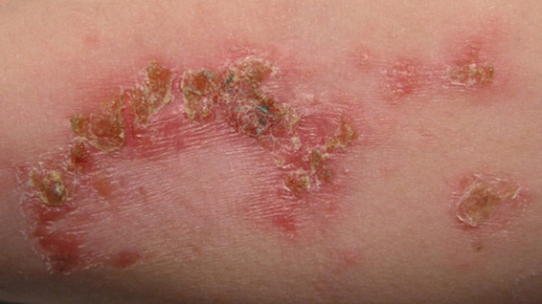  Figure 48 Impetigo

SIGNS AND SYMPTOMS
- Non bullous impetigo (classic form): flaccid vesicle on erythematous skin which becomes pustular and forms a yellowish crust. Different stages of the infection may be present simultaneously. The lesion does not leave a scar. The most common sites of infection are around the nose and mouth, on the limbs or on the scalp.
- Bullous impetigo: large flaccid bullae and erosions of the skin in the Ano-genital region in newborns and infants.
- Ecthyma: an ulcerative form of impetigo that leaves scars. This form is most common in the immunocompromised (e.g. HIV infection, malnutrition), diabetics and alcoholics.
- Regardless of the type of impetigo: absence of fever or systemic signs.

COMPLICATIONS
- Abscess, pyodermitis, cellulitis, lymphangitis, osteomyelitis, septicaemia;
- Acute glomerulonephritis (routinely look for signs of glomerulonephritis).

TREATMENT

- Clean with water and soap or antiseptic (for example gentian violet, povidone, savlon, or chlorhexidine) 2 times per day and dry. Use gentian violet if impetigo is near mucous membranes (eyes, mouth).
- Gently remove the crust after softening them with Vaseline
- Keep dry (if on the buttocks of children, leave them uncovered).
- Cut the fingernails, shave the head if necessary (if a lot of lesions on the head).
- Cloxacillin PO for 7 days
  - Children over 10 years: 15 mg/kg 3 times daily (max. 3 g daily)
  - Adults: 1 g 3 times daily

ABSCESS
This is a collection of pus in the soft tissues, most commonly due to Staphylococcus aureus. There is a red, painful, hot, localized swelling. There may be fever and enlarged lymph nodes. Antibiotics cannot reach the abscess cavity very well so the treatment is to cut open the abscess to allow the pus to drain out (incision and drainage).

Some abscesses are not hot and not painful (‘cold’ abscess). If you find this, think of TB.

TREATMENT

Indurated stage
Amoxicillin PO
Children: 30 mg/kg 3 times daily
Adults: 1 g 3 times daily
+ Metronidazole PO
Children: 10 to 15 mg/kg 3 times daily
Adults: 500 mg 3 times daily
OR
Amoxicillin/clavulanic acid (co-amoxiclav) PO (The dose expressed in Amoxicillin)
Children < 40 kg: 50 mg/kg 2 times daily
Children ≥ 40 kg and adults:: 1 tablet of 875/125 mg, 3 times daily

Suppurative stage
- Surgical drainage

CELLULITIS AND ERYSIPELAS
Acute skin infections, most often due to Group A beta-haemolytic streptococcus, and at times Staphylococcus aureus (including methicillin resistant S. aureus–MRSA). Recurrence is common in adults.

SIGNS AND SYMPTOMS
- Skin erythema, oedema with well demarcated margins, warmth, pain, usually on the lower limbs and at times the face.
- Often with fever, lymphadenopathy and lymphangitis.
- Look for a portal of entry (bite, ulcer, wound, intertrigo, eczema, fungal infection, etc.).
- Rare systemic complications: septicaemia, acute glomerulonephritis.

TREATMENT
- Immobilisation and elevation of the limb (higher than the heart).
- Cool and wet dressing.
- Do not cut open.
- Give ibuprofen for pain and inflammation
- Give antibiotics:

Mild cases
Amoxicillin/clavulanic acid (co-amoxiclav) PO for 7 to 10 days.
(The dose is expressed in amoxicillin)
Children < 40 kg: 25 mg/kg 2 times daily
Children ≥ 40 kg and adults: 1 tablet of 875/125 mg 2 times daily

Severe cases: high fever, patient unwell.

- Admit to IPD, do blood culture
- Start intravenous antibiotics:

Cloxacillin IV infusion over 60 minutes 5
Children 1 month to 12 years: 12.5 to 25 mg/kg every 6 hours
Children over 12 years and adults: 1 g every 6 hours

If there is clinical improvement after 48 hours (afebrile and erythema and oedema have improved) switch to Amoxicillin/clavulanic acid PO at the doses indicated above to complete 7 to 10 days of treatment.

FUNGAL SKIN INFECTIONS

CANDIDA
Fungal infection of the skin or mucous membranes, sometimes also called ‘thrush’. Mostly seen in patients with previous use of antibiotics, diabetes mellitus, decreased immunity or pregnancy. Common types of infection are oral candidiasis and vaginal candidiasis. Oral candidiasis is common in neonates or elderly but unusual for other ages. If find oral candidiasis in other age groups then consider immunosuppression e.g. HIV, cancer.

SIGNS AND SYMPTOMS
- Oral Candidiasis: removable white spots in the mouth, painful and difficult swallowing.
- Vaginal Candidiasis

TREATMENT
Oral Thrush

- Nystatin 400,000 IU/day – give 1 lozenge to be sucked QID for 7 days or 1ml of oral suspension (100,000 IU) QID for 7 days. Oral suspension should be swilled around oral cavity and swallowed.

RINGWORM
Fungal infection of the skin.

SIGNS AND SYMPTOMS
- Round dry lesions that grow slowly (taking weeks to months).
- Dry white scales on the edges with a clearing in the centre, they are very itchy, not painful
- No fever.
- Sometimes there are pustules.
- On the scalp it may be associated with localized loss of hair.

TREATMENT

Local treatment:
- 2 times per day clean with soap and water, dry and apply ketoconazole 2% cream BID for 2 weeks or longer if necessary.
- Other topical antifungals can also be used, such as clotrimazole, miconazole, or whitfield ointment.

Scalp ringworm:
- If on head shave head or cut hair short
- Treat secondary infection first
- If scalp ringworm: need to also give oral antifungals
  - e.g. griseofulvin PO for 6 weeks (can give up to 12 weeks) Child <12yrs: 10-20mg/kg per day (max 500mg per day) Children >12yrs/Adults: 500mg OD (1g OD if severe infection) Contraindicated in pregnant women

Note: men should not make their wives pregnant within 6 months of the griseofulvin treatment, women should wait until 1 month after treatment before getting pregnant.
Note: For adults over 35 years, consider checking baseline liver function tests before treatment, and again at 4 weeks if available.
If there is no improvement, make sure it is not leprosy.

VIRAL SKIN INFECTIONS

HERPES SIMPLEX
Recurrent infection of skin and mucous membranes due to infection with Herpes Simplex Virus. After the first infection, the virus stays in the body and can recur if the person has another illness, is stressed or exposed to cold or sunlight. The infection always happens in the same place. Common places: lips, mouth, eyes and genital area. Herpes is spread by direct contact with lesions. Herpes lesions heal by themselves in approximately 10 days, but they will often recur.
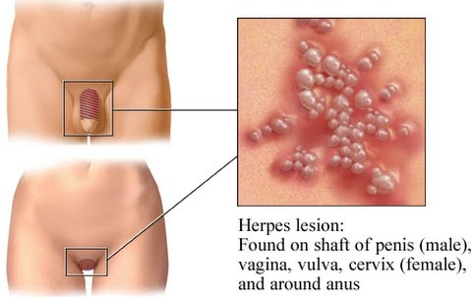

SIGNS AND SYMPTOMS
- Group of small vesicles filled with clear fluid on the skin or the mucosa (mouth or genital area).
- Often the vesicles have broken and become crusted when the patient comes to the clinic.
- Very painful, may have tingling and itching before the lesions appear.
- In the mouth: Pain and difficulty eating. Ulcers in the mouth and on the lips. Often the gums are swollen.

Complications
Infections in the eyes can be severe causing keratitis and blindness.

If a pregnant woman has a genital lesion, it can be very dangerous for the newborn baby because the baby can become infected during delivery.

TREATMENT

Mild/moderate infections:
- No antiviral treatment is needed and supportive care is enough

Severe cases with necrotic lesions or extensive lesions or in the face spreading to the eye:

- Oral acyclovir, if available, 200mg 5 times per day for minimum 5 days, given in the first 48 hours of symptoms starting

On the skin
- Clean lesions with savlon (antiseptic cream) and let dry.
- Apply GV (can be used on mucous membranes)

In the mouth:
- Wash the mouth with warm salty water.
- GV, if secondary infection, treat with amoxicillin.

In the eyes:
- Wash the eyes with cool boiled water.
- Apply ointment to the eye e.g. TEO to keep moist.
- Refer to doctor for consultation.

On the genitals
- Wash with soap and water. Give paracetamol for pain. Condoms help prevent the spread of herpes.
- Men or women who have difficulty passing urine need oral acyclovir.
- Acyclovir is not known to be harmful in pregnancy. Active genital herpes at delivery should have caesarean section.

VARICELLA ZOSTER/CHICKENPOX
This is a very common disease caused by the Varicella Zoster virus, and spreads easily. Other persons in the family or in the neighborhood might have the same symptoms.

SIGNS AND SYMPTOMS
- Slight fever, headache, feeling unwell.
- Itchy, round spots of different sizes with clear liquid inside, some may be crusty.
- Whole body: more on the trunk and less on the arms and legs.

TREATMENT
- Clean with water and soap.
- Cut the fingernails, to reduce damage from scratching.
- Apply GV only on infected spots. Secondary infections: antibiotic treatment.
- Treat the fever with paracetamol.
- Only in cases of severe itching, give PO chlorpheniramine 1-3 days.
- If lesions in the eye treat with an ointment such as Terramycine Eye Ointment.

HERPES ZOSTER (SHINGLES)
A rash caused by the reactivation of the chickenpox virus. It occurs to people that have previously had chickenpox. After you recover from chickenpox, some of the virus (varicella zoster) stays in the body in an inactivated form in the spinal cord. Sometimes the virus becomes active again and causes shingles. It may happen at any age, but frequently in patients with low immunity. More common in adults than children. | 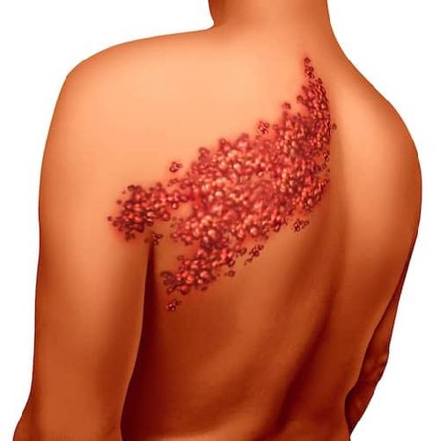

SIGNS AND SYMPTOMS
- Often fever and chills a few days before the rash develops. Feeling unwell.
- Moderate to severe pain at the site where the rash will develop. Pain may come before you can see the rash.
- 4 or 5 days later the vesicles appear on a red base (similar to herpes simplex but over a larger area).
- The vesicles become pustules, then crusts.
- The rash is distinctive because it appears in the area of the affected nerve (dermatome), therefore it is usually only on one side of the body, very often on the chest but it can be found anywhere on the skin or mucosa (depending on the affected nerve).

Treatment
- Treat lesions as for Herpes Simplex.
- Apply cold compresses.
- Follow pain protocol (see p.28).
- Consider amitriptyline if pain is not relieved by painkillers as it is very effective against nerve pain.
- If eye is affected or severe disease discuss with the doctor and consider referral. Acyclovir can help if available, but only if given in the first 48 hours after eruption of lesions.

Mild/moderate infections:
- No antiviral treatment is needed and supportive care is enough

Severe cases with necrotic lesions or extensive lesions or in the face spreading to the eye:
- Oral acyclovir, if available, 200mg 5 times per day for minimum 5 days, given in the first 48 hours after eruption of lesions.

Note: The patient is infectious to people who have not had chicken pox. This is especially important for contact with pregnant women – advise them to stay away from pregnant women who have never had chickenpox

PARASITIC SKIN INFECTIONS

SCABIES
Scabies is a parasitic infection of the skin. It is common in this region and spreads easily. Transmission is by close direct contact. The mite invades into the skin causing an inflammatory reaction.
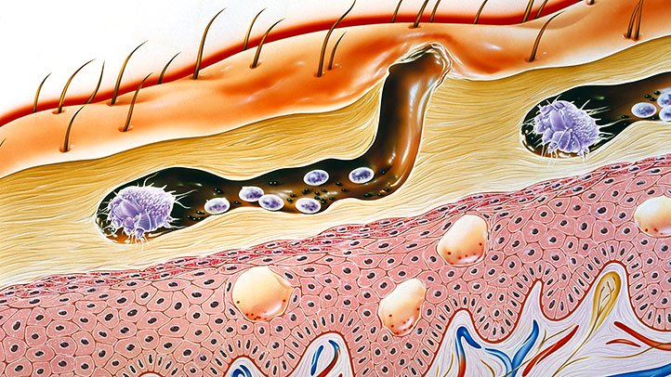
Figure 49 The mite invading into the skin.

SIGNS AND SYMPTOMS
- Itching (especially at night).
- Small sores, scratch marks and burrows (tunnels under the skin) can be found between the fingers and toes, around the wrists, axilla or groin and other places.
- The back and face are not affected.

Other members in the family may have it too. If suspect in child examine the mother, especially her hands. Scabies lasts for weeks to months. The sores can become infected: If there are any sign of infection treat with antibiotics first (see p.223) and then the scabies.

Note: There is a severe form called Norwegian scabies, which is thick, scaly, red plaques which can look like psoriasis, 50% occur without itching.

TREATMENT
- Treat secondary infection first.
- Wash the whole body with water and soap
- Treat all people in the family and close contacts at the same time.
- Ideally use permethrin as have to apply for less time, only need to apply once, and does not need diluted in children.

Medication

- 5% Permethrin lotion for child >2m and adults (does not need dilution)
- One application, apply to whole body except face/mucous membranes, Allow to dry and then put on clean clothes. Do not wash for at least 8 hours. (It may be easier to apply permethrin in the evening to avoid washing.)
- 25% Benzyl benzoate Use if <2m or permethrin not available (needs diluted)
  - Child < 2 yrs – 1 part 25% lotion + 3 parts water apply for 12 hrs (or if <6 mths for 6 hrs) then rinse
  - Child 2-12 yrs – 1 part 25% lotion + 1 part water, apply for 24 hrs then rinse off
  - Child >12 yrs/adults – undiluted 25% lotion, apply for 24 hrs then rinse off
- REPEAT application after 24hrs
- Cut fingernails and apply lotion under the nails.
- Wash the clothes and bedding for the whole family with boiled water and soap and then dry in the sun. If cannot wash expose to the sun for 3 days, ideally in a completely closed bag
- Educate patients that the itching may continue for several weeks. This is a reaction to the dead parasite. Calamine lotion may be needed.
- For severe cases (Norwegian scabies) refer to hospital as the patient needs isolation

If no response after treatment make sure that the treatment has been applied properly and that all members of the family have been treated.

CUTANEOUS LARVA MIGRANS (HOOKWORM INFECTION)
The disease is caused by the larvae of animal hookworms. Eggs are found in dog or cat faeces on the ground. Humans walking bare foot or lying on the sand can become infected by larval invasion through intact skin. The larvae travel under the skin leaving a red irregular tract, most often on the feet. | 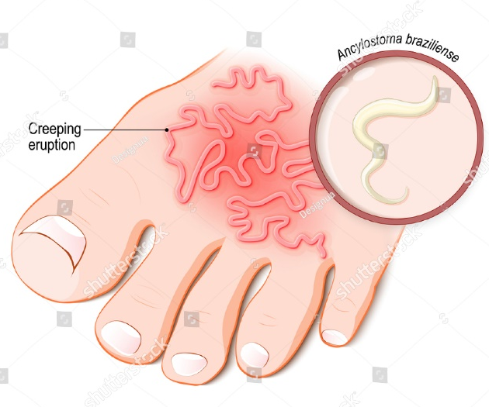

SIGNS AND SYMPTOMS
- Very itchy red tracks on the skin. The larvae travel a few millimetres each day.
- Foot and ankle are the most common sites.
- The larvae can survive for weeks before they die.

DIAGNOSIS
Hookworm eggs may be found in stool examination.

TREATMENT
Albendazole Adult/Child >6m: 400mg STAT. (Note: if >6m but <10kg give 200mg STAT)

PREVENTION
Wearing shoes or sandals.

LARVA CURRENS (STRONGYLOIDES INFECTION)
The disease is caused by migrating Strongyloides stercoralis larvae. The worm enters the body by making a hole in the skin and then moves around the body causing a rash.

SIGNS AND SYMPTOMS

Acute strongyloides
- The area around where the worm entered the body may have redness and itching and last for up to a few weeks.
- May also get pulmonary symptoms (dry cough, dyspnoea, wheeze) if the worm travels to the lungs.
- Once larvae get to the intestine they can cause GI symptoms e.g. bloating, abdominal/epigastric pain, vomiting, diarrhoea.

Chronic strongyloides
- Intestinal larvae may re-infect their host (auto-infection) by penetrating through the intestinal wall or from the skin around the anus.
- Chronic infections lead to recurrent pulmonary and GI symptoms.
- When the worm moves around the body it causes itchy red tracks on the skin between the neck and knees that last for several hours to days. The worm/rash moves 5-10cm per hour and the rash comes and goes. This rash is called larva currens.

DIAGNOSIS
Larvae may be detected in a stool examination.

TREATMENT
Ivermectin is the ideal treatment but is not available. Instead use Albendazole Adult/Child >6m: 400mg OD for 3 days.
(Note: if >6m but <10kg give 200mg OD)

PREVENTION
Wearing shoes or sandals.

NON-INFECTIVE SKIN RASH

URTICARIA (ALLERGIC RASH)
Allergic skin reaction. Often it is impossible to find the cause of the allergy but common causes are:
- Medication: If the patient is under a new treatment (e.g. quinine, amoxicillin, co-trimoxazole.)
- Insect bites, cat hair, worms, colouring in drinks, contact with plants/metals, food

SIGNS AND SYMPTOMS
A raised, oedematous, red rash that changes quickly in size and shape (within minutes) on the whole body. Swellings are transient (they persist only for minutes - maximum 24 hours). Very itchy.

TREATMENT
- Cool down with water.
- Remove the cause: stop new medication, stop contact with plants, metals, foods etc.
- Cut fingernails to prevent scratching which can lead to infection.
- If severe itching: give chlorpheniramine until itching stops.
In case of oedema of the face or difficulty breathing/wheeze, treat as anaphylactic shock.

ECZEMA
Non-specific inflammatory skin reaction to special factors.

SIGNS AND SYMPTOMS
- Red, scaly/dry, itchy lesions
- Anywhere on the body, usually on both sides of the body (especially at the front of the elbows and behind the knees where the joint bends (flexure areas).
- It may be localised or widespread, dry or wet but usually long lasting.
- The dry lesions are very itchy and there is serous (like water) exudation, there may be vesicles.
- It can appear and disappear many times at the same place.
- Chronic eczema can cause thickening of the skin (lichenification)
- Secondary infections are common.
- Eczema can look very similar to ringworm, especially on the face.

TREATMENT
- Clean with soap and water 2 times daily.
Then:
  - for acute eczema: calamine lotion, one application 2 times daily
  - for chronic eczema: zinc oxide ointment, one application 2 times daily
- Look for and treat any pre-existing condition (scabies, lice etc.).
- For patients with secondary infections: treat as impetigo (see page 120).
- For patients with intense pruritus, antihistamines for a few days.

COMPLICATION

Eczema herpeticum

- Is a serious infection with herpes virus when the virus affects the body.
- It is mostly seen as a complication of eczema
- Localized eruption of blisters with crusting. Systemically unwell with fever.
- Treat with acyclovir PO 200mg (100mg if <2yrs old) 5 times per day for 10 days. If immunocompromised e.g. HIV give double dose.

PSORIASIS
A chronic inflammatory skin condition that produces thick scaly skin.

SIGNS AND SYMPTOMS
- Skin: chronic scaly pink lesions on extensor surfaces e.g. front of knees, elbows, scalp, and trunk, sometimes itchy.
- Nails: pits in nails, yellow colour.
- Joints: can get swollen joints, especially hands and feet (psoriatic arthritis).

There are many different types of psoriasis. Two most common types are:
  - Plaque psoriasis: lesions on extensor surfaces.
  - Guttate psoriasis: multiple 1-10mm lesions small scaly lesions (like tear drops) mainly on trunk, upper arms and thighs.

TREATMENT

- Stop smoking, avoid alcohol and decrease weight if overweight
- Expose skin to sunlight
- Apply Vaseline QID
- Consider hydrocortisone cream if not improving or if acute flare up (see information above about steroid cream).
- Give NSAIDs +/- omeprazole for stomach protection in cases of arthritis.
- For very thickened skin lesions try Whitfield ointment twice a week – but stop if getting worse.

LEPROSY

Leprosy can look like many other skin conditions, some nerve and bone and eye conditions
Leprosy is caused by a bacteria, Mycobacterium Leprae. If treatment is not given, smear positive patients can spread the bacteria from their noses into the air. Risk of infection from air is not very high. Touching the skin of a person with leprosy does NOT cause infection. Almost all properly treated patients are NOT infectious. Most people do NOT get leprosy illness even if they are in contact with the bacteria.

Think of leprosy when you have a patient with:
• One or more skin patches that is
  - Pale or discoloured (reddish or copper-brown colour)
  - Do not itch
  - Lasts for 6 weeks or more
  - Does not look like one of the common skin conditions
  - Does not improve with other treatment.

• Both skin changes AND nerve signs (enlargement of nerve, reduced feeling or loss of movement). A pale or discoloured skin patch with reduced feeling and an enlarged nerve is very likely to be leprosy.

Leprosy should be considered in all patients with painless injuries, burn wounds or ulceration of the hands or feet.

SIGNS AND SYMPTOMS

Skin
Maculae (flat), often pale centre with raised red edges. Papules (raised, solid, rounded), often red. Plaques (raised, spread), often red.

Nerves
Enlargement of peripheral nerves in legs, arms, neck or head outside brain. Peripheral nerve pain, nerve tenderness, reduced skin feeling, weakness or loss of muscle strength (claw hand, wrist drop, foot drop, facial palsy), muscle wasting.

Eyes
Loss of feeling over conjunctiva (front surface of eye). The patient is not able to close the eye (lagophthalmos), the lower eye lid turns out (ectropion). Eyebrow loss, eyelashes thin and turn in (entropion). Dry eyes, conjunctivitis, corneal damage, iritis (inflammation of the iris), blindness.

If your area has a leprosy control programme, refer any suspected patient for diagnosis and management

HISTORY TAKING
- Short duration (3 weeks or less), and itching make the diagnosis less likely.

PHYSICAL EXAMINATION
- Check the patient’s entire body, in a good light, for abnormal patches of skin - colour change, dryness, thicker than normal, loss of hair.

- Check nerves for enlargement (can see or palpate nerve):
  - Ulnar - inside and slightly above the elbow in the ulnar groove (keep arm bent).
  - Median - in front of the elbow and in front of wrist.
  - Radial - over the distal radius, on the thumb side above the wrist.
  - Peroneal (lateral popliteal) - behind the fibula at the outside of the knee (knee bent)
  - Tibial - behind the medial malleolus at the inside of the ankle.
  - Posterior auricular - in the neck, below and behind the ear, turn the neck.
  - Cutaneous nerves near to a skin patch.

- Check for sensation by testing the centre of skin lesions for loss of ‘light touch’ feeling using a piece of cotton wool or paper. Also for pain with a common pin (pinprick) and temperature sensation loss. Loss of sensation suggests leprosy. ‘Light touch’ feeling is lost before pain sensation.

- Check cornea (trigeminal nerve) for loss of touch sensation, using cotton wool.

- Check muscles of the feet, hands and face for weakness and for loss of muscle

DIAGNOSIS
Diagnosis is confirmed by finding the bacteria in:

- Split skin smear test- scraping of skin from 2-4 areas with lesions and 2 normal areas of skin (normally ear lobes), and sent on a slide for Ziehl Neelsen (ZN) and AFB testing. This is often only done in specialist clinics/ hospitals.
- Nasal swab
Even if the skin and nose smears are negative, a patient can still have leprosy. Therefore diagnosis of leprosy relies on clinical signs and symptoms in cases when split skin/nasal swab smear is negative. Thorough clinical examination is important.

TREATMENT
Medical treatment with drugs is the best way to help patients with leprosy. It is easy to treat the infection, but nerve damage will never go away. Early recognition and effective treatment prevents from deformity and disability. It is important to diagnose and start treatment early, to prevent nerve damage. Multiple drug treatment (MDT) is used in the medical treatment of leprosy in order to prevent development of drug resistance. Taking the drugs regularly with correct dosages and until completion of the defined treatment duration is very important in order to prevent drug resistance as well as to prevent from reappearance (relapse) of the disease. Treatment regimen varies depending on the clinical classification of the disease (by World Health Organization (WHO)) as below.

Paucibacillary forms  (least contagious forms) |  | Multibacillary forms  (most contagious forms)
Tuberculoid | Borderline Tuberculoid | Borderline | Borderline Lepromatous | Lepromatous
T.T | B.T | B.B | B.L | L.L

WHO classification
In order to simplify diagnosis and to promote rapid implementation of treatment, the WHO has simplified clinical classification of leprosy and differentiates only 2 forms:
– Multibacillary leprosy: more than 5 skin lesions
– Paucibacillary leprosy: 1 to 5 skin lesions

Age | Multibacillary Leprosy  (More than 5 skin lesions) | Paucibacillary Leprosy  (1 to 5 skin lesions)
Children under 10 years | rifampicin PO: 10 mg/kg once monthly  + clofazimine PO: 6 mg/kg once monthly and 1 mg/kg once daily  + dapsone PO: 2 mg/kg once daily | rifampicin PO: 10 mg/kg once monthly  + clofazimine PO: 6 mg/kg once monthly and 1 mg/kg once daily  + dapsone PO: 2 mg/kg once daily
Children 10 to 14 years | rifampicin PO: 450 mg once monthly  + clofazimine PO: 150 mg once monthly and 50 mg once daily  + dapsone PO: 50 mg once daily | rifampicin PO: 450 mg once monthly  + clofazimine PO: 150 mg once monthly and 50 mg once daily  + dapsone PO: 50 mg once daily,
Children 15 years and over and adults | rifampicin PO: 600 mg once monthly  + clofazimine PO: 300 mg once monthly and 50 mg once daily  + dapsone PO: 100 mg once daily | rifampicin PO: 600 mg once monthly  + clofazimine PO: 300 mg once monthly and 50 mg once daily  + dapsone PO: 100 mg once daily
Duration | 12 months | 6 months

LEPROSY REACTIONS
These reactions usually occur during the course of treatment in patients with multibacillary leprosy (BL and LL).
They are associated with the immunological response to M. leprae antigens. Urgent treatment is required to avoid irreversible disability. Do not interrupt ongoing leprosy treatment.

TREATMENT
– Reversal reactions:
Prednisolone (or prednisone) PO: 0.5 to 1 mg/kg once daily for 2 weeks. Re-examine the patient every 2 weeks and decrease the dosage if the neurological signs recede. According to clinical response, treatment may last 3 to 6 months

WOUNDS
A wound is a break in the skin that can be caused by many different things e.g. cut, bite, surgical wound etc.

TREATMENT
For every wound follow these steps to treat the wound. For more detail of each step see below.

- Always take general precautions for you and the patient e.g. gloves
- Remove any old dressing
- Examine the wound
  - Look at the colour
  - Look for infection – consider antibiotics if the wound looks infected/signs of systemic infection
- Clean the wound – clean with polyvidone iodine solution and sterile water or normal saline and rinse.
- Explore the wound – use local anaesthetic 1% lidocaine and wait for 2 minutes, look for foreign bodies.
- Tetanus prevention
- Assess for sensation, function and blood supply to the limb
- Excision of the wound – remove non-viable tissue
- Suturing – consider immediate or delayed suturing
- Dressing
- Consider complications

It is very important to follow these steps:

1. General precautions
- Make sure you explain the procedure to the patient.
- Always wear protective equipment e.g. gloves.
- Always have someone to help you.
- Try to be as sterile as possible, clean equipment between patients.
- Always go from clean to dirty e.g. if multiple wounds start with the cleaner wounds.
- Always give painkillers before examining wound, wait for enough time to allow the medication to work.
- Discard of all sharps in the sharps containers.
- If wounds are more than 6 hours or contaminated then delay suturing.
- Give Tetanus prevention care.
- Consider referring deep severe wounds or wounds that cover large areas.

2. Remove old dressing
- Wash hands or disinfect with alcohol rub.
- Use non-sterile gloves, remove the tape/bandage.
- If the last bandage/gauze is stuck to the wound loosen with NSS or sterile water before removing.
- Look at the gauze, if there is lots of discharge/green colour/smells bad then suspect a wound infection and consider starting antibiotics.
- Discard the dressing and non-sterile gloves in the correct place.

3. Examine the wound
1. Look at the colour
- Black area = necrosis, wet or dry infected eschar (be careful to distinguish from dark red old blood and black).
- Yellow/green area = infected tissue/pus.
- Red area = granulation – usually a sign of healing (but red edges = inflammation or infection). If the granulation tissue is heaped up higher than the edges of the normal skin, you should dress the wound with some pressure to push down the granulation tissue. This will allow the normal skin edges to grow over the granulation tissue.
- Pink area = epithelisation, final stages of wound healing.

2. Look for infection

If the wound is sutured and you see the following signs then there is an infection and you should remove one or more of the sutures and assess for general signs of infection e.g. fever:
- Red, indurated and painful edges.
- Drainage of pus between the sutures by itself or when pressure applied.
- Lymphangitis or subcutaneous crepitations around the wound.

If you think the wound is infected (or it is a high risk wound (see below)) treat with cloxacillin. Note in immunosuppression e.g. diabetes, kidney failure, HIV etc. healing can be delayed. Treat with antibiotics for a longer time if there is a slowly healing infection.

4. Clean the wound
- Wash hands again/disinfect with alcohol rub.
- Use sterile gloves if available, otherwise use a new pair of non-sterile gloves.
- Clean according to what the wound looks like:

- Clean sutured or clean open wound; use NSS to remove any dirt, work from the cleanest to the dirtiest area, use new swabs for each stroke, dab dry with sterile gauze.
- Necrotic or infected open wounds – clean with polyvidone iodine (7.5% scrub 1 part solution + 4 parts of NSS). Rinse thoroughly with normal saline then dab dry with sterile gauze.

5. Explore the wound
- If the wound is not clean and you are worried that there may be a foreign body inside use local anaesthetic 1% lidocaine and wait for 2 minutes, explore the wound to look for foreign bodies.

6. Consider Tetanus Prevention
- If high risk wound: deep wounds, war wounds, wounds with bone fractures, wounds with devitalized tissue, extensive burns, foreign body; wounds older than 6 hours inject tetanus immunoglobulin around the wound (see below).

7. Assess for sensation, function and blood supply to the limb
- Make sure the patient can still move and feel the affected area, and that the skin is pink, not cold and cap refill is <2 seconds.
- If there is any abnormality discuss with the doctor. If the wound is severe then the patient may need an amputation which may not be available at the clinic, so consider referral.

8. Excise the wound

- Remove any non-viable tissue carefully using sterile equipment.

9. Suture the wound (if necessary)

- Immediately suture: if the wound is clean, skin is normal, wound is less than 6 hours old (or less than 24 hours old if on face, scalp, upper limbs, or hands).
- Delay suture: if bite, bullet/shell/mine/shrapnel wound, if the skin has bruising or necrosis, if does not fit criteria for immediate suturing, do daily dressing change with cleaning and removal of necrotic tissue and consider suturing after 72 hours.

10. Dressing the wound

- Clean sutured or clean open wound: re-cover a wound with sterile gauze and bandage.
- Necrotic or infected open wounds: Apply sterile Vaseline and remove all necrotic tissue at each dressing change until the wound is clean.

11. Consider complications

- Foreign body (from the trauma or from gauze packing) can delay healing and make the wound worse. If the wound is not healing, inspect wound inside for foreign bodies. May need to do incision to inspect deep wounds.
- Granulation tissue grows faster than surrounding skin, and the skin edges cannot grow over the heaping granulation tissue. Use skin grafting over the granulated tissue. If skin graft is not available, use moderate pressure dressing to push down the granulation tissue and this will allow skin edges to cover the large wound or ulcer. It can be many weeks of daily dressing changes until the wound is completely healed.

TETANUS PREVENTION
- To complete ATT

BURNS
Burns are injuries to tissues caused by heat, friction, electricity, radiation or chemicals.

HISTORY
- When did the burn take place?
- What caused the burn? Electrical burns can cause more extensive damage than is first seen.
- What is the age of the patient? Burns are more severe in the very old and very young.
- Has there been any inhalation of hot smoke? Look for dyspnoea with chest wall indrawing, burned nose hairs or soot around the nose and mouth.

EXAMINATION
Severity of burns are evaluated on the basis of the depth, location, and size of the burn.

Depth of the burn:

Superficial burn: Red, dry and painful, it does not blister.

Superficial partial thickness burn: Pink and moist blisters may be present.

Deep partial thickness burn: White or mottled pink, with some painless areas.

Full thickness burn: White, mottled or charred and are dry.

Note: Patients with electrical burns need an ECG

Location of the burn:

Document in the IPD chart and lemma the location of the burn

Note: Burns are more severe when on the face, hands, joints and perineum.

Size of the burn:

To calculate the amount of burned skin (% body surface area) use following table:

Lund Browder table-Percentage of body surface area according to age

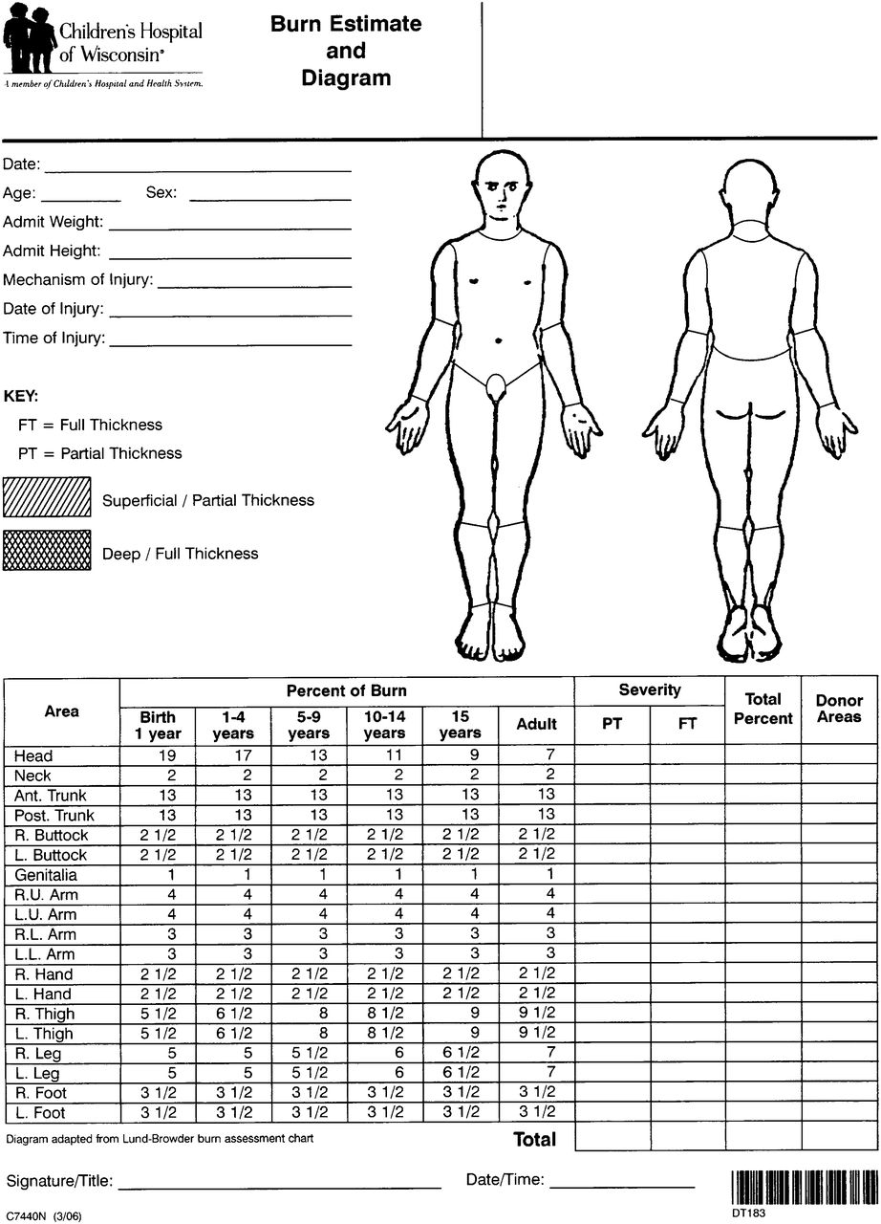
Figure 50 Burn percentage of skin

For example: 2 year old with burn to right upper arm (=4%), right lower arm (=3%), and hand (=2.5%)
Total body surface = 4 + 3 + 2.5 = 9.5%

HEALTH EDUCATION

Nutrition
All babies should be exclusively breastfeed for the first 6 months. They should have other foods introduced into their diet after 6 months.

Type of food to eat
Different foods provide different nutrients, which do different jobs for the body.
- Some foods help to prevent infection:
Green vegetables, pumpkins, carrots, fruits
- Some foods help the body to grow and develop:
Eggs, beans, chicken, fish, meat
- Some foods provide energy for the body:
Rice, potato, noodles, bread
Children need food from all these groups to be healthy. Help the parents to think of 5 foods from the groups that they can access regularly.

How often to eat
Children should eat at least 3 meals per day. If they are sick or malnourished they should eat 5-6 times per day.

Hydration
Good hydration means the child has enough water for the body to work well.
- The child should always have access to safe clean drinking water (this may be boiled and cooled water).
- They should pass urine around 4-6 times in 24 hours and it should be clear color. If urine is dark give the child more water to drink.
- If the child is < 6 months old there is enough water in the breastmilk – no need to give extra water.
If the child has diarrhoea they need to take more fluid to prevent dehydration. The carer can give:
- Continue breastfeeding
- ORS,
- Coconut water,
- Rice soup with chicken/vegetables/egg added
If the child starts to have signs of dehydration or is unwell for more than 2 days come to the clinic.

Breastfeeding
Children should be given only breast milk for the first 6 months.
- If food is started earlier the child may not be able to digest and get infection or diarrhea.
- If the mother is worried about the baby’s weight they should come to the clinic rather than starting other food earlier than 6 months.
Advise the mother that she needs good nutrition while breastfeeding. She does not need to restrict her diet. She should eat food from all groups as above. She should drink plenty of water.

Weaning
Once the child is 6 months of age they should start to eat a soft diet of nutritious food
- Mix vegetables, pumpkin etc. into rice soup
- Add beans, chicken, egg
- Give soft fruit
Gradually increase amount of food and variety.

Hygiene
Infection can be prevented by keeping clean

Personal hygiene
All family members should try to have good personal hygiene as well as the child. This includes:
- Taking regular baths (at least 1 time per day and if dirty)
- Use soap when bathing
- Keep finger and toe nails short and clean
- Keep hair clean – wash regularly and brush, to prevent head lice.
- Change nappy/pamper/cloth if wet or dirty and wash child. Leaving wet can increase risk of UTI
- Brush teeth 2 x per day

Hand washing
This is a very important way to prevent infection!
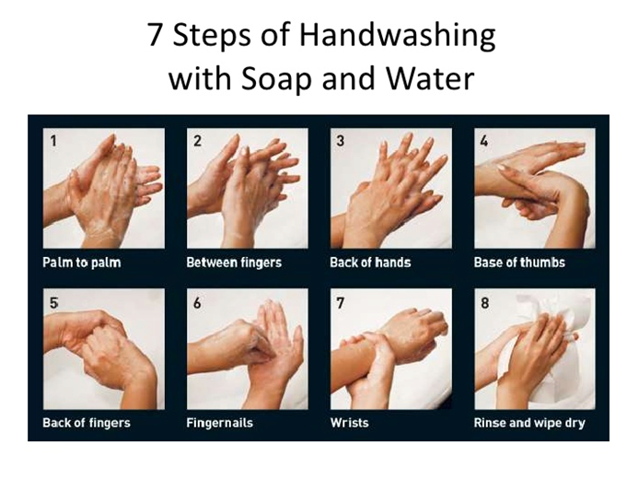
When to wash your hands:
- Before eating
- After going to the toilet, or cleaning child’s stool/urine/vomit
- Before preparing food
- After touching rubbish
- After touching animals
- Any time there is visible dirt on the hands

Environment hygiene
If the living environment is kept clean infection is less likely to spread
- Sweep the house regularly
- Throw rubbish in the proper place
- Clean outside house
- Keep your drains clear
- Cover your water container and clean container regularly
- Keep animals outside of the house

Recognizing danger signs of a sick child and signs of malnutrition

Signs of malnutrition
Healthy child next to a malnourished child | Child with severe malnutrition | Child with severe malnutrition
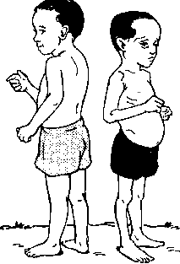 | 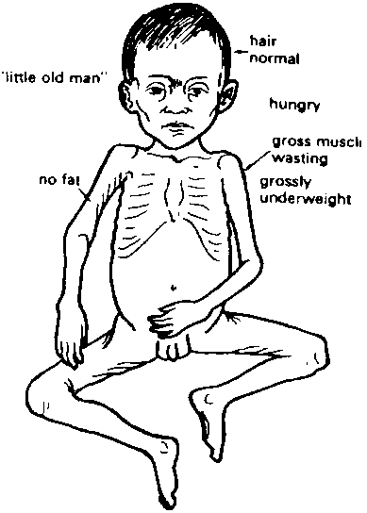 | 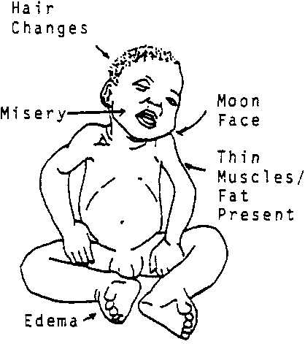

How to recognize a child with malnutrition?
Appearance | - Oedema  - Looks like an ‘old man’  - Muscle wasting / very thin  - Hair colour change  - Peeling skin with colour change
Behavior | - Crying a lot  - Can’t move well / tired  - Can’t eat and drink well  - Sleeping a long time  - No interest to play
Other symptoms | - Signs of infection fever  - Cough/loose motion  - Liver and spleen large  - Vomiting

Danger signs of a sick child
All parents should know these signs of serious illness and should know where they can go for help

- Depressed fontanelle
- Vomiting
- Lethargic/weakness
- Convulsion
- Not able to eat/drink
- Sunken eyes
- Chest indrawing
- Fast/difficult breathing
- High/or low temp
- Sunken or bulging fontanel
- Cyanosis
- Cold extremities

Immunization
Immunizations protect your child and also the community against serious diseases.
Protection against
10 diseases:
- TB
- Hepatitis B
- Diphtheria
- Pertussis
- Tetanus
- Polio
- Measles
- Mumps
- Rubella
- Japanese encephalitis
At MTC we provide immunizations the same as the Thai schedule.
- It is important to take child regularly for immunization.
- If not immunized there is a risk of severe disease and disease outbreak
- Sometimes children have a mild reaction to immunization such as fever or rash – can give paracetamol. Come back to the clinic if there are danger signs or the fever continues for ≥ 2 days.
- Very rarely there may be a severe reaction. If the child has cyanosis or a seizure – come back quickly.
- Do not scratch if swelling after BCG immunization.

Family planning
Parents should understand the benefits of family planning.
Ask the parent how many children do they want? Discuss the benefits of spacing between pregnancies, planning number of children and keeping families small
- Better health for mother and less risk of complicated pregnancy
- Decreases risk of nutrition problem for child – can breastfeed for longer
- Easier to provide – education, clothing, food, more time to spend with the child
MTC can provide many different types of family planning methods. Including:
- Emergency contraceptive pill
- Condom
- Oral contraceptive pill
- Depo injection
- Implanon®
- Intrauterine Device (IUD)
- Vasectomy
- Tubal ligation referral
Should advise referral to RHOPD for mother to have opportunity to discuss with staff the best method for her situation.
Remind mother that she should come on time for follow up for family planning otherwise there may be a gap where she is able to get pregnant.
Advise mother it is best to get family planning supplies from a clinic such as MTC because:
- She will see a health worker who can help decide the best method and review her health
- It is free
- If family planning supplies are bought from small shop the quality may not be good.

Safe food preparation
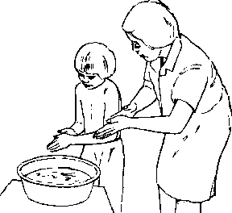
Following these following steps can prevent infection from unclean food:
- Always wash your hands before and after preparing food and before feeding your child.
- Wash the child’s hands before they eat.
- Wash the ingredients before cooking
- Wash the utensils (spoons/knifes/plates) before using
- Make sure all meat/fish/egg is well cooked
- Eat the food you have prepared the same day. Do not keep and feed to the child the next day, unless you have a fridge.
Bacteria will have grown in the food and can cause infection, especially if the child has already weak immune system due to malnutrition
- If possible reheat the food well before eating – this will kill any bacteria
- Keep the food in a clean place
- Raised off the floor
- Covered to protect from flies
- Away from any animals

Safe feeding
If a child is not able to swallow safely they will get frequent chest infections and may choke.
A parent/carer should be aware that if their child has the following problems while feeding their swallow may not be safe:
- Coughing
- Choking
- Vomiting
- Difficult breathing
To prevent difficulty swallowing the parent should know that they should not feed a child while lying down. The child should be sitting and should be alert.
If there is a possibility of a difficult swallow the child should have an assessment by a health worker who has been trained in safe feeding.

DENTAL DISEASES

DISEASES OF GUMS AND TEETH

The most common problems are infections in the tooth (dental caries) and inflammation of the gums (gingivitis).

Both disorders are the result of lack of daily cleaning of teeth and gums and may eventually cause tooth loss.

Note: For most dental conditions it is important to seek trained help from a dentist. Here is a brief overview of some conditions.

DENTAL CARIES
Cavities in the tooth that can be complicated by local infections.

RISK FACTORS

  - Sugar rich diet
  - Poor teeth strength
  - Infrequent or no teeth cleaning.

SIGNS AND SYMPTOMS
- Black colouration and tooth erosion.
- Usually pain, especially when eating or drinking cold foods.

TREATMENT
- In cases of constant pain, look for a specific source (tooth).
- Treat the pain with paracetamol
- Treat any swelling with ibuprofen and antibiotics (amoxicillin and metronidazole). If swelling is reduced refer to dental team.
- If there is no swelling but constant pain, refer to the dental team.
- The most effective treatment is to fill the cavity OR to extract the tooth. Refer to trained dental team.

PREVENTION
Daily cleaning of the teeth and gums.

GUM DISEASES
Gum diseases do not cause much pain, so people may not realize that there is a problem.

GINGIVITIS
Inflammation of the gums around the teeth. This is the most common oral disease.

SIGNS AND SYMPTOMS
Red and swollen gums, bleeding while brushing, bad mouth smell.

TREATMENT
- Daily cleaning of teeth and gums.
- Chlorhexidine 0.2% mouthwash or salt water mouthwash.

PREVENTION
- Daily cleaning of teeth and gums.
- Removal of calculus (dental plaque) by dental team.

PERIDONTITIS
A bacterial infection of the supporting structures of the teeth.

SIGNS AND SYMPTOMS
Pain, fever, swelling of the gums and/or pus Mobility of the infected tooth.

TREATMENT
- Daily oral hygiene.
- Oral amoxicillin and metronidazole
- Extraction of the affected tooth.

PREVENTION
- Daily cleaning of teeth and gums
- Removal of calculus (dental plaque) by dental team.

STOMATITIS
A disorder of inflammation of the oral mucosa. It usually heals in about 10 days after starting treatment or removing the cause. Discuss with doctor if lesions do not disappear or return within 2 weeks, the patient may need investigation for immunodeficiency e.g. HIV.

SIGNS AND SYMPTOMS
- Pain with difficulty eating
- Nausea, vomiting.

CAUSES
- Fungal e.g. candidiasis (oral thrush) white patches on tongue, inside cheek (may spread to pharynx) - occurs frequently in infants, malnourished children, diabetic patients and immunosuppressed patients e.g. HIV, cancer. Can also occur if patients who take steroid inhaler e.g. budesonide do not wash their mouth out after using inhaler.
- Viral e.g. herpes stomatitis
- Vitamin Deficiencies – especially if inflammation of corners of the mouth (angular stomatitis)
- Trauma
- Systemic diseases

TREATMENT
- Maintain feeding and hydration. When necessary use nasogastric tube.
- Treat according to the likely cause of the stomatitis:

- Fungal infections: like thrush (Candidiasis): Nystatin give 1 lozenge to be sucked QID for 7 days or 1ml of oral suspension (100,000 IU) QID for 7 days (total 400,000 IU per day). Oral suspension should be swilled around mouth and then swallowed.
- Viral infections: wash the mouth with warm salty water and treat with gentian violet. If there is secondary bacterial infection, wash mouth with chlorhexidine 0.2% and treat with amoxicillin.
- Vitamin Deficiencies: replace deficiencies (see malnutrition chapter)
Note: Viral infections such as primary and secondary herpes should be treated with supportive care only and these are generally self-limiting, with a two week duration. Chlorhexidine and antibiotics do not help in viral infections and may complicate oral thrush.

PREVENTION
If taking corticosteroid inhaler e.g. budesonide advise to wash mouth out (take water in mouth, and spit out water – do not swallow) after each use. Educate about good diet.

TRAUMA
If a permanent tooth is knocked out it should be replaced (pushed back into the socket) as quickly as possible.
Do not replace children’s milk (primary) teeth that have been knocked out.

TREATMENT
Treat the pain with paracetamol
- Put permanent tooth back. Make sure that patient can close his mouth in normal position. If not, align the tooth in place.
- Advice the patient to avoid solid food for 2 weeks so must have soft food only.

EYE DISEASES

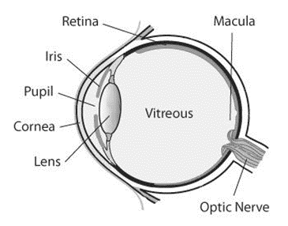
Figure 51 Anatomy of an eye

POOR VISION (Refraction error)
Poor vision is a common problem. A person with poor vision may be suffering from a disease of the eye, or is simply in need of eyeglasses. Most of the conditions that cause poor vision can be detected by careful examination of the eye (cornea scars, cataracts, obvious infections etc.).
Use of a PINHOLE will help to establish whether a person needs eyeglasses. To make a pinhole make a very small hole in a piece of paper. If vision improves when looking through a pinhole, then eyeglasses are needed.

Poor near vision (Longsightedness)
- Commonly known as ‘longsightedness’, this condition affects the ability to see close-up objects, and tends to get worse with age.
- Poor near vision can be divided into two groups depending on age:
  - People under the age of 40 who develop poor near vision are diagnosed with Hyperopia. For this condition, vision can be corrected with plus power lens eyeglasses.
  - Almost all people over the age of 40 will suffer from poor near vision. Activities such as reading and sewing become difficult or impossible. The loss of close-up vision is part of the natural ageing process, and is called Presbyopia. For this condition, vision can be helped with reading glasses (plus power lens eyeglasses).
Poor long-distance vision (Shortsightedness)
- Commonly known as ‘shortsightedness’, this condition causes distant objects to be blurred, whilst close-up objects can be seen clearly e.g. schoolchildren who cannot read the blackboard. This is called Myopia. For this condition, vision can be corrected with minus power lens eyeglasses.
- Poor vision at dusk and at night
- Night blindness is one of the early signs of vitamin A deficiency.

INFECTIONS

CONJUNCTIVITIS
Can be caused by a bacterial or viral infection, or an allergic reaction of the conjunctivae of one or two eyes. It is sometimes difficult to diagnose if an eye inflammation is due to infection (bacterial or viral), allergy, irritation or other causes.

SIGNS AND SYMPTOMS
- Red eye
- Bacterial conjunctivitis: often pus discharge, eyelids stuck together on waking up, infection of one eye at the beginning, usually responds to Terramycin Eye Ointment (TEO).
- Viral conjunctivitis: watery secretions, no itching, do not respond to TEO, usually disappear within one week without complications. In the rainy season there are often outbreaks of viral conjunctivitis. For example, this may affect up to 20-30% of the camp population.
- Allergic conjunctivitis: lots of tears, eyelid oedema, itching, both eyes, does not respond to TEO, reduce symptoms by washing eyes with clean water.
- Congenital conjunctivitis: due to Neisseria gonorrhoea or Chlamydia if child born to infected mother (if suspect discuss with doctor)
Viral and allergic conjunctivitis do not respond to treatment with Terramycin Eye Ointment (TEO) but the ointment will relieve symptoms and will prevent secondary bacterial infection.

DIAGNOSIS
Clinical.
Note: bacterial and viral conjunctivitis can be very contagious, wear gloves when examining and/or wash hands well afterwards

TREATMENT
First choice medication for conjunctivitis is Terramycin Eye Ointment (TEO)
Although TEO contains tetracycline (similar to doxycycline), it is safe to use ointment in children, pregnant and breast-feeding women.

- Antibiotic ointment TEO: apply QID until two tubes are finished.
- If do not have or no response to TEO: use chloramphenicol (1 drop 6 times per day).
- Hot compresses may help reduce swelling.
- Show your patient how to put ointment or drops in the eye. Mothers may need to help their children putting eye ointment or drops in the eyes.
- Tell the patient to wash their hands and face before and after touching the infected eye
- Ask the patient to return if the eye is not better after finishing treatment.
- Never patch an infected eye.
Refer serious eye infections, infections involving the cornea and infections not responding for treatment to where they have trained specialists in eyes e.g. Mae Tao Clinic, Mae Sot Hospital

PREVENTION
Personal hygiene, wash hands regularly.

TRACHOMA
Trachoma is a highly contagious eye infection caused by the bacterium Chlamydia trachomatis. It is no longer common on the border. However, occasionally active infections are found in children, and adults who care for children. Most people will not be aware that they are infected. Trachoma is more common when sanitation and hygiene are not good. Health education and prevention are an important part of controlling infection.
With repeated infections over a lifetime, this disease can cause blindness

SIGNS AND SYMPTOMS
There are different stages of infection:
- Follicles (small bumps) → eye lid becomes inflamed → scar tissue forms → scarring of the cornea.
- This scarring can cause loss of vision, and make the eye more likely to get infected by bacteria or viruses.

DIAGNOSIS
- Made by external eye examination and checking the patient’s medical history.
- Look underneath the upper eyelid for the presence of follicles, signs of inflammation, the direction of the eyelashes and at the cornea.
- Diagnosis should be made by a medic who has been trained in eye care so refer the patient to a facility such as Mae Tao Clinic or Mae Sot Hospital if suspect.

TREATMENT
Treatment of (Acute phase) follicles and inflammation:

- Clean eyes and face several times per day.
- Azithromycin: Adult: 1g STAT, Child: 20mg/kg STAT give dose for patient and all of family.
- Can also use TEO in early stage to make eyes more comfortable
- If fails: give TEO BID for 6 weeks
- Check all other family members for possible infection.
- Advice the patient to return to the clinic when treatment is finished for re-assessment, as sometimes the treatment needs to be repeated.
Treatment of (Late phase) scarring:
In the later stages of trachoma, the primary infection may be gone but there is damage underneath the eyelid (scarring) and the eyelashes may turn in (trichiasis), causing damage to the cornea (corneal opacity).
- In most cases surgery is helpful. These patients should be referred to a medic who has had eye training.
- While waiting for surgery if can do regular follow up can tape eyelashes to eyelid using thin strip of sticking plaster. This protects the cornea but it is important that the eyelid can open and close perfectly. Replace the plaster when
It starts to peel off (usually once a week), continue for 3 months.

SAFE STRATEGY: TREATMENT AND PREVENTION
The SAFE Strategy is a public health approach to try to educate on treatment and prevention of trachoma.
- SURGERY
- ANTIBIOTICS (to treat the infection)
- FACIAL CLEANLINESS (hygiene)
- ENVIRONMENTAL CHANGE (increase access to clean water and sanitation)

PREVENTION
Health education on hygiene and sanitation.

EYE INJURIES
Injuries or trauma to the eye can cause blindness or loss of the eye. Once the injury has occurred, you must prevent secondary infection.

IMMEDIATE FIRST AID
Clean the eye carefully with a large amount of NSS or clean water. If there has been alkali in the eye e.g. cement this can cause a very severe eye problem so wash with at least 5 litres of water and make sure all the objects are removed.

DIAGNOSIS
- Need to examine the eye for any foreign bodies
  - The eye will be very painful so ideally need to use anaesthetic eye drops e.g. Tetracaine 0.5%.
  - If do not have special anaesthetic eye drops can use local anaesthetic e.g. 2-3 drops lignocaine instead. (Note: if only have lignocaine/adrenaline combination use with caution: adrenaline will cause the pupil to dilate (get bigger) which could cause an attack of angle closure glaucoma. If you use this then you must warn the patient if they get severe pain in the eye after a few hours to come back to the clinic immediately.)
- If have fluorescein dye then look at the eye under a blue light for any corneal scratches: these will show up in yellow.

TREATMENT
- Remove any foreign bodies. Look carefully at all areas of the eye especially the cornea and under the upper eyelid as this is where most foreign bodies attach to the eye.
- Apply a large amount of antibiotic ointment (TEO).
- If the cornea is scratched apply a pressure patch to the eye.
- Remove the patch and re-evaluate the next morning.
- Continue treatment with ointment and patching as needed.
- Never leave a patch on longer than overnight.
If an infection develops, STOP patching. A patched eye is a good place to grow bacteria.
NEVER PATCH AN INFECTED EYE
- Serious injuries, where the eyeball has been opened or penetrated, should be referred to hospital. Use an eye shield (not a patch) if a patient with an open eye injury needs to be transported to another location.
- Mostly, these serious injuries result in blindness or loss of the eye.

CORNEAL ULCERS
An ulcer on the cornea of the eye.

CAUSES
- Corneal ulcers may be caused by damage to the eye. This might be very small like a foreign body in the eye (most common cause)
- They may be bacterial, or fungal, and can be very difficult to differentiate between the two causes clinically.
- The history is important: if the injury is caused by vegetable material it is likely that the infection is fungal.

SIGNS AND SYMPTOMS
- Very painful eye, red and watering, and often the ulcer can be seen in the cornea as a greyish area.

DIAGNOSIS
If a drop of fluorescein dye is put in the eye and the eye examined with a blue light, the ulcer will stain yellow.

TREATMENT
• Bacterial corneal ulcers may respond to antibiotic treatment but fungal ulcers are very difficult to treat as there are no very effective antifungal agents.
• Corneal ulcers need to be treated very intensively with topical antibiotics e.g. chloramphenicol drops every hour and need to be referred for specialist treatment.

CATARACT
A cataract is a condition of the eye that affects the ability to see. It can affect all or part of the lens (the part of the eye that we see through). Cataracts are probably the leading cause of blindness on the Thailand-Myanmar border.

DIAGNOSIS
When looking through the pupil: the affected lens will be cloudy white in colour. If have an ophthalmoscope it will be difficult to see the back of the eye.

TREATMENT
There are no medicines that can treat cataract. Only surgery will help so referral to eye specialist is needed.

PTERYGIUM
Pterygium is the name for special tissue growth on the cornea. It is usually triangular in shape with the point pointing towards the centre of the cornea. Most of the time the pterygium will grow onto the cornea from the nasal (nose) side of the eye. A pterygium can be white in colour, although it can also present like conjunctiva or muscle tissue. It is not known why people develop pterygium. Long exposure to sunlight is a risk factor and most patients with pterygium have a family history (genetic influence). Once a pterygium is present, it will not go away.
Pterygium is not an infection, there is no need to provide treatment with TEO

TREATMENT
Surgery is the treatment, and is done depending on the size of the pterygium.

- Small pterygium: does not need removal, because it often comes back again after surgery (in these cases it will grow back faster). Treatment for a small pterygium is to reassure the patient that this is not an infection or serious (tumour) growth.
- Large pterygium: requires surgery, as if left it could reach the pupil and interfere with vision. When a pterygium reaches 2 or 3 millimetres from the edge of the pupil, the patient should be placed on the surgery list.

GLAUCOMA
Glaucoma is a disease of the optic nerve where it gets damaged because of increasing pressures inside the eye (called intra-ocular pressure (IOP)). The damage is irreversible.

There are two types of glaucoma:

  - Acute (Closed Angle) Glaucoma: when the pressure of the eye suddenly increases which can lead to blindness within a few months. This type is much more common on the Thailand-Myanmar border.
  - Chronic (Open Angle) Glaucoma: when the eye progressively gets damaged by high intra-ocular pressure. Some types of glaucoma are painless and progress slowly and silently

ACUTE CLOSED ANGLE GLAUCOMA = EMERGENCY
SYMPTOMS | Rapid onset severe pain of the eye and surrounding the eye, blurred vision, nausea, vomiting.
EXAMINATION | Patient looks unwell, red eye, hazy cornea, non-reactive mid-dilated pupil usually only one eye
TREATMENT | Acetazolamide 500mg PO STAT and pilocarpine 2% 1 drop both eyes  REFER PATIENT TO HOSPITAL IMMEDIATELY

DIAGNOSIS
- Measure Intra-ocular pressure with eye pressure tool (Schiotz tonometer): Intra-Ocular Pressures (IOP) will be raised (IOP normal range 10mm - 22mmHg).
- Check visual fields (confrontation test): there may be visual field loss: this is irreversible.
- Look with ophthalmoscope: you may see optic disc cupping.
- Check light perception and pupil reaction: in advanced glaucoma, the patient has abnormal pupil reactions to light due to loss of the optic nerve.

TREATMENT
- If you suspect glaucoma start treatment immediately with: Acetazolamide (Diamox) 250mg PO QID
- Pilocarpine 2% 1 drop QID for both eyes
- REFER IMMEDIATELY for surgery to avoid complete blindness
- After surgery, patients should have regular IOP checks and control of glaucoma medication.

STRABISMUS

Strabismus (squint) is when the eyes do not look in the same direction.

CAUSES
In children:
- Often develops in a child with normal eyes when aged 3-4 years.
- Listen to the parents, as they are the most likely to notice a squint in an infant.
- The eyes may be squinting but the child is able to move both eyes in all directions when tested.
- Often these squints are because the child needs eyeglasses.
- The main problem is that the eye that is squinting may become lazy without specialist treatment.
- A few cases of squint will occur when there is a defect in the eye causing loss of vision in that eye.
- ALL CASES of children with a squint should be referred to an eye specialist.

In adults:
- Squints occur suddenly and are due to paralysis of one of the muscles and when tested the eyes will not be able to move in all directions normally.
- This may be caused by something very simple or be a sign of serious illness.
- These cases should also be referred to an eye specialist.

DIAGNOSIS

- Shine a torch from about one metre and observe the central corneal light reflex, it should appear in the same place in both eyes. The light will be nearer the nose in a divergent squint and further away in a convergent squint.
- Shine the light in to the eyes while asking the patient to look at your nose, cover the eye you think is normal with your hand and observe the one you think has a squint to see if there is any movement of the eye to focus. If it does not move, there is either no squint or there is no vision in that eye.
- Children old enough to cooperate with a visual perception test should be assessed.

TREATMENT
If you detect a squint, then refer the patient to an eye specialist. For children if it is not treated by 6 years of age the child can lose sight permanently in that eye.

XEROPHTHALMIA
Vitamin A deficiency is a major problem on the border (not only in diseases associated with the eyes, but also for childhood illnesses and child mortality). Xerophthalmia is an eye condition associated with Vitamin A deficiency. If left untreated it can progress to irreversible blindness. Vitamin A deficiency can occur in anyone, but usually affects children between 1 and 6 years old. Most babies who are breast-fed will not develop vitamin A deficiency.

SIGNS AND SYMPTOMS

The clinical stages of xerophthalmia:
  - Night Blindness: Poor vision in dusk when the sun goes down. This symptom is known as ‘night blindness’ or ‘chicken blindness’, and is often the first sign of xerophthalmia.

  - Conjunctival dryness (Conjunctival xerosis): Dryness of the tear layer on the conjunctiva. The conjunctiva will start to look dry and rough. Even after the patient blinks, the eyes remain dry.

- Bitot’s spots: Bitot’s spots are bubbles or foam on the conjunctiva that usually appear close to the cornea. The spots are mostly white/grey coloured.

- Corneal dryness (Corneal xerosis): It is easy to see if the cornea becomes dry as it does not reflect light well and does not look smooth.

- Corneal ulcer/ keratomalacia: If the cornea stays dry too long, it is in danger of contracting bacterial or viral infections known as corneal ulcers. These can cause holes on the cornea (keratomalacia). If a patient contracts a corneal ulcer, the eye can suffer permanent vision loss.

- Corneal scarring: When the cornea heals, there may be scarring which can cause blindness. Corneal scarring is permanent.

Note: Not all patients with vitamin A deficiency will develop eye complications (or the eye shows only a little drying), but some infections can cause rapid deterioration and blindness can develop in just a few days. Long-term vitamin A deficiency can cause gradual damage to the eyes.

DIAGNOSIS

Diagnosis is made by an external eye examination and investigation of the patient’s medical history. Check for all stages of xerophthalmia in both eyes. Final diagnosis should be made by a medic who has been trained in eye care.

TREATMENT

- All cases of corneal dryness should be given 2 tubes of TEO to prevent the cornea from becoming infected. Apply BID and protect eye with an eye pad after each application.
- All patients seen with corneal ulcers/ keratomalacia must be seen by a doctor.
- Vitamin A treatment

Children less than 6 months |  |  | Children age 1 year and older and adults (>8 kg)
Day of diagnosis | (D 1) | 50,000 IU | Day of diagnosis | (D 1) | 200,000 IU
Next day | (D 2) | 50,000 IU | Next day | (D 2) | 200,000 IU
One week later | (D 8) | 50,000 IU | One week later | (D 8) | 200,000 IU
Children between 6 and 11 months (<8 kg) |  |  | Women of reproductive age
Day of diagnosis | (D 1) | 100,000 IU | 25,000 IU once a week for 8 weeks
Next day | (D 2) | 100,000 IU
One week later | (D 8) | 100,000 IU

PREVENTION OF XEROPHTHALMIA

See Vitamin A deficiency chapter. Distribution of vitamin A capsules to each child every 6 months is effective in prevention of Vitamin A deficiency, especially in children with measles, severe diarrhoea, or severe respiratory tract infection.

PREVENTION OF XEROPHTHALMIA/ VITAMIN A DEFICIENCY
Newborn | Vitamin A 50,000 | IU at birth.
Less than 6 months (if not given at birth) | Vitamin A 50,000 | IU.
Children 6 months to 1 year | Vitamin A 100,000 | IU. Every 4-6 months.
Children 1 year and up | Vitamin A 200,000 | IU. Every 4-6 months.
Women of child bearing age | Vitamin A 200,000 | IU (give within 1 month of birth).

MENTAL HEALTH
mhGAP Intervention Guide Version 2.0
For mental, neurological and substance use disorders (MNS)
In non-specialized health settings

ESSENTIAL CARE & PRACTICE

A. GENERAL PRINCIPLES
– Use effective communication skills
– Promote respect and dignity

B. ESSENTIALS OF MENTAL HEALTH CLINICAL PRACTICE
– Assess physical health
– Conduct a MNS assessment
– Manage MNS conditions

A. GENERAL PRINCIPLES

I. Use Effective Communication Skills
Create an environment that
- Facilitates open communication
- Meet the person in a private space, if possible.
- Be welcoming and conduct introductions in a culturally appropriate manner.
- Maintain eye contact and use body language and facial expressions that facilitate trust.
- Explain that information discussed during the visit will be kept confidential and will not be shared without prior permission.
- If carers are present, suggest to speak with the person alone (except for young children) and obtain consent to share clinical information.
- When interviewing a young woman, consider having another female staff member or carer present.

Involve the person
- Include the person (and with their consent, their carers and family) in all aspects of assessment and management as much as possible. This includes children, adolescents and older adults.

Start by listening
- Actively listen. Be empathic and sensitive.
- Allow the person to speak without interruption.
- If the history is unclear, be patient and ask for clarification.
- For children, use language that they can understand. For example, ask about their interests (toys, friends, school, etc.).
- For adolescents, convey that you understand their feelings and situation.

Be friendly, respectful and nonjudgemental at all times
- Always be respectful.
- Don’t judge people by their behaviours and appearance.
- Stay calm and patient.

Use good verbal communication skills
- Use simple language. Be clear and concise.
- Use open-ended questions, summarizing and clarifying statements.
- Summarize and repeat key points.
- Allow the person to ask questions about the information provided.

Respond with sensitivity
When people disclose difficult experiences (e.g. sexual assault, violence or self-harm)
Show extra sensitivity with difficult topics.
Remind the person that what they tell you will remain confidential.
Acknowledge that it may have been difficult for the person to disclose the information.

II. Promote Respect and Dignity
DOs | DON’Ts
- Treat people with MNS conditions with respect and dignity.  - Protect the confidentiality of people with MNS conditions.  - Ensure privacy in the clinical setting.  - Always provide access to information and explain the proposed treatment risks and benefits in writing, if possible.  - Make sure the person provides consent to treatment.  - Promote autonomy and independent living in the community.  - Provide persons with MNS conditions with access to supported decision making options | - Do not discriminate against people with MNS conditions.  - Do not ignore the priorities or wishes of people with MNS conditions.  - Do not make decisions for, on behalf of, or instead of the person with MNS conditions.  - Do not use overly technical language in explaining proposed treatment.

B. ESSENTIALS OF MENTAL HEALTH CLINICAL PRACTICE

I. Assess Physical Health
Take a detailed history and ask about risk factors.
Physical inactivity, inappropriate diet, tobacco, harmful alcohol and/or substance use, risky behavior and chronic disease.

Perform a physical examination.

Consider a differential diagnosis.
Rule out physical conditions and underlying causes of MNS presentations by history, physical examination and basic laboratory tests as needed and available.

Identify comorbidities.
Often, a person may have more than one MNS condition at the same time. It is important to assess and manage this when it occurs.

Persons with severe mental disorders are 2 to 3 times more likely to die of preventable disease like infections and cardiovascular disorders. Focus on reducing risk through education and monitoring

II. Conduct a MNS Assessment
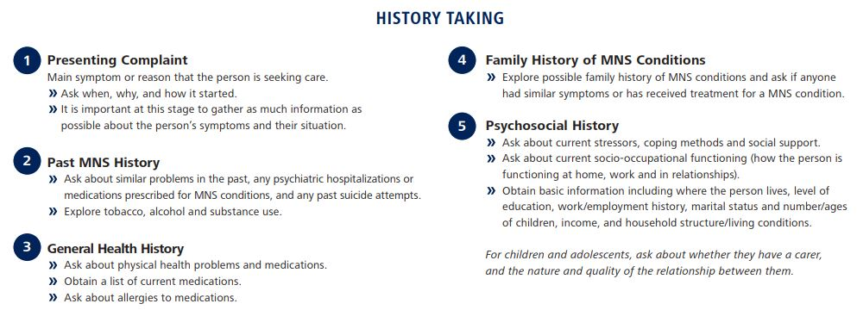
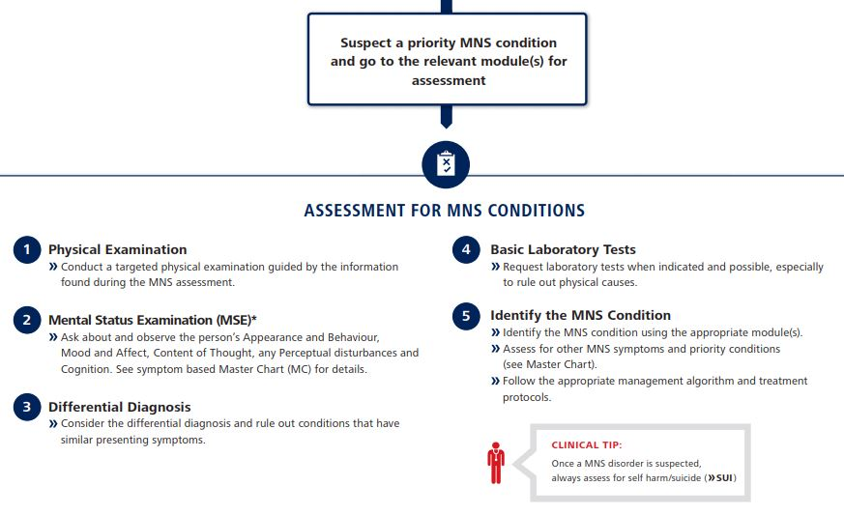

III. Manage MNS Conditions
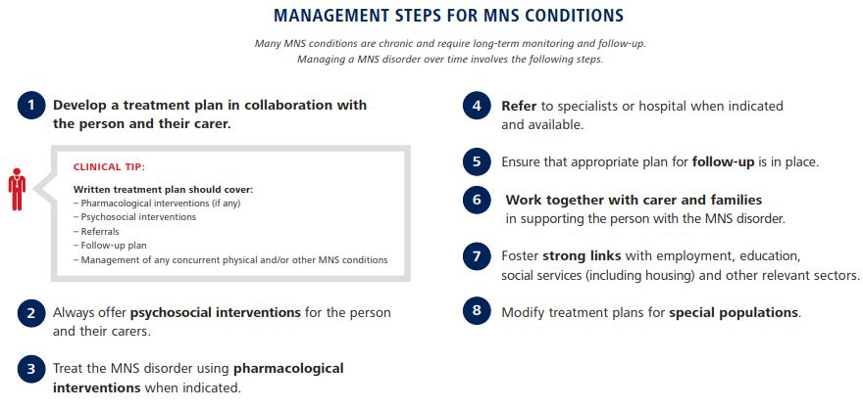
1. Treatment Planning
- Discuss and determine treatment goals that respect the willingness and preferences for care.
- Involve the carer after obtaining the person’s agreement.
- Encourage self-monitoring of symptoms and explain when to seek care urgently.

2. Psychosocial Interventions
A. Psychoeducation
- Provide information about the MNS condition to the person, including:
- What the condition is and its expected course and outcome.
- Available treatments for the condition and their expected benefits.
- Duration of treatment.
- Importance of adhering to treatment, including what the person can do (e.g. taking medication or practicing relevant psychological interventions such as relaxation exercises) and what carers can do to help the person adhere to treatment.
- Potential side-effects (short and long term) of any prescribed medication that the person (and their carers) need to monitor.

B. Reduce stress and strengthen social supports
- Address current psychosocial stressors:
- Identify and discuss relevant psychosocial issues that place stress on the person and/or impact their life including, but not limited to, family and relationship problems, employment/occupation/livelihood issues, housing, finances, access to basic security and services, stigma, discrimination, etc.
- Assist the person to manage stress by discussing methods such as problem solving techniques.
- Assess and manage any situation of maltreatment, abuse (e.g. domestic violence) and neglect (e.g. of children or the elderly).
- Discuss with the person possible referrals to a trusted protection agency or informal protection network. Contact legal and community resources, as appropriate. Identify supportive family members and involve them as much as possible and appropriate.
- Strengthen social supports and try to reactivate the person’s social networks.
- Identify prior social activities that, if reinitiated, would have the potential for providing direct or indirect psychosocial support (e.g. family gatherings, visiting neighbours, community activities, religious activities, etc.).
- Teach stress management such as relaxation techniques.

C. Promote functioning in daily activities
- Provide the person support to continue regular social, educational and occupational activities as much as possible.
- Facilitate inclusion in economic activities.
- Offer life skills training, and/or social skills training if needed.

D. Psychological Treatment
Psychological treatments are interventions that typically require substantial dedicated time and tend to be provided by specialists trained in providing them. Nonetheless, they can be effectively delivered by trained and supervised non-specialized workers and through guided self-help (e.g. with use of e-mental health programmes or self-help books).

The interventions listed below are described briefly in the glossary.
Example of Intervention Recommended for
- Behavioral Activation - DEP
- Relaxation Training - DEP
- Problem Solving Treatment - DEP
- Cognitive Behavioural Therapy (CBT) - DEP, CMH, SUB, PSY
- Contingency Management Therapy - SUB
- Family Counseling or Therapy - PSY, SUB
- Interpersonal Therapy (IPT) - DEP
- Motivational Enhancement Therapy - SUB
- Parent Skills Training - CMH

DEP – Depression
CMH – Child Mental Health
SUB – Substance Abuse Disorder
PSY - Psychosis

3. Pharmacological Interventions
- Educate the person about risks and benefits of treatment, potential side effects, duration of treatment, and importance of adherence.
- Exercise caution when providing medication to special groups such as older people, those with chronic disease, women who are pregnant or breastfeeding, and children/ adolescents. Consult a specialist as needed.

4. Referral to specialist/hospital if needed
- Stay alert for situations that may require referral to a specialist/hospital, for example, non-response to treatment, serious side effects with pharmacological interventions, comorbid physical and/or MNS conditions, risk of self-harm/ suicide.

5. Follow-up
Arrange a follow-up visit after the initial assessment.
After every visit, schedule a follow-up appointment and encourage attendance. Schedule the appointment at a mutually convenient time.
Schedule initial follow-up visits more frequently until the symptoms begin to respond to treatment.

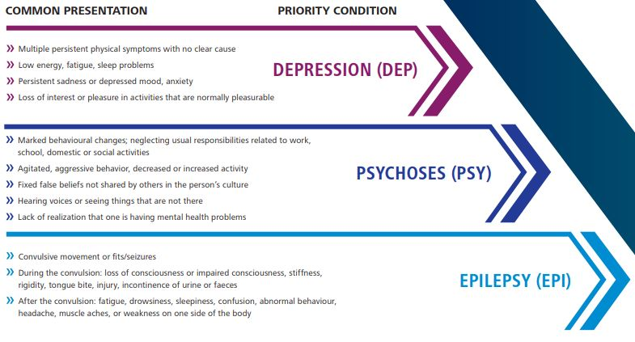
Figure 52 Master Chart of MNS Conditions

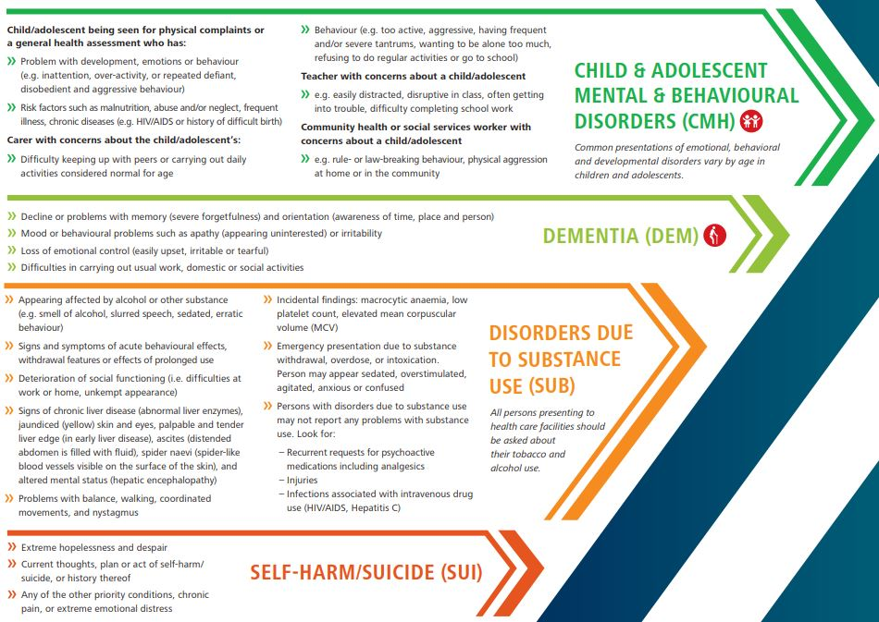
Figure 53 Master Chart of MNS Conditions

DEPRESSION
People with depression experience a range of symptoms including persistent depressed mood or loss of interest and pleasure for at least 2 weeks.

MNS ASSESSMENT

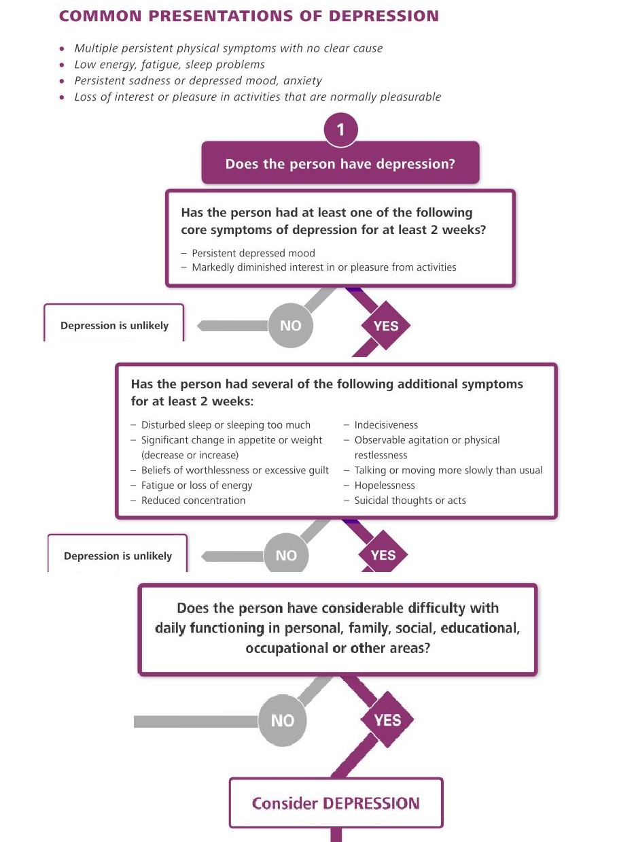

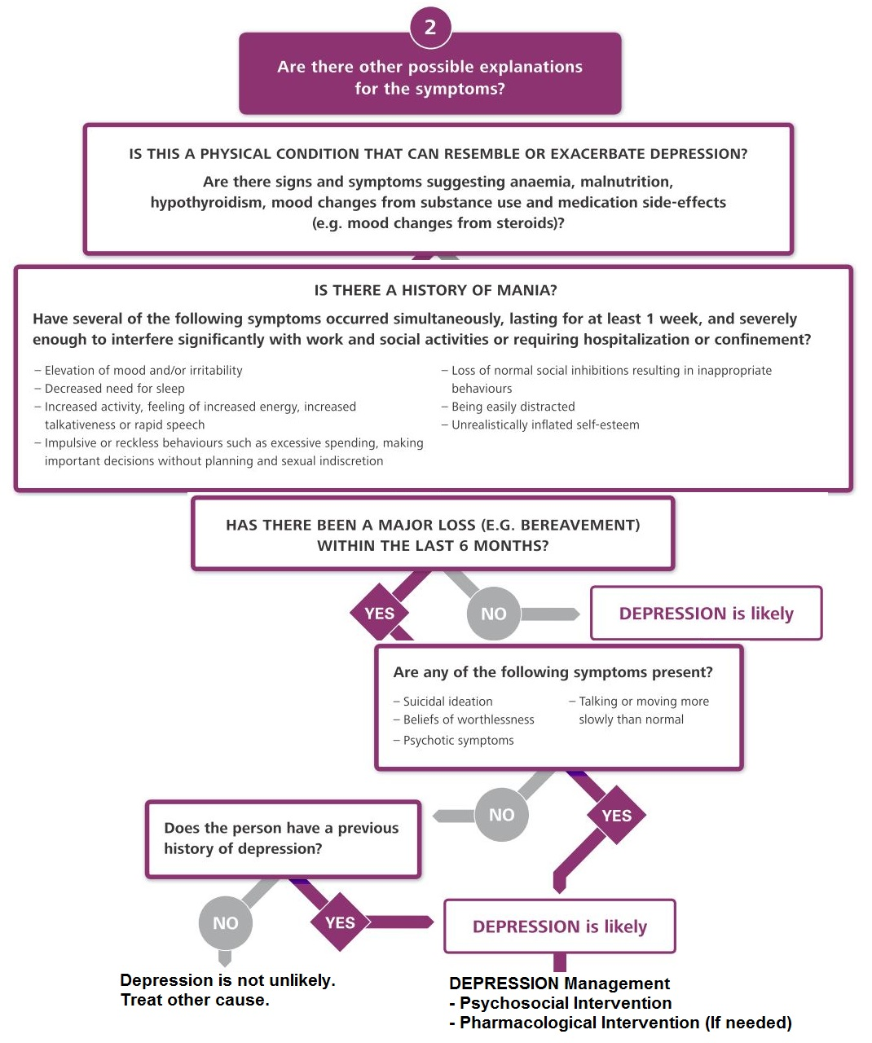

PSYCHOSOCIAL INTERVENTION

PSYCHOEDUCATION
Depression is very common that can happen to anybody. It does not mean weak and lazy.

DON’T
(-) attitude “you should be stronger” “Pull yourself together” as depression is not visible condition like fractures and wounds.

MISCONCEPTION: easily control their symptoms by sheer willpower.

UNDERSTANDING: unrealistically negative opinions about themselves, their life and future. Condition is very difficult. Depression can cause unjustified thoughts of hopelessness and worthlessness. (These are prognostic facts to see in follow-up) Self-harm or Suicide are common. If they have it, they shouldn’t act on them, but should tell trusted person, and come back immediately for help.

PROMOTE FUNCTIONS
Even if it is difficult, encourage the person to try to do as many of the following as possible: – Try to start again (or continue) activities that were previously pleasurable.
– Try to maintain regular sleeping and waking times.
– Try to be as physically active as possible.
– Try to eat regularly despite changes in appetite.
– Try to spend time with trusted friends and family.
– Try to participate in community and other social activities as much as possible.
Explain to the person and carer that these activities can all help improve mood.

PSYCHOLOGICAL TREATMENT TOOLS
- Behavioral Activation
- Relaxation Training
- Problem Solving Treatment
- Cognitive Behavioural Therapy (CBT)
- Interpersonal Therapy (TPT)

PHARMACOLOGICAL INTERVENTION

Discuss and decide together
Not addictive, take every day, some side effects in first few days but resolve soon, 4-6 weeks to get response, start low-go slow, at least 6 months, mostly 9-12 months free from symptoms, do not stop yourself.

Manic symptoms – STOP antidepressant immediately
Don’t combine 2 antidepressants.
Increased suicidal idea in adolescents and younger.
Young: Start with fluoxetine
Pregnant and BF mother: Avoid as much as possible.
Can use lowest dose. Avoid Fluoxetine.
Old: Avoid amitriptyline if possible. CVS: Avoid Ami.
Suicidal thoughts: Fluoxetine (prevent overdose suicide)

MEDICATION | DOSING | SIDE EFFECTS | CONTRAINDICATIONS  CAUTIONS
AMITRIPTYLINE  (A tricyclic antidepressant (TCA) | Start 25 mg at bedtime.  Increase by 25-50 mg per week to 100-150 mg  daily (maximum 300 mg).  Note: Minimum effective dose in adults is 75 mg.  Sedation may be seen at lower doses.  Elderly/Medically Ill: Start 25 mg at bedtime to  50-75 mg daily (maximum 100 mg).  Children/Adolescents: Do not use | Common: Sedation, orthostatic hypotension (risk of fall),  blurred vision, difficulty urinating, nausea, weight gain,  sexual dysfunction.  Serious: ECG changes (e.g. QTc prolongation), cardiac  arrhythmia, increased risk of seizure. | Avoid in persons with cardiac disease, history of seizure,  hyperthyroidism, urinary retention, or narrow angle-closure glaucoma,  and bipolar disorder (can trigger mania in people with untreated bipolar  disorder).  Overdose can lead to seizures, cardiac arrhythmias, hypotension,  coma, or death.  Levels of amitriptyline may be increased by anti-malarials including  quinine.
FLUOXETINE  (a selective serotonin  reuptake inhibitor (SSRI)) | Start 10 mg daily for one week then 20 mg daily.  If no response in 6 weeks, increase to 40 mg  (maximum 80 mg).  Elderly/medically ill: preferred choice.  Start 10 mg daily, then increase to 20 mg  (maximum 40 mg).  Adolescents  Start 10 mg daily. Increase to 20 mg daily if no  response in 6 weeks (maximum 40 mg). | Common: Sedation, insomnia, headache, dizziness,  gastrointestinal disturbances, changes in appetite, and  sexual dysfunction.  Serious: bleeding abnormalities in those who use  aspirin or other non-steroidal anti-inflammatory drugs, low  sodium levels. | Caution in persons with history of seizure.  Drug-Drug interactions: Avoid combination with warfarin  (may increase bleeding risk). May increase levels of TCAs, antipsychotics,  and beta-blockers.  Caution in combination with tamoxifen, codeine, and tramadol (reduces  the effect of these drugs).

PSYCHOSES
Two severe mental health condition
1. Psychosis
2. Bipolar Disorder

PSYCHOSIS | BIPOLAR DISORDER
Psychosis is characterized by distorted thoughts and perceptions, as well as disturbed emotions and behaviours. Incoherent or irrelevant speech may also be present. Symptoms such as hallucinations – hearing voices, or seeing things that are not there; delusions – fixed, false beliefs; severe abnormalities of behaviour – disorganized behaviour, agitation, excitement, inactivity, or hyperactivity; disturbances of emotion – marked apathy, or disconnect between reported emotion and observed affect, such as facial expression and body language, may also be detected. | Bipolar disorder is characterized by episodes in which the person’s mood and activity levels are significantly disturbed. This disturbance consists on some occasions of an elevation of mood and increased energy and activity (mania), and on others of a lowering of mood and decreased energy and activity (depression). Characteristically, recovery is complete between episodes. People who experience only manic episodes are also classified as having bipolar disorder.

MNS ASSESSMENT

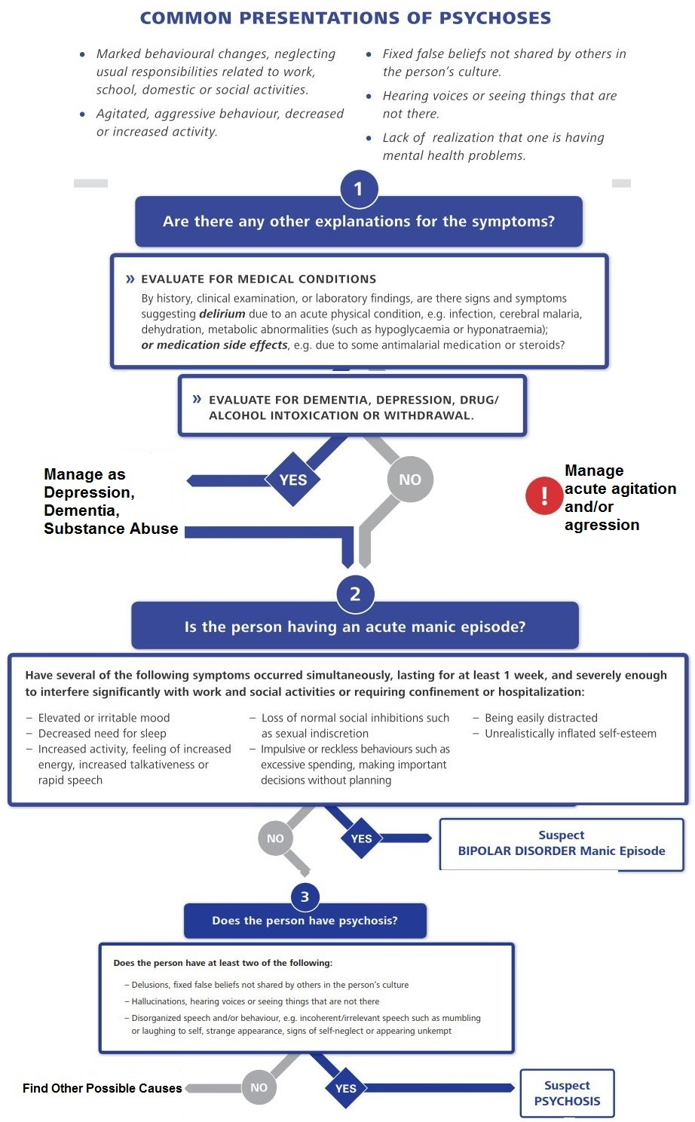

PSYCHOSOCIAL INTERVENTIONS

Psychoeducation
Key messages for the person and their carers:
- Explain that the symptoms are due to a mental health condition, that psychosis and bipolar disorders can be treated, and that the person can recover.
- Clarify common misconceptions about psychosis and bipolar disorder.
- Do not blame the person or their family or accuse them of being the cause of the symptoms.
- Educate the person and the family that the person needs to take the prescribed medications and return for follow-up regularly.
- Explain that return and/or worsening of symptoms are common and that it is important to recognize these early and visit to the health facility as soon as possible.
- Plan a regular work or school schedule that avoids sleep deprivation and stress for both the person and the carers.
- Encourage the person to solicit advice about major decisions especially ones involving money or major commitments.
- Recommend avoiding alcohol, cannabis or other nonprescription drugs, as they can worsen the psychotic or bipolar symptoms.
- Advise them about maintaining a healthy lifestyle, e.g. a balanced diet, physical activity, regular sleep, good personal hygiene, and no stressors.
- Stress can worsen psychotic symptoms. Note: Lifestyle changes should be continued as long as needed, potentially indefinitely.
- These changes should be planned and developed for sustainability

Reduce stress and strengthen social supports
- Coordinate with available health and social resources to meet the family’s physical, social, and mental health needs.
- Identify the person’s prior social activities that, if reinitiated, would have the potential to provide direct or indirect psychological and social support, e.g. family gatherings, outings with friends, visiting neighbors, social activities at work sites, sports, and community activities.
- Encourage the person to resume these social activities and advise family members about this.
- Encourage the person and carers to improve social support systems.

Promote functioning in daily living activities
- Continue regular social, educational and occupational activities as much as possible.
- It is best for the person to have a job or to be otherwise meaningfully occupied.
- Facilitate inclusion in economic activities, including culturally appropriate supported employment.
- Offer life skills training and/or social skills training to enhance independent living skills for people with psychosis and bipolar disorders and for their families and/or carers.
- Facilitate, if available and needed, independent living and supported housing that is culturally and contextually appropriate in the community.

General advice for carers
- Do not try to convince the person that his or her beliefs or experiences are false or not real. Try to be neutral and supportive, even when the person shows unusual behaviour.
- Avoid expressing constant or severe criticism or hostility towards the person with psychosis.
- Give the person freedom of movement.
- Avoid restraining the person, while also ensuring that their basic security and that of others is met.
- In general it is better for the person to live with family or community members in a supportive environment outside of the hospital setting.
- Long-term hospitalization should be avoided.

PHARMACOLOGICAL INTERVENTIONS
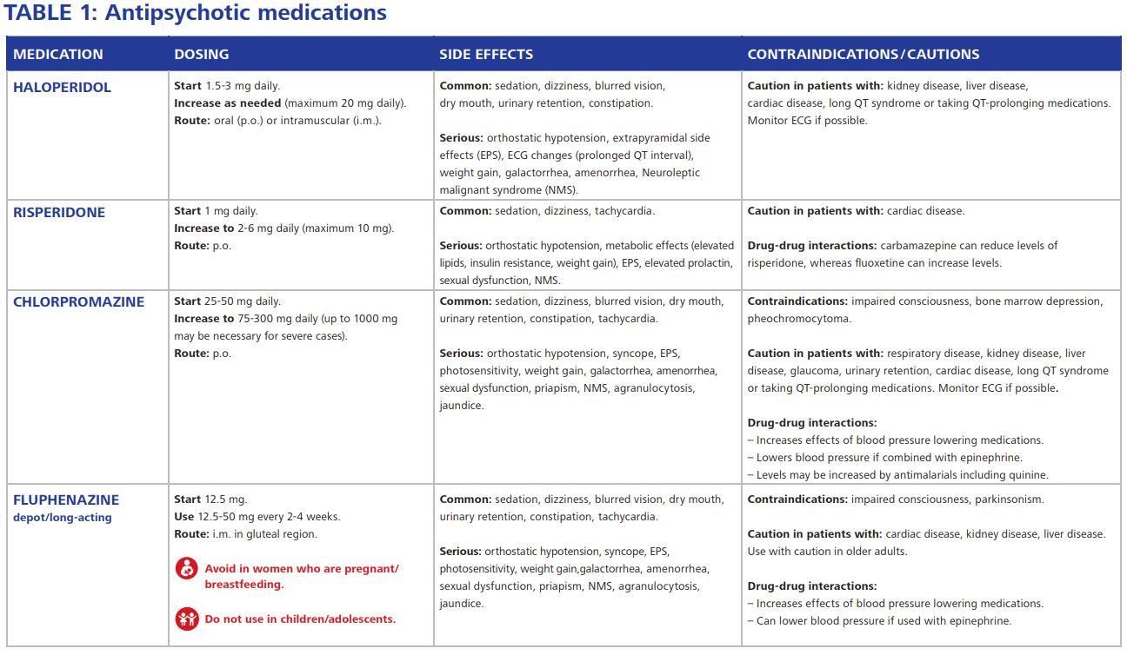

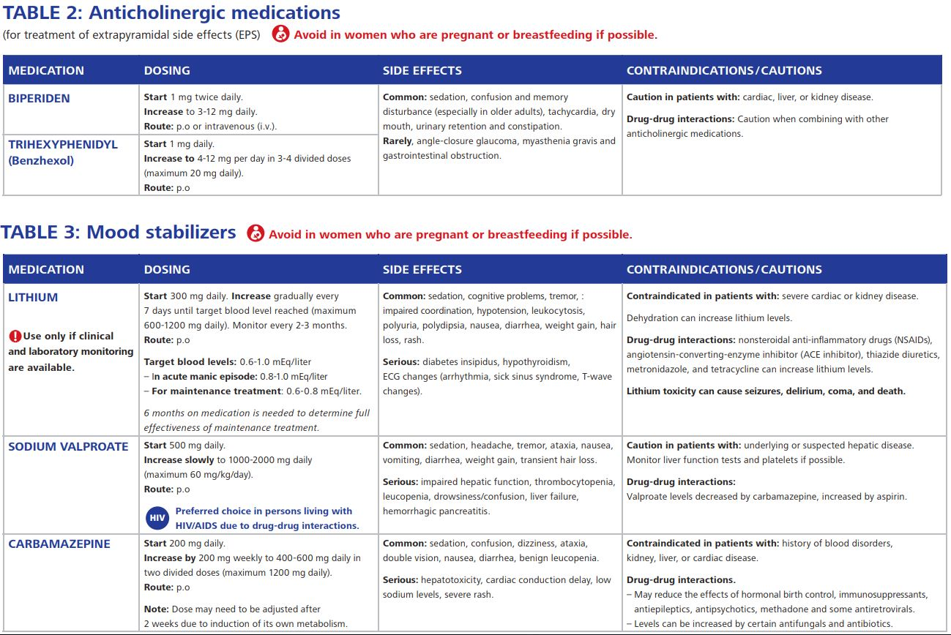

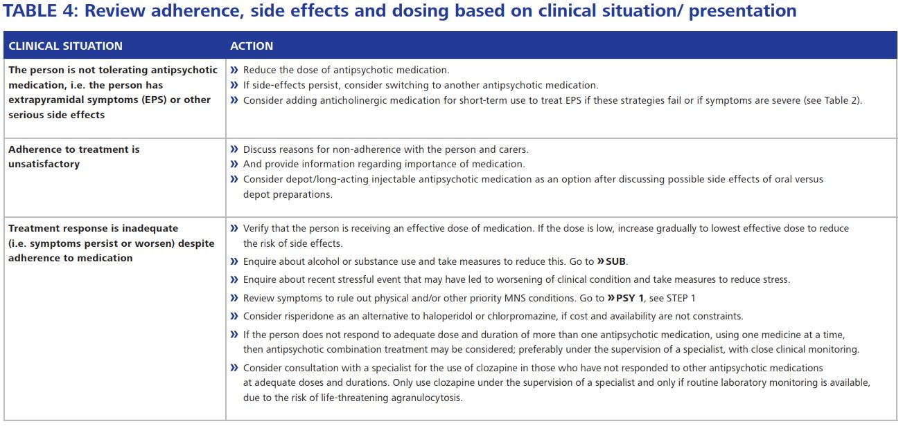

FOLLOW UP
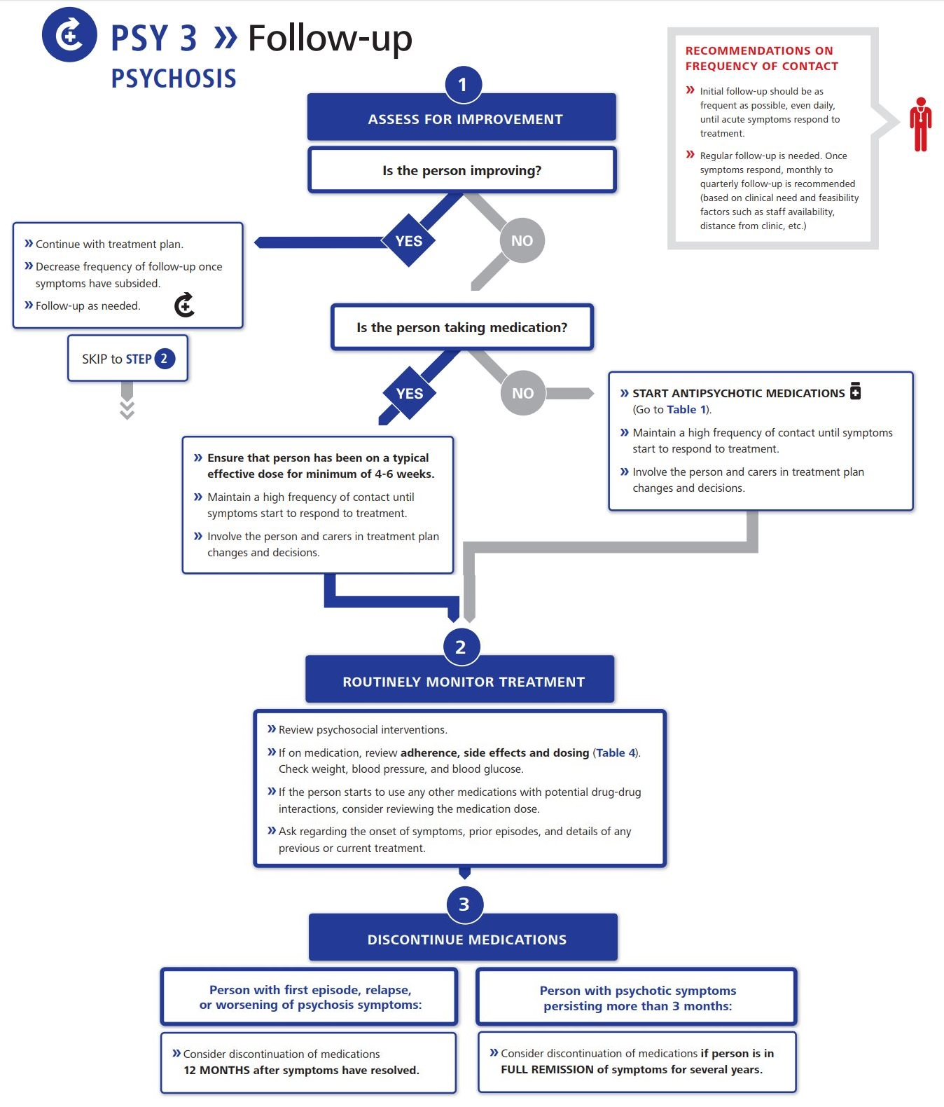

CHILD & ADOLESCENT MENTAL & BEHAVIOURAL DISORDERS
DEVELOPMENTAL DISORDER is an umbrella term covering disorders such as intellectual disability as well as autism spectrum disorders. These disorders usually have a childhood onset, impairment or delay in functions related to central nervous system maturation, and a steady course rather than the remissions and relapses that tend to characterize many other mental disorders.

BEHAVIOURAL DISORDERS is an umbrella term that includes specific disorders such as attention deficit hyperactivity disorder (ADHD) and conduct disorders. Behavioural symptoms of varying levels of severity are very common in the general population. Only children and adolescents with a moderate to severe degree of psychological, social, educational or occupational impairment in multiple settings should be diagnosed as having behavioural disorders.

EMOTIONAL DISORDERS are among the leading mental healthrelated causes of the global burden of disease in young people. Emotional disorders are characterized by increased levels of anxiety, depression, fear, and somatic symptoms.

Children and adolescents often present with symptoms of more than one condition and sometimes the symptoms overlap. The quality of home and social educational environments influence children’s and adolescents’ wellbeing and functioning. Exploring and addressing psychosocial stressors along with opportunities to activate supports are critical elements of the assessment and management plan.

COMMON PRESENTATIONS OF CHILD & ADOLESCENT MENTAL & BEHAVIOURAL DISORDERS
Child/adolescent being seen for physical complaints or a general health assessment who has:
- Any of the typical presenting complaints of emotional, behavioural or developmental disorders
- Risk factors such as malnutrition, abuse and/or neglect, frequent illness, chronic diseases (e.g. HIV/AIDS or history of difficult birth)

Carer with concerns about the child/adolescent’s:
- Difficulty keeping up with peers or carrying out daily activities considered normal for age
- Behaviour (e.g. too active, aggressive, having frequent and/or severe tantrums, wanting to be alone too much, refusing to do regular activities or go to school)

Teacher with concerns about a child/adolescent
- E.g. easily distracted, disruptive in class, often getting into trouble, difficulty completing school work

Community health or social services worker with concerns about a child/adolescent
- E.g. rule- or law-breaking behaviour, physical aggression at home or in the community
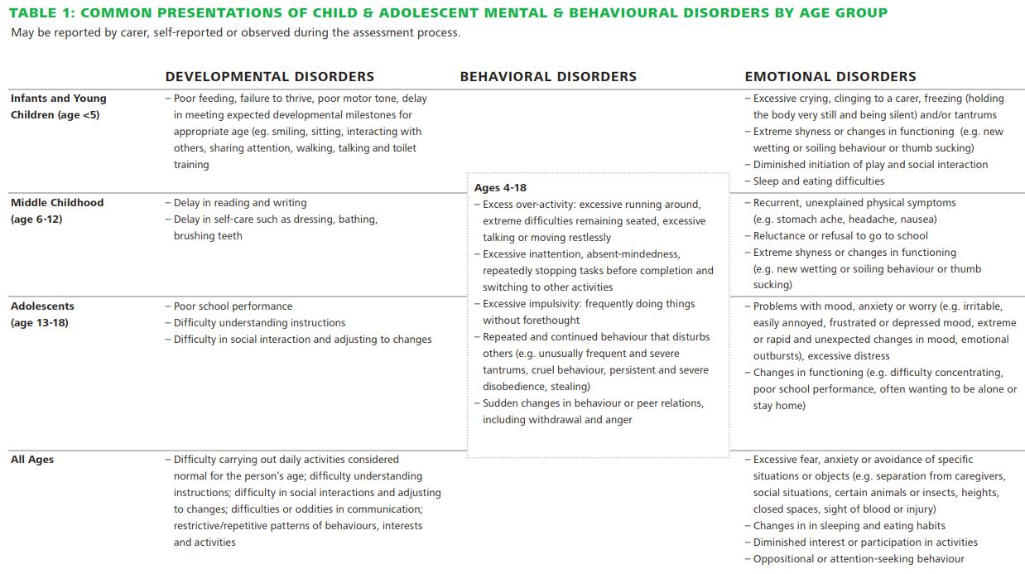

PSYCHOSOCIAL INTERVENTIONS
Guidance to promote child/adolescent well-being and functioning

ENCOURAGE THE CARER TO:
- Spend time with their child in enjoyable activities.
- Play and communicate with their child/adolescent.
- Listen to the child/adolescent and show understanding and respect.
- Protect them from any form of maltreatment, including bullying and exposure to violence in the home, at school, and in the community.
- Anticipate major life changes (such as puberty, starting school, or birth of a sibling) and provide support.

ENCOURAGE AND HELP THE CHILD / ADOLESCENT TO:
- Get enough sleep.
- Promote regular bed routines and remove TV or other electronic devices with screens from the sleeping area/bedroom.
- Eat regularly. All children/adolescents need three meals (breakfast, mid-day, and evening) and some snacks each day.
- Be physically active. If they are able, children and adolescents aged 5–17 should do 60 minutes or more of physical activity each day through daily activities, play, or sports.
- Participate in school, community, and other social activities as much as possible.
- Spend time with trusted friends and family.
- Avoid the use of drugs, alcohol, and nicotine.

Psychoeducation to person and carers and parenting advice
- Explain the delay or difficulty to the carer and the child/ adolescent as appropriate and help them identify strengths and resources.
- Praise the carer and the child/adolescents for their efforts.
- Explain to the carer that parenting a child/adolescent with an emotional, behavioural or developmental delay or disorder can be rewarding but also very challenging.
- Explain that persons with mental disorders should not be blamed for having the disorder. Encourage carers to be kind and supportive and show love and affection.
- Promote and protect human rights of the person and the family and be vigilant about maintaining human rights and dignity.
- Help carers to have realistic expectations and encourage them to contact other carers of children/adolescents with similar conditions for mutual support.

PHARMACOLOGICAL INTERVENTION
- Refer to specialist

DISORDERS DUE TO SUBSTANCE USE
Disorders due to substance use include both drug and alcohol use disorders and certain conditions including acute intoxication, overdose and withdrawal.

ACUTE INTOXICATION is a transient condition following intake of a psychoactive substance resulting in disturbances of consciousness, cognition, perception, affect, or behaviour.

OVERDOSE is the use of any drug in such an amount that acute adverse physical or mental effects are produced.

WITHDRAWAL is the experience of a set of unpleasant symptoms following the abrupt cessation or reduction in dose of a psychoactive substance; it has been consumed in high enough doses and for a long enough duration for the person to be physically or mentally dependent on it. Withdrawal symptoms are, essentially, opposite to those that are produced by the psychoactive substance itself.

HARMFUL USE is a pattern of psychoactive substance use that damages health. This damage may be physical, e.g. liver disease, or mental, e.g. episodes of depressive disorder. It is often associated with social consequences, e.g. family or work problems.

DEPENDENCE is a cluster of physiological, behavioural, and cognitive phenomena in which the use of a psychoactive substance takes on a much higher priority for a given individual than other behaviours that once had greater value. It is characterized by a strong craving to use the substance and a loss of control over its use. It is often associated with high levels of substance use and the presence of a withdrawal state upon cessation.

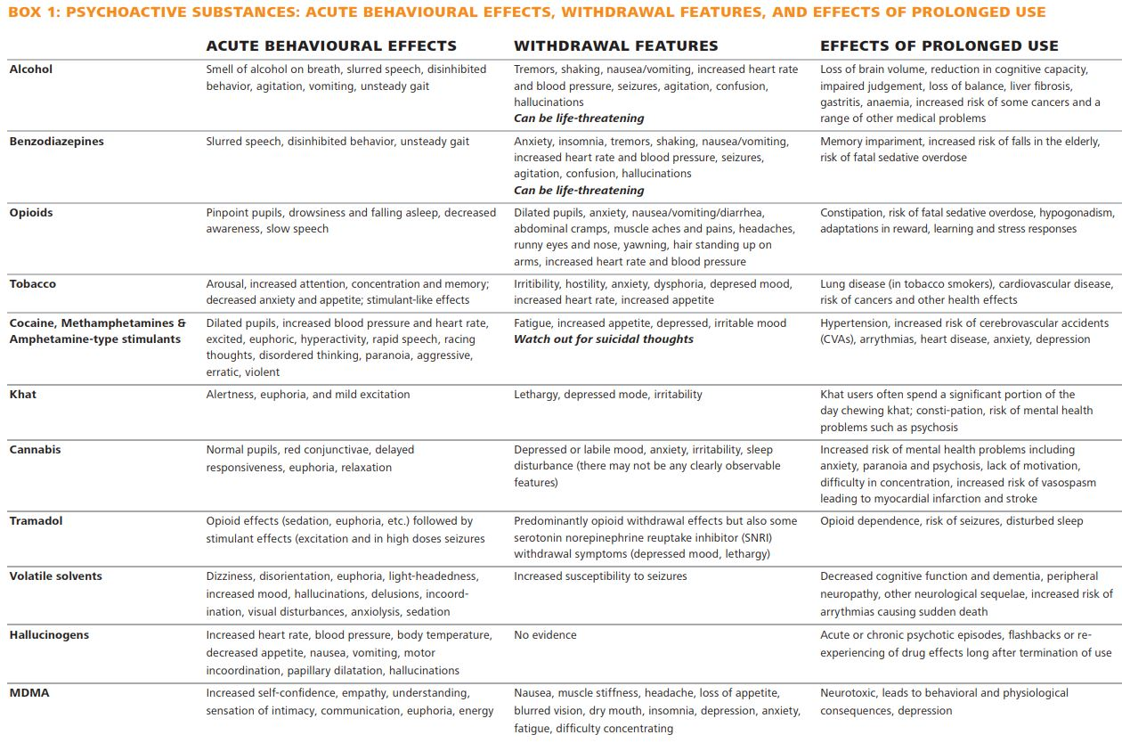

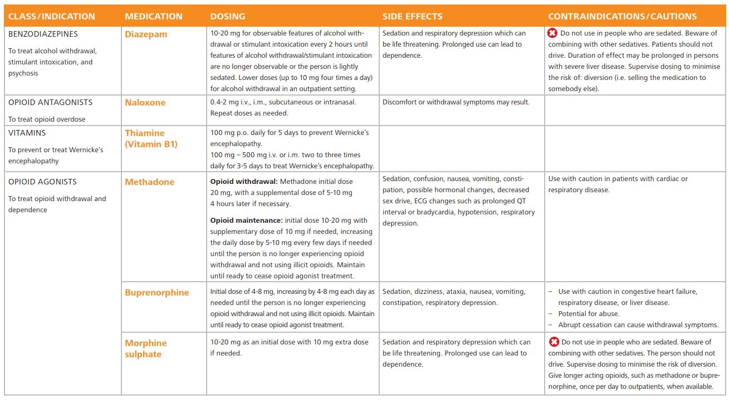

SELF-HARM / SUICIDE
Suicide is the act of deliberately killing oneself. Self-harm is a broader term referring to intentional self-inflicted poisoning or injury, which may or may not have a fatal intent or outcome.
Any person over 10 years of age experiencing any of the following conditions should be asked about
- thoughts or plans of self-harm in the last month, and
- about acts of self-harm in the last year:

» Any of the priority MNS conditions
» Chronic pain
» Acute emotional distress

Evaluate for thoughts, plans and acts of self-harm during the initial assessment and periodically thereafter, as required. Attend to the person’s mental state and emotional distress

Has the person attempted a medically serious act of self-harm?
Assess if there is evidence of self-injury and/or signs/symptoms requiring urgent medical treatment:
- Signs of poisoning or intoxication
- Bleeding from self-inflicted wound
- Loss of consciousness
- Extreme lethargy

Is there an imminent risk of self-harm/suicide?
- Current thoughts or plan of self-harm/suicide
- History of thoughts or plan of self-harm in the past month or act of self-harm in the past year in a person who is now extremely agitated, violent, distressed or lacks communication

Is there a history of thoughts or plan of self-harm in the past month or act of self-harm in the past year?

Does the person have concurrent MNS conditions?
- Depression
- Disorders due to substance use
- Child & adolescent mental and behavioral disorders
- Psychoses
- Epilepsy

Does the person have chronic pain?
Does the person have emotional symptoms severe enough to warrant clinical management?
- Difficulty carrying out usual work, school, domestic or social activities
- Repeated self-medication for emotional distress, or unexplained physical symptoms
- Marked distress or repeated help-seeking

PSYCHOSOCIAL INTERVENTION

Offer and activate psychosocial support

Offer support to the person
- Explore reasons and ways to stay alive.
- Focus on the person’s strengths by encouraging them to talk of how earlier problems have been resolved.
- Consider problem-solving therapy to help people with acts of self-harm within the last year, if sufficient human resources are available.
- Mobilize family, friends, concerned individuals and other available resources to ensure close monitoring of the person as long as the risk of self-harm/suicide persists.
- Advise the person and carers to restrict access to means of self-harm/suicide (e.g. pesticides/toxic substances, prescription medications, firearms, etc.) when the person has thoughts or plans of self-harm/suicide.
- Optimize social support from available community resources. These include informal resources, such as relatives, friends, acquaintances, colleagues and religious leaders or formal community resources, if available, such as crisis centres, and local mental health centres.

Carers support
- Inform carers and family members that asking about suicide will often help the person feel relieved, less anxious, and better understood.
- Carers and family members of people at risk of self-harm often experience severe stress. Provide emotional support to them if they need it.
- Inform carers that even though they may feel frustrated with the person, they should avoid hostility and severe criticism towards the vulnerable person at risk of self-harm/suicide.

Psychoeducation
Key messages to the person and the carers
- If one has thoughts of self-harm/suicide, seek help immediately from a trusted family member, friend or health care provider.
- It is okay to talk about suicide. Talking about suicide does not provoke the act of suicide.
- Suicides are preventable.
- Having an episode of self-harm/suicide is an indicator of severe emotional distress. The person does not see an alternative or a solution. Therefore, it is important to get the person immediate support for emotional problems and stressors.
- Means of self-harm (e.g. pesticides, firearms, medications) should be removed from the home.
- The social network, including the family and relevant others, is important for provision of social support.

ANXIETY DISORDERS

Anxiety or mental stress often occurs when we are frightened or worried. Anxiety disorders are defined when a sense of fear or worry makes it hard for someone to do normal activities of life (e.g. completing school work or caring for children) or when anxiety is persistent. When feeling anxiety or stress, the heart usually starts beating faster, reactions are quicker and we are more alert. Headaches and sweating are common. This is the body’s normal reaction to stress, but problems occur when levels of stress are too high or they are unable to be relieved.

- When these symptoms become chronic the patient may have an anxiety disorder. More severe symptoms from unrelieved anxiety can include sleeplessness, heart palpitations, depression, violence, withdrawal and psychosomatic complaints.

- An acute anxiety attack is an acute episode of severe anxiety with severe psychosomatic symptoms: patients may have chest pain, difficulty breathing, palpitations, dizziness and fear that they are going to die.

TREATMENT

Always look for an underlying mental disorder (depression, PTSD or psychosis) and give specific treatment.
Acute anxiety attack:
- Try to calm down the patient by talking and listening carefully and reassuring.
- Encourage deep breathing and put them in a quiet private place.
- Consider diazepam PO only in severe acute anxiety attacks (see below).
- Use counselling techniques (see p.151).

Non-medication treatment options:

- Cognitive behavioural therapy. This should be carried out by trained health workers. This form of therapy has a lot of similarities with counselling (see p.151).

Treatment by medication:
- For long-term treatment antidepressants (SSRIs or amitriptyline) can work well.
- Beta blockers e.g. propranolol 40mg OD (increase to TID if necessary) can help with anxiety symptoms of racing heart especially if also have high BP or if tremor/palpitations are the main symptoms. Monitor BP and PR.
- For an acute anxiety attack you can use diazepam (5-15mg PO in 2-3 divided doses for a maximum of 1-2 weeks and reduce dose by half in last few days of treatment) to lower the anxiety.

**Note: diazepam medicine is very addictive: only use it if the patient’s anxiety cannot be controlled through counselling.**

POST TRAUMATIC STRESS DISORDER

Post-traumatic stress disorder (PTSD) is a condition that occurs as a response to severe and prolonged fear. It is characterized by continual high levels of anxiety that interfere significantly with the person’s ability to lead their life. This disorder is common in people that have experienced violent situations, or have escaped from life-threatening situations, both of which are common experiences for refugees and migrants.

CAUSES

  - Life threatening violence, either a single event or over a long period of time.
  - Violence experienced either directly by the patient or seen by the patient to have happened to somebody else.
  - Escaping from possible violence, or fear of capture.

SIGNS AND SYMPTOMS
- Persistent re-experiencing: images, thoughts or perceptions about the traumatic experience which intrude despite efforts to block them out (the patient tries not to think about it but cannot). It may include distressing dreams and flashbacks (reliving the experience).
- Avoidance: patient avoids places, situations, people associated with the trauma, may use alcohol, drugs to help do this.
- Increased arousal: constant state of alert, exaggerated startle response (very easily scared), anxiety, insomnia, poor concentration, may have somatic symptoms e.g. high BP, sweating, shaking, tachycardia, headache etc.

TREATMENT
Non-medication treatment options:
- Counselling (Essential care and practice)
- Relaxation therapy.
- ‘Survivors of violence’ need to feel safe and secure in their environment.
- Empathy: listen and accept what the person is saying. Ask how they feel about the incident, express your support.
- Talk and listen, ask the patient about the history of their problems. For example, when was the first time they felt the headaches, or could not sleep? What things were happening in their lives around that time? Try to locate a probable cause for their symptoms.
- Try to listen to the patient’s problems. Do not to judge them based upon their stories, express that you are interested in what they have to say and try to let them express themselves. Above all, let the patient know they are not alone and that you understand the reasons for their stress.
- Group counselling may be helpful – if the patient interacts with others who have had similar experiences, they may feel less alone.

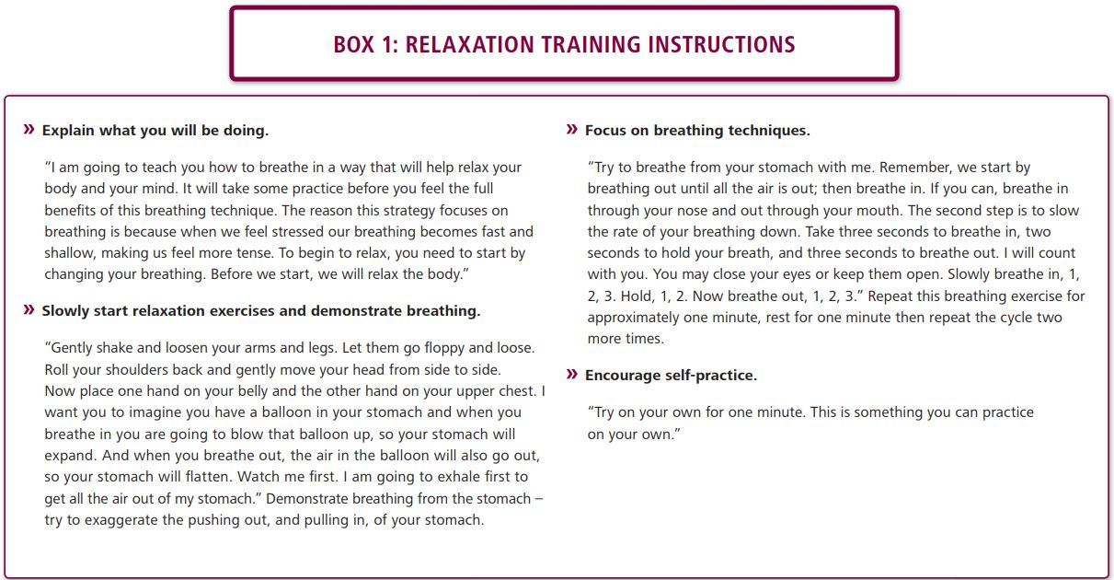

EMERGENCIES

BASIC CARDIO - RESPIRATORY RESUSCITATION
Basic cardio respiratory resuscitation is the immediate care given to someone in cardio-respiratory shock.

What is a shock?

Definition
A shock is a clinical syndrome in which the peripheral blood flow is inadequate to return sufficient blood to the heart for normal function. Transport of oxygen to organs and tissue isn’t enough. If this is not treated quickly, heart and brain may fail, which can lead to death.

What causes circulatory shock?
- The heart fails to pump blood, or the blood vessels dilate, as in severe infection or allergic shock, reducing the blood pressure.
- Fluids or blood loss, through burns, severe diarrhea or vomiting.

Signs of shock

At first step
- a rapid pulse
- pale, grey-blue skin, especially inside the lip. Fingernails or earlobe, if pressed, will not regain its colour immediately
- sweating and cold, clammy skin

Shock developed. There may be:
- weakness and giddiness
- nausea, and possibly vomiting
- thirst
- rapid, shallow breathing
- a weak pulse, when the pulse at the wrist disappears, about half the blood volume will have been lost.

As the brain's oxygen supply weakens, there may be:
- Restless, anxious and even aggressive
- Gasp for air (air hunger)
- Unconscious
- The heart will stop

Steps of resuscitation
Resuscitation of the patient means 'stimulating breathing and/or heart beat when the patient fails to do this itself'. The nurse must act calmly and with confidence.
D – Is there Danger?
R – Is the patient Responsive?
S – Send for HELP!
A – Open/clear Airway
B – Is the patient breathing?
C – Start CPR
30 compressions: 2 Breaths
OR continuous compressions
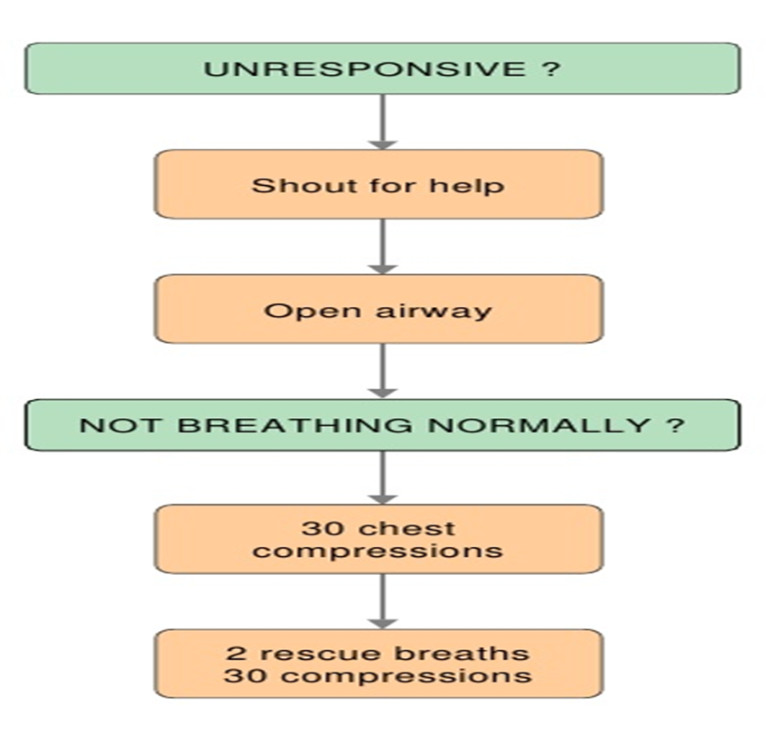
Figure 54 Resuscitation in adult (ref: UK's RC)

Requirements
- Minimal CPR interruptions
- Oxygen cylinder
- Equipment
- Self-inflating bag-valve mask
- Cannula
- IV fluid set
- IV Adrenaline and IV fluids
- Syringes and needles
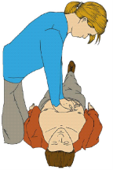  Figure 55 Body position of cardiac massage | 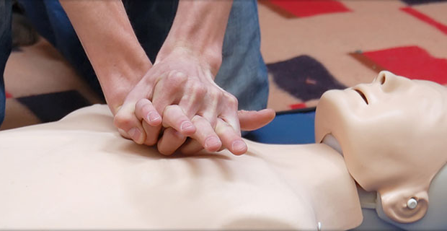  Figure 56 Hand position of cardiac massage
- Kneel by the side of the patient. Patient is lying on the back on a hard surface
- Place the heel of one hand in the center of the patient chest.
- Place the heel of your other hand on top of the first hand
- Interlock the fingers of your hands
- Position yourself vertically above the patient’s chest and, with your arms straight, press down on the sternum 4-5cm
- After compression, release all the pressure on the chest without losing contact.
- Repeat at a rate of about 100 / minute, about 1 or 2 massages per second
- Combine 30 chest compressions with 2 artificial ventilations

Artificial ventilation (Adult)
- Two techniques: mouth to mouth or Ambu-bag
1. Mouth to mouth
- Be sure that the airway is free
- Pinch the soft part of the nose closed.
- Maintain chin lift
- Take a normal breath and place your lips around the mouth. Blow steadily into the mouth during 1 second. Check movement of the chest.
- Repeat it one time.
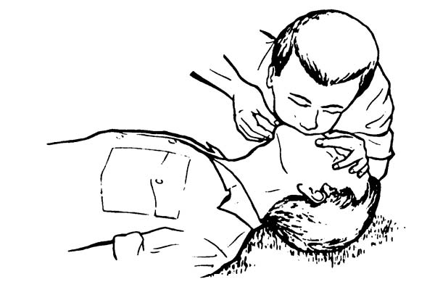
Figure 57 Mouth to mouth ventilation

2. Ambubag
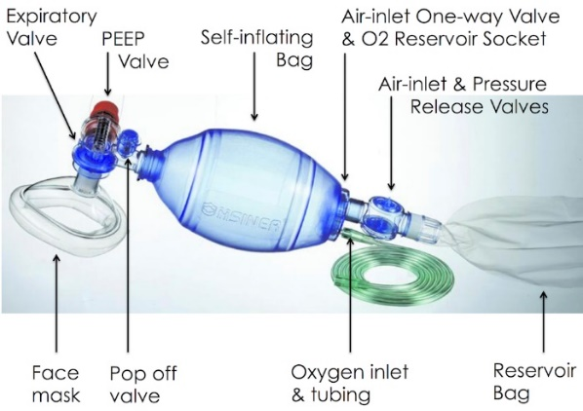 | 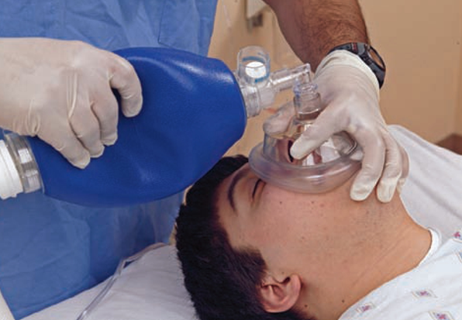
Figure 58 Ambu Bag ventilation
- Choose the correct size of mask for the patient
- Maintain the hyper extension of the head
- Apply the mask properly over the patient’s face by grasping his chin but without strangling him
- Press the balloon adapted to ambubag at the same rhythm than mouth to mouth.

Always check the effect of your artificial respiration:
- Avoid air escaping
- Look at the chest movement

Within the first 10 seconds, the procedures had to be done are
- Call for HELP
- Move the table to allow access around the patient
- Start good quality CPR with minimal interruptions (never more than 10s off the chest)
Do not stop CPR unless told to!

Within the first minute, the procedures had to be done are

- Bag-valve mask should be used to ventilate the patient WITH oxygen. Use two person technique.
- 30:2 CPR:Ventilation ratio
- IV access should be obtained with IV fluids connected
- IV adrenaline 1mg should be given STAT (then every 5 minutes)
- Every 2 minutes, pause CPR and do a central pulse check (femoral and/or carotid)

Resuscitation should be stopped if:
- Signs of life develop
- Return of pulse
- Team decides that resuscitation will be unsuccessful (After the resuscitation have not succeeded by 20 minutes)

If returned of spontaneous circulation occurs:
- Put patient in recovery position with oxygen (aim saturation 94-98%)
- Continue to treat underlying cause
- IVF if needed, check glucose
- Severe observation chart

Importance notes
- Everyone knowing their roles within the team.
- Minimal distractions/calm atmosphere
- No one shouting
- Not everyone watching
- Privacy and dignity
- Use of curtains around bed
- Easy access to equipment
- Prepare cardiac Arrest box
- Debriefing as a team
- Identifying sick patients and monitoring them closely
- Prevention is always best
- If a patient is very sick or has serious co-morbidities, always alert for CPR preparation
- Ideally this should be decided early in admission
- Should be discussed with patient and family
- This needs to be documented and handed over

What do you do in priority to unresponsive patient with a normal breathing?
- Turn the patient into the safety lateral position  - Check for continued breathing | 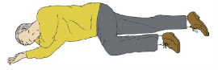

Resuscitation in child
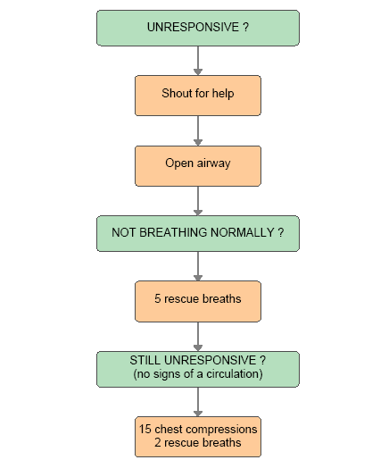
Figure 59 Resuscitation in children (ref: UK's RC)

Artificial ventilation (Children)
Three techniques: mouth to mouth, mouth to mouth and nose or ambubag
For child over 1 year: Mouth to mouth
- Pinch the soft part of the nose closed with the index and thumb of your hand on his forehead  - Open his mouth a little, but maintain the chin  - Take a breath and blow steadily into the mouth over about 1 – 1.5 seconds. Repeat it 5 times.  - Identify effectiveness by seeing that the chest has risen and fallen in a similar fashion to your rescue breaths | 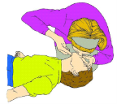  Figure 60 Mouth to mouth ventilation (Child over 1 year)

For infant: Mouth to mouth and nose
- Ensure a neutral position of the head and chin lift  - Same procedure as above. But cover the mouth and nasal apertures with your mouth | 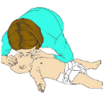  Figure 61 Mouth to mouth and nose ventiation (Infants)

Ventilation with ambubag
- Choose the correct size of mask for the patient  - Maintain the hyper extension of the head  - Apply the mask properly over the patient’s face by grasping his chin but without strangling him  - Press the balloon adapted to ambubag at the same rhythm than mouth to mouth.  Always check the effect of your artificial respiration:  - Avoid air escaping  - Look at the chest movement | 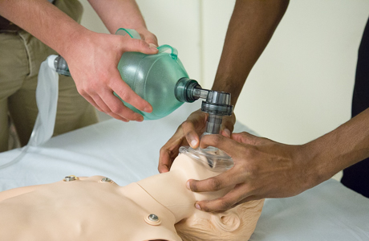  Figure 62 Ventilation with Ambu bag (Infants, Children and adults)

If you detect signs of circulation:
Continue rescue breathing until it starts spontaneously
Put the child in safety lateral position
Check frequently the child

Two fingers chest compression (Infants)
Use 2 fingers for an infant under 1 year. Place both thumbs flat side by side while the other hand is holding the head  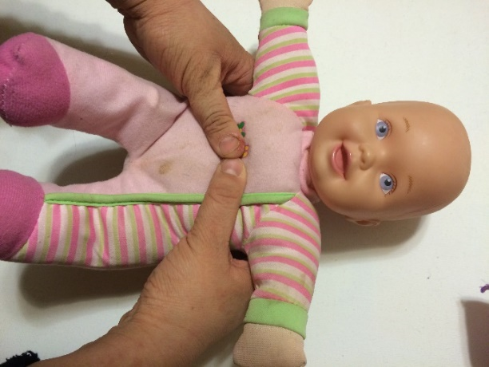 | 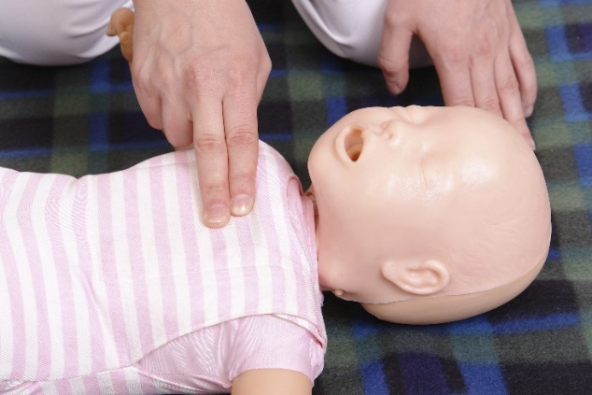  Figure 63 Two fingers technique (Infants)
Use one or 2 hands for a child over 1 year  - 1 hand technique (Children)  - 2 hands technique (same as adult) | 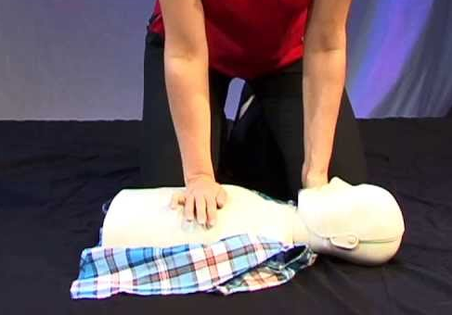  Figure 64 One hand technique CPR (Children)

In addition to resuscitation:
- Raise and support the victim legs to improve the blood supply to the heart and brain. Take care if you suspect a fracture.
- Give appropriate treatment for the cause of shock
- Reassure the victim
- Keep the victim warm by covering with coat or blanket

What do you do in case of airway obstruction?
Airway obstruct ion occurs when the airway becomes blocked due to a solid object, fluids or the back of the tongue.
A person who is choking may quickly stop speaking, stop breathing, attempt to cough, lose consciousness and finally die.
It’s important not to confuse the ariway obstruction with heart attack, seizures, fainting, …

Chest thrusts for baby and child
- If a baby is distressed or stops coughing, lay face down on your forearm with the head low and support his back and chin.  - Give up to 5 back slaps between the shoulder blades.  - Check the mouth. Remove any noticeable obstruction with one finger.  - If this fails, turn the baby on to his/her back. Give up to 5 forceful chest thrusts with 2 fingers. Check the mouth.  If the baby is unconscious, try up to 5 mouth-to-mouth breathings.  Continue the cycle: back slaps, chest thrusts, mouth checks and breathing attempts until the baby restarts breathing. | 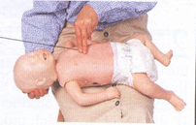  Figure 65 Chest thrusts for baby and child

Chests thrusts and abdominal thrusts for adult
Apply up to 5 back blows as follows:  1. Stand to the side and slightly behind the victim  2. Support the chest on one hand  3. Give up to five sharp blows between the shoulder blades with the heel of other hand  If it fails: do abdominal thrust (Heimlich maneuver)  1. Stand behind the patient and put both arms round the upper part of his abdomen  4. Clench your fist and place it above the umbilicus  5. Grasp this hand with your other hand and pull sharply  Repeat 5 times  If necessary: alternate five back blows with five abdominal thrusts | 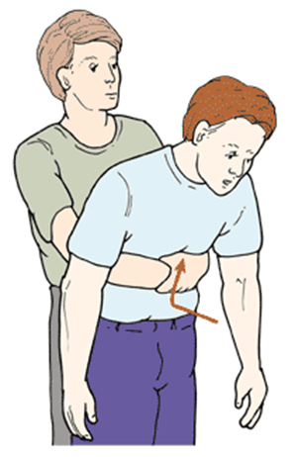  Figure 66 Chest thrusts for adult

SHOCK
In shock, the blood flow (and blood volume) is not enough to keep the person alive. The vital organs (e.g. brain, heart) do not get enough blood and oxygen to work.

Shock is an emergency, delay in treatment causes death

Low BP is a late sign in shock. Do not wait for low BP before treating shock

CAUSES

1. HYPOVOLEMIC SHOCK (Shock caused by loss of blood or fluids):
Causes:
- Severe bleeding anywhere in the body (e.g. trauma, ectopic pregnancy, ruptured aorta aneurysm)
- Severe fluid loss (e.g. severe vomiting and diarrhoea, burns, severe ascites, severe dengue)

2. VASODILATORY SHOCK (Shock caused by widening of the blood vessels):

- Bacterial infection (septic shock)
- Severe allergic reaction (anaphylactic shock)
- Severe brain injury or bleeding (neurogenic shock)
- Taking of certain drugs or poisons.

3. CARDIOGENIC SHOCK (Shock caused by weak pumping of heart = heart failure):

- Vitamin B1 deficiency (see p.187)
- Damaged heart valve (see p.40)
- Abnormal rhythm of the heart: too fast (tachycardia) or too slow (bradycardia)
- Lung collapse (pneumothorax)
- Heart attack (myocardial infarction)

4. SEPTIC SHOCK (shock caused by the effects of an infection on the body)
Causes:
- Any severe infection

5. ANAPHYLACTIC SHOCK (Shock caused by a severe allergic reaction): Causes:
- Severe allergic reaction e.g. penicillin, peanuts

SIGNS AND SYMPTOMS
Signs and symptoms can vary with the different kinds of shock, but some are common in most patients:
- Fast and weak pulse (>100 bpm in adults).
- Fast, shallow breathing (> 30 respirations per minute in adults).
- Cold, sweaty (‘clammy’) skin occurs in most shock patients. An exception is the flushed skin in the early stages of vasodilatory shock (for example, in septic shock).
- Hypotension (low blood pressure) – Systolic BP < 90 mmHg occurs in most shock patients. Note: Low BP is a late sign of shock, do not wait for low BP in treating a patient with other signs of shock
- Low urine output (= oliguria): urine production less than 0.5ml/kg/hr in adults and 1ml/kg/hr in children
- Change in mental state: at the onset patients are agitated, then confused, then drowsy and then in coma.

In SEPTIC SHOCK you also find:
- High or low temperature.
- History of chills before the fever started.
- Warm skin.

In ANAPHYLACTIC SHOCK you also find:

- Sometimes a history of taking certain medicines (especially penicillins and anti-inflammatories), of insect bite, or ingestion of some food (especially seafood and nuts). Symptoms of anaphylaxis can last from 5 minutes to several hours.
- Oedema (swelling) of lips and throat which makes breathing difficult.
- Wheezing.
- High BP before it drops to low levels.
- Sometimes an itchy rash quickly spreading over all the body.
- Sometimes vomiting and diarrhoea.

 | ASSESS FOR | TREATMENTS LIKELY TO BE NEEDED FOR SHOCK
DR | Danger  Response | Gloves  Safe place, call for help
A | Airway obstruction  Speaking, stridor,  swelling, secretions | Simple airway manoeuvres +/- airway if needed  Suction if needed (and available)  Oxygen (high flow)  Adrenaline nebuliser 5ml STAT if anaphylactic shock and airway swelling or stridor
B | RR, SpO2, Chest indrawing/cyanosis  tracheal tug  Listen to chest | Salbutamol nebuliser Adult/>5yr 5mg; Child <5yr 2.5mg STAT if have wheeze  (consider anaphylactic shock)  Position patient: If dyspnoea sit up right (but if very low BP raise legs to level  above head)
C | HR, BP, Cap refill  Urine output, Temp  Listen to HS | Put in 2 biggest (16G or 18G) IV cannula – take bloods e.g. Hct, CBC, MS, BC,  dextrose etc.  If signs of shock give fluid bolus NSS or R/L if diarrhoea (unless cardiogenic  shock)
D | Check dextrose  Any drugs needed e.g.  antibiotics, paracetamol | For details on specific treatment see below  Septic shock: ceftriaxone  Anaphylactic shock: adrenaline IM, chlorpheniramine, hydrocortisone  Cardiogenic shock: furosemide +/- vitamin B1  Give dextrose if low
E | AVPU/GCS  Expose and examine all  over body | Review notes and charts  History, further investigations, treatment plan

1. HYPOVOLEMIC SHOCK: BLOOD/FLUID LOSS
- If bleeding stop by applying pressure
- Give IV fluids NSS Adult: 500ml-1L STAT; Child 10-20ml/kg STAT (or R/L if diarrhoea). If severe hypovolaemia may need to give at least 2L in the first hour in adults.
- If there is still bleeding, fluid replacement must include ongoing losses: this could mean giving 2L of fluids per 1 hour in adults.
- Shock from blood loss requires blood transfusion, several units may be necessary.

AIM TO REPLACE 2-3 TIMES THE ESTIMATED LOSS

e.g. if loss is 1L then the patient will need 2-3L rapidly

2. SEPTIC SHOCK
- Give IV fluids NSS Adult: 500ml-1L STAT; Child 10-20ml/kg STAT (or R/L if diarrhoea). Re-assess vital signs after fluid bolus.
- Give high doses: ceftriaxone, preferably IV (or IM if cannot get IV access).
- Try to find the source of the infection.

3. ANAPHYLACTIC SHOCK
- Drug or blood infusions should be stopped immediately.
- Give IV fluids NSS Adult: 500ml-1L STAT; Child 10-20ml/kg STAT. You may need to give at least 2L in the first hour in adults.
- Give:

ADRENALINE  IM: 1 in 1,000  (1 vial = 1ml = 1mg) | CHLORPHENIRAMINE  IV or IM  (1 vial = 1ml = 10mg) | HYDROCORTISONE  SLOW IV OR IM
ACUTE PHASE
>12yrs/Adult: 0.5ml  6yrs-12yrs: 0.25ml  6m-6yrs: 0.12ml  <6m: 0.05ml | Adult: 10-20mg  12–18yrs: 10mg  6–12yrs: 5mg  6m–6yrs: 2.5mg  <6m 250 mcg/kg (max.2.5 mg) | >12yrs/Adult 200mg  6-12yrs: 100mg  1-5yrs: 50mg  <1yr: 25mg
Repeat dose at intervals until BP and pulse are  back to normal | Give STAT over 1 minute | (Can also use dexamethasone)
AFTER ACUTE PHASE
 | Continue QID, switch to PO chlorpheniramine when improved:  >12yrs/Adult: 4mg QID  (max 24mg/d)  6-12yrs: 2mg QID  (max 12mg/d)  3-5yrs: 2mg QID  (max 6mg/d)  1-2yrs: 1mg BID  (max 3mg/d) | Can repeat hydrocortisone 3-4 times per day if required.  Switch to PO prednisolone when improved/stable.
4. CARDIOGENIC SHOCK

- Treat the cause (e.g. anaemia, Beriberi).
- For heart failure treatment see pg.36.

GENERAL REMARKS

Careful monitoring in all patients of:
- Vital signs (pulse rate, blood pressure, respiratory rate) every 15 minutes.
- Urine output (consider a urinary catheter) – minimum output should be at least 0.5ml/kg/hr in adults and 1ml/kg/ hr in children.
- Fluid balance chart: record all fluid input and all fluid losses: urine, blood.
- Lung crepitations and/or rising respiratory rate may indicate too much fluid.

DIAGNOSIS

Determine the cause of shock AFTER the patient is stabilised (using DR-ABCDE)

TREATMENT

Try to identify the underlying cause and treat as above.

LONG-TERM MANAGEMENT

Shock is an acute condition – if you do not manage to improve the patient’s vital signs rapidly, he/she will die.

If the condition improves and vital signs return to normal (e.g. Adults: pulse <100 bpm, systolic BP>90 mmHg, urine output >0.5ml/kg/hr and mental condition improves) adjust the rate of infusion to 1L in 6hrs.

PREVENTION

Once someone is in shock, the sooner shock is treated the less damage there may be to the person’s vital organs such as the kidney, liver and brain. Early first aid and emergency medical help can save his or her life.

Ideally, people who have a history of a severe allergy reaction to insect bites or medicines should be instructed to carry (and use) an emergency kit consisting of injectable adrenaline (epinephrine) and chewable antihistamine (if available). They should also wear a bracelet or necklace stating their allergy.

COMA

DEFINITION

Reduced level of consciousness. There are different degrees of reduced level of consciousness and coma is the most severe.

Drowsiness Patient can be easily woken up by talking or touching them
Stupor Patient can be woken up with strong stimulation (e.g. speaking loudly or touching firmly).
Coma Patient cannot be woken up

EMERGENCY TREATMENT
 | ASSESS FOR | TREATMENTS LIKELY TO BE NEEDED FOR SHOCK
DR | Danger  Response | Gloves  Safe place, call for help
A | Airway obstruction  Speaking, stridor,  swelling, secretions | Simple airway manoeuvres +/- airway if needed  Suction if needed (and available)  Oxygen (high flow)
B | RR, SpO2, Chest indrawing/cyanosis  tracheal tug  Listen to chest | Nebuliser if wheeze  Position patient: If dyspnoea sit up right but if very low BP raise legs to level  above head
C | HR, BP, Cap refill  Urine output, Temp  Listen to HS | Put in 2 biggest (16G or 18G) IV cannula – take bloods e.g. Hct, CBC, MS,BC, dextrose etc.  Give fluid bolus NSS Adult: 500ml STAT; Child 10ml/kg STAT (or R/L ifdiarrhoea)
D | Check dextrose  Any drugs needed e.g.antibiotics, paracetamol | Give dextrose if low  Give medications according to cause
E | AVPU/GCS  Expose and examine all  over body | Review notes and charts  History, further investigations, treatment plan  Assess for cause of coma, and treat  Coma position to prevent aspiration (see below)

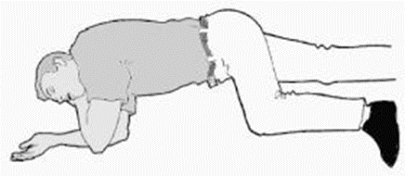

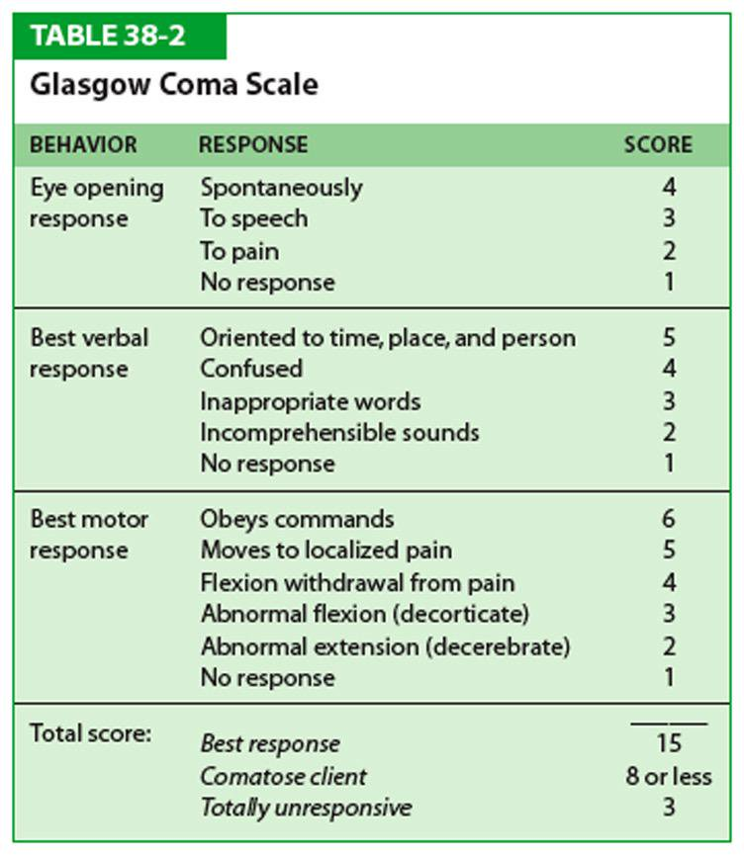

 | Possible Cause
Coma with fever | Malaria, meningitis, encephalitis, sepsis, or other severe infections
Coma with or without fever | Severe hypoglycaemia (dextrose <45mg/dL or <2.5mmol/l)  Severe dehydration
Coma without fever | Head trauma (accident), poisoning, stroke, cerebral haemorrhage

LONG TERM MANAGEMENT OF COMA

- Re-position the patient every 2 hours from one side to the other. Show the family how to re-position the patient. Remind them not to let the patient lie flat on his back. In that case the tongue might block the airway or vomit may enter the airway.
- Put in a urine catheter. Monitor fluid balance (input/output) in order to avoid dehydration.
- If the coma is following a head trauma DO NOT use 5% dextrose during the first 48 hours (sugar can worsen the brain damage) except in hypoglycaemic patients.
- Regularly reassess the patient: check the vital signs every 2 hours.
- Check GCS on admission and then twice a day.
- Check dextrose twice a day as the patient cannot eat or drink.
- Wash the patient all over once a day. Clean the patient whenever urine and/or stools are passed. Wash the affected area and do not just wipe with dry cloth or paper. Help the family to do this.
- Clean the mouth and moisten lips at least 4 times a day. Vaseline applied on the lips prevents cracking.
- Clean the eyes with NSS and cotton wool. Apply Terramycin Eye Ointment (TEO) BID to avoid conjunctivitis, drying up of cornea, and injury. Drying up of cornea can lead to blindness. Close the eyes with a plaster/tape if they stay open.
- Teach the family how to do massages and perform passive limb movements every 4 hours to maintain muscle tone and prevent contractions.
- In prolonged coma consider NG feeding depending on the cause and prognosis. This must be discussed with the doctor.
- Ask the family not to leave the patient alone.
- If the patient condition does not improve despite full treatment, see palliative care chapter for end of life care.

CONVULSIONS

Convulsions are a sudden loss of consciousness with or without cyanosis and strong movements of the arms and legs generally lasting for a few minutes. Sometimes the patient also passes urine or bites his tongue.

**If your patient regains consciousness immediately and is not disorientated after the attack, or if the patient remains conscious during the crisis, it is not a convulsion**

When the movements stop, the patient may remain unconscious and breathe deeply for up to half an hour. The patient slowly returns to normal consciousness, and during this time the patient may be disoriented, asking the same questions many times (e.g. about what happened to him/her, where he/she is etc.).

EMERGENCY TREATMENT
 | ASSESS FOR | TREATMENTS LIKELY TO BE NEEDED FOR SHOCK
DR | Danger  Response | Gloves  Safe place, call for help
A | Airway obstruction  Speaking, stridor,  swelling, secretions | Simple airway manoeuvres +/- airway if needed  Suction if needed (and available)  Oxygen (high flow)
B | RR, SpO2, Chest indrawing/cyanosis  tracheal tug  Listen to chest
C | HR, BP, Cap refill  Urine output, Temp  Listen to HS | Put in 2 biggest (16G or 18G) IV cannula – take bloods e.g. Hct, CBC, MS,BC, dextrose etc.
D | Check dextrose  Any drugs needed e.g.antibiotics, paracetamol | If fitting continues for more than 3 minutes give:  Diazepam Slow IV or IM or PR  Adults: 10mg (1 vial) ( if IV max 0.5ml in 30 seconds)  Child: 0.4mg/kg (max 10mg)  **When the patient is moving, it can be easier to give first dose IM or PR but IV  is quicker and better.**  If dextrose low give IV  Adult and Child: 5ml/kg 10% dextrose bolus  Neonates: 2ml/kg 10% dextrose bolus  Give any other drugs according to cause
E | AVPU/GCS  Expose and examine all  over body | History, further investigations, treatment plan.  Assess for cause of convulsion, and treat.  Coma position to prevent aspiration (see below) after fitting if no respiratory  distress

Diazepam IV
1 vial = 10mg / 2ml

Give IV injections SLOWLY (max 0.5 ml in 30 seconds)

Diazepam Rectally (PR) or IM
Diazepam PR or IM is NOT diluted
How to give PR:
- Draw up the dose from an ampoule of diazepam into a 1ml syringe
- Remove the needle
- Insert the syringe into the rectum 4 to 5 cm and inject the diazepam solution
- Hold buttocks together for a few minutes

If the patient is still fitting:

- After 3-5 minutes give a second dose of diazepam
- CALL DOCTOR, AND BEGIN REFERRAL PROCESS
- After another 3-5 minutes give a third dose of diazepam

**Note: Ideally we would give IV phenobarbitone but not available so need to refer – the patient is at risk of not getting enough oxygen to the brain so this must be done urgently**

DIAGNOSIS:
- Check blood sugar for hypoglycaemia.
- Look for signs of infection (meningitis, malaria etc.).
- Ask for past and recent medical history, previous convulsion episodes, and medication taken.

When looking for causes, the next list could be helpful: remember AEIOU

A: Alcohol, E: Eclampsia, I: Infections, O: Organ failure, U: Uraemia (= renal failure)

TREATMENT
Goals of treatment are:
- Stop convulsions quickly.
- Treat fever if present especially in children under 5 as it can be the cause of the convulsions.
- Find and control the underlying cause.
- Prevent complications by protecting the person from injury. Try to prevent a fall. Lay the person on the ground in a safe area. Clear the area of furniture or other sharp objects.

DIABETIC EMERGENCIES
 | ASSESS FOR | TREATMENTS LIKELY TO BE NEEDED FOR SHOCK
DR | Danger  Response | Gloves  Safe place, call for help
A | Airway obstruction  Speaking, stridor,  swelling, secretions | Simple airway manoeuvres +/- airway if needed  Suction if needed (and available)  Oxygen (high flow)
B | RR, SpO2, Chest indrawing/cyanosis  tracheal tug  Listen to chest
C | HR, BP, Cap refill  Urine output, Temp  Listen to HS | Put in 2 biggest (16G or 18G) IV cannula – take bloods e.g. Hct, CBC, MS,BC, dextrose etc.
D | Check dextrose  Any drugs needed e.g.antibiotics, paracetamol | If dextrose LOW:  If dextrose 45-70mg/dL:  Give oral sugar solution (water mixed with sugar) or sweet drink to prevent  severe hypoglycaemia.  If dextrose <45mg/dL:  If able to drink: give oral sugar solution (water mixed with sugar) or sweet  drink  If unable to drink e.g. in coma: insert IV cannula and give Adult/Child: 5ml/  kg 10% dextrose bolus (D10W), Neonate 2ml/kg 10% dextrose  If dextrose HIGH give IV NSS:  Adult: 1L in 1 hour  Child: 10ml/kg in 1 hour
E | AVPU/GCS  Expose and examine all  over body | History, further investigations, treatment plan.  Assess for cause of high/low dextrose, and treat /refer

HYPERGLYCAEMIA (Dextrose >200mg/dL or >11 mmol/L)
• Think about diagnosis of diabetes if
  - No history but has symptoms of diabetes
  - Has history of diabetes and has been unwell recently or does not take medications regularly, may have poor appetite
  - Fast RR, ketotic breath (breath smells sweet), dehydration, vomiting, abdominal pain, coma
  - Urine dipstick positive for ketones

• Insert an IV cannula, start NSS:
  - Adult 1L in 1 hour
  - Children 10ml/kg in 1 hour (the risk of fluid overload is higher in children)

• This patient needs insulin that is not available at many clinics, after starting IV fluids discuss with the doctor about referring to hospital. (If the patient has Type 2 Diabetes the blood sugar may decrease with IV fluids, and may be treated without referring).

HYPOGLYCAEMIA (Dextrose <70mg/dL (=3.8mmol/l) Note: <45mg/dL (=2.5mmol/l) is severe hypoglycaemia)
• Symptoms: sweating, hunger, tremor, dizziness, drowsiness, aggressive/irritable, confusion, convulsion, coma
• If dextrose 45-70mg/dL:
Give oral sugar solution (water mixed with sugar) or sweet drink to prevent severe hypoglycaemia.

• If dextrose <45mg/dL:
If able to drink: give oral sugar solution (water mixed with sugar) or sweet drink
If unable to drink e.g. in coma: insert IV cannula and give Adult/Child: 5ml/kg 10% dextrose bolus, Neonate 2ml/ kg 10% dextrose
• After giving oral/IV dextrose re-check blood dextrose after 15 minutes to make sure it is >70mg/dL

GASTRO-INTESTINAL BLEEDING

CAUSES
- Peptic ulcer disease
- Varices (from portal hypertension from liver disease e.g. alcoholism)

SIGNS/SYMPTOMS
- Will vomit brown liquid (like coffee) or fresh blood and/or will have melaena (black sticky smelly stools). (Remember that patients on iron tablets will have black stools).
- May have signs of shock – tachycardia, low BP, high cap refill, cold peripheries

EMERGENCY TREATMENT

 | ASSESS FOR | TREATMENTS LIKELY TO BE NEEDED FOR SHOCK
DR | Danger  Response | Gloves  Safe place, call for help
A | Airway obstruction  Speaking, stridor,  swelling, secretions | Simple airway manoeuvres +/- airway if needed  Suction if needed (and available)  Oxygen (high flow)
B | RR, SpO2, Chest indrawing/cyanosis  tracheal tug  Listen to chest
C | HR, BP, Cap refill  Urine output, Temp  Listen to HS | 2 IV cannulas (biggest size possible 16G or 18G)  Take bloods e.g. Hct, blood group, BUN*, CBC, MS, dextrose etc.  Fluid bolus 1L STAT  Transfuse if signs of shock
D | Check dextrose  Any drugs needed e.g.antibiotics, paracetamol | See below for doses  If UGI bleeding and suspect PEPTIC If suspect PORTAL HYPERTENSION e.g.  ULCER DISEASE e.g. history of abdominal high alcohol intake, chronic hep B or  pain, no risk factors for liver disease: C or signs of cirrhosis discuss with the  Omeprazole OR Ranitidine doctor and consider:  Ceftriaxone +/- Vitamin K
E | AVPU/GCS  Expose and examine all  over body | History, further investigations, treatment plan

SECONDARY TREAMENT
No food or drink
• REFER TO HOSPITAL URGENTLY

SPECIFIC TREATMENT

If suspect peptic ulcer disease (e.g. history of abdominal pain, no risk factors for liver disease) (see p.80)

• Give omeprazole IV 40mg (or PO if no IV) or ranitidine 50mg IV (diluted to 20ml given over 2 minutes)

If suspect portal hypertension from cirrhosis (see p.93) (e.g. history of high alcohol intake, chronic hep B or C or signs or cirrhosis) discuss with the doctor about also doing the following:
- IV ceftriaxone 1g OD for 5-7 days – varices are often associated with bacterial infection
- Vitamin K IM 2.5-10mg STAT dose
- When stable start propranolol 40mg BID

NEUROLOGICAL EMERGENCY: STROKE

STROKE IS A LIFE THREATENING EMERGENCY!

Using FAST technique can be very helpful.

F - Facial weakness: Has their face fallen on one side? Can they smile?
A - Arm weakness: Can the person raise both arms and keep them there? Is there weakness on one side?
S - Speech and communication difficulties: Is their speech slurred?
T - Time: Time is important, needs URGENT to transfer to the hospital if you see any single one of these signs

 | ASSESS FOR | TREATMENTS LIKELY TO BE NEEDED FOR SHOCK
DR | Danger  Response | Gloves  Safe place, call for help
A | Airway obstruction  Speaking, stridor,  swelling, secretions | Simple airway manoeuvres +/- airway if needed  Suction if needed (and available)  Oxygen
B | RR, SpO2, Chest indrawing/cyanosis  tracheal tug  Listen to chest
C | HR, BP, Cap refill  Urine output, Temp  Listen to HS | Put in IV cannula – take bloods e.g. Hct, CBC, MS, dextrose etc.  **Note: Do not give BP medication to reduce the BP as the high BP may be needed  to supply the brain with more oxygen**
D | Check dextrose  Any drugs needed e.g.antibiotics, paracetamol | Give dextrose if low
E | AVPU/GCS  Expose and examine all  over body | If abnormal neurology exam e.g. facial droop, one sided weakness, high tone, increased  reflexes → suggests diagnosis of stroke  Review notes and charts  History, further investigations, treatment plan

TREATMENT

- Urgent referral to hospital if you see any one of these signs – the quicker the patient receives treatment the more they are likely to survive and recover from their symptoms

Appendix

Appendix 1. FORMAL DIAGNOSIS OF COPD by SPIROMETRY
When the ratio of forced expiratory volume in 1 second over forced vital capacity (FEV1/FVC) is less than 70% of that predicted for a matched control, it is diagnostic for a significant obstructive defect. Criteria for assessing the severity of airflow obstruction (based on the percent predicted postbronchodilator FEV1) are as follows:
Table 41 Formal diagnosis of COPD by spirometry
Stages of COPD | Management summary
Stage I (mild):  FEV1 80% or greater of predicted | Short-acting bronchodilator as needed
Stage II (moderate):  FEV1 50-79% of predicted | Short-acting bronchodilator as needed;  long-acting bronchodilator(s);  cardiopulmonary rehabilitation
Stage III (severe):  FEV1 30-49% of predicted | Short-acting bronchodilator as needed;  long-acting bronchodilator(s);  cardiopulmonary rehabilitation;  inhaled glucocorticoids if repeated exacerbations
Stage IV (very severe):  FEV1 less than 30% of predicted or FEV1 less than 50% and chronic respiratory failure | Short-acting bronchodilator as needed;  long-acting bronchodilator(s);  cardiopulmonary rehabilitation;  inhaled glucocorticoids if repeated exacerbation;  long-term oxygen therapy (if criteria met);  consider surgical options such as lung volume reduction surgery (LVRS) and lung transplantation

Appendix 2. F-75 and F-100 recipes
F-75
- Full-cream dried milk 35 g,
- 100 g sugar,
- 20 g (or ml) oil,
- Make up to 1,000 ml with water

F-100
- Full-cream dried milk 110 g,
- 50 g sugar,
- 30 g (or ml) oil,
- Make up to 1,000 ml with water

Isotonic and cereal based F-75
Cereal-based, low-osmolar F-75 (334 mOsmol/l) - This may be helpful for children with osmotic diarrhoea
- Replace 30 g of the sugar with 35 g cereal flour in F-75 recipes above.
- Cook for 4 min.

Appendix 3. ReSoMal

ReSoMal = Rehydration Solution for Malnutrition
ReSoMal is only for patients with severe acute malnutrition.

1 pack ORS = 150 ml.
But for ReSoMal 2 packs should be diluted with 720 ml – this is to reduce the amount of sodium.

Mix together:
For this recipe packet ORS should contain in 1 x 150 ml sachet:
- Dextrose 3 g
- NaCl 0.53 g
- KCl 0.23 g
- Na citrate 0.4 g
For mmol/l see below *
- ORS 2 packets
- Water 720 ml
- Sugar 22g
- Potassium - KCl 1.75 g (3 ½ tab 500 mg/tab)
Crush well before mixing

If no packet ORS available make ReSoMal with:
Conversion g-mmol
 | gram | mmol
Sugar | 1 | 5.6
NaCl | 1 | 29
KCl | 1 | 13
- Water 1,000 ml
- Sugar 40 g
- 1.5 g salt
- 3 g potassium (6 tablets 500 mg/tablet)

 | Packet ORS MTC (same as old WHO ORS)* |  | WHO new  Low osmolality |  | WHO ReSoMal |  | MTC ReSoMal
 | gram/l | mmol/l* | gram/l | mmol/l | Gram/l | mmol/l | gram/l | mmol/l
Sugar | 20 | 112 | 13.5 | 75.6 | 38.5 | 215.6 | 38.9 | 217.7
NaCl | 3.5 | 101.5 | 2.6 | 75.4 | 1.6 | 45 | 1.4 | 42
KCl | 1.5 | 19.5 | 1.5 | 19.5 | 3 | 40 | 3.1 | 40
Mg | 0 | 0 | 0 | 0 |  | 3 | 0 | 0
*Note all ORS also contains trisodium citrate dehydrate

Appendix 4: MUAC, z-score table and others nutrition charts
FOR CHILD:
MUAC measure | MUAC colour | MUAC meaning
More or = to 135 mm | GREEN | Normal
125 mm to 134 mm | YELLOW | At risk of malnutrition
110 mm to 124 mm | ORANGE | Moderate malnutrition
less than 110 mm | RED | Severe malnutrition

FOR PREGNANT AND LACTATING WOMEN: < 210 mm = moderate malnutrition
< 170 mm = severe malnutrition

Appendix 5: Weight for height and malnutrition
Age | Method | Moderate malnutrition | Severe malnutrition
6 months to 10 years (or under 130 cm) | Z-Score | -3 to < -2 | < -3  or Oedema
6 months to 10 years (or under 130 cm) | Z-Score | Discharge when  > - 1,5 for 2 weeks | Discharge when  > -2 for 2 weeks (and SFP)
Adolescents  10 to 18 years (or over 130 cm) | % of median chart | > or = 70%  < 80% | < 70%
Adolescents  10 to 18 years (or over 130 cm) | % of median chart | Discharge when  > 85% for 2 weeks | Discharge when  > or = 80% for 2 weeks
Adults  More than 18 years old | BMI | > or = 16  < 17  (or > or = 15 and < 16 if over 50 years) | < 16  (or < 15 if over 50 years)
Adults  More than 18 years old | BMI | Discharge when  > 17 for 2 weeks  (or > 16 if over 50 years) | Discharge when  > 16 for one week  (or > 15 if over 50 years)

Appendix 6: WHO growth chart (Boys)
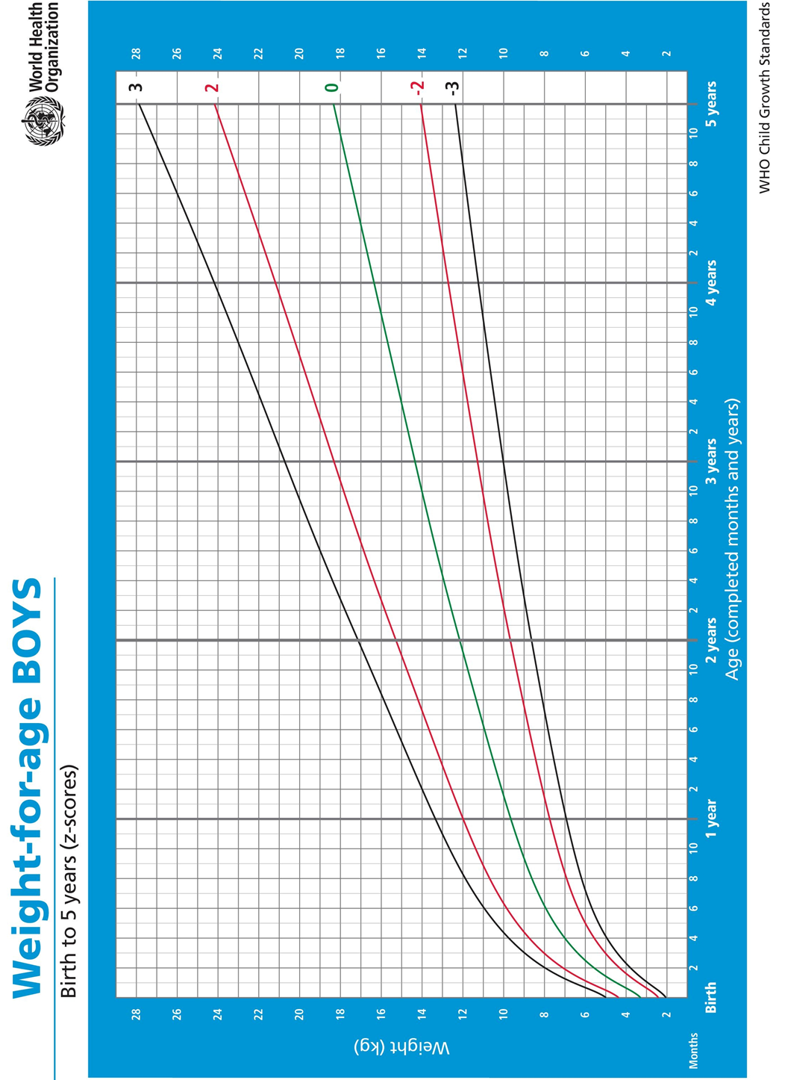

Appendix 7: WHO growth chart (Girls)

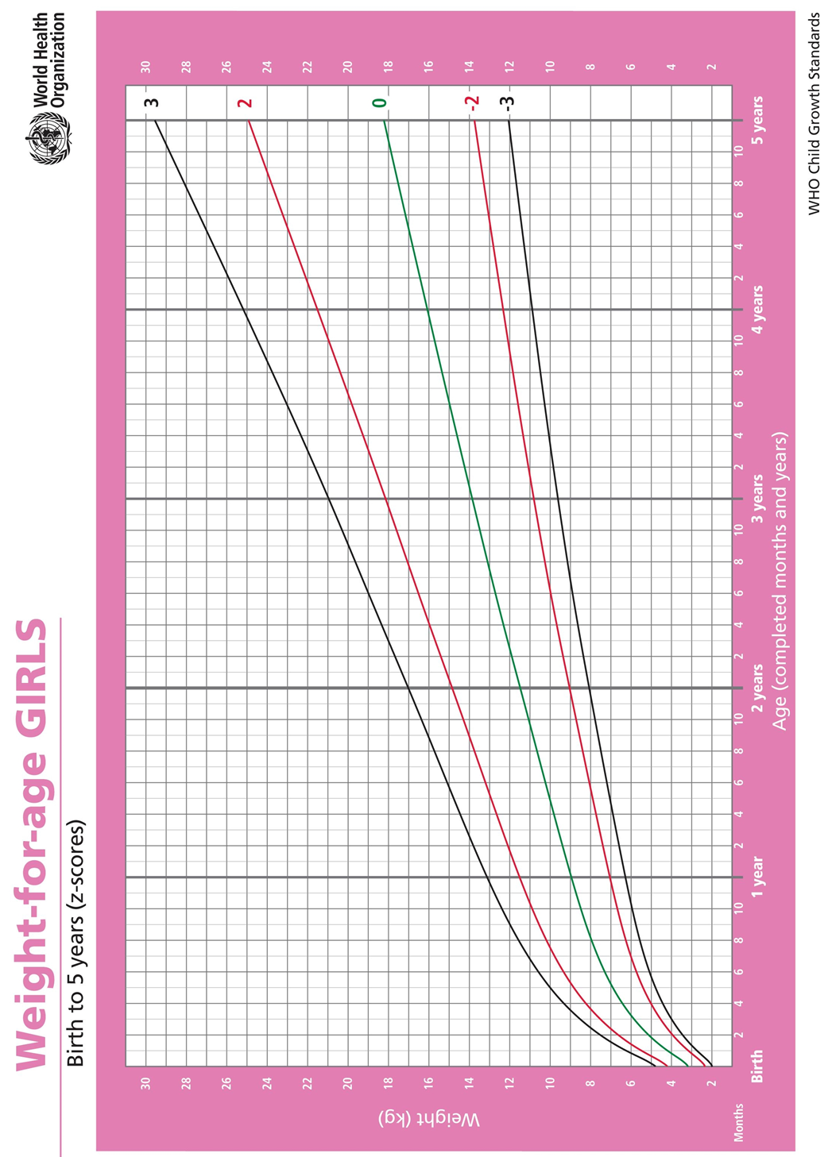

Appendix 8: Weight for Age table (Boys)
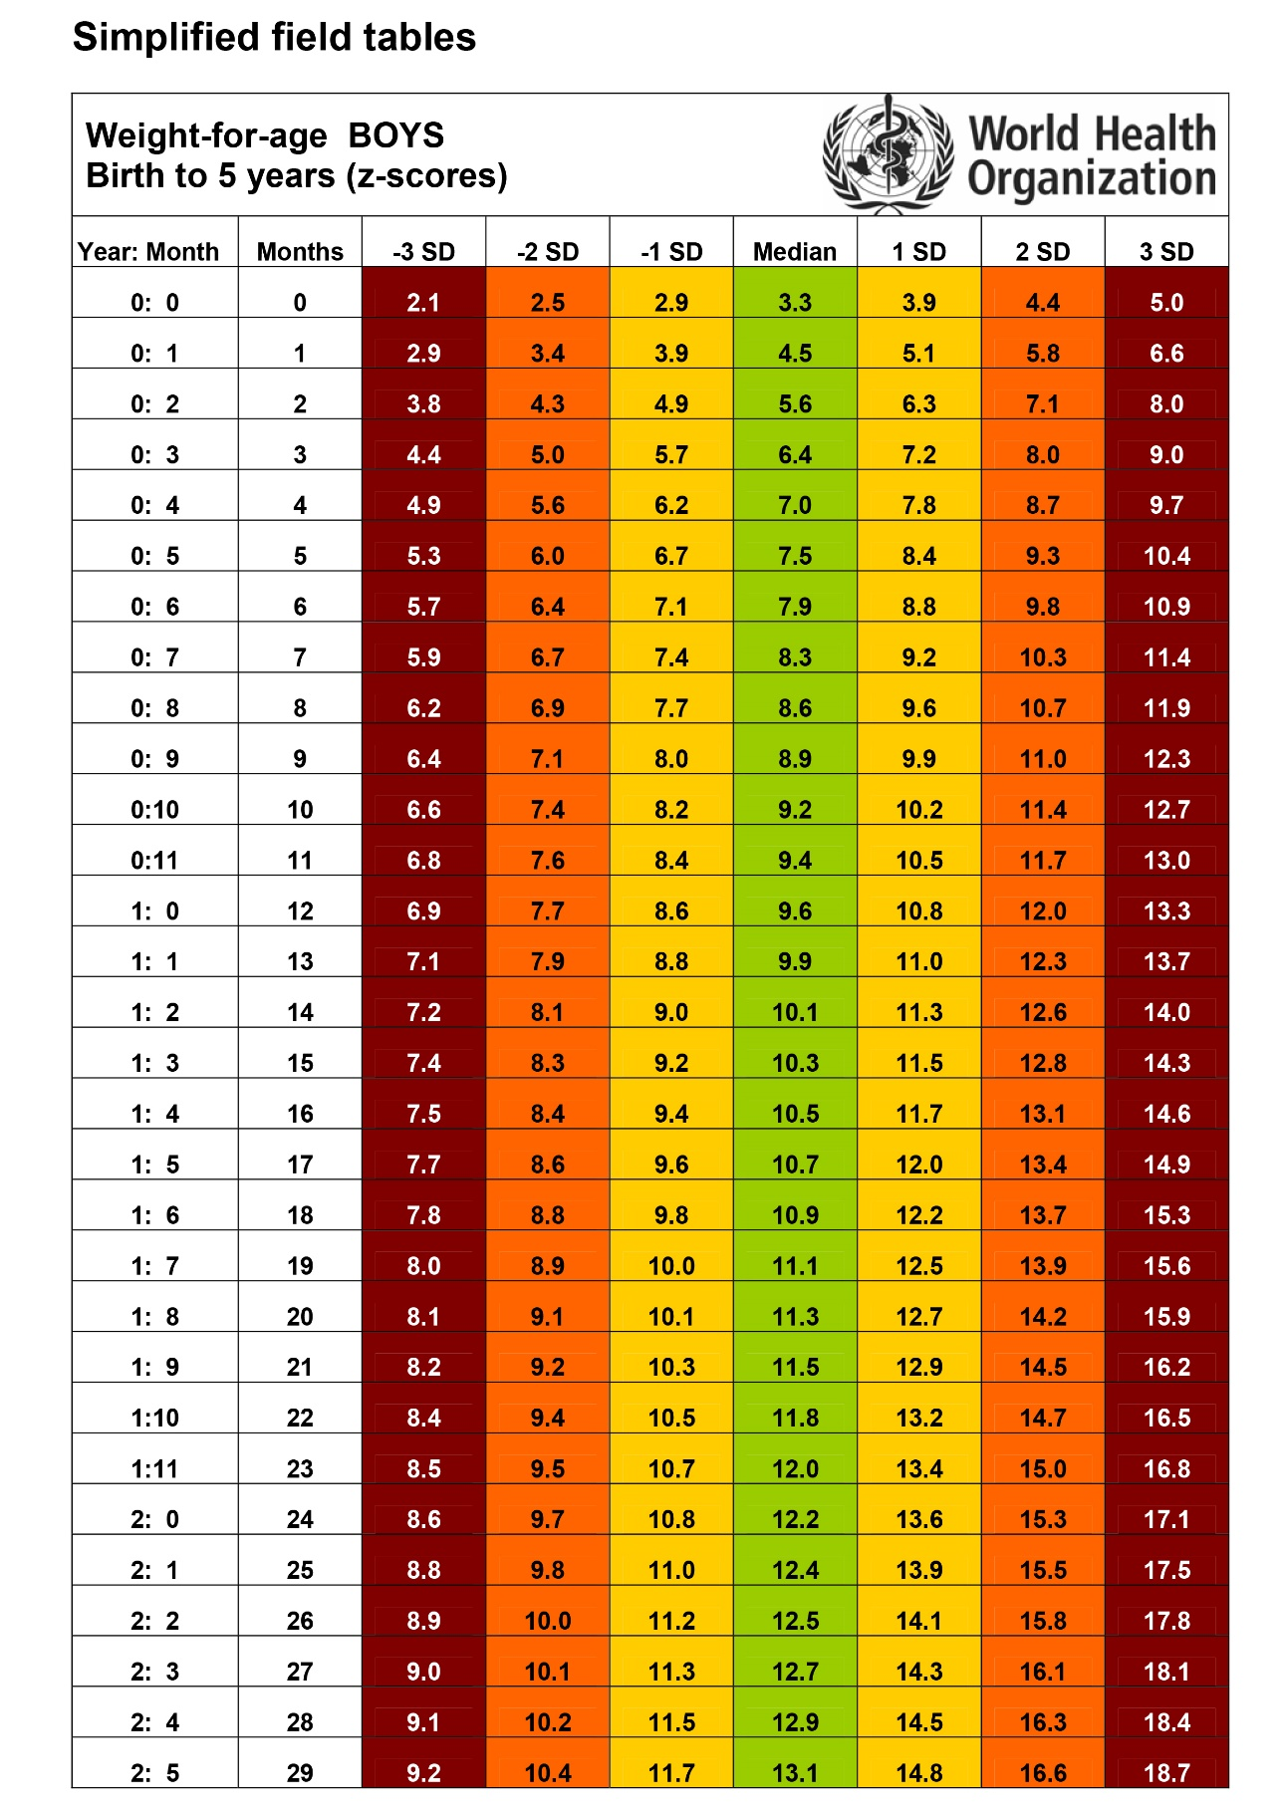

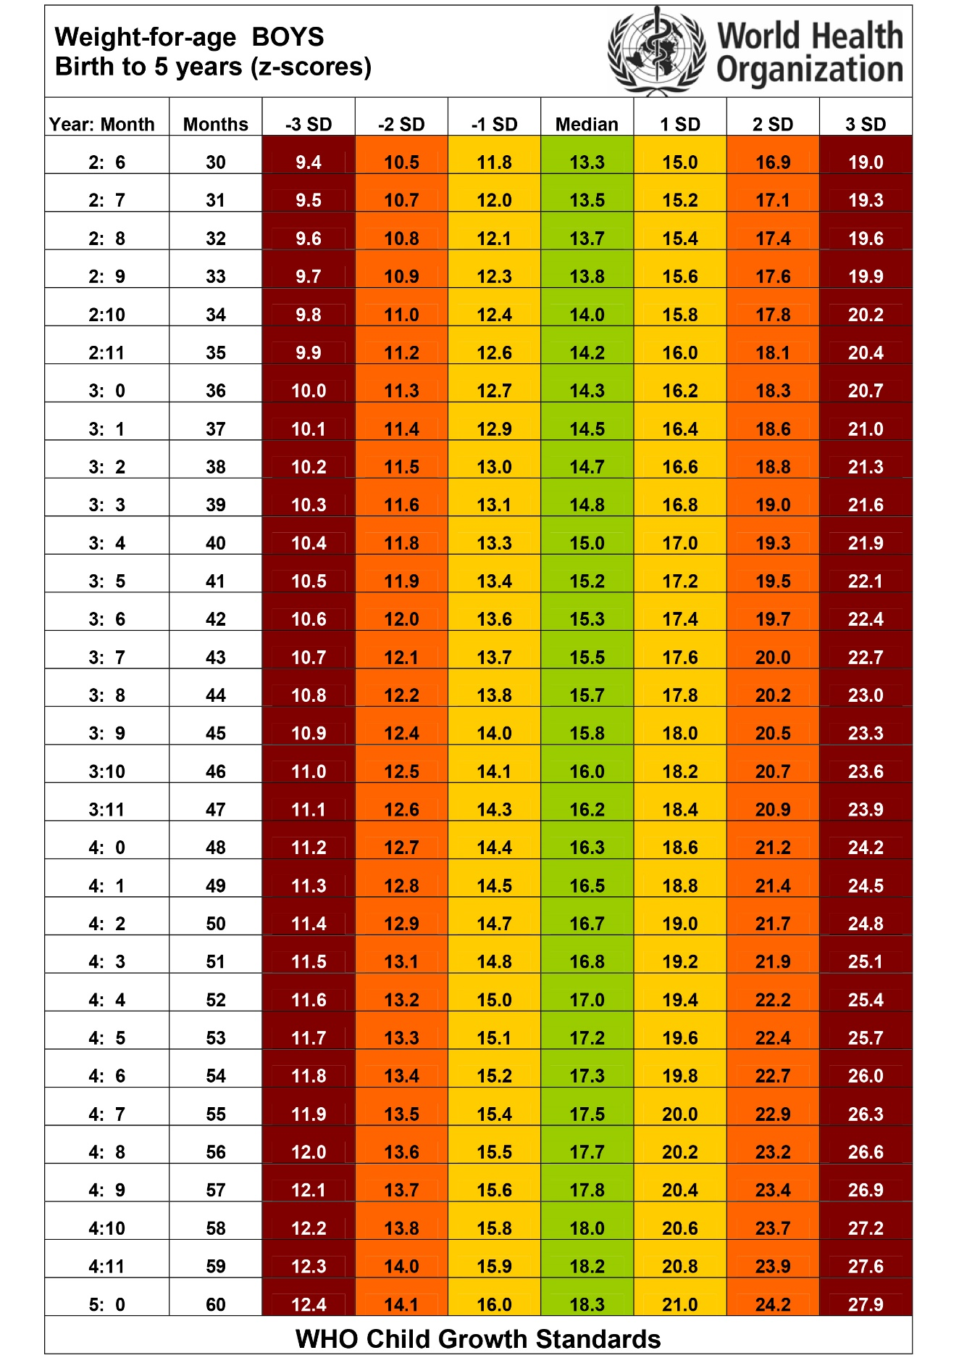

Appendix 9: Weight for Age table (Girls)
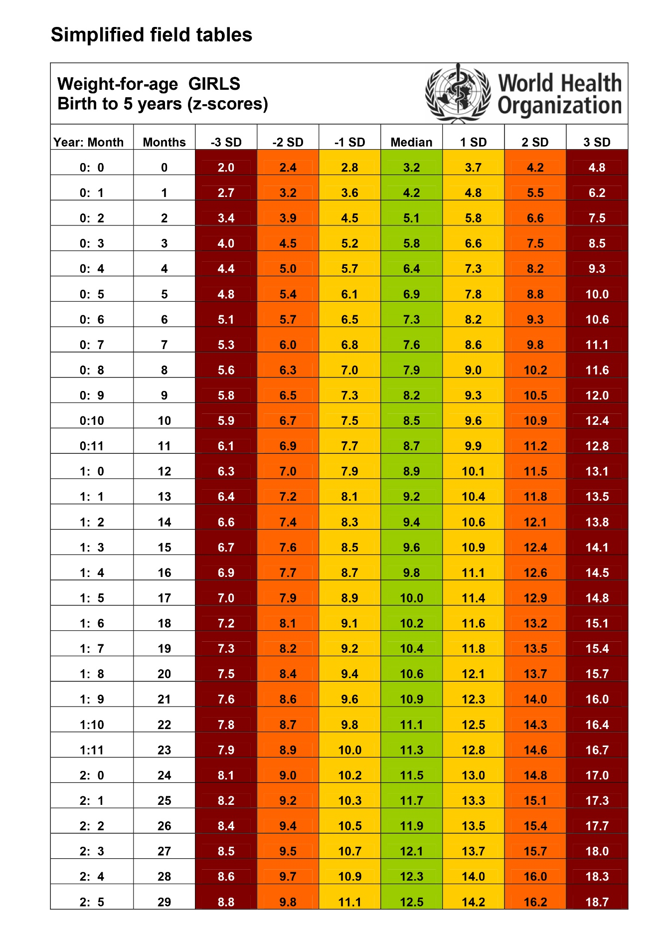

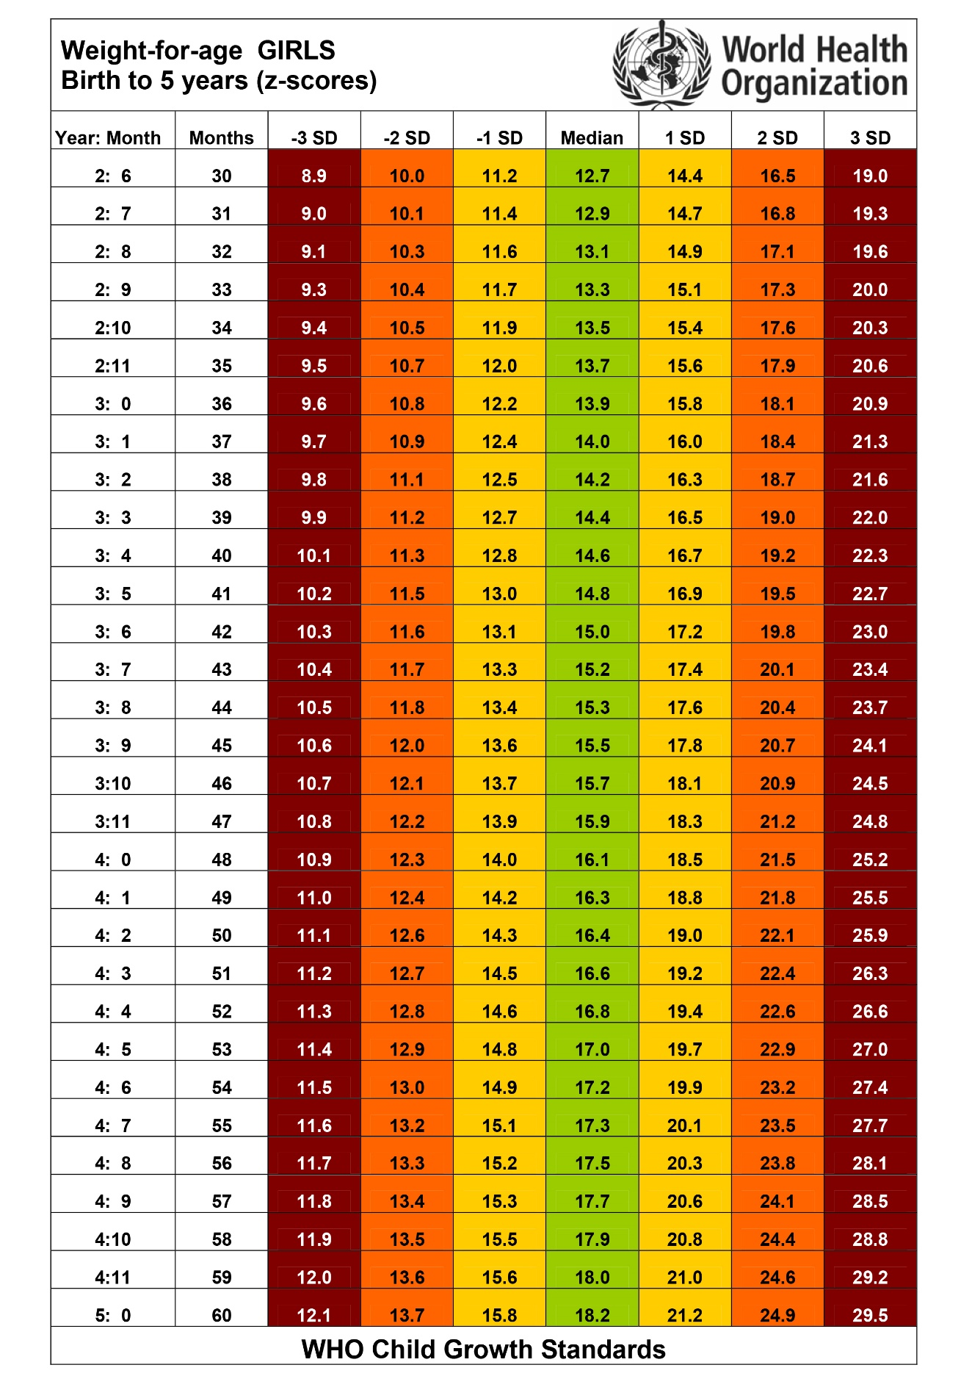

Lists of abbreviations
3TC - Lamivudine
ABC - Abacavir
AFB - acid fast bacilli
AIDS - acquired immunodeficiency syndrome
ART - antiretroviral therapy
ARV - antiretroviral drug
ATV - atazanavir
AZT - azidothymidine or zidovudine
BD - twice daily
bPI - boosted protease inhibitor
CD4 - count CD4+ T-lymphocyte count
CMV - cytomegalovirus
CNS - central nervous system
COPD - chronic obstructive pulmonary disease
CSF - cerebrospinal fluid
CrAg - cryptococcal antigen
CVD - cardiovascular diseases
d4T - stavudine
DAA - direct acting antiviral agent for HCV
DBS - dried blood spot
DDI - didanosine
DRV - darunavir
DTG - dolutegravir
EFV - efavirenz
eGFR - estimated glomerular filtration rate
EID - early infant diagnosis
ETV - etravirine
FDC - fixed-dose combination
FTC - emtricitabine
Hb - haemoglobin
HBV - hepatitis B virus
HCV - hepatitis C virus
HIV - human immunodeficiency virus
HIV DNA - HIV deoxyribonucleic acid
HIV RNA - HIV ribonucleic acid
HSV - herpes simplex virus
HTS - HIV testing services
INH - isoniazid
INSTI - integrase strand transfer inhibitor (integrase inhibitor)
IRIS - immune reconstitution inflammatory syndrome
IVD - in vitro diagnostics
LA - latex agglutination
LAM - lipoarabinomannan
LF - urine lateral flow (test for diagnosing TB)
LPV - lopinavir
LPV/r - ritonavir-boosted lopinavir
MTCT - mother-to-child transmission of HIV
MDR-TB - multi-drug resistance tuberculosis
NAP - National AIDS Programme
NAT - nucleic acid test
NCD - non-communicable disease
NNRTI - non-nucleoside reverse transcriptase inhibitor
NRTI - nucleoside reverse transcriptase inhibitor
NSAID - non-steroidal anti-inflammatory drug
NVP - nevirapine
OD - once a day
OI - opportunistic infection
OST - opioid substitution therapy
Us P 24 Ag - ultrasensitive P 24 antigen test
PCP - Pneumocystis jerovecii pneumonia
PEN - Package of Essential NCD interventions
PEP - post-exposure prophylaxis
PrEP - pre-exposure prophylaxis
PGL - persistent generalized lymphadenopathy
PI - protease inhibitor
PITC - provider-initiated HIV testing and counseling
PLHIV - people living with HIV
PMTCT - prevention of mother-to-child transmission of HIV
PPE - pruritic papular eruption
/r - low dose ritonavir to boost another PI
RAL - raltegravir
RCT - randomized control trial
RTV - ritonavir
RDT - rapid diagnostic test
STI - sexually transmitted infections
TG - transgender
TST - tuberculin skin test
TB - tuberculosis
TDF - tenofovir disoproxil fumarate
UNAIDS - Joint United Nations Programme on HIV/AIDS
UNODC - United Nations Office on Drugs and Crime
VL - viral load
VMMC - voluntary male medical circumcision
WHO - World Health Organization

Reference:
- Allina health pain assessment scale, https://www.allinahealth.org/uploadedImages/Content/Health_Conditions_and_Treatments/Health_Library/Patient_education/Allina-Health-Pain-Assessment-Scale-fullsize.jpg
- Universal pain scale assessment tools, National Health System, UK, https://www.nes.scot.nhs.uk/media/2701203/faces_scale_tool.pdf
- Murtagh’s general practice, sixth edition, Mc Graw Hill Education, 2015
- Boston Children’s Hospital, hypertension symptoms and causes in children.
- https://upload.medbullets.com/topic/120011/images/e4d2094c_3f91f376.79508c5a.jpg
- https://www.123rf.com/profile_stockdevil
- Invective endocarditis, Oct 16 2017, Medscape, the heart.org, https://emedicine.medscape.com/article/216650-overview
- Health topic, Cincinnati Children's Hospital Medical Center, September 2018, https://www.cincinnatichildrens.org/health/t/tof
- Understanding the aetiology and resolution of chronic otitis media from animal and human studies, Mahmood F. Bhutta, Ruth B. Thornton, Lea-Ann S. Kirkham, Joseph E. Kerschner, Michael T. Cheeseman, Disease Models & Mechanisms 2017 10: 1289-1300; doi: 10.1242/dmm.029983
- https://parents.education/wp-content/uploads/2016/05/sinusitis-lg.jpg
- Battaglia A, Burchette R, Hussman J, Silver MA, Martin P, Bernstein P, Comparison of Medical Therapy Alone to Medical Therapy with Surgical Treatment of Peritonsillar Abscess. Otolaryngol Head Neck Surg. 2018 Feb. 158 (2):280-6 (Medline)
- GUIDELINES FOR THE MANAGEMENT OF COMMON CHILDHOOD ILLNESSES Second edition, 2013, WHO
- Revised WHO Classification and Treatment of Pneumonia in Children at Health Facilities: Evidence Summaries, https://www.ncbi.nlm.nih.gov/books/NBK264159/
- Guidelines for the clinical management of HIV infection in Myanmar, 2017, National AIDS programme, Department of Public Health, Ministry of Health and Sports, Myanmar, WHO-Myanmar
- Consolidated guidelines on the use of antiretroviral drugs for treating and preventing HIV infection, Summary of recommendation, WHO-2017
- GUIDELINES ON POST-EXPOSURE PROPHYLAXIS FOR HIV AND THE USE OF CO-TRIMOXAZOLE PROPHYLAXIS FOR HIV-RELATED INFECTIONS AMONG ADULTS, ADOLESCENTS AND CHILDREN: RECOMMENDATIONS FOR A PUBLIC HEALTH APPROACH, WHO 2014
- Consolidated guidelines on HIV testing services, 5Cs, July 2015, WHO
- Consolidated guidelines oh HIV prevention, diagnosis, treatment and care for key populations, 2016, WHO
- Consolidated guidelines of the use of antiretroviral drugs for treating and preventing HIV infection, recommendations for a public health approach, second edition, 2016
- Companion handbook of the WHO guideline for the programmatic management of drug-resistant tuberculosis, 2014
- The Stages of HIV Infection, U.S department of health human services, AIDS info, July 2018
- Burma border guideline, 2016
- https://www.who.int/ith/diseases/hivaids/en/
- Malnutrition Guidelines, 2016, Mae Tao Clinic
- mhGAP Intervention Guide Mental Health Gap Action Programme Version 2.0 for mental, neurological and substance use disorders in non-specialized health settings, WHO, 2016
- MSF Clinical guideline 2018

